Banker's Order
To (name of your bank)
of (bank's address)
Street
Town
County
Post Code
Please pay David Anderson Africa Trust:
the sum of (amount in words) 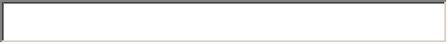
each *month/quarter/year until further notice starting (*delete as appropriate)
on the 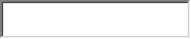(day) of 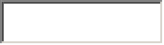(month) 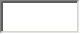(year)
and debit my account number 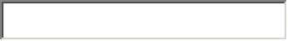
sort code
Signed .............................................................
Name................................................................
on the (day) of (month) (year)
The Banker's Order should be returned to DAAT and not sent to the charity's bank.
If you are a taxpayer, please fill in the Gift Aid Declaration on the Donation From and send to us with your Banker's Order.
Please return to: The Fund Administrator, DAAT, 2 Old School Norfolk Street, Cambridge CB1 2LE

