David Anderson Africa Trust

NEWSLETTER

Winter 2007

WIFIP Studio gets a facelift with support from DAAT

WIFIP (Women in the Fishing Industry Programme) Education and Development is a non-profit organisation working in western Kenya on open learning opportunities for women. DAAT has made a contribution to WIFIP’s new recording studios and we have been working with WIFIP to produce a business plan and funding proposals. We were delighted to learn that WIFIP has received an award for excellence in distance teaching materials from the Commonwealth of Learning for its handbook for women group leaders http://www.col.org/colweb/site/pid/4394.

In the early days, WIFIP had to source recordings from commercial studios, which was time consuming and very expensive. DAAT helped WIFIP to fund their own in-house audio studio to develop their distance learning programmes. The quality and quantity of WIFIP audio learning programmes has been much improved by the acquisition of a project mix audio interface, studio monitors and a studio condenser microphone. This studio has reduced the production costs by nearly 60%, and audio materials can now be produced on schedule without having to wait for outside companies to deliver.

Commercial recording companies use professional actors to record programmes, whereas WIFIP sources their own readers from their target audience who are more in touch with the realities of the situations being described. Finally, now that the recording is efficient and cost effective, WIFIP are able to produce many more programmes within their limited budget.

The programmes that WIFIP produces are aimed at women in the fishing industry who are isolated from educational support that we would take for granted. They cover important topics such as HIV/AIDS, maternal and child health and sanitation. The women using these programmes have talked of the improved quality and clarity of recordings and how they relate to the cast as they are their own peers with whom they empathise and identify. This has impacted positively on the community and influenced changes in behaviour that are so important to control diseases such as HIV in the target communities.

Challenges
There remain challenges to overcome in production – they need a soundproof studio room. The departmental staff need ongoing training to continue the development of their production skills and knowledge and they need more equipment.

Extracts of update from Jennipher Kere, WIFIP

New WIFIP recording equipment

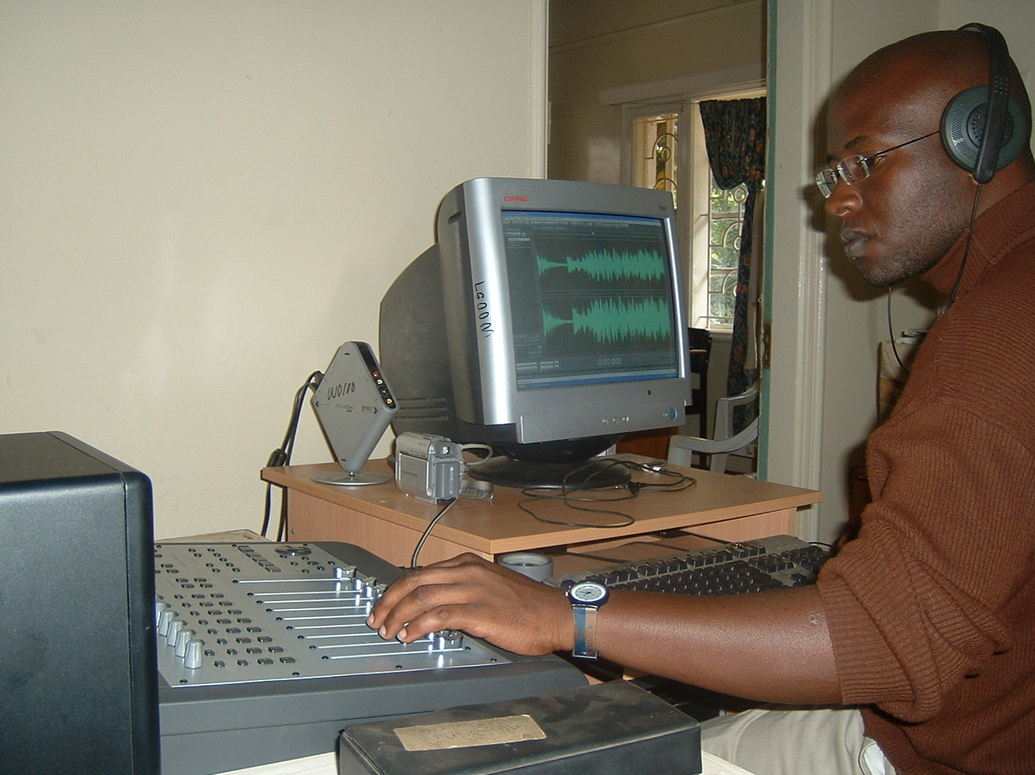
If you would like to know more about WIFIP programmes and funding needs, please contact us and we can give you more information.

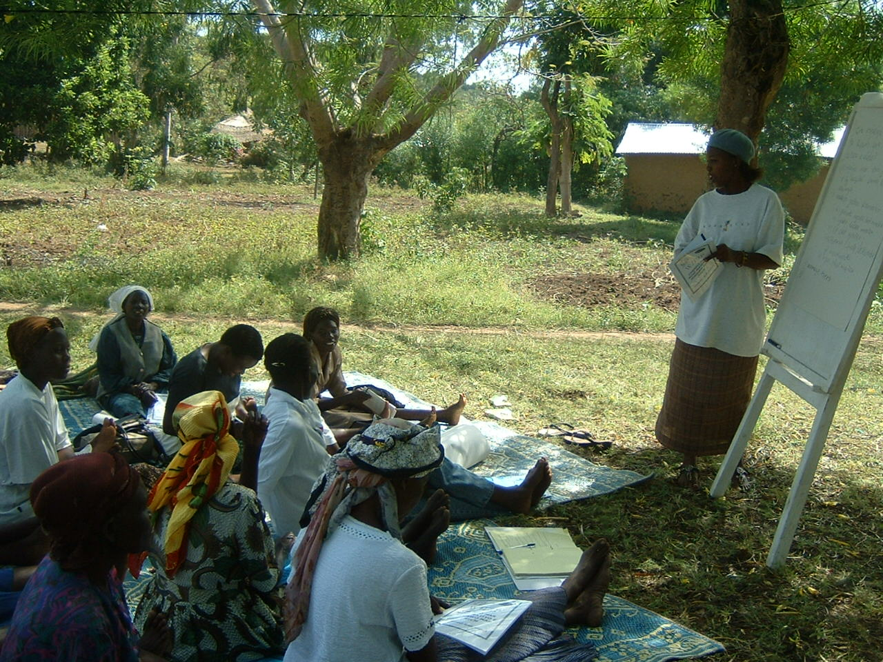

WIFIP group during a learning session

A thank you from a student sponsored by DAAT

I am afraid words could not express my real thanks for what DAAT has done for me. When I was hopeless, not knowing what to do and where to go for my future, DAAT put the way where there seemed not to be a way. I once was like other young hopeless young African men, but today I am somebody. I was a useless creature but today I am proud to be useful in African society. Through me you change lives of a whole community that I will be serving. By supporting students you are bringing sustainable development and peace into our poor and wartorn countries.

At the Daystar University I had peace as I could never be chased out of class due to lack of fees as DAAT is well known and credible. I had not have to waste my time borrowing books or waiting for others to finish using those of the library but I immediately bought mine due to your support. Your support helps a student not to drop out due to lack of fees. It really helps a student to get school fees which is the problem number one for Africans not to study. I am proud and grateful to DAAT.

I pray that may God lead you in continuing your ministry serving God and His people. Pray for me too so that I may support some students as you did for me.

Sibo Muhire, Goma, Democratic Republic of Congo

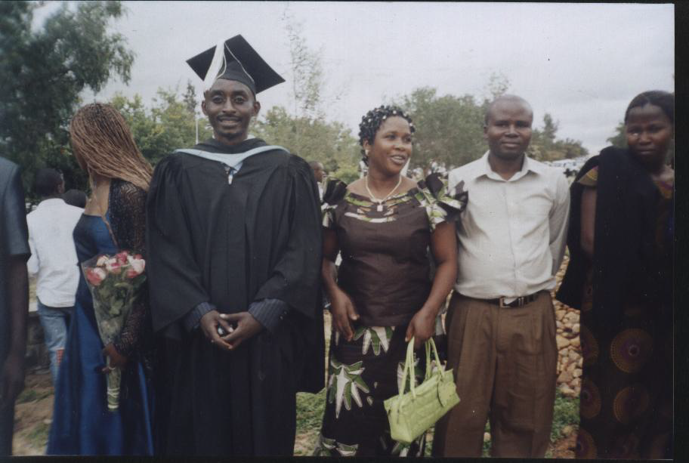

Sibo Muhire on his graduation day

Sibo has recently returned to his home in the Congo, and is looking for work related to his Community Development degree.

Supporting DAAT’s work

I started giving to DAAT after I went to Kenya and met intelligent, hard working and interesting Africans who were stuck in poor circumstances due to a lack of opportunities. I'm also aware that Kenya is one of the better African countries in this respect. In a civilised society, it should always be possible for these diligent individuals to change their circumstances for the better, and DAAT provides the funding to allow this to happen.
I teach undergraduate students at a British university. I am frequently struck by how
some British students take their opportunities for granted.

It is often the international students who are the easiest to teach – they know how fortunate they are to be at university, studying for a degree that will give them a skilled vocation and a chance of a life-time income. I know that students who are funded by DAAT will be like these international students: aware of the opportunity they've been given and determined to do the best they can as a result.
Peter Saffrey

More news about Kenya

DAAT is currently supporting two students at University through the Tatwa-Maahe Educational Trust.
The Tatwa-Maahe Educational Trust (TMET) is a charity dedicated to helping school pupils and schools in the Kuria District of southwest Kenya. It was set up by a social anthropologist who first carried out research there in the 1950s and is named after two prominent Kuria who combined a commitment to the language and culture of the traditional society with activities integral to the modern changes affecting it.

Primarily the charity helps with the payment of school fees of bright but poor girls. These now average the equivalent of about £190 per annum for most secondary District schools but are much higher for the better
National schools.

BeeKeeping in Lesotho

The project in Lesotho funding training for women to keep bees in order to produce honey on a commercial basis is in progress. The project initially encountered problems with finding a suitable training establishment,

In exceptional cases help is given to boys. The charity also makes grants to individual schools to assist with buildings, equipment and books.

Since 1991 when the charity was first set up it has transmitted about £41,000 to help with schools and schooling and since 1997, when it first started making direct awards to pupils, it has given full or partial support to 58 students, of whom 18 have received support throughout their four-year course. Two of our students have reached university and one has completed his degree. We are hoping that our policy of especially assisting girls will help them towards achieving university places.

Malcolm Ruel

If you would like to provide a donation for these or other students, do ask us for more information.

but training has now started, and we hope to provide more updates in our next newsletter.

New Graduate From Open University of Tanzania

Caroline Soyabi graduated in autumn 2007 with a Bsc in Education. She started her open university course, funded by DAAT, in 2003. She is a teacher at a secondary school, a widow with one son. She said that

the distance learning programme allowed
her to be at home for her family, retain her full time job, and to participate in other community activities while working towards a better future.

New initiatives in open learning

We would like to welcome Tony Dodds back as a trustee of DAAT. His experience establishing Open University centres is of great relevance to our work with the Open University of Tanzania, where we have for many years been supporting women and disabled students with their distance learning studies. Tony has recently carried out two consultancies for the Commonwealth of Learning to help in the development of plans for new open school initiatives.

Tony visited Nigeria in January 2005 to help the Federal Universal Basic Education Commission to draw up a proposal to establish a national open school for Nigeria. It is expected that first steps to implement the proposals will be taken in 2007. The plans pay special attention to the provision of continuing education to adolescent and young adult women, especially in rural areas, who have been forced by social and economic circumstances to drop out of formal school, as well as to the continuing education needs of nomadic communities.

In 2006 Tony Carried out a similar consultancy for the Allama Iqbal Open University of Pakistan, which is also seriously considering taking a new initiative to provide open learning opportunities to larger numbers of pre-tertiary out-of-school learners than it has reached in the past. It is expected that heavy emphasis will be put on enabling more young women and adolescent girls to continue their education beyond initial primary school.

These initiatives reflect the growing recognition worldwide that open and distance learning has a crucial role to play in making educational opportunities available to young people who have been deprived of the opportunity to continue with their education in

formal schools. This recognition was given added emphasis at the Commonwealth of Learning's bi-annual Pan-Commonwealth Forum in Jamaica in November 2006 when
awards of excellence in open and distance learning were made to two Open Colleges in
Southern Africa, the Namibian College of Open Learning (NAMCOL) and the Botswana College of Distance and Open Learning (BOCODOL).

Contact details
email: mail@daat.org.uk
website: www.daat.org.uk

Donations and general correspondence to our Administrator Jo Bradley, at:

2 The Old School
Norfolk Street,
Cambridge, CB1 2LE

Trustees
Ms Janis Anderson, Mrs Mary Anderson,
Ms Cath Attlee, Dr Tony Dodds, Dr Davina Hoile
Mr Jason Pennells, Mr John Thomas

The DAAT has advisors based in the UK and in Africa, whose specific expertise is often drawn upon.

I wish to support DAAT and enclose a donation of £.................
I wish to support DAAT on a regular basis and request a Banker's Order form..........
I am a UK taxpayer and would like DAAT to treat as Gift Aid my donations made since 6 April 2000 until I notify you otherwise ………..(please tick).
Name:………………………………………………….
Address:……………………………………………….
…………………………………………………………
…………………………………………………………

Signature.....................................Date..........................
Registered Charity No. 1001425
Company limited by guarantee. Registered No. 2567707.
Registered office: 1 Bell Leys, Wingrave, Bucks, HP22 4QD

