# TVS’ IT programme – evidence of success

We are increasingly introducing measures to demonstrate the effectiveness of our work in Tyume. In November 2013 we introduced basic tests for our IT learners. There were 3 tests with different levels of difficulty, depending on the amount of teaching learners had received and their abilities; all the tests examined their knowledge of Microsoft Word.

In September 2014 many of these learners took the test **at the next level of difficulty**. The pass rate was set at 65%; all learners reaching this were rewarded with an ‘Achievement Certificate’. Additional awards were given to those achieving 65% - 76% (bronze/red star); 77% - 89% (silver star); 90% - 99% (gold star); 100% (2x gold stars).

There were marked improvements in students’ test results:

**Dyamala Primary School**

2013 overall pass rate: 37% (bronze - 10%; silver - 22%; gold - 5%)

2014 overall pass rate: 66% (bronze -13%; silver - 19%; gold - 34%)

|  |  |  |
| --- | --- | --- |
|  |  |  |
| DSC_3359 | DSC_4968 |

**Festile Soga Primary School**

2013 overall pass rate: 50% (bronze – 12.5%; silver - 12.5%; gold - 25%)

2014 overall pass rate: 82% (bronze - 18%; silver - 35%; gold - 29%)

|  |  |  |
| --- | --- | --- |
| DSC_3373 |  | DSC_4847 |

**Ncera Zantsi Primary**

2013: overall pass rate: 62.5% (bronze - 37.5%; silver - 12.5%; gold - 12.5%)

2014: overall pass rate: 70% (bronze - 29%; silver - 35%; gold - 6%)

|  |  |  |
| --- | --- | --- |
|  |  |  |
| DSC_3367 | DSC_4917 |

**Mabandla Primary**

2013: overall pass rate 60% (bronze - 0%; silver - 20%; gold - 40%)

2014: overall pass rate: 43% (bronze - 3.5%; silver - 11%; gold: 28.5%)

|  |  |
| --- | --- |
|  | DSC_4984 |

**Gwali Primary**

2013: overall pass rate: 75% (bronze – 50%; silver – 25%; gold – 0%)

2014: overall pass rate 82% (bronze - 28%; silver - 45%; gold: 10%)

|  |  |  |
| --- | --- | --- |
| DSC_3380 |  | DSC_4855 |

In January 2014, TVS began working with 2 more primary schools and 2 secondary schools. These learners were tested for the first time in November 2014.

**Hopefield Primary** Overall pass rate: 56% (bronze - 0%; silver - 22%; gold - 34%)

**Auckland Primary** Overall pass rate: 33% (bronze - 0%; silver - 27%; gold: 6%)

|  |  |  |
| --- | --- | --- |
| Hopefield Primary |  | Auckland Primary |
| DSC_4876 | DSC_4994 |
|  |  |

**Gqibibhongo High School** Overall pass rate: 78% (bronze - 11%; silver - 22%; gold 45%)

**Enkenkwezini Secondary School** Overall pass rate: 72% (bronze - 5%; silver - 28%; gold - 39%)

|  |  |  |
| --- | --- | --- |
| Gqibibhongo High School |  | Enkwenkwezini SS School |
| DSC_4877 | DSC_4938 |

# TVS Study Camp December 2014 – hard work and fun!

December’s study camp was a departure from the usual pattern – and an unqualified success as far as the participants were concerned. It involved an older age group than usual – school leavers from 5 secondary schools in Tyume Valley. The first week was held at our usual study camp venue, Hobbiton Outdoor Centre in Hogsback. This was followed by a second, non-residential week in premises loaned from Fort Hare University in Alice. The fortnight’s programme was built around the themes of ‘Healthy Living’ and ‘Preparation for the World of Work’. It included an introduction to MS Office; internet searching, emails and graphics; building CVs; and formatting letters and documents.

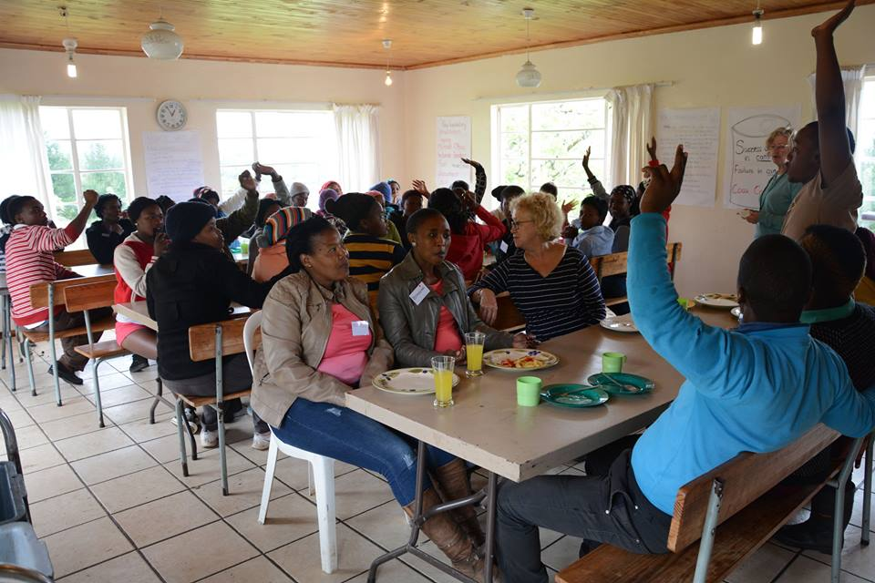

Students’ motivation was high; they viewed the experience as a valuable opportunity and performed accordingly. By the end of the two weeks they formed a cohesive social group who enjoyed each other’s company and supported each other well.

Steph Gallier and Liz Button who led the camp attributed the success to a number of factors. Careful planning beforehand, both in the UK and in Tyume, included briefing participating schools and students so they knew what to expect (and what was expected of them). The involvement of TVS’ IT teacher Vuvu Tomi and assistants Bongiwe and Nontombi contributed to the study camp’s high staffing levels; they worked hard and took a genuine interest in the students’ success. Extending the study camp for a second week allowed teaching and skills to be reinforced and was again appreciated by the students. Photos on Facebook and videos of presentations provided further reinforcement.

Thanks to the input of TVS volunteers Steph and Liz, plus UK volunteer James ???, the study camp cost only £4,000 – incredible value for money. This included the supply of USB sticks, lanyards, name badges, pens, pencils, notebooks and laminated certificates for the students, who were also given money to make their own transport arrangements to Alice for the second week. A further outcome was help for Vuvu Tomi in planning lessons and observing a range of different teaching methods.

We hope to repeat this successful experience again!

# London Marathon 2015

Karen Barker, a member of the Church of the Good Shepherd, Carshalton Beeches and the Good Shepherd Runners group, will be running in the 2015 London Marathon to raise funds for TVS. We expect she will set up a fundraising page in the New Year. Please look out on the TVS website ([www.tvschools.org.uk](http://www.tvschools.org.uk)) for further details.