**TYUME VALLEY SCHOOLS**

**DEVELOPMENT ASSOCIATION**

**ANNUAL REPORT 2014–2015**

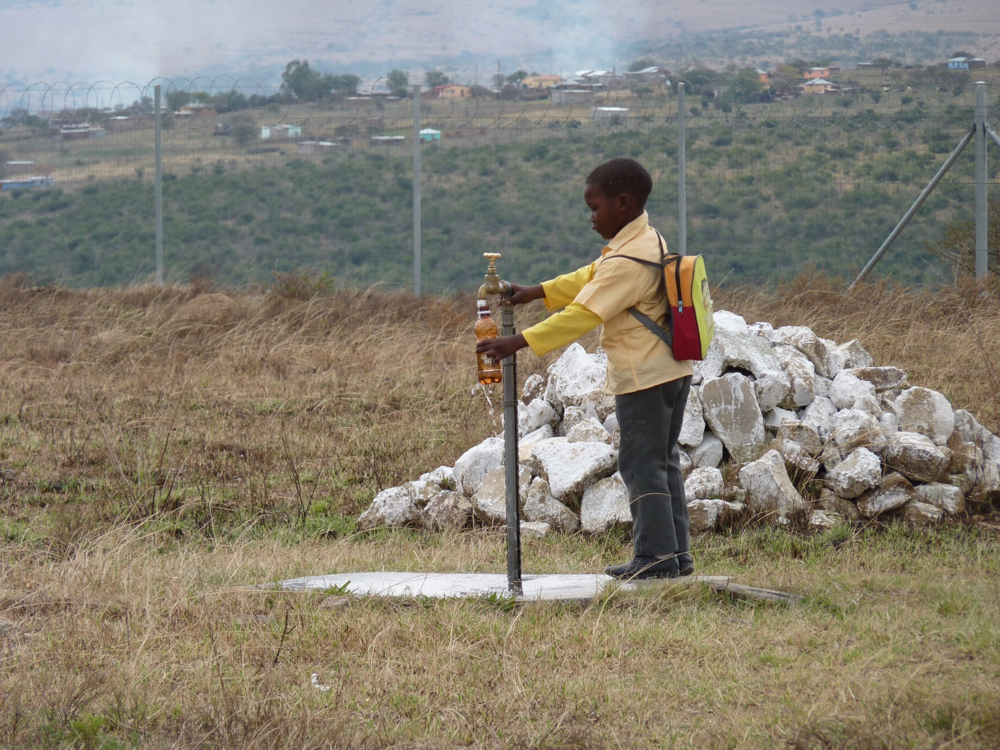

**TVS is an independent charity working in a rural area of Eastern Cape Province, South Africa. Its mission is to enhance educational opportunities and improve life chances for children in the Tyume Valley.**

**TVS**

[www.tvschools.org.uk](http://www.tvschools.org.uk)

TVS is a charity registered with the Charity Commission. (Registration No.1103909)

**Joint chairs:** Sue Richards and Caroline Glendinning

**Treasurer:** Margaret Kiloh

**Newsletter and Minutes Secretary:** Elizabeth Hanks

**Committee members:** Liz Button, Stephanie Gallier, Jim Lewis, Geraldine Palmer

**Overview 2014-2015**

Tyume Valley Schools Development Association (TVS) has been working for 11 years in Tyume Valley, Eastern Cape, South Africa. It aims to improve educational opportunities and life chances for local children and thus challenge some of the huge social and economic inequalities that still exist in this impoverished rural area. Raising funds from charitable trusts and subscribers in the UK, TVS works closely with primary and secondary schools in the valley. TVS’ activities are concentrated on developing teachers’ and children’s proficiency and confidence in English; introducing children to basic IT and keyboard skills; and reinforcing this learning through more relaxed experiences at residential study camps.

During the past 11 years over 3,000 children have benefitted from TVS’ activities. Many more have benefitted indirectly, through the support and resources TVS has been able to give local teachers to develop their educational skills and confidence and thereby improve the children’s learning experiences.

TVS’ effectiveness has been hugely enhanced over the past two and a half years by the work of UK volunteer Vicky Riley. Vicky has been based in Tyume; she works closely with schools and local community organisations to make sure activities run smoothly and she also supports our local staff. Sadly, shortages of funding mean that we will be unable to support Vicky at the same level after the end of 2015. Therefore the emphasis of our work is increasingly on making sure our activities and achievements are sustainable for the future. Vicky’s hard work has made an enormous difference; both TVS and local schools will greatly miss her contribution.

Several long-standing Committee members have retired this year. Many thanks to Sue Hubbert, Maggie Ofori and Nic Suggit for their hard work over the years. We have been fortunate that Jim Lewis, a recently retired primary head teacher with long-standing links to South Africa and Tyume, has joined the Committee.

**IT programme**

TVS’ IT programme is well-established, with 11 primary and 4 secondary schools receiving lessons this year. Up to 250 students attend these classes each week. Classes are delivered by Vuvu Tomi and two assistants Nontombi and Bongiwe. All three trainers come from villages in Tyume Valley. They are also being supported by TVS to develop their teaching and IT skills; we hope this will improve their longer-term employment opportunities.

Vuvu Tomi is taking increasing responsibility for organising the IT programme as a whole, and for supervising Nontombi and Bongiwe. In anticipation of Vicky Riley’s reduced input in the future, we have also made some progress in setting up ‘clusters’ of schools, whereby one school takes responsibility for paying for the IT training that it and neighbouring schools receive.

Increasingly the IT trainers use laptops that they take with them to their schools; this avoids the transport problems of getting children to and from a central IT lab.

We are increasingly trying to demonstrate the effectiveness of our work. In November 2013 we introduced testing for IT learners, to examine their proficiency with Microsoft Word. There were 3 tests with different levels of difficulty, depending on the amount of teaching learners had received and their abilities. In September 2014 many of these learners took the test **at the next level of difficulty**. The pass rate was set at 65%; all learners reaching this were rewarded with an ‘Achievement Certificate’. Additional awards were given to those achieving 65% - 76% (bronze/red star); 77% - 89% (silver star); 90% - 99% (gold star); 100% (2x gold stars). There were marked improvements in students’ results between 2013 and 2014, even with the increased difficulty of the tests. We realise that testing can be controversial in some educational circles. However, discussions with local educators have confirmed that in the Tyume context testing has important motivational benefits.

**English programme**

At the beginning of 2014 two continuing groups of learners - 20 learners from Nqwiliso Tyali, Ntulikazi, Hopefield, and Dyamala Primary Schools and 27 learners from Ncera Zantsi, Mabandla, Gwali, and Festile Soga Primary Schools - began a new English course. This was designed to further develop learners’ speaking and listening skills and introduce them to sentence-building and independent writing skills.

Personal journals were introduced to encourage pupils to write freely and created a calm atmosphere for writing. Educators were introduced to current methods in language teaching - using the word wall, editing wall, redrafting, peer editing and teacher conference - as alternatives to more directive methods of teaching. The course finished in October with a trip for learners to the Hobbiton Outdoor Education Centre. It was successful in improving writing skills but it was clear that further development is necessary and a follow-up course is currently being discussed.

At the start of 2015, 63 Grade 3 learners from four different schools began the Year 1 Starting English Course. The learners were divided into two groups, Group A consisting of learners from Auckland Primary School and Group B consisting of learners from Elethu, Gilton and Nomvume Primary Schools. Two classes a week for each group were held at Auckland Primary, with four teachers drawn from the participating schools.

Training Workshops for the four teachers were held at the beginning of each term and these 2 groups have had a very successful year so far. The learners have improved rapidly. The teachers have adjusted to the new teaching methods and routines very quickly.

Both groups completed the first two parts of the Year 1 course at the beginning of June and will then go on to Part 3, The Stories. The materials for Part 3 have been edited and revised by Brian Walter and Vicky Riley, together with the teachers themselves. The course will finish at the end of the second term, enabling the focus for the remaining terms to be on the continuing groups from 2014.

**Study camps**

We organised two study camps at Hobbiton Outdoor Activity Centre in Hogsback during the year.

The first study camp, in December 2014, involved an older age group than usual – 30 school leavers from 5 secondary schools in Tyume Valley. The first week was held at Hobbiton; this was followed by a second, non-residential week in premises at Fort Hare University in Alice. The fortnight’s programme was built around the themes of ‘Healthy Living’ and ‘Preparation for the World of Work’. It included an introduction to MS Office; internet searching, email and graphics; building CVs; and formatting letters and documents. Students’ motivation was high; they viewed the experience as a valuable opportunity and extending the camp for a second week allowed teaching and skills to be reinforced. Thanks to the input of Vicky Riley, our South African IT trainer Vuvu, assistant IT trainers Bongiwe and Nontombi, and TVS volunteers Steph Gallier, Liz Button and James Turner the camp cost only £4,000 – incredible value for money. This included supply of USB sticks, lanyards, name badges, pens, pencils, notebooks and laminated certificates for the students, who were also given money to make their own transport arrangements to Alice for the second week. TVS’ IT teacher Vuvu Tomi and assistants Bongiwe and Nontombi contributed to the study camp’s high staffing levels. Vuvu was also able to get experience of planning lessons and of different teaching methods. She will put these into practice in December 2015 when she takes lead responsibility for planning another school leavers’ study camp.

In February 2015 we held a more conventional study camp for 100 primary school children, divided into two groups; each stayed at Hobbiton for half a week. Jerry, Helen, Aaron and Rhys, teachers from Beths Grammar School, Bexley, gave up their half-term holiday to run the camp. The focus of the camp was the development of the children’s English language speaking and listening skills, along with a range of cross-curricular activities - all designed to improve their confidence in English. We are very grateful to all four volunteer teachers and particularly to Jerry Parsons, who has already made a commitment to return and run another Hobbiton study camp in 2017.

**School partnerships**

School partnerships are an excellent way of channelling teaching and learning resources into Tyume Valley schools. They also enable children in the UK partner school to learn more about life in South Africa. Email, Skype and blogging make it increasingly easy to set up and maintain relationships between schools and learners. Teacher exchanges between partner schools can have lasting impacts on South African teachers’ skills and confidence.

TVS has already helped to set up a number of partnerships between Tyume and UK schools. We work closely with Settle Primary School North Yorkshire and its partner school in Tyume, at Kwezana. School partnerships are an area of activity TVS hope to develop further in the coming year, as they can provide on-going support to local schools even if TVS has to reduce its level of activity in the valley.

**Planning for the future**

TVS was originally established as a 10-year project. It has already exceeded that by a year! We are now planning a gradual exit strategy, with the aim of leaving a lasting legacy in the Valley. The first priority is to plan for a reduction in Vicky Riley’s role as TVS volunteer from the end of 2015, when some of our grant funding comes to an end.

We have begun to hand over responsibility for the IT programme. Our IT trainer Vuvu Tomi is now responsible for organising not just her own teaching timetable but those of her assistants Nontombi and Bongiwe. Vuvu will also take the lead in organising another study camp for school leavers in December 2015. TVS Committee members will organise their visits to Tyume to ensure essential preparation for other future study camps is undertaken. We are also making a major effort to set up longer-term partnerships between Tyume Valley and English schools. A further possible development will be to offer some financial support to secondary schools in the Valley who, with the help of their local School Governing Bodies, are starting to organise ‘Matric Camps’. Students spend up to 5 weeks boarding at their school to prepare for their Matriculation exams; the impact is clearly visible in significantly improved exam results.

A major priority is to secure further funding to continue our very successful English programme; we have established links with the South African Research, Training and Development Institute (SADRAT) in Port Elizabeth, which will enable TVS to apply to South African funding bodies. However, even without this, we anticipate being able to continue with broadly the same level of activities until 2017 or 2018. Beyond that, with continued support from our regular subscribers, we expect to be able to continue sending some funding to schools in the Tyume Valley for many years to come, as long as we can set up appropriate accountability arrangements.

**Summary of Accounts Year ended 5th April 2015**

|  |  |  |  |  |  |
| --- | --- | --- | --- | --- | --- |
|  | **Unrestricted funds**  **(£)** | **Restricted funds**  **(£)** | **Total funds**  **(£)** | **Difference**  **(%)** | **Previous**  **Year**  **(£)** |
| **Incoming resources**  Donations  HMRC Gift Aid | 47,869 | - | 47,869  - | -31  -100 | 69,372  1,786 |
|  |  |  |  |  |  |
| **Total Incoming Resources** | **47,869** | **-** | **47,869** | **-32.73** | **71,158** |
|  |  |  |  |  |  |
| **Resource Expenditure**  Employment (working in South Africa)  Travel and expenses (South Africa)***\****  Transfer to South Africa account  Marketing  Equipment | 13,304  9,552  30,000 | - | 13,304  9,552  30,000 | 21  -51  0 | 11,000  19,485  30,000  - |
|  |  |  |  |  |  |
| **Total Resources Expended** | **52,856** | **-** | **52.856** | **-13** | **60,485** |
|  |  |  |  |  |  |
| **Net movement in funds** | **4,987** | **-** | **4,987** | **-147** | **10,673** |
|  |  |  |  |  |  |
| **Cash funds last year** | **34,796** | **-** | **34,796** | **44** | **24,123** |
|  |  |  |  |  |  |
| **Cash funds this year end** | **29,809** | **-** | **29,809** | **-14** | **34,796** |
|  |  |  |  |  |  |

***\*****Please note that £8.2k of SA travel and expenses relates to amounts claimed by volunteers in relation to air fares etc., which is then donated back to TVSDA to attract Gift Aid and sometimes matching funding.*

In 2014/2015 we received over £47k donations. This included £14k from Dial-a-Flight, together with a promise of £8k a year for our final three years. No other applications to trusts funds, either in the UK or South Africa, were successful this year, and our BG target was reduced, without prior notification, from £14k to £10k. However several successful events – particularly the London marathon and church/local events – raised smaller amounts and the Pinmar contribution helped us to reach the £10k BG target. More effort has been put into contacting current and past supporters, who contribute a regular £7k a year via standing orders.

We are particularly grateful to Karen Barker, a member of the Church of the Good Shepherd, Carshalton Beeches and the Good Shepherd Runners group, who ran in the 2015 London Marathon to raise funds for TVS. Apart from the enormous personal triumph of running over 26 miles, Karen raised over £2,000 for TVS.

Trustees Statement

These summarised accounts produced by Toby Roberts have been extracted from the full annual financial statements that were approved by Tyume Valley Schools Trustees. The full annual financial statements have been reviewed by a qualified accountant. The full annual report and financial statements have been submitted to the Charity Commission.