Registration Form

Please send me the registration fee of € 40 by cheque, cash or bank transfer with this form (Details at bottom of column). *If possible, please send the form to get to me by October 15th.*

|  |  |
| --- | --- |
| Name: |  |
| Forename: |  |
| Address: |  |
| Telephone: |  |
| E-Mail: |  |
| Age: |  |
| Nationality: |  |
| Present studies: |  |

Participation: active passive

Would you like to have Alexander Lessons? Yes

No

If yes, how many?

On which pieces do you want to work with William Cuthbertson ? :

----------------------------------------------------------------------------------------------------------------------------------------------------------------------------------------------------------------------------------------------------------------------------------------

Place, date: __________________________________

Signature:__________________________________

Please send form to:

**William Cuthbertson**

**Theodor-Heuss-Str.16**

**D-79183 Waldkirch**

**Tel.** 49 7681/409260**

**E-Mail: w.cuthbertson@gmx.de**

Bank account:

**William Cuthbertson**

**IBAN: DE 31 68092000 2609161119**

**BIC: GENODE 61 EMM Volksbank Breisgau Nord**

(„Meisterkurs“ ; name of participant)

**Fees:**

**Registration fee:**

€ 40 for active and passive participation. The fee should be sent with this form. This fee is an extra administration fee and will only be returned if the course is already full. It will *not be refunded* if the participant cannot come.

**Course fee:**

€ 280 for active participation.

€ 160 for passive participation.

***The course fee must be paid on the first day of the course.***

**Day ticket.**

€40 for listeners

€20 for listeners under 18.

**Half day ticket.**

€20 (€10)

**Alexander Lesson:**

€50 ; 3 lessons €135

Since a maximum of 15 pianists can take part actively, acceptance will be on a first come first served basis.

**Timetable:**

Practice times: 8 - 10 a.m. and 6 - 8 p.m. (except Wednesday and Saturday)

Exercises: 2-3 p.m.

Masterclasses:10 a.m.-1 p.m. and 3 - 6 p.m.

**Accommodation:**

For information on hotels, holiday flats, or bed and breakfast accommodation please contact:

**Zwei Täler Land**

**Kirchplatz 2**

**D-79183 Waldkirch**

Tel. **49 7681/19433

**E-Mail:** [info@zweitaelerland.de](mailto:info@zweitaelerland.de)

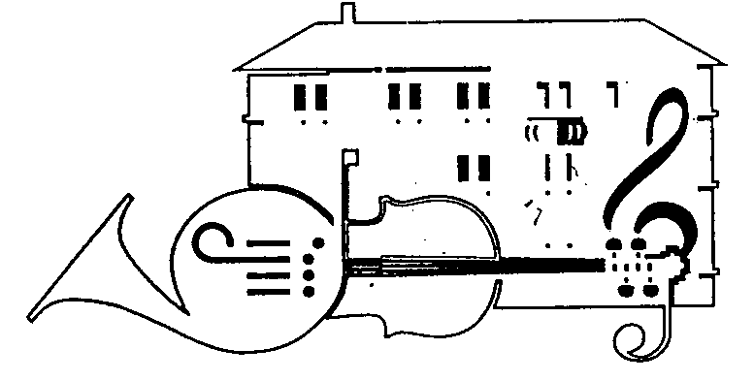

Waldkirch Music School

18th International

Peter Feuchtwanger Masterclass for piano

**William Cuthbertson**

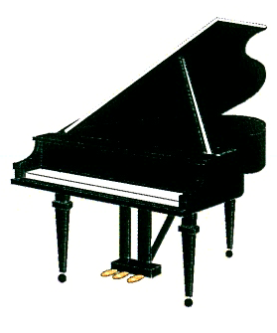

Waldkirch Music School and Lecture Hall, Sick AG

**Waldkirch, Germany**

**30th October – 4th November**

**2017**