**18th International Peter Feuchtwanger Master Class for piano**

**William Cuthbertson**

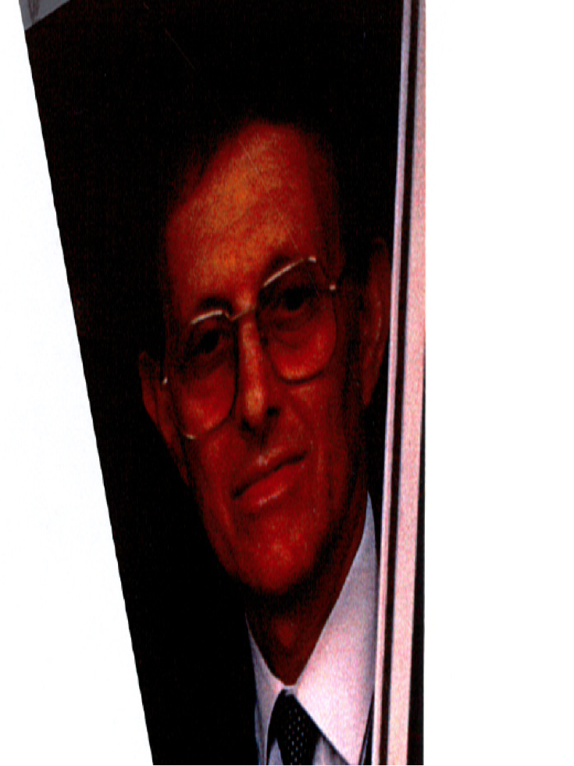

**Peter Feuchtwanger (1930-2016)** was born in Munich, Germany. He studied piano with Gerti Rainer (a pupil of Emil von Sauer), Max Egger, Edwin Fischer and Walter Gieseking, composition with Hans Heimler (a pupil of Alban Berg, Heinrich Schenker and Felix Weingartner) and Lennox Berkeley and also Indian and Arabic music and philosophy with Nazir Jairazbhoy and Dr. Arnold Bake. His encounter with the Rumanian pianist, Clara Haskil was the most decisive musical influence in his life. He also researched into Belcanto, the technique used in the golden age of singing. Peter Feuchtwanger was a member of the jury of many international piano competitions and Vice President of EPTA UK (European Piano Teachers’Association). He was Professor and Vice president of the Internationaler Akademie für musikalische Bildung e.V. and was a visiting Professor at the Mozarteum in Salzburg. He gave master classes throughout the world from 1967 until 2015 Peter Feuchtwanger lived and worked in London, where he died in 2016.

“ He has great experience as a teacher and to work with him has always been a great experience, his advice always helpful, never arbitrary and of an incredible high standard…”

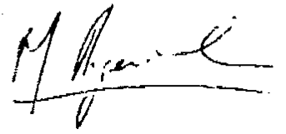

**Martha Argerich**

“As a teacher he is extraordinary. He seems to know immediately what is wrong with a pianist and he explains so easily the reason - what is wrong and what is right - and puts the pupil at ease and draws out the best. In fact I do not know anyone like Mr. Feuchtwanger who can so quickly lead the artist in the right direction.”

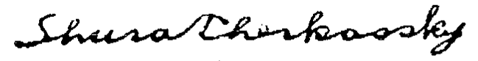

Shura Cherkassky

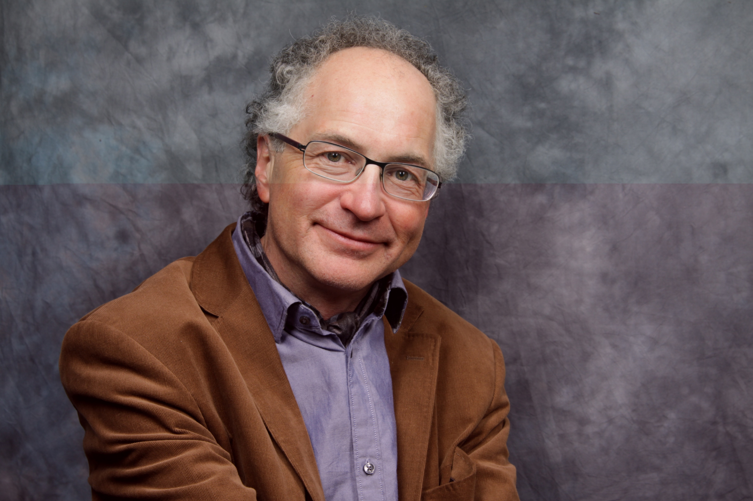

***Course teacher :***

**William Cuthbertson**, who was born and brought up in England, has lived in Waldkirch, near Freiburg, in Germany’s Black Forest for many years. He plays an active part in local cultural activities, both as performer and organizer.

As a child Cuthbertson won many musical prizes in his home county of Kent, where his teacher was Bernard King. He studied piano at the Royal Academy of Music in London with Ruth Harte and Gordon Green. He then continued his studies in Krakow, Poland on a Polish Government scholarship, studying with Ludwik Stefanski, and has continued to specialize in playing works by Chopin.

A very significant person in William Cuthbertson’s life is the renowned London-based German pianist, composer and pedagogue Peter Feuchtwanger. Cuthbertson is considered a master of improvisation, a skill he developed at Sevenoaks School under the guidance of Brian Townend and from time to time he accompanies silent films with free improvisation. His teaching is eclectic, using what approach is most applicable, complementary and at the same time in harmony with Peter Feuchtwanger's brilliant insights.

William Cuthbertson has given concerts in Germany, Holland, Poland, Denmark, Norway, England, Russia, Austria, Sweden, Switzerland and in the United States. In 2010 , Chopin’s 200th anniversary, he gave a series of six recitals in Waldkirch and in 2011, three Liszt recitals for Liszt's 200th anniversary. In November 2017 he will be a jury member of the International Chopin Competition in Bangkok.

"Cuthbertson succeeds in reaching an area of musical weightlessness, an unleashed virtuosity that lets the listener" fly " with him. (Solothurner Zeitung)

"Master of soft tones"  *(Fränkische Landeszeitung)*

"In the twelve Etudes Opus 25 Cuthbertson works with sharp contrasts and achieves a dramatic concentration which is second to none." *(Badische Zeitung)*

"It's hard to put into words what our ears heard and what feelings

Cuthbertson elicited in the audience with his playing "

*(Badische Zeitung)*

***Exercises:***

**Manfred Seewann,** joint editor of the official book on Peter Feuchtwanger's exercises, will assist in teaching these exercises on the course. He studied with Karl Wingler, Erik Then-Bergh, Gitti Pirner and Peter Feuchtwanger and has often been an assistant on Professor Feuchtwanger's masterclasses. He regularly gives concerts in Germany and in other European countries.

Each day Manfred Seewann and William Cuthbertson will work with the course participants on these technical exercises for curing playing-related disorders in pianists, which are also designed for learning a functionally natural behaviour in piano playing.

The book on Peter Feuchtwanger’s exercises and a demonstration DVD are now available in German. Info from [Blido@t-online.de](mailto:blido@t-online.de)

***Alexander Technique:***

During the course the participants can have lessons in the F.M.Alexander Technique with **Martina Barufke.**

This form of work with the body deals with expanding and directing one’s attention. In addition to a better awareness of the fingers, hands and arms, one develops a feeling for one’s body as a whole when playing the piano, leading to more supple reactions and an increased feeling of living in the present. **M.Barufke,** who lives in Waldkirch and has been teaching the Alexander Technique since 1990, studied with Yahuda Kupperman, Elisa and Eckart Ruschmann in Freiburg. She has also studied further with Israeli, American and German Alexander teachers. In addition she is qualified in Spiraldynamik and has experience in Grindler therapy and Ideokinese.

***Concerts:***

On Wednesday evening (1st November) , the guest artist, **Ekaterina Khvedelidze (Georgia)**  will give a recital in the lecture hall of Sick AG, and on Saturday evening the course participants can play in the closing concert.

**Waldkirch** is situated 15km north-east of Freiburg on the edge of the Black Forest. It has retained the charm of its old town centre beneath the ruins of the Kastelburg castle. In the middle of the town is the market place dating from the Middle Ages, and not far from there is the former Propstei building, now the Elztalmuseum, where Kaiser Wilhelm 1 once stayed.

The Master Classes will take place in the Waldkirch Music School (Merklinstr. 19), where practice rooms are also available. The Waldkirch Music School is the oldest municipal music school in Germany

More information about Peter Feuchtwanger can be found on his website: www.peter-feuchtwanger.de and about William Cuthbertson at www.cuthbertson.de

This brochure can be downloaded from :

www.peter-feuchtwanger.de and [www.cuthbertson.de](http://www.cuthbertson.de)