Animals recognition – CIFAR  
#1 Model

Learning rate: 0.0002

Optimization algorithm: RMSProp

Loss function: categorical crossentropy

Batch size: 200

Amount of epochs: 120(stopped at 39)

Train/Validation split: 90% train set, 10% validation set

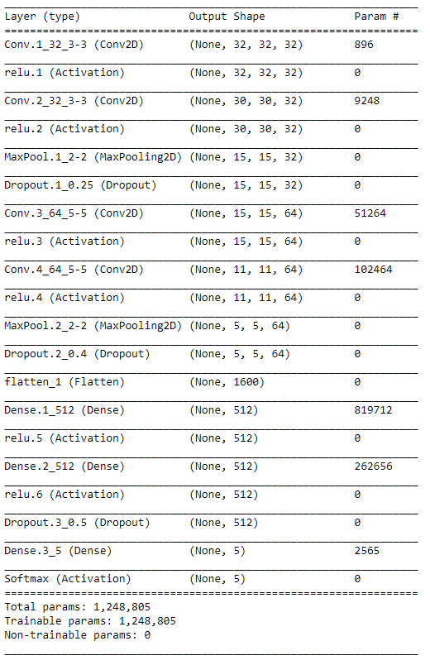Model summary:  
explanation: Conv.2_32_3-3 : conv layer, index 1, 32 filters , of size(3,3)  
 MaxPool.1_2-2 : max pooling layer, index 1, of size(2,2)  
 Dropout.1_0.25: Dropout layer, index 1, of 0.25%  
 Dense.1_512: Dense layer, index 1, of size 512  
 relu.1: Relu activation layer, index 1

Models Accuracy and loss:  
