Animals recognition – CIFAR  
#3 Model

Learning rate: 0.0001

Optimization algorithm: Adam

Loss function: categorical crossentropy

Batch size: 128

Amount of epochs: 100

Train/Validation split: 80% train set, 20% validation set

Model summary:  
explanation: Conv.2_32_3-3 : conv layer, index 1, 32 filters , of size(3,3)  
 MaxPool.1_2-2 : max pooling layer, index 1, of size(2,2)  
 Dropout.1_0.25: Dropout layer, index 1, of 0.25%  
 Dense.1_512: Dense layer, index 1, of size 512  
 relu.1: Relu activation layer, index 1

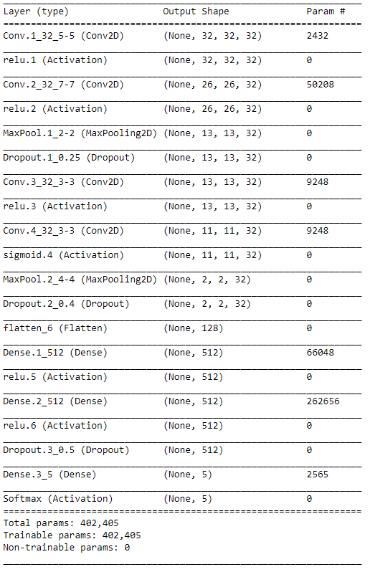

Models Accuracy and loss:  
