Lab 8 – Endpoint Security: Microsoft Defender Firewall

Lab 8 – In this lab, I configured an enterprise firewall baseline for Windows 10/11 devices using Microsoft Intune Endpoint Security. I created and deployed a Microsoft Defender Firewall policy to enable firewall protection across Domain, Private, and Public network profiles, enforcing a secure default posture with inbound traffic blocked and outbound traffic allowed. The policy was assigned at the device level to ensure protection regardless of user sign-in. Successful policy deployment and enforcement were checked on the endpoint using Windows Security.

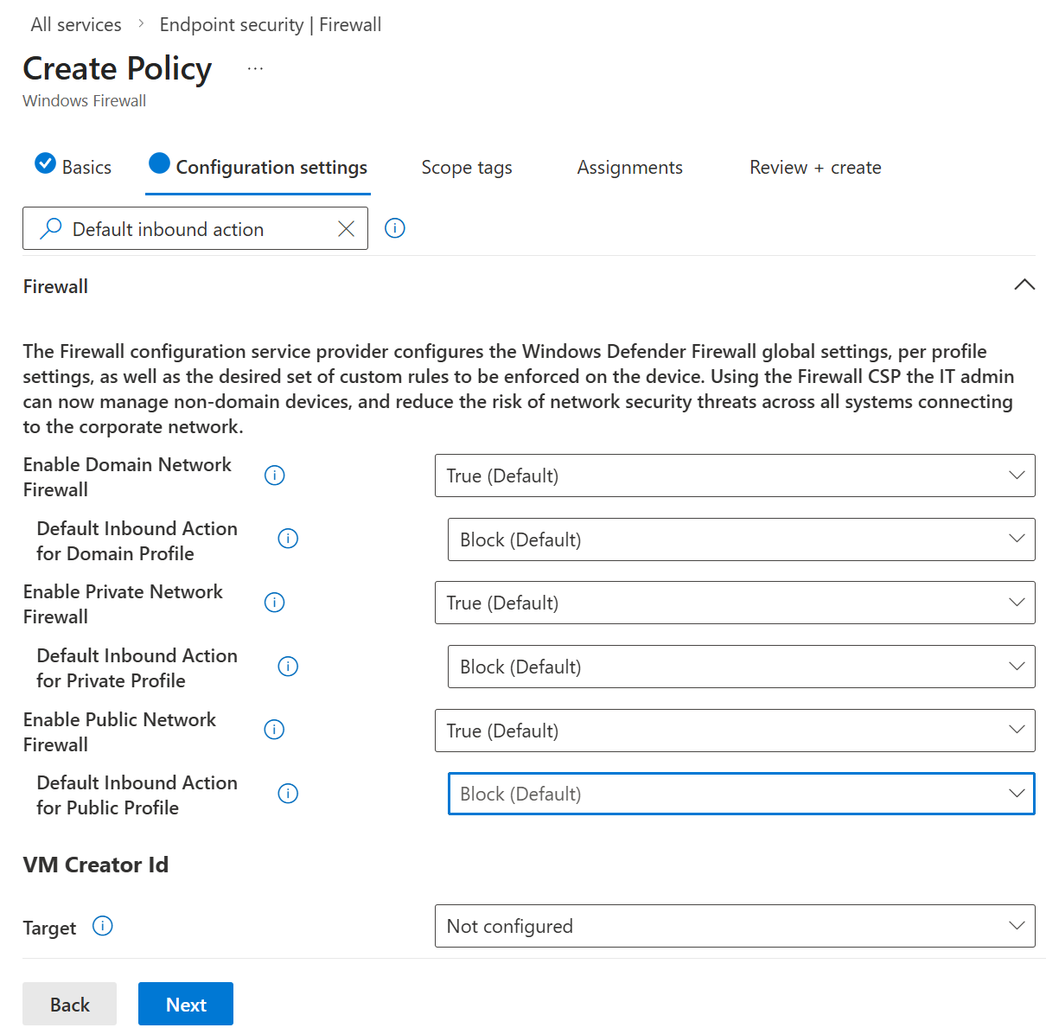

Notes: This screenshot shows the firewall policy configuration where the default inbound action is explicitly set to Block for Domain, Private, and Public network profiles. This ensures unsolicited inbound network traffic is denied across all network types, enforcing a secure firewall.
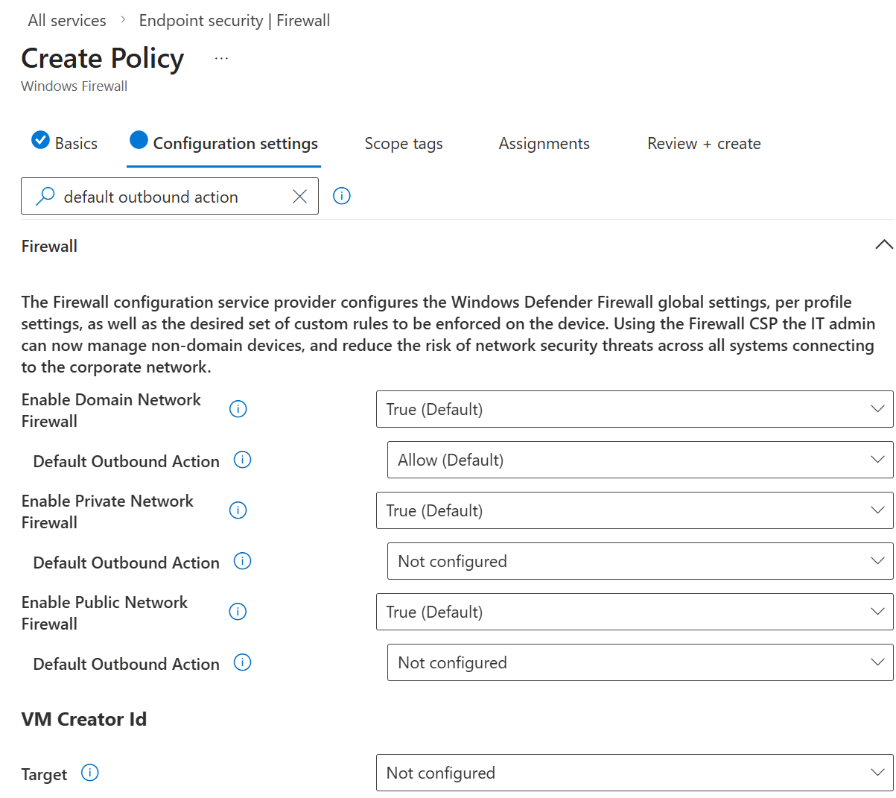
Notes: This screenshot shows the default outbound traffic configuration for the firewall policy. Outbound connections are allowed by default, aligning with good firewall practices while maintaining strong inbound traffic restrictions.
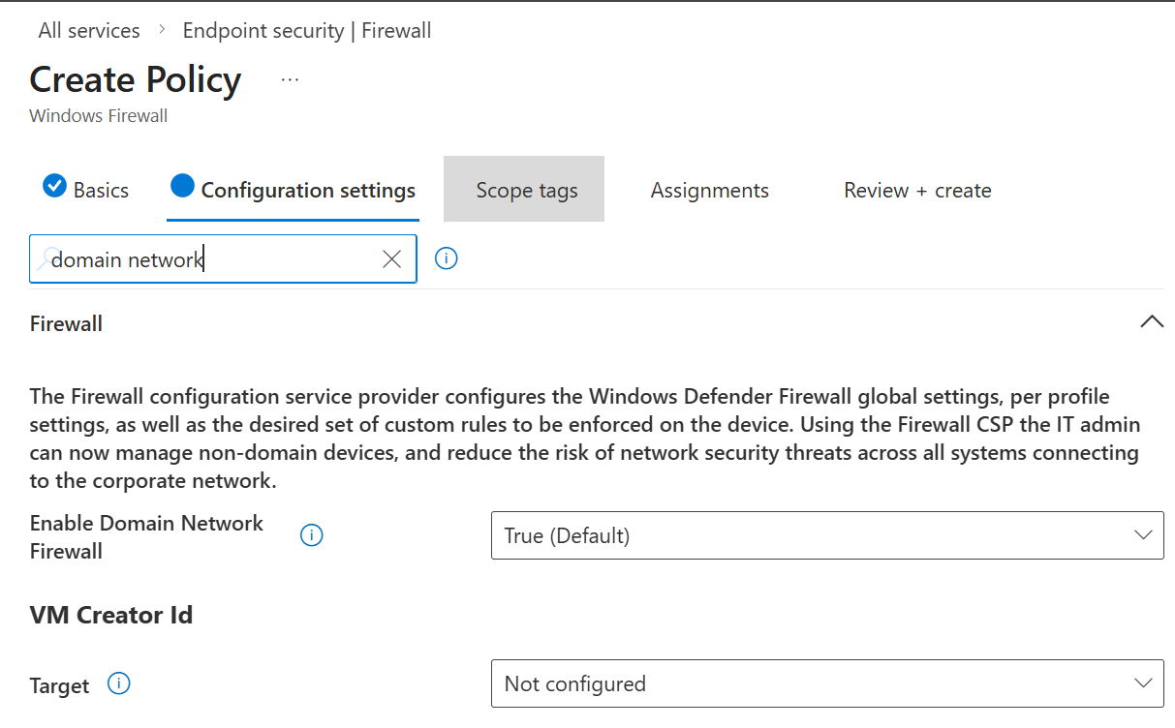
Notes: This screenshot shows the Domain network firewall configuration. Microsoft Defender Firewall is enabled for the Domain profile, ensuring firewall protection is enforced when the device is connected to a corporate or domain-managed network.

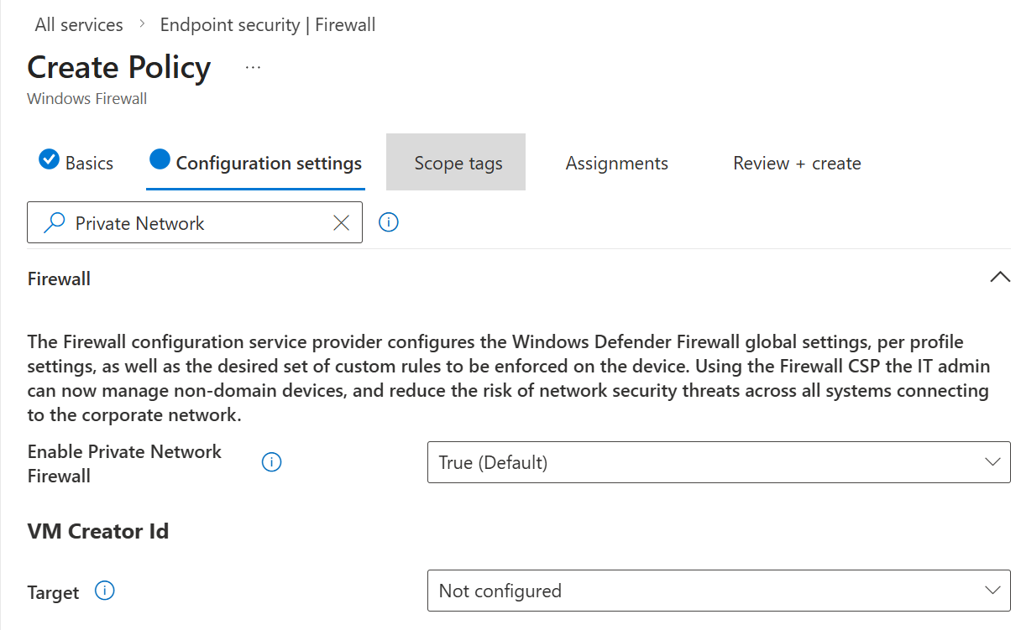
Notes: This screenshot shows the Private network firewall configuration. Microsoft Defender Firewall is enabled for the Private profile, providing protection when the device is connected to trusted private networks such as home or internal office networks.
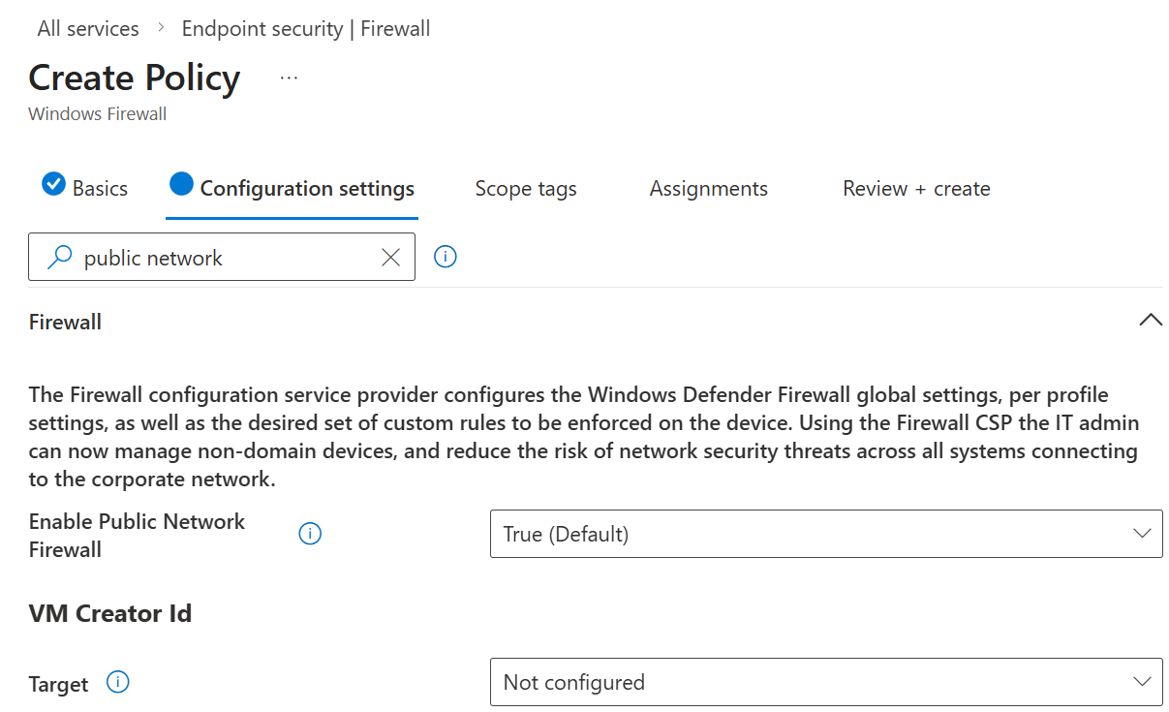
Notes: This screenshot shows the Public network firewall configuration. The firewall is enabled for the Public profile, enforcing a strict security posture when the device is connected to public or untrusted networks.

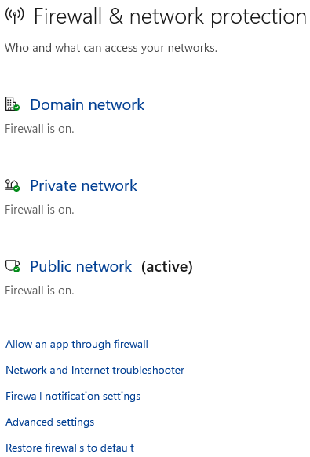
Notes: This screenshot shows the Windows Security Firewall & network protection page on the managed endpoint. It confirms that Microsoft Defender Firewall is active and enforced across Domain, Private, and Public network profiles following policy deployment from Microsoft Intune.

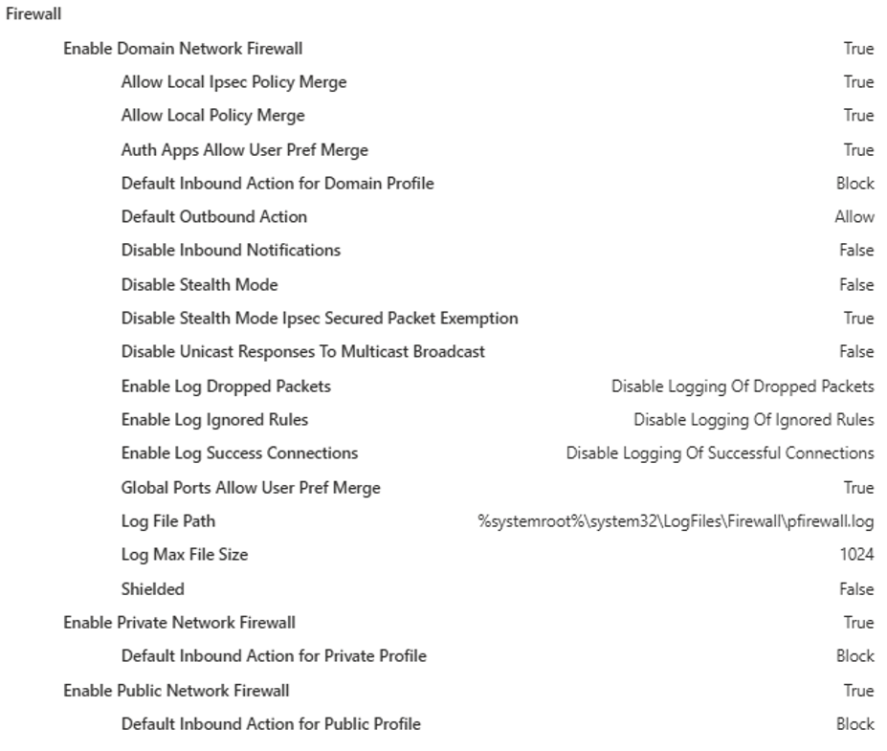
Notes: This screenshot shows the final review and summary of the Microsoft Defender Firewall policy in Intune. It confirms that firewall protection is enabled across all network profiles, inbound traffic is blocked by default, outbound traffic is allowed, and the policy is assigned to all managed devices.

Lab 8 – Summary
In this lab, I implemented centralized firewall enforcement for Windows 10/11 devices using Microsoft Intune Endpoint Security. A Microsoft Defender Firewall policy was configured to enable firewall protection across all network profiles and enforce secure inbound and outbound traffic behaviour.
The policy was assigned at the device level to ensure consistent protection across all managed endpoints. Deployment was verified using Microsoft Intune configuration status and confirmed on the endpoint through Windows Security, demonstrating successful policy application and enforcement.
This lab demonstrates how Microsoft Intune can be used to centrally manage endpoint firewall security and how administrators can validate policy enforcement through both management and endpoint-level controls.

