Validation of NNDIST computer programs
  - Guillaume DANIEL, Oct. 8, 2025

NNDIST : Computer programs for the computation of the « nearest-neighbor distance between pairs of earthquakes in a given catalog » (Baiesi & Paczuski, 2004), and for the declustering of background events based on their nearest-neighbor distance. It is composed of two executables
- nndistance / nndistance.exe : Compute the « nearest-neighbor distance » for all earthquakes listed in a given catalog
- nndecluster / nndecluster.exe : Decluster background events from the catalog, based on their nearest-neighbor distance

Program syntax :
- nndistance CONFIG.TXT
- nndecluster CONFIG.TXT
where CONFIG.TXT is a text file containing program parameters, and formatted as follows :
Figure A: NNDIST configuration file format for input parameters
### PARAMETERS FILE FOR PROGRAM NNDISTANCE ###
### TEST CONFIGURATION FILE FOR CATALOG ###
### PRODUCED BY GU ET AL (2013) AND USED ###
### BY ZALIAPIN & BEN-ZION (2020) ###
### ###
### THESE LAST AUTHORS IDENTIFIED AN ###
### AVERAGE PROPORTION OF BACKGROUND ###
### EVENTS EQUAL TO 0.26 +/- 0.003 ###
##############################################
input_catalogue: etas_catal_2d.34_nndist_starting_day366.txt
minimum_magnitude: 2.5
unit_for_geog_coordinates_[km,degrees]: km
fractal_dimension: 1.5
parameter_w: 0.0
parameter_p: 0.5
parameter_q: 0.5
parameter_eta0: 0.1
parameter_alpha0: 0.1
parameter_npert: 10
output_file: output.txt

Validation procedure
The validation of this program is done by comparing NNDIST results with those obtained in two selected publications using the same (synthetic) dataset :
- Nearest-neighbor distance calculations compared with results of Gu et al. (2013)
- Declustering results compared to Zaliapin & Ben-Zion (2020).

Dataset
The dataset is a synthetic simulation of an Epidemic-Type Aftershock Sequence model (ETAS) realized by Gu et al. (2013) using parameter values listed in Table 1 below.
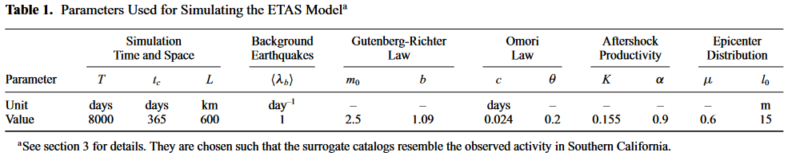

In our testing directiory, this catalogue is saved in file « etas_catal_2d.34_nndist.txt ».

Truncation
To follow the recommendations of Gu et al (2013), we truncate the catalogue to dates $t>t_{c}$, with $t_{c}=365$ days (see Table 1). This truncated catalogue is saved in file « etas_catal_2d.34_nndist_starting_day366.txt ». This truncation has also been applied in the analysis of Zaliapin & Ben-Zion (2020).

Units
The original catalogue contains dates expressed in days, and spatial coordinates expressed in meters. In our analyses, we adapt these space and time units in order to produce metrics and plots comparable to those used in these two respective studies :
- Gu et al (2013) used time expressed in seconds, and spatial coordinates in meters
- Zaliapin & Ben-Zion (2020) used time expressed in years, and spatial coordinates in km

Formula
The nearest-neighbor distance metric $η$ between event $j$ and parent $i$ is defined by the product two rescaled time and spatial distance metrics $T$ and $R$:
$$η_{j}=min⁡(η_{ij},i<j)$$
Where
$$η_{ij}=T_{ij}∙R_{ij}$$
$$T_{ij}=t_{ij}∙{10}^{-qwm_{i}}$$
$$R_{ij}={\left(r_{ij}\right)}^{d}∙{10}^{-pwm_{i}}$$
With $t_{ij}$being the time difference between event and parent, $r_{ij}$being their spatial distance, $d$ the fractal dimension of the entire dataset, $m_{i}$ the magnitude of the parent, and $w, p \text{and} q$ user-defined parameters so that $p+q=1$.

Nearest-neighbor distance calculation
In a first step, we verify the coherency of NNDISTANCE nearest-neighbor distance calculations by comparing estimates with those obtained by Gu et al. (2013). We used parameters listed in Table 2. This comparison is done by visual inspection of the 2-D (smoothed) distributions of (R, T) components of $η_{j}$, see Figure B. As both the overall shape of the 2-D distribution and the range of (T, R) components values match, we can conclude that our estimates are coherent with theirs.
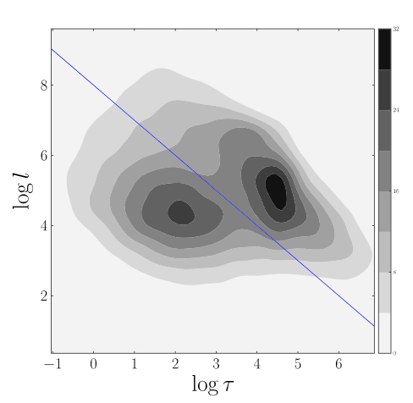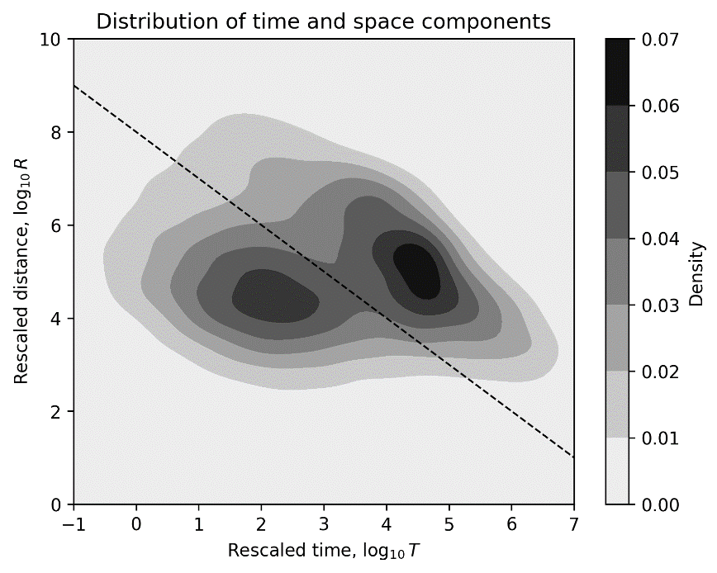
Figure B : Visual comparison of nearest-neighbor distance distributions for the ETAS synthetic dataset, and projected onto their rescaled time and space components. (Top) Results obtained by Gu et al (2013). (Bottom) Results obtained by NNDIST. Dotted lines on both graphs correspond to the constant $η_{j}={10}^{8}$ level.
Table 2: Parameters used by Gu et al (2013) for the computation of nearest-neighbor distances
Parameter | Value
w | 1.09 (=b)
p | 0.5
q | 0.5
d | 2.0

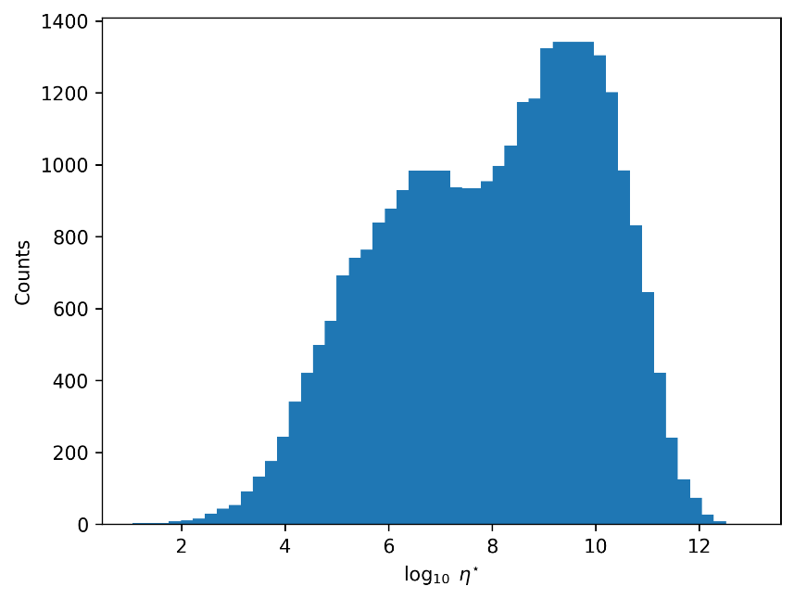
Figure C : Distribution of nearest-neighbor distances values $η_{j}$ obtained using NNDIST for the ETAS synthetic dataset.

Declustering results
We now compare the implementation of the Zaliapin & Ben-Zion (2020) declustering algorithm, hereafter named “ZBZ2020”, in our program NNDECLUSTER.
We compare our results with those reported in their original study which introduced the principles of the method. We focus only on the ETAS synthetic dataset case. Note that this use-case makes use of the same synthetic dataset than in the previous exemple and described above in the “Dataset” subsection. Below, we present two verifications based on different values of the α₀ parameter.
In the first test, we apply the following procedure:
- Apply the ZBZ2020 declustering algorithm, using parameters given in Table 3, where $α_{0}=0$,
- From the resulting declustered catalogue, compute the proportion of background events $P_{bg}$,
- Compare $P_{bg}$ with the value with Zaliapin & Ben-Zion (2020) results, as reported in Table 4 below.
Our results lead to a realization of the declustered catalog containing 7208 background events, which corresponds to 26.71% of the total dataset. In addition, if we sum over the entire dataset all probabilities that each event is a background event, we obtain an average proportion equal to 26.42% of background events. This latter quantity is less dependent on randomness than the previous one which is generated by a random thinning procedure. However, when the number of random perturbations is sufficiently large (e.g., $≳$ 10000), the difference between both values vanishes. This result is very coherent with the 26 ± 0.3 % proportion reported by Zaliapin & Ben-Zion (2020) in their study, see Table 4.

Table 3 : Parameters used in our first test on the declustering method
Parameter | Value
w | 0.0
p | 0.5
q | 0.5
d | 1.6
η₀ | 0.1
α₀ | 0.0
nb. perturbations | 10 000

Table 4 : Declustering results obtained by Zaliapin & ben-Zion (2020) for the ETAS synthetic dataset (reproduced from Table 3 in their original article)
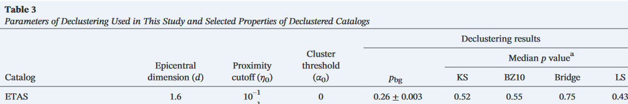

In the second test, we investigate the spatial and temporal properties of the declustered catalogue. We use again the same synthetic ETAS simulation dataset, and apply the following procedure:
- Apply the ZBZ2020 declustering algorithm, using parameters given in Table 5, where $α_{0}=0.1$,
- Using our results, we reproduce the Figures 3b and 4c presented in the original article of Zaliapin & Ben-Zion (2020) to compare the temporal and spatial properties of our declustered catalogue with those obtained by these authors.

Our results lead to a realization of the declustered catalogue containing 7871 background events, which corresponds to a proportion of 29.17% of all events included in the original dataset (or 29.02% in average, based on the sum of probabilities for each event). These values are very close to 28.5%, which is the true proportion of background events in the simulated dataset, as reported by Zaliapin & Ben-Zion (2020).
The spatial distribution and temporal evolution of the declustered catalogue are also very similar to results presented in their study, see Figure D and Figure E.

Table 5: Parameters used in our second test on the declustering method
Parameter | Value
w | 0.0
p | 0.5
q | 0.5
d | 1.6
η₀ | 0.1
α₀ | 0.1
nb. perturbations | 1000

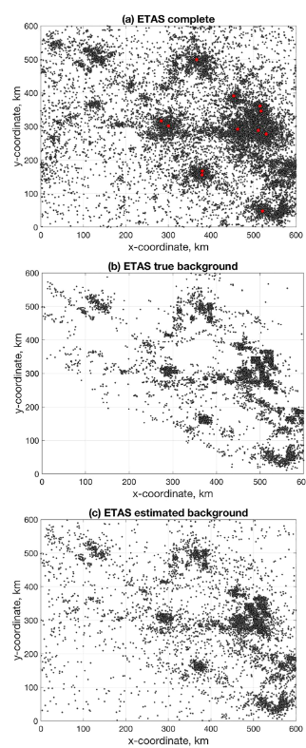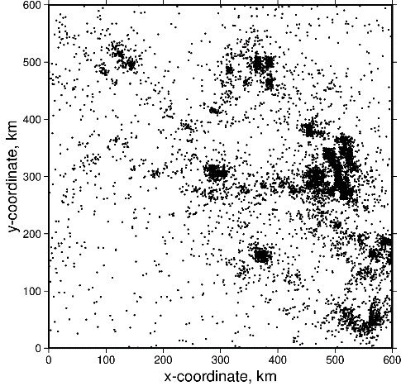
Figure D : Comparison of the spatial distribution of the declustered ETAS dataset. (Left) Zaliapin & Bezn-Zion (2020) results. (right) Results obtained with program NNDECLUSTER.

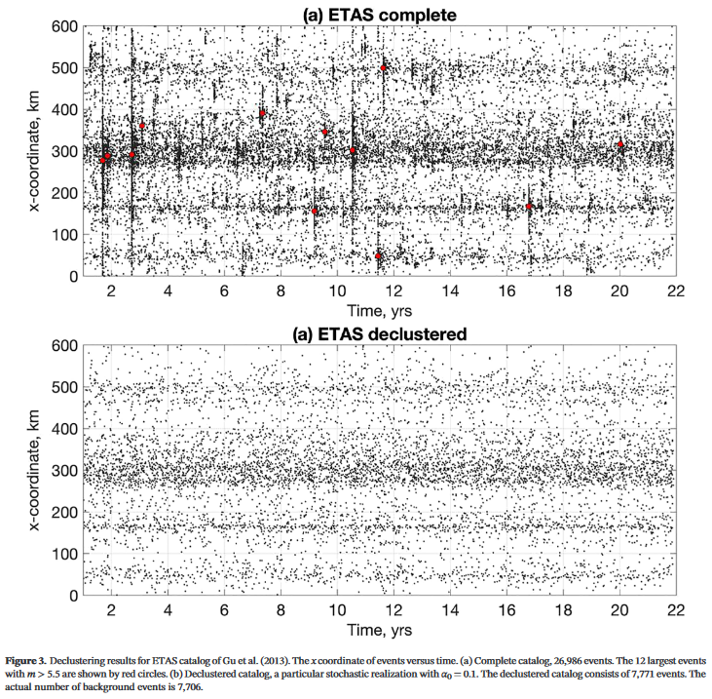

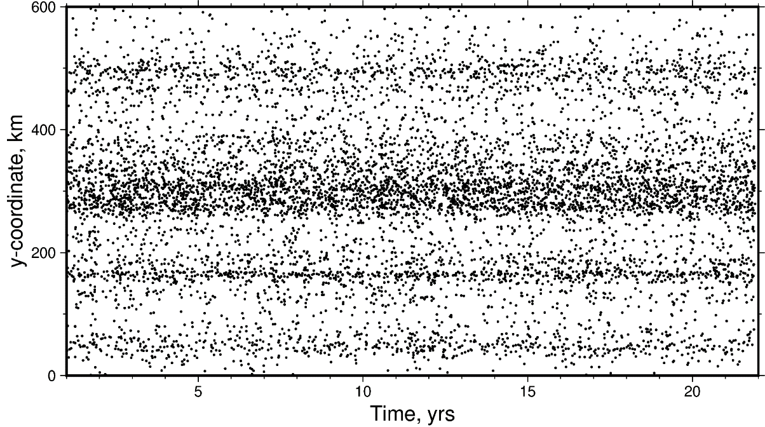
Figure E : Comparison of the temporal evolution of the declustered ETAS dataset. (Top, framed) Zaliapin & Ben-Zion results. (Bottom) Results obtained using program NNDECLUSTER. Note that label of the vertical axis in the original figure is misleading, as the value represented is the y-coordinate.
References
- Baiesi, M., and M. Paczuski, 2004, Scale-free networks of earthquakes and aftershocks, Phys. Rev. E, 69, 066106. https://doi.org/10.1103/PhysRevE.69.066106.
- Gu, C., A. Y. Schumann, M. Baisesi, J. Davidsen, 2013, Triggering cascades and statistical properties of aftershocks, J. Geophys. Res., Solid Earth, 118, 4278-4295. https://doi.org/10.1002/jgrb.50306.
- Zaliapin, I., and Y. Ben-Zion, 2020, Earthquake declustering using the nearest-neighbor approach in space-time magnitude domain, J. Geophys. Res., Solid Earth, 125, e2018JB017120. https://doi.org/10.1029/2018JB017120.

