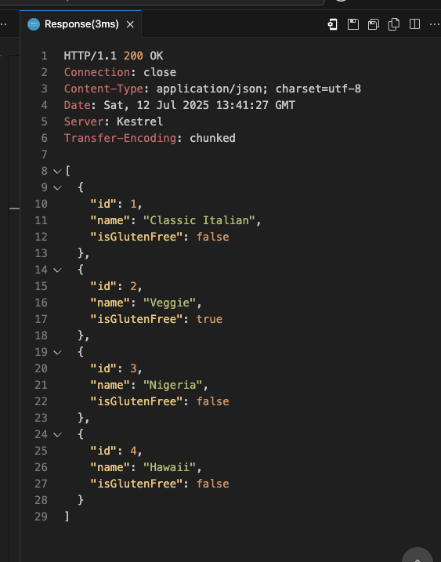

Sales Summary

----------------------------

Total Sales: $2,012.20

Details:

sales.json: $88.88

sales.json: $88.88

salestotals.json: $0.00

sales.json: $99.00

salestotals.json: $0.00

sales.json: $1,234.22

salestotals.json: $0.00

sales.json: $501.22

salestotals.json: $0.00