### 通过hadoopAPI访问文件

@Test

**public** **void** readFileByAPI() **throws** IOException{

Configuration conf = **new** Configuration();

conf.set("fs.defaultFS", "hdfs://192.168.75.201:8020/");

FileSystem fs = FileSystem.*get*(conf);

Path path = **new** Path("/user/index.html");

FSDataInputStream fis =fs.open(path);

**byte**[] bytes = **new** **byte**[1024];

**int** len = -1;

ByteArrayOutputStream baos = **new** ByteArrayOutputStream();

**while**((len = fis.read(bytes))!=-1){

baos.write(bytes, 0, len);

}

System.*out*.println(**new** String(baos.toByteArray()));

fis.close();

baos.close();

}

第二种方式：

@Test

**public** **void** readFileByAPI2() **throws** IOException{

Configuration conf = **new** Configuration();

conf.set("fs.defaultFS", "hdfs://192.168.75.201:8020/");

FileSystem fs = FileSystem.*get*(conf);

Path path = **new** Path("/user/index.html");

FSDataInputStream fis =fs.open(path);

ByteArrayOutputStream baos = **new** ByteArrayOutputStream();

IOUtils.*copyBytes*(fis, baos, 1024);

System.*out*.println(**new** String(baos.toByteArray()));

fis.close();

baos.close();

}

### 通过代码创建文件夹

@Test

**public** **void** makeFileByAPI() **throws** IOException{

Configuration conf = **new** Configuration();

conf.set("fs.defaultFS", "hdfs://192.168.75.201:8020/");

FileSystem fs = FileSystem.*get*(conf);

fs.mkdirs(**new** Path("/user/myhadoop"));

}

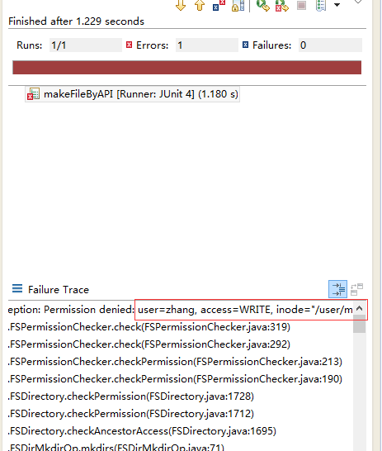 // 注意HDFS文件的权限问题

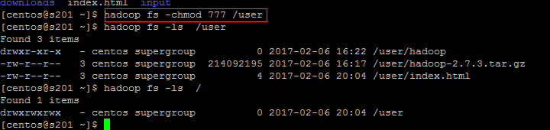

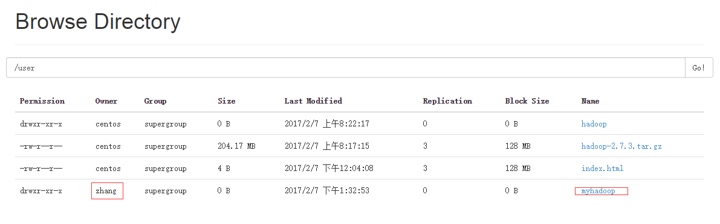

// 指定HDFS目录的拥有者也可规避写权限问题

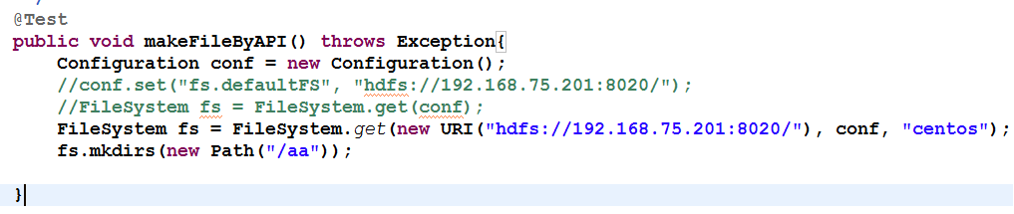

/**

* remove File from HDFS

*/

@Test

**public** **void** removeFile() **throws** Exception{

Configuration conf = **new** Configuration();

conf.set("fs.defaultFS", "hdfs://192.168.75.201:8020/");

FileSystem fs = FileSystem.*get*(conf) ;

Path p = **new** Path("/user/myhadoop/a.txt");

fs.delete(p, **true**);

}