1. **Negative binomial GLM**
   1. Fit the model

# Fit model

mod_nb <- glmmTMB::glmmTMB(tick_abundance ~ season * grass_sp,

data = data,

family = "nbinom2")

* 1. Check residuals

# Check residuals

DHARMa::simulateResiduals(mod_nb, plot = TRUE)

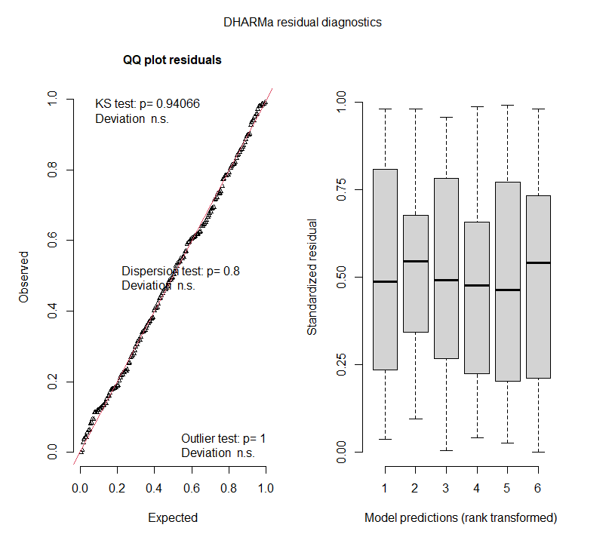

* 1. Test for zero inflation

# Test for zero inflation

DHARMa::testZeroInflation(mod_nb)

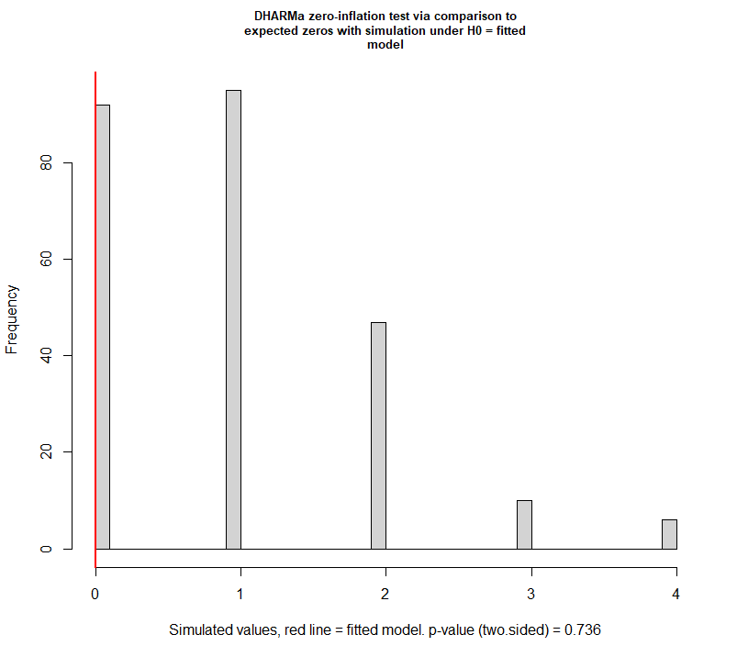

* 1. Test parameter significance

# Negative binomial GLM - type II sum-of-squares

car::Anova(mod_nb,

type = "II",

test = "Chisq")

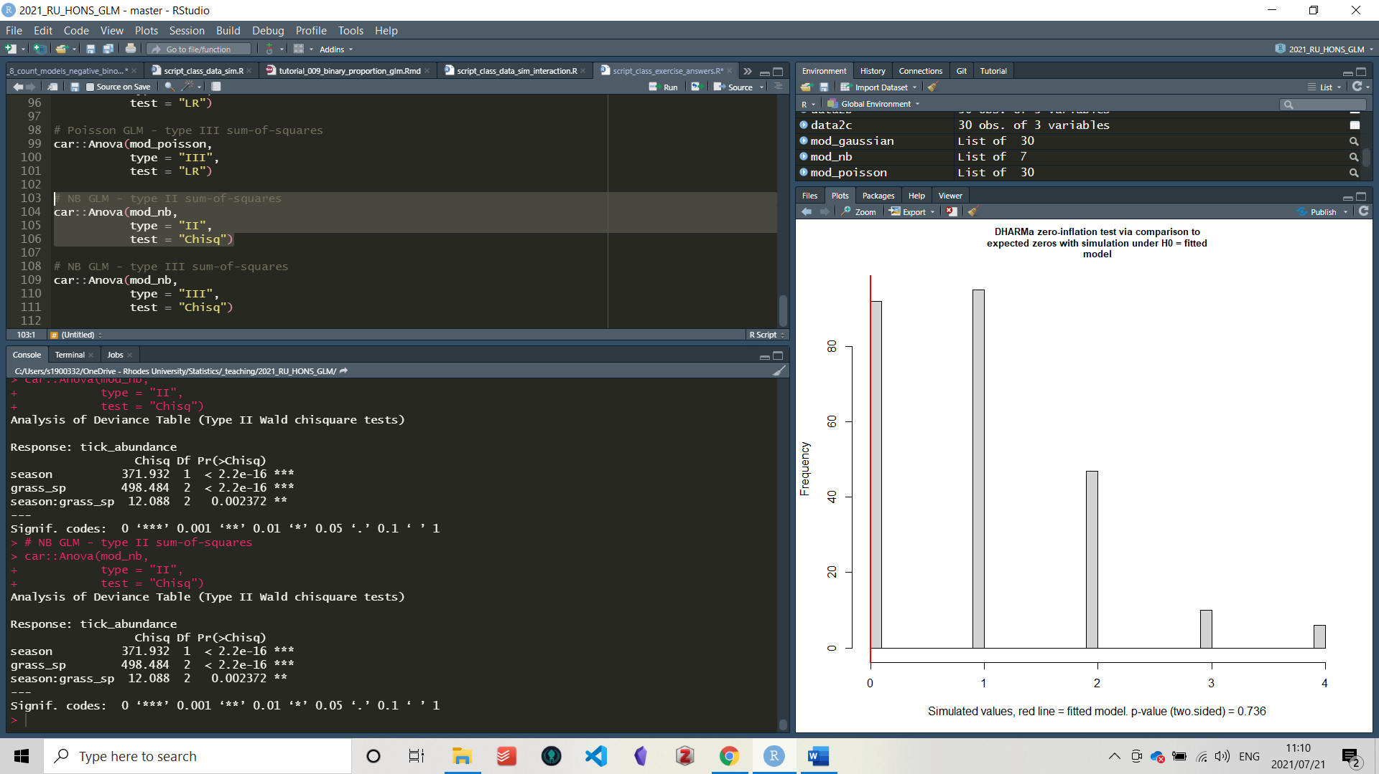

# Negative binomial GLM - type III sum-of-squares

car::Anova(mod_nb,

type = "III",

test = "Chisq")

