<http://www.cis.pku.edu.cn/faculty/vision/wangliwei/software.html>

**Introduction**

1. nodule detection: deconvolutional structure to Faster Regionbased Convolutional Neural Network (Faster R-CNN)(2-D)(Caffe) .

2. false positive reduction(3-D DCNN)(Keras backended on Tensorflow).

3. classify malignancy(2 modified 3D CNNS)

final output(a logistic regression method is used to merge intermediate results.)

4. other image process methods(image denoising and alignment)

**Data prepare and preprocessing**

1.LIDC-IDRI: only nodules labeled by at least 3 radiologists are positive,the rest are excluded

2.DSB stage1: manually and roughly label scans in training set, where cancers are diagnosed

check the whole dataset and flip CT volumes if they are not scanned from head to foot

3.SPIE: no additional processing

flip regression:

input: the slice chosen from 11th to 19th slices

output: whether the scan is from head to feet (we average outputs for 5 slices)

(use a simple CNN trained on DSB stage1)

lung segmentation:

use a threshold to get low-HU areas

The largest area is regarded as the pulmonary parenchyma area after some morphological operations such as dilation and erosion.

**Nodule Detection**

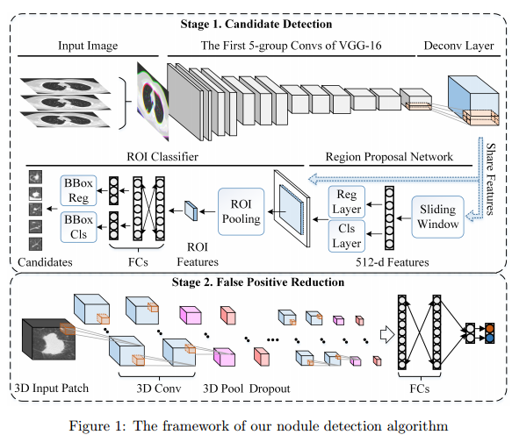

1. add a deconvolutional layer: kernel size(4), stride size(4) ,padding size(2) after the last layer of the original feature extractor(five-group convolutional layers of VGG-16Net)

2. region proposal network:

input: 3 × 3 spatial window of deconvolutional feature map

map each sliding window to a 512-dimensional feature

the feature is fed into two sibling fully-connected layers for regressing the boundingbox of regions(Reg Layer) and predicting objectness score(Cls Layer)

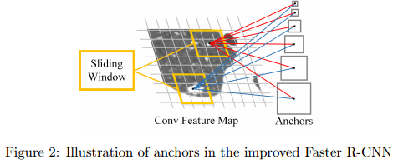

each sliding-window: simultaneously predict multiple ROIs.

The multiple ROIs are parameterized relative to the corresponding reference boxes->anchors. six anchors for each sliding window: 4×4, 6×6, 10×10, 16×16, 22×22, and 32 × 32 .

more about “region proposal networks”: S. Ren, K. He, R.B. Girshick, and J. Sun. Faster r-cnn: Towards realtime object detection with region proposal networks. In Advances in neural information processing systems, pages 91–99, 2015.

**False Positive Reduction Using 3D DCNN**

**Nodule Malignancy Classification**

**Model Ensemble**