摘要

本文针对不透明制品配色问题的**优化设计**和**实际生产应用**进行了研究。首先建立了三种着色剂在不同波长下**K/S与浓度的拟合数学模型，**并求解了其函数关系式和拟合系数。然后结合K-M光学模型和CIELAB色彩空间的总色差计算方法，在给定目标样R值的前提下，建立了不透明制品配色的**优化模型，**并利用**模拟退火算法**求解了模型。在其基础上，考虑成本控制和批量配色，利用**主要目标法**对多个决策目标中的色差进行约束，并在该约束条件下求解以价格为主要目标的优化模型。最后在实际生产情况中，引入生产方和购买方，考虑到能耗影响和市场变化趋势等因素，采用**逐次线性加权和法**求解多目标优化模型，计算出五个样本的五个最优的不同配方。

**针对问题一**，建立了三种着色剂在一定波长范围内浓度与对应K/S值的多**项式拟合数学模型**。首先，选取三种着色剂在一定波长范围内浓度与对应K/S值的数据并绘制出散点图，根据其趋势选取三种可行的数学拟合模型，分别求解其拟合系数，根据其拟合系数选取拟合效果最好的多项式拟合数学模型，并进一步求解所有数据的函数关系式和拟合系数，将求解结果记录在表格中。

**针对问题二**，建立了不透明制品配色**色差最小的单目标多决策变量优化模型**，并用**模拟退火算法**求解模型得到了最优决策变量。首先将三种着色剂的浓度作为决策变量，将三种着色剂的浓度在0%到5%之间且三种着色剂的浓度最多只有一种浓度为0%作为约束条件，配方与目标样的总色差最小为目标函数建立优化模型。再利用模拟退火算法，调整退火温度衰减率和马尔可夫链的长度，基于 **Metropolis 准则**求解出与目标样的色差最为接近的10个不同配方并记录在表格中。

**针对问题三**，建立了不透明制品配色**成本最低的单目标多决策变量优化模型**，用**主要目标法**将目标函数中的色差转换为约束条件，并借助模拟退火算法进行求解。首先将第二问最优解的色差在一定范围内的溢出作为约束条件，三种着色剂的浓度作为决策变量，不透明制品配色的成本最低作为目标函数建立优化模型。利用主要目标法将第二问中最优解对应的色差作为基础，在允许0.1色差溢出的约束条件下使成本达到最低，利用模拟退火算法求解出10个最优的不同配方并记录在表格中。

**针对问题四**，建立了不透明制品配色色差、成本和总重三个目标函数的**多目标多决策变量优化模型，**使用**逐次线性加权和法**处理三个目标函数并借助模拟退火算法进行求解。首先将色差函数和成本函数进行线性加权，通过对加权值的线性分割，利用模拟退火算法，求得离散加权值对应的所有最优解，从中选取总重最小的五组最优解。调整加权值线性分割的精度，选取五组最优解分布最为广泛的精度作为最优分割精度，对应的五组解作为最终的最优解，同样计算剩余4个样本得到5个样本对应的25个最优配方并记录在表格中。

本文模型的优点为：1.解构了问题中几个参数之间复杂的数学关系并用函数的形式来表示，提高了**计算精度和速度**。2.进行了合理的假设，在优化模型中抓住了主要的目标函数，采用多种方式处理**多目标函数**，让模型和算法准确高效。3.充分考虑了**实际情况**，提高了模型的实用性，可以应对多种市场要求和生产情况。4.采用**模拟退火算法**等启发式算法，有利于**跳出局部最优解**，得到的优化结果具有一定的参考意义。

**关键词**：不透明制品配色 优化模型 多项式拟合 模拟退火算法 主要目标法 逐次线性加权法

问题重述

模型假设与分析

1. 假设K-M光学模型中只考虑K/S值与R值之间的关系，以便于排除其他因素对计算和拟合的影响。
2. 假设三种着色剂的浓度范围均在附件给出数据中的0%~5%之间，用于对浓度作为决策变量时进行约束。
3. 假设价格的浮动是在色差达到最优解的基础上进行的，用于处理多目标函数。
4. 假设着色剂的克重与能耗成正相关，市场对不透明制品的评判依据于色差和成本。

问题一的模型建立与求解

问题分析

本问给出了三种着色剂在不同波长下K/S与浓度的关系，要求根据数据拟合不同波长下两者的关系，并确定函数关系式和拟合系数。首先，选取部分数据转化为散点图，根据其走势选取几组较为贴近的函数模型，利用python程序求解其拟合系数，通过比较几种函数模型的拟合系数，选取拟合效果最好的函数模型。将附件二给出的参数带入该函数模型并进行拟合，可以求出函数关系式和拟合系数。

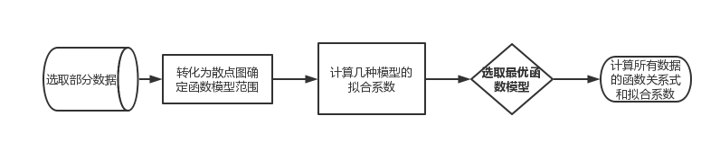

问题一流程图

模型建立

函数模型范围的确定

选取三种着色剂在一定波长范围内浓度与对应K/S值的数据，绘制成散点图，如图所示。

根据其走势及点数可得出三种可行的拟合数学模型，分别是指数、多项式（五次）、线性。编写python程序，对三组数据用以上三种数学模型进行拟合，并分别得出其拟合系数，如下表。

|  |  |  |  |  |  |
| --- | --- | --- | --- | --- | --- |
| **多项式拟合效果** | | | | | |
| **红色** | | **黄色** | | **蓝色** | |
| **波长** | **拟合系数** | **波长** | **拟合系数** | **波长** | **拟合系数** |
| 400nm | 0.999076132 | 440nm | 0.999999713 | 420nm | 0.999763562 |
| 420nm | 0.995717453 | 460nm | 0.999999645 | 440nm | 0.999746542 |
| 440nm | 0.995330826 | 480nm | 0.999999384 | 460nm | 0.999846013 |
| 460nm | 0.998755091 | 500nm | 0.999996570 | 480nm | 0.999868641 |
| 480nm | 0.999581224 | 520nm | 0.999984150 | 500nm | 0.999814362 |

|  |  |  |  |  |  |
| --- | --- | --- | --- | --- | --- |
| **线性拟合效果** | | | | | |
| **红色** | | **黄色** | | **蓝色** | |
| **波长** | **拟合系数** | **波长** | **拟合系数** | **波长** | **拟合系数** |
| 400nm | 0.993971696 | 440nm | 0.999862864 | 420nm | 0.999538700 |
| 420nm | 0.989907616 | 460nm | 0.999830523 | 440nm | 0.999505492 |
| 440nm | 0.988996478 | 480nm | 0.999705822 | 460nm | 0.999699565 |
| 460nm | 0.997066209 | 500nm | 0.999671167 | 480nm | 0.999743713 |
| 480nm | 0.999013098 | 520nm | 0.998480473 | 500nm | 0.999146403 |

|  |  |  |  |  |  |
| --- | --- | --- | --- | --- | --- |
| **指数拟合效果** | | | | | |
| **红色** | | **黄色** | | **蓝色** | |
| **波长** | **拟合系数** | **波长** | **拟合系数** | **波长** | **拟合系数** |
| 400nm | 0.934644924 | 440nm | 0.934657092 | 420nm | 0.921696518 |
| 420nm | 0.920713026 | 460nm | 0.933791539 | 440nm | 0.921190421 |
| 440nm | 0.911892027 | 480nm | 0.932692830 | 460nm | 0.921835270 |
| 460nm | 0.928669274 | 500nm | 0.931823636 | 480nm | 0.922394841 |
| 480nm | 0.930468760 | 520nm | 0.925882375 | 500nm | 0.916104179 |

考虑到三种数学模型的拟合效果都较为优秀，这里给出保留九位小数的拟合数据，来更为精确地判断拟合效果的优劣。经过对三种数学模型的拟合系数的比较，最终选取精度最高的多项式进行拟合。将其余数据均带入python程序进行数据分析并将结果导出。三种着色剂在不同波长下K/S与浓度的函数关系式与拟合系数，如下表。其中浓度为百分比数值

|  |  |  |
| --- | --- | --- |
| 波长 | 红色 | |
| **函数关系式** | **拟合系数** |
| 400nm | Y = 0.002051X^5-0.010625X^4-0.03136X^3+0.181794X^2+0.631014X+0.612139 | 0.999076132 |
| 420nm | Y = -0.012674X^5+0.161986X^4-0.705964X^3+1.160046X^2+0.191246X+0.249396 | 0.995717453 |
| 440nm | Y = -0.012674X^5+0.161986X^4-0.705964X^3+1.160046X^2+0.162746X+0.130041 | 0.995330826 |
| 460nm | Y = -0.006337X^5+0.080993X^4-0.352982X^3+0.580023X^2+0.382851X+0.16443 | 0.998755091 |
| 480nm | Y = -0.006337X^5+0.080993X^4-0.352982X^3+0.580023X^2+0.833352X+0.214509 | 0.999581224 |
| 500nm | Y = -0.006337X^5+0.080993X^4-0.352982X^3+0.580023X^2+1.429895X+0.277175 | 0.999827136 |
| 520nm | Y = -0.006337X^5+0.080993X^4-0.352982X^3+0.580023X^2+2.229895X+0.343731 | 0.999921032 |
| 540nm | Y = -0.006337X^5+0.080993X^4-0.352982X^3+0.580023X^2+2.429895X+0.319349 | 0.999932427 |
| 560nm | Y = -0.006337X^5+0.080993X^4-0.352982X^3+0.580023X^2+2.329895X+0.363999 | 0.999927062 |
| 580nm | Y = -0.005484X^5+0.069501X^4-0.300351X^3+0.488842X^2+0.878256X+0.031301 | 0.999631976 |
| 600nm | Y = -0.00561X^5+0.068259X^4-0.282375X^3+0.447774X^2+0.027184X+0.017194 | 0.999044898 |
| 620nm | Y = -0.000132X^5+0.001688X^4-0.007425X^3+0.012295X^2+0.045176X+0.008161 | 0.999778342 |
| 640nm | Y = 2.0e-5X^5-0.000213X^4+0.000686X^3-0.00058X^2+0.009633X+0.006701 | 0.999028053 |
| 660nm | Y = -2.4e-5X^5+0.000292X^4-0.001249X^3+0.002107X^2+0.003789X+0.00523 | 0.99498286 |
| 680nm | Y = -1.1e-5X^5+0.000147X^4-0.00071X^3+0.001342X^2+0.001148X+0.006499 | 0.998261544 |
| 700nm | y = -1E-5x5 + 0.000147x4 - 0.000710x3 + 0.001341x2 + 0.000148x + 0.006200 | 0.990015435 |

|  |  |
| --- | --- |
| 黄色 | |
| **函数关系式** | **拟合系数** |
| Y = -0.003817X^5+0.041305X^4-0.151455X^3+0.217372X^2+1.49948X+0.483956 | 0.999999594 |
| Y = -0.003817X^5+0.041305X^4-0.151455X^3+0.217372X^2+1.59948X+0.494269 | 0.999999641 |
| Y = -0.003817X^5+0.041305X^4-0.151455X^3+0.217372X^2+1.79948X+0.484631 | 0.999999713 |
| Y = -0.003817X^5+0.041305X^4-0.151455X^3+0.217372X^2+1.60948X+0.4185 | 0.999999645 |
| Y = -0.003817X^5+0.041305X^4-0.151455X^3+0.217372X^2+1.19948X+0.322496 | 0.999999384 |
| Y = -0.002641X^5+0.028986X^4-0.108313X^3+0.158117X^2+0.776735X+0.207159 | 0.99999657 |
| Y = -0.002641X^5+0.028986X^4-0.108313X^3+0.158117X^2+0.326735X+0.107696 | 0.99998415 |
| Y = -0.000272X^5+0.002981X^4-0.01109X^3+0.016092X^2+0.142663X+0.047312 | 0.999991237 |
| Y = -0.000231X^5+0.002448X^4-0.008708X^3+0.011759X^2+0.05533X+0.023342 | 0.99995724 |
| Y = -0.000864X^5+0.009848X^4-0.038713X^3+0.062082X^2-0.011645X+0.013055 | 0.997255859 |
| Y = -1.8e-5X^5+0.000177X^4-0.000594X^3+0.000748X^2+0.006688X+0.00463 | 0.99669633 |
| y = -1E-05x5 + 0.0001x4 - 0.0004x3 + 0.0005x2 + 0.002x + 0.0024 | 0.999993488 |
| Y = -3.0e-6X^5+3.3e-5X^4-0.000114X^3+0.000139X^2+0.000959X+0.002011 | 0.995144929 |
| y = -3E-06x5 + 3E-05x4 - 0.0001x3 + 0.0001x2 + 0.0006x + 0.0018 | 0.999955768 |
| y = -3E-06x5 + 3E-05x4 - 0.0001x3 + 0.0001x2 + 0.0004x + 0.0017 | 0.999899550 |
| y = -3E-06x5 + 3E-05x4 - 9E-05x3 + 9E-05x2 + 0.0003x + 0.0014 | 0.999903013 |

|  |  |
| --- | --- |
| 蓝色 | |
| **函数关系式** | **拟合系数** |
| Y = 0.009116X^5-0.107796X^4+0.428374X^3-0.661366X^2+0.739095X-0.007768 | 0.999449649 |
| Y = -0.00052X^5+0.006226X^4-0.025767X^3+0.039744X^2+0.283189X+0.014166 | 0.999763562 |
| Y = -0.00052X^5+0.006226X^4-0.025767X^3+0.039744X^2+0.273189X+0.012276 | 0.999746542 |
| Y = -0.00052X^5+0.006226X^4-0.025767X^3+0.039744X^2+0.353189X+0.010555 | 0.999846013 |
| Y = -0.00052X^5+0.006226X^4-0.025767X^3+0.039744X^2+0.383189X+0.012625 | 0.999868641 |
| Y = 0.000424X^5-0.005624X^4+0.025163X^3-0.052617X^2+0.607543X+0.00962 | 0.999814362 |
| Y = 0.000424X^5-0.005624X^4+0.025163X^3-0.052617X^2+0.747543X+0.014251 | 0.999882996 |
| Y = 0.001218X^5-0.010554X^4+0.01593X^3+0.045462X^2+0.805218X+0.036563 | 0.999521571 |
| Y = 0.001218X^5-0.010554X^4+0.01593X^3+0.045462X^2+1.205218X+0.038923 | 0.999773703 |
| Y = -0.001731X^5+0.031472X^4-0.191258X^3+0.442689X^2+1.381631X+0.061326 | 0.999679078 |
| Y = -0.001731X^5+0.031472X^4-0.191258X^3+0.442689X^2+1.581631X+0.068624 | 0.999743847 |
| Y = -1.2e-5X^5+0.013236X^4-0.126905X^3+0.353883X^2+1.722591X+0.068569 | 0.999781595 |
| Y = -0.001731X^5+0.031472X^4-0.191258X^3+0.442689X^2+1.601631X+0.064267 | 0.999749221 |
| Y = 0.001218X^5-0.010554X^4+0.01593X^3+0.045462X^2+1.205218X+0.032173 | 0.999773703 |
| Y = -0.00052X^5+0.006226X^4-0.025767X^3+0.039744X^2+0.483189X+0.012261 | 0.999916552 |
| Y = -0.00052X^5+0.006226X^4-0.025767X^3+0.039744X^2+0.333189X-0.000798 | 0.999827516 |

为形式统一，表格中多项式系数保留六位，对拟合系数有千分位上的影响。

问题二的模型建立与求解

问题分析

本题给出了目标样的R值、光谱三刺激值加权表和着色剂K/S的基础数据，要求建立不透明制品配色的优化模型。首先由K-M光学模型得到不透明制品中吸收系数K与散射系数S的比值和反射率R之间的数学关系表达式，从而得到不同浓度配方对应的反射率R值，结合目标样的R值，根据CIELAB色彩空间的总色差计算方法，计算出总色差ΔE，色差要求小于1，并且色差越小说明配方越接近目标样。因此建立以三种颜色的浓度为决策变量，以总色差最小为目标函数优化目标的优化模型，用模拟退火算法求解模型得到10个不同配方的最优解。

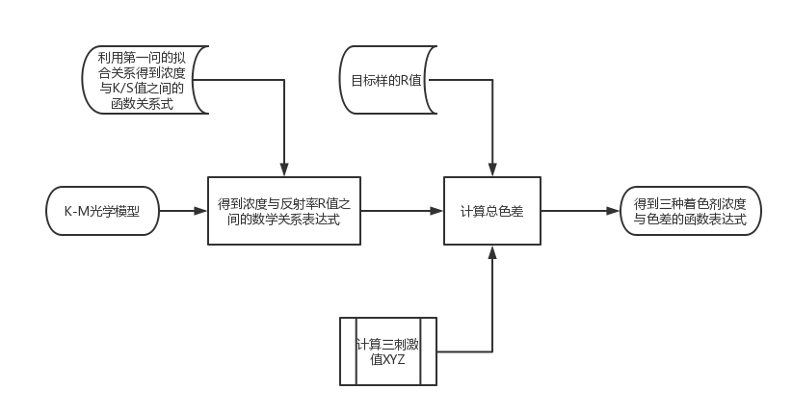

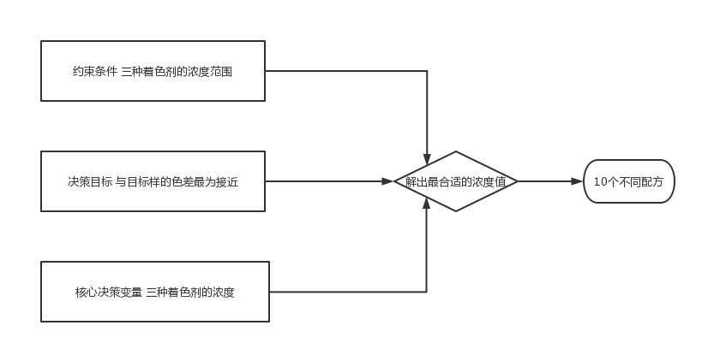

问题二流程图

模型建立

由K-M光学模型得到在 λ 波长处，基材的K/S值、着色剂的K/S值与反射率R之间的关系，其中每个着色剂的K/S值具有加和性，其数学关系表达式如下：

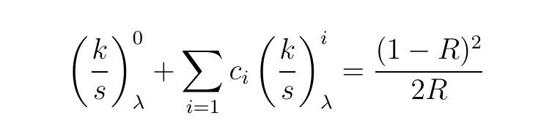

其中每种着色剂的浓度所对应的K/S值使用第一问的拟合函数关系式进行计算，此处用python构造函数进行计算：

def KS(c，RYB，n)

由三种着色剂浓度计算对应R值，构造函数解一元二次方程：

def calcurR(c1,c2,c3)

在CIELAB色彩空间中，总色差计算方法的颜色参数L、红绿色度a、黄蓝色度b中出现的三刺激值XYZ的计算方法如下：

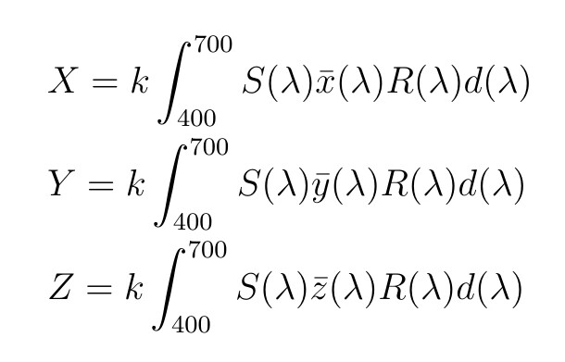

构造函数由模型样与目标样在可见光全光谱上R值计算所对应的三刺激值XYZ：

def calcuXYZ(R)

由三刺激值XYZ计算得到颜色参数明度、红绿色度和黄蓝色度，其计算方法如下：

若x/x0、y/y0、z/z0均大于0.008856，则按以下下公式计算:

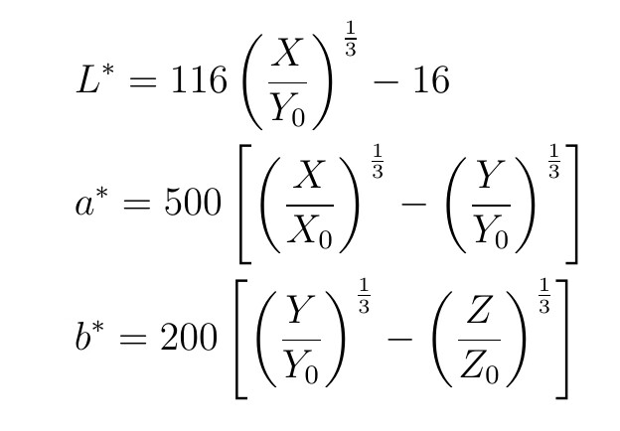

否则，按以下公式计算：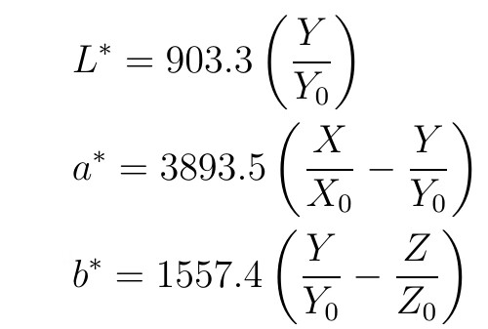

由模型样和目标样分别求得对应的L*、a*、b*，做差得到ΔL*、Δa*、Δb*，并进一步计算得到总色差，其计算方法如下：

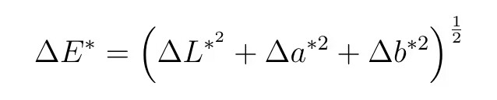

综合上述计算结果，定义函数F，计算总色差，即为目标函数，如下：

F(c1,c2,c3,R_target)

建立以下模型：

**目标函数**：F(c1,c2,c3,R_target)

**决策变量**：三种着色剂的浓度 $c_{1}$， $c_{2}$， $c_{3}$

**约束条件： $0<=c_{1},c_{2},c_{3}<=5(\%)$**且三种着色剂的浓度最多只有一种浓度为0

$$\left\{\begin{aligned}Fmin \\ KS(c，RYB，n) \\ calcurR(c1,c2,c3)\end{aligned}\right.\frac{def calcuXYZ(R)}{F(c1,c2,c3,R_target)}$$

模型求解

模拟退火基本原理

模拟退火算法(Simulated Annealing，简称SA)的思想最早是由Metropolis等提出的。其出发点是基于物理中固体物质的退火过程与一般的组合优化问题之间的相似性。模拟退火法是一种通用的优化算法,它通过模拟金属在高温下退火冷却的过程，逐步搜索问题的解空间，以找到全局最优解或者近似最优解。

模拟退火算法流程图

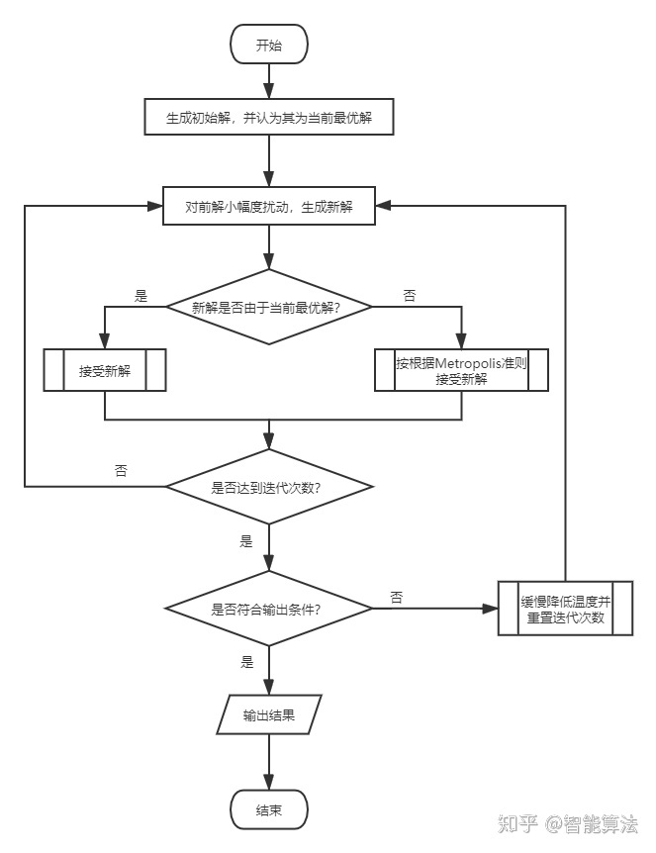

结果展示

通过上述求解过程，得到10个配方的三种着色剂的浓度以及对应的色差，如下表：

|  |  |  |  |  |
| --- | --- | --- | --- | --- |
|  | 着色剂浓度百分比 | | |  |
| 样本编号 | 红色 | 黄色 | 蓝色 | 色差 |
| 1 | 0.405868753388968 | 0.0159161185404972 | 0.0443280051055219 | 0.0188764541197549 |
| 2 | 0.1079889286433858 | 3.028029619014244e-05 | 0.15581905846612099 | 0.683038928860927 |
| 3 | 0.19605127018610666 | 2.2357602251466338e-05 | 0.18098796521718252 | 0.716074725904492 |
| 4 | 0.00014309268924249743 | 0.03962821828028015 | 0.4302292924618222 | 0.551665824951313 |
| 5 | 6.87883483275753e-05 | 0.0220150074677026 | 0.3484044894071973 | 0.539150614371575 |
| 6 | 0.428444319092513 | 2.1995866696073113e-05 | 0.061805755191506134 | 0.721389835912762 |
| 7 | 0.3074447633566366 | 0.3573555296269151 | 0.07862051384656951 | 0.0327795861003594 |
| 8 | 0.10492920025242758 | 0.07981259554212641 | 0.14868613976092473 | 0.0260248943922577 |
| 9 | 0.031031329787946996 | 0.035943901695614344 | 0.3520823877367484 | 0.0186130549584457 |
| 10 | 0.06863792643266634 | 0.23496849152490215 | 0.4335639853741024 | 0.00996035647229648 |

问题三的模型建立与求解

问题分析

本题给出了基底材料的重量与色母粒单位千克重价格表，要求考虑成本控制与批量配色，改进配色模型。首先，利用浓度＝着色剂克重/基材重量公式，可实现浓度与着色剂克重之间的转换，每种着色剂的克重乘以对应色母粒单位克重并求和，即可得到每种配方的总价格。所以，将每种配方的总价格和总色差最小作为决策目标，利用**主要目标法**，也即只让一个最主要的决策目标作为优化的目标，将其他目标适当兼顾，把非主要决策目标降为约束条件。这里在第二问的基础上，以第二问得到的最优解的色差为基准，允许0.1范围的溢出作为约束条件，求解价格的最小值，得到目标函数。利用**模拟退火算法**求解最优的决策变量，并将着色剂克重转换为着色剂浓度，得到10个不同配方的最优解。

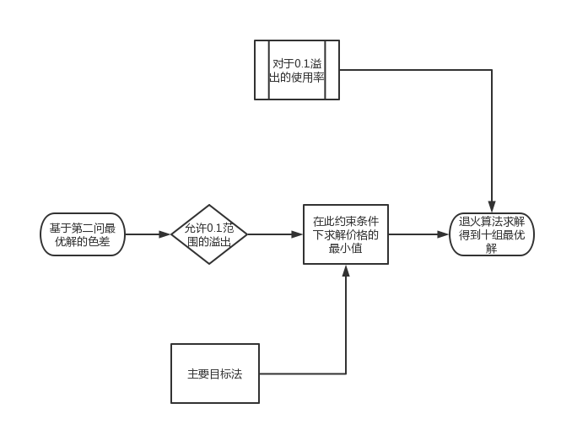

问题三流程图

模型建立

引入色差变化比例来衡量对于0.1色差溢出的使用率：

(delta_E - delta_E1)*10

引入价格差来衡量优化效果：

ΔCalcuprice（c1,c2,c3）

建立以下模型：

目标函数 E_best

约束条件 0.1的色差偏离容许度

决策变量 三种着色剂的浓度

$$\left\{\begin{aligned}E_best \\ (delta_E - delta_E1)*10 \\ ΔCalcuprice（c1,c2,c3）\end{aligned}\right.$$

模型求解与结果展示

运用模拟退火算法求解模型得到十个最优解与对应的色差变化比例与价格差，如下表

问题四的模型的建立与求解

问题分析

在实际生产过程中，对于不透明制品的生产方而言，其选取方案的主要依据是盈利和能耗问题，而对于不透明制品的购买方而言，考虑的主要是商品的质量和价格问题。本问题中，商品的成本决定了其盈利能力及价格，制品的着色剂用量决定了生产能耗，商品的色差决定了其质量。面对市场中消费者对价格与质量重视程度的改变趋势和日益严重的能源问题，对于每个样品给出的五个方案，应当满足以下条件：可以通过挑选并更改方案平衡制品成本及色差因素来应对市场趋势的改变，同时尽可能的减少配色所需的着色剂来减少能耗。

模型建立

引入函数来衡量配色所需的配色剂：

G(c1,c2,c3)

引入函数来衡量配色所需的成本：

M（c1，c2，c3）

引入函数来衡量配色的色差：

F(c1,c2,c3,R_target)

引入质量和价格的线性加权来衡量市场对价格与质量的重视程度：

F+Q*M

其中Q为加权系数，在模拟退火算法中设定每次运行模拟退火算法程序进行20次迭代，每次迭代对Q进行1.5倍的指数迭代增长，以实现线性加权中加权数值的变化，来拟合市场的变化趋势。对Q的初值进行改变，分别为0.1、0.2、0.3，来实现加权精度的改变。对于每组加权精度计算出来的所有最优解，选取G(c1，c2，c3）值最小的五组，对于三组加权精度，选取五个最优解分布最广泛的一组作为最终最优解。按照同样的方法计算出剩余四组样品的最优解。

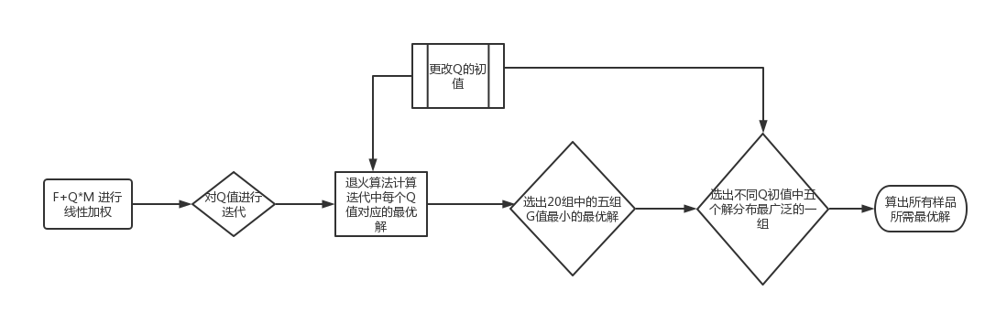

问题四流程图

建立模型如下：

目标函数：G（c1，c2，c3） M（c1，c2，c3） F(c1,c2,c3,R_target)

约束条件：G（c1，c2，c3）最小的五组解分布的广泛程度

决策变量：三种着色剂的浓度

$$\left\{\begin{aligned}G（c1，c2，c3）\frac{F+Q*M}{} \\ M（c1，c2，c3 \\ F(c1,c2,c3,R_target)\end{aligned}\right.$$

模型求解与结果展示

模型评价与推广

模型优点

1. 解构了问题中几个参数之间复杂的数学关系并用函数的形式来表示，提高了**计算精度和速度**。
2. 进行了合理的假设，在优化模型中抓住了主要的目标函数，采用多种方式处理**多目标函数**，让模型和算法准确高效。
3. 充分考虑了**实际情况**，提高了模型的实用性，可以应对多种市场要求和生产情况。

4.采用**模拟退火算法**等启发式算法，有利于**跳出局部最优解**，得到的优化结果具有一定的参考意义。

模型缺点及改进

模型中处理多目标函数问题时，进行决策时缺少必要依据，以及对于加权系数的参数值确定，也缺乏必要依据。可以通过查找文献资料等确定实际情况中几种目标函数的权重划分，使优化结果更接近真实情况。

附录A 数据拟合-python源程序

1. import re
2. import pandas as pd
3. import numpy as np
4. import sympy as sp
5. import matplotlib.pyplot as plt
6. from scipy.stats import linregress
7. from scipy.optimize import curve_fit
8. excel_data = pd.read_excel('ks_value.xlsx')
9. color_start = 3
10. y_data_list = []
11. coefficients_list = []
12. expression_y_list = []
13. r_squared_list = []
14. x = sp.Symbol('X')
15. for color in range(0, 3):
16. column = 400
17. column_str = str(column)
18. column_final = f'{column_str}nm'
19. color_end = color_start + 7
20. x_data = excel_data.loc[color_start:color_end, 'concentration'].astype(float)
21. for num in range(2, 18):
22. column_final = f'{column_str}nm'
23. print(column_final)
24. y_data = excel_data.loc[color_start:color_end, column_final].astype(float)
25. y_data_list.append(y_data)
26. coefficients = np.polyfit(x_data, y_data, deg=5)
27. decimal_places = 6
28. rounded_coefficients = np.round(coefficients, decimal_places)
29. poly = np.poly1d(rounded_coefficients)
30. coefficients_list.append(rounded_coefficients)
31. column += 20
32. column_str = str(column)
33. print(rounded_coefficients)
34. reversed_coefficients = rounded_coefficients[::-1]
35. expression = sum(reversed_coefficients[i] * x ** i for i in range(5, -1, -1))
36. expression_str = str(expression)
37. expression_final = re.sub(r'\*\*', '^', expression_str)
38. expression_final = re.sub(r'\*', '', expression_final)
39. expression_final = re.sub(r' ', '', expression_final)
40. expression_y = f'Y = {expression_final}'
41. expression_y_list.append(expression_y)
42. print(expression_y)
43. x_fit = np.linspace(min(x_data), max(x_data), 100)
44. y_fit = poly(x_fit)
45. y_fit_resampled = np.interp(x_data, x_fit, y_fit)
46. y_mean = np.mean(y_data)
47. ss_total = np.sum((y_data - y_mean) ** 2)
48. ss_residual = np.sum((y_data - y_fit_resampled) ** 2)
49. r_squared = 1 - (ss_residual / ss_total)
50. r_squared_list.append(r_squared)
51. plt.scatter(x_data, y_data, label='Original Data')
52. plt.plot(x_fit, y_fit, color='red', label='Fitted Polynomial')
53. plt.xlabel('X')
54. plt.ylabel(expression_y)
55. plt.legend()
56. plt.show()
57. color_start = color_end + 1
58. data = {
59. '函数关系式': expression_y_list,
60. '拟合系数': r_squared_list
61. }
62. df = pd.DataFrame(data)
63. writer = pd.ExcelWriter('Q1_polynomial.xlsx', engine='xlsxwriter')
64. df.to_excel(writer, sheet_name='polynomial', startrow=2, startcol=1, index=False)
65. writer.save()

附录B 问题二中出现的所有函数定义及模拟退火算法-python源程序

1. def KS(c,RYB,n):#n与波长线性相关，函数根据颜料浓度获得K/S值
2. CC = [[[ 0.002051,-0.010625,-0.031360,0.181794,0.631014,0.612139],
3. [-0.012674,0.161986,-0.705964,1.160046,0.191246,0.249396],
4. [-0.012674,0.161986,-0.705964,1.160046,0.162746,0.130041],
5. [-0.006337,0.080993,-0.352982,0.580023,0.382851,0.164430],
6. [-0.006337,0.080993,-0.352982,0.580023,0.833352,0.214509],
7. [-0.006337,0.080993,-0.352982,0.580023,1.429895,0.277175],
8. [-0.006337,0.080993,-0.352982,0.580023,2.229895,0.343731],
9. [-0.006337,0.080993,-0.352982,0.580023,2.429895,0.319349],
10. [-0.006337,0.080993,-0.352982,0.580023,2.329895,0.363999],
11. [-0.005484,0.069501,-0.300351,0.488842,0.878256,0.031301],
12. [-0.005610,0.068259,-0.282375,0.447774,0.027184,0.017194],
13. [-0.000132,0.001688,-0.007425,0.012295,0.045176,0.008161],
14. [2.0e-5,-0.000213,0.000686,-0.00058,0.009633,0.006701],
15. [-2.4e-5,0.000292,-0.001249,0.002107,0.003789,0.00523],
16. [-1.1e-5,0.000147,-0.00071,0.001342,0.001148,0.006499],
17. [-1e-5,0.000147, - 0.000710,0.001341,0.000148,0.006200]],
18. [[-0.003817,0.041305,-0.151455,0.217372,1.49948,0.483956],
19. [-0.003817,0.041305,-0.151455,0.217372,1.59948,0.494269],
20. [-0.003817,0.041305,-0.151455,0.217372,1.79948,0.484631],
21. [-0.003817,0.041305,-0.151455,0.217372,1.60948,0.4185],
22. [-0.003817,0.041305,-0.151455,0.217372,1.19948,0.322496],
23. [-0.002641,0.028986,-0.108313,0.158117,0.776735,0.207159],
24. [-0.002641,0.028986,-0.108313,0.158117,0.326735,0.107696],
25. [-0.000272,0.002981,-0.01109,0.016092,0.142663,0.047312],
26. [-0.000231,0.002448,-0.008708,0.011759,0.05533,0.023342],
27. [-0.000864,0.009848,-0.038713,0.062082,-0.011645,0.013055],
28. [-1.8e-5,0.000177,-0.000594,0.000748,0.006688,0.00463],
29. [-1E-05,0.0001,- 0.0004,0.0005,0.002,0.0024],
30. [-3.0e-6,3.3e-5,-0.000114,0.000139,0.000959,0.002011],
31. [-3E-06,3E-05,- 0.0001,0.0001,0.0006,0.0018],
32. [-3E-06,3E-05,- 0.0001,0.0001,0.0004,0.0017],
33. [-3E-06,3E-05,- 9E-05,9E-05,0.0003,0.0014]],
34. [[0.009116,-0.107796,0.428374,-0.661366,0.739095,-0.007768],
35. [-0.00052,0.006226,-0.025767,0.039744,0.283189,0.014166],
36. [-0.00052,0.006226,-0.025767,0.039744,0.273189,0.012276],
37. [-0.00052,0.006226,-0.025767,0.039744,0.353189,0.010555],
38. [-0.00052,0.006226,-0.025767,0.039744,0.383189,0.012625],
39. [0.000424,-0.005624,0.025163,-0.052617,0.607543,0.00962],
40. [0.000424,-0.005624,0.025163,-0.052617,0.747543,0.014251],
41. [0.001218,-0.010554,0.01593,0.045462,0.805218,0.036563],
42. [0.001218,-0.010554,0.01593,0.045462,1.205218,0.038923],
43. [-0.001731,0.031472,-0.191258,0.442689,1.381631,0.061326],
44. [-0.001731,0.031472,-0.191258,0.442689,1.581631,0.068624],
45. [-1.2e-5,0.013236,-0.126905,0.353883,1.722591,0.068569],
46. [-0.001731,0.031472,-0.191258,0.442689,1.601631,0.064267],
47. [0.001218,-0.010554,0.01593,0.045462,1.205218,0.032173],
48. [-0.00052,0.006226,-0.025767,0.039744,0.483189,0.012261],
49. [-0.00052,0.006226,-0.025767,0.039744,0.333189,-0.000798]]]#K/S在不同颜色，不同波长下关于颜料浓度的多项式系数
50. return CC[RYB][n][0]*c**5 + CC[RYB][n][1]*c**4 + CC[RYB][n][2]*c**3 + CC[RYB][n][3]*c**2 + CC[RYB][n][4]*c + CC[RYB][n][5]
51. def calcuR(c1,c2,c3):#由三种染色剂浓度求R值
52. KS0 = [0.039492,0.025906,0.017964,0.015092,0.011439,0.009515,0.007961,0.006947,0.006284,0.005889,0.005238,0.004948,0.004626,0.004247,0.004100,0.003617]
53. KS1 = []
54. KS2 = []
55. KS3 = []
56. for i in range(16):
57. KS1.append(KS(c1,0,i))
58. for i in range(16):
59. KS2.append(KS(c2,1,i))
60. for i in range(16):
61. KS3.append(KS(c3,2,i))
63. a = []
64. for i in range(16):
65. a.append(KS0[i] + c1*KS1[i] + c2*KS2[i] + c3*KS3[i])
66. R = []
67. for i in range(16):
68. R.append(a[i]+1 - (a[i]**2 + 2*a[i])**0.5)
69. return R#获得全波段
70. def calcuXYZ(R):#由R获得XYZ值
71. lis_3 = [[0.136,0.014,0.613],
72. [1.644,0.172,7.820],
73. [3.463,0.560,17.755],
74. [3.065,1.300,17.697],
75. [0.803,2.530,7.703],
76. [0.036,4.337,2.056],
77. [1.062,6.870,0.548],
78. [3.385,8.644,0.123],
79. [6.069,8.583,0.000],
80. [8.361,7.163,0.000],
81. [8.707,5.100,0.000],
82. [6.463,3.004,0.000],
83. [3.109,1.295,0.000],
84. [1.053,0.416,0.000],
85. [0.275,0.107,0.000],
86. [0.059,0.023,0.000]]
87. X = 0
88. Y = 0
89. Z = 0
90. for i in range(16):
91. if i == 0 or i == 15:
92. X += lis_3[i][0]*R[i]#R指标是波长的话要改
93. else:
94. X += lis_3[i][0]*2*R[i]
96. for i in range(16):
97. if i == 0 or i == 15:
98. Y += lis_3[i][1]*R[i]#R指标是波长的话要改
99. else:
100. Y += lis_3[i][1]*2*R[i]
102. for i in range(16):
103. if i == 0 or i == 15:
104. Z += lis_3[i][2]*R[i]#R指标是波长的话要改
105. else:
106. Z += lis_3[i][2]*2*R[i]
108. return [X,Y,Z]
109. def calcuLab(XYZ):#输入XYZ列表
110. X0 = 94.83
111. Y0 = 100
112. Z0 = 107.38
113. L = 116*(XYZ[1]/Y0)**(1/3) - 16
114. a = 500*((XYZ[0]/X0)**(1/3) - (XYZ[1]/Y0)**(1/3))
115. b = 200*((XYZ[1]/Y0)**(1/3) - (XYZ[2]/Z0)**(1/3))
116. lis = [L,a,b]
117. return lis#返回L*,a*,b*列表
118. def calcu_delta_E(Lab1,Lab2):#由两组L*,a*,b*列表获得色差
119. delta_E = 0
120. for i in range(3):
121. delta_E += (Lab1[i]-Lab2[i])**2
122. return delta_E**0.5
123. def F(c1,c2,c3,R_target):#目标函数
124. return calcu_delta_E(calcuLab(calcuXYZ(calcuR(c1,c2,c3))),calcuLab(calcuXYZ(R_target)))
125. #以下为模拟退火算法求解函数优化问题
126. import random
127. import math
128. R_target = [0.681044,0.724153,0.749374,0.752377,0.733554,0.699726,0.663874,0.652066,\
129. 0.642280,0.689994,0.720488,0.725711,0.732905,0.771153,0.838096,0.859082]
130. sol_new1 = 2.5#初始值
131. sol_new2 = 2.5
132. sol_new3 = 2.5
133. sol_current1 = sol_new1#迭代过程中记录
134. sol_current2 = sol_new2
135. sol_current3 = sol_new3
136. sol_best1 = sol_new1
137. sol_best2 = sol_new2
138. sol_best3 = sol_new3
139. E_current = 100#目标函数优化初始化
140. E_best = 100
141. T = 0.5#初始温度
142. T1 = 0.1#结束温度
143. aa = 0.99#温度衰减率
144. while T >= T1:
145. times = 0
146. E_record = []
147. while times < 1000:
148. times += 1
149. sol_new01 = sol_new1 + (random.random()-0.5)*0.05
150. sol_new02 = sol_new2 + (random.random()-0.5)*0.05
151. sol_new03 = sol_new3 + (random.random()-0.5)*0.05
153. if 0 <= sol_new01 <= 5 and 0 <= sol_new02 <= 5 and 0 <= sol_new03 <= 5 and\
154. sol_new01*sol_new02 + sol_new01*sol_new03 + sol_new02*sol_new03 > 1e-7:
155. sol_new1 = sol_new01
156. sol_new2 = sol_new02
157. sol_new3 = sol_new03
158. else:
159. times -= 1
160. continue
161. E_new = F(sol_new1,sol_new2,sol_new3,R_target)
162. if E_new < E_current:
163. E_current = E_new
164. sol_current1 = sol_new1
165. sol_current2 = sol_new2
166. sol_current3 = sol_new3
167. if E_new <E_best:
168. E_best = E_new
169. sol_best1 = sol_new1
170. sol_best2 = sol_new2
171. sol_best3 = sol_new3
172. else:
173. if random.random()<math.e**(-(E_new-E_current)/T):
174. E_current = E_new
175. sol_current1 = sol_new1
176. sol_current2 = sol_new2
177. sol_current3 = sol_new3
178. else:
179. sol_new1 = sol_current1
180. sol_new2 = sol_current2
181. sol_new3 = sol_current3
182. E_record.append(E_current)
183. T = T*aa
184. print('E_record ',E_record)
185. print('sol_best: ',sol_best1,sol_best2,sol_best3)#最优解
186. print('E_best ',E_best)#色差

附录C 第三问中出现的函数定义及调整的模拟退火算法-python源程序

1. def calcuprice(c1,c2,c3):
2. return 0.01*(c1*2*60 + c2*2*65 + c3*2*63)
3. def F(c1,c2,c3,R_target):
4. return calcu_delta_E(calcuLab(calcuXYZ(calcuR(c1,c2,c3))),calcuLab(calcuXYZ(R_target)))
5. #以下为模拟退火算法求解函数优化问题
6. import random
7. import math
8. k = 0
9. lis_sol_best = [[0.40586875338896833,0.015916118540497272,0.04432800510552193],
10. [0.1079889286433858,3.028029619014244e-05,0.15581905846612099],
11. [0.19605127018610666,2.2357602251466338e-05,0.18098796521718252],
12. [0.00014309268924249743,0.03962821828028015,0.4302292924618222],
13. [6.87883483275753e-05,0.0220150074677026,0.3484044894071973],
14. [0.428444319092513,2.1995866696073113e-05,0.061805755191506134],
15. [0.3074447633566366,0.3573555296269151,0.07862051384656951],
16. [0.10492920025242758,0.07981259554212641,0.14868613976092473],
17. [0.031031329787946996,0.035943901695614344,0.3520823877367484],
18. [0.06863792643266634,0.23496849152490215,0.4335639853741024]]
19. R = [[0.507045,0.532145,0.546225,0.557051,0.493464,0.430796,0.370752,0.359875,0.365956,0.513965,0.716593,0.837977,0.888602,0.900323,0.906528,0.913298],
20. [0.681044,0.724153,0.749374,0.752377,0.733554,0.699726,0.663874,0.652066,0.642280,0.689994,0.720488,0.725711,0.732905,0.771153,0.838096,0.859082],
21. [0.629420,0.668642,0.690550,0.693808,0.654061,0.603730,0.553318,0.539833,0.534764,0.616401,0.680087,0.695650,0.705559,0.747784,0.823197,0.846680],
22. [0.598105,0.636542,0.647724,0.634758,0.638956,0.610761,0.589352,0.556888,0.500971,0.457357,0.439055,0.430547,0.437718,0.503085,0.646008,0.692619],
23. [0.641290,0.680826,0.695806,0.685813,0.690465,0.665507,0.646113,0.616788,0.565565,0.524583,0.507192,0.499046,0.506062,0.568136,0.697296,0.738285],
24. [0.507637,0.534544,0.550889,0.560809,0.488216,0.420199,0.357506,0.345772,0.351452,0.499036,0.703689,0.825218,0.874593,0.889770,0.901908,0.910100],
25. [0.376815,0.379640,0.371046,0.387641,0.401820,0.412266,0.412390,0.425963,0.439564,0.576515,0.736379,0.810591,0.836221,0.858021,0.886589,0.898088],
26. [0.611623,0.636383,0.644250,0.654583,0.661286,0.657130,0.645990,0.645381,0.639611,0.688578,0.719943,0.725500,0.732772,0.771024,0.837919,0.858908],
27. [0.616192,0.654238,0.667361,0.660191,0.663057,0.638999,0.618215,0.593015,0.547792,0.519088,0.506045,0.498777,0.505973,0.568058,0.697160,0.738137],
28. [0.457151,0.471454,0.465966,0.472114,0.495952,0.506516,0.517486,0.510463,0.471248,0.447707,0.436959,0.430048,0.437543,0.502925,0.645742,0.692336]]
29. R_target = R[k]
30. sol_new1 = lis_sol_best[k][0]
31. sol_new2 = lis_sol_best[k][1]
32. sol_new3 = lis_sol_best[k][2]
33. sol_current1 = sol_new1#迭代过程中记录
34. sol_current2 = sol_new2
35. sol_current3 = sol_new3
36. sol_best1 = sol_new1
37. sol_best2 = sol_new2
38. sol_best3 = sol_new3
39. E_current = 999999#目标函数优化初始化
40. E_best = 999999
41. T = 0.5#初始温度
42. T1 = 0.1#结束温度
43. aa = 0.99#温度衰减率
44. lis_delta_E_best = [0.018876454119754943,0.683038928860927,0.7160747259044927,0.5516658249513138,0.5391506143715753,0.7213898359127621,0.032779586100359435,0.026024894392257712,0.018613054958445764,0.009960356472296485]
45. while T >= T1:
46. print(T)
47. times = 0
48. E_record = []
49. while times < 1000:
50. times += 1
51. sol_new01 = sol_new1 + (random.random()-0.5)*0.001
52. sol_new02 = sol_new2 + (random.random()-0.5)*0.001
53. sol_new03 = sol_new3 + (random.random()-0.5)*0.001
54. *#print(times,F(sol_new01,sol_new02,sol_new03,R_target) , lis_delta_E_best[k]+0.1)*
55. if 0 <= sol_new01 <= 5 and 0 <= sol_new02 <= 5 and 0 <= sol_new03 <= 5 and\
56. sol_new01*sol_new02 + sol_new01*sol_new03 + sol_new02*sol_new03 > 1e-7 and\
57. F(sol_new01,sol_new02,sol_new03,R_target) < lis_delta_E_best[k] + 0.1:#0.1的色差偏离容许度
58. sol_new1 = sol_new01
59. sol_new2 = sol_new02
60. sol_new3 = sol_new03
61. else:
62. times -= 1
63. continue
64. E_new = calcuprice(sol_new1,sol_new2,sol_new3)
65. if E_new < E_current:
66. E_current = E_new
67. sol_current1 = sol_new1
68. sol_current2 = sol_new2
69. sol_current3 = sol_new3
70. if E_new <E_best:
71. E_best = E_new
72. sol_best1 = sol_new1
73. sol_best2 = sol_new2
74. sol_best3 = sol_new3
75. else:
76. if random.random()<math.e**(-(E_new-E_current)/T):
77. E_current = E_new
78. sol_current1 = sol_new1
79. sol_current2 = sol_new2
80. sol_current3 = sol_new3
81. else:
82. sol_new1 = sol_current1
83. sol_new2 = sol_current2
84. sol_new3 = sol_current3
85. E_record.append(E_current)
86. T = T*aa
87. print('sol_best: ',sol_best1,sol_best2,sol_best3)#最优解
88. print('E_best ',E_best)#目标函数优化值
89. delta_E = calcu_delta_E(calcuLab(calcuXYZ(calcuR(sol_best1,sol_best2,sol_best3))),calcuLab(calcuXYZ(R_target)))
90. delta_E1= calcu_delta_E(calcuLab(calcuXYZ(calcuR(lis_sol_best[k][0], lis_sol_best[k][1], lis_sol_best[k][2]))),calcuLab(calcuXYZ(R_target)))
91. print('色差 ',delta_E)
92. print('色差变化比例',(delta_E - delta_E1)*10)
93. print('价格差 ',calcuprice( sol_best1, sol_best2, sol_best3) - calcuprice( lis_sol_best[k][0], lis_sol_best[k][1], lis_sol_best[k][2]))

附录D 第四问中出现的函数定义以及更改后的模拟退火算法-python源程序

1. def F(c1,c2,c3,R_target,Q):#目标函数
2. return calcu_delta_E(calcuLab(calcuXYZ(calcuR(c1,c2,c3))),calcuLab(calcuXYZ(R_target))) + calcuprice(c1,c2,c3)*Q
3. #以下为模拟退火算法求解函数优化问题
4. import random
5. import math
6. k = 0
7. lis_sol_best = [[0.40586875338896833,0.015916118540497272,0.04432800510552193],
8. [0.1079889286433858,3.028029619014244e-05,0.15581905846612099],
9. [0.19605127018610666,2.2357602251466338e-05,0.18098796521718252],
10. [0.00014309268924249743,0.03962821828028015,0.4302292924618222],
11. [6.87883483275753e-05,0.0220150074677026,0.3484044894071973],
12. [0.428444319092513,2.1995866696073113e-05,0.061805755191506134],
13. [0.3074447633566366,0.3573555296269151,0.07862051384656951],
14. [0.10492920025242758,0.07981259554212641,0.14868613976092473],
15. [0.031031329787946996,0.035943901695614344,0.3520823877367484],
16. [0.06863792643266634,0.23496849152490215,0.4335639853741024]]
17. R = [[0.507045,0.532145,0.546225,0.557051,0.493464,0.430796,0.370752,0.359875,0.365956,0.513965,0.716593,0.837977,0.888602,0.900323,0.906528,0.913298],
18. [0.681044,0.724153,0.749374,0.752377,0.733554,0.699726,0.663874,0.652066,0.642280,0.689994,0.720488,0.725711,0.732905,0.771153,0.838096,0.859082],
19. [0.629420,0.668642,0.690550,0.693808,0.654061,0.603730,0.553318,0.539833,0.534764,0.616401,0.680087,0.695650,0.705559,0.747784,0.823197,0.846680],
20. [0.598105,0.636542,0.647724,0.634758,0.638956,0.610761,0.589352,0.556888,0.500971,0.457357,0.439055,0.430547,0.437718,0.503085,0.646008,0.692619],
21. [0.641290,0.680826,0.695806,0.685813,0.690465,0.665507,0.646113,0.616788,0.565565,0.524583,0.507192,0.499046,0.506062,0.568136,0.697296,0.738285],
22. [0.507637,0.534544,0.550889,0.560809,0.488216,0.420199,0.357506,0.345772,0.351452,0.499036,0.703689,0.825218,0.874593,0.889770,0.901908,0.910100],
23. [0.376815,0.379640,0.371046,0.387641,0.401820,0.412266,0.412390,0.425963,0.439564,0.576515,0.736379,0.810591,0.836221,0.858021,0.886589,0.898088],
24. [0.611623,0.636383,0.644250,0.654583,0.661286,0.657130,0.645990,0.645381,0.639611,0.688578,0.719943,0.725500,0.732772,0.771024,0.837919,0.858908],
25. [0.616192,0.654238,0.667361,0.660191,0.663057,0.638999,0.618215,0.593015,0.547792,0.519088,0.506045,0.498777,0.505973,0.568058,0.697160,0.738137],
26. [0.457151,0.471454,0.465966,0.472114,0.495952,0.506516,0.517486,0.510463,0.471248,0.447707,0.436959,0.430048,0.437543,0.502925,0.645742,0.692336]]
27. lis_delta_E_best = [0.018876454119754943,0.683038928860927,0.7160747259044927,0.5516658249513138,0.5391506143715753,0.7213898359127621,0.032779586100359435,0.026024894392257712,0.018613054958445764,0.009960356472296485]
28. R_target = R[k]
29. LIS_Q_sol_best = []
30. LIS_Q_mess = []
31. LIS_Q = []
32. LIS_deltaE = []
33. Q = 0.1
34. for n in range(10):
35. print(n)
36. sol_new1 = 1#初始值
37. sol_new2 = 1
38. sol_new3 = 1
39. sol_current1 = sol_new1#迭代过程中记录
40. sol_current2 = sol_new2
41. sol_current3 = sol_new3
42. sol_best1 = sol_new1
43. sol_best2 = sol_new2
44. sol_best3 = sol_new3
45. E_current = 99999#目标函数优化初始化
46. E_best = 99999
47. T = 0.5#初始温度
48. T1 = 0.02#结束温度
49. aa = 0.985#温度衰减率
50. while T >= T1:
51. print(T)
52. times = 0
53. *#E_record = []*
54. while times < 1000:
55. times += 1
56. sol_new01 = sol_new1 + (random.random()-0.5)*0.05
57. sol_new02 = sol_new2 + (random.random()-0.5)*0.05
58. sol_new03 = sol_new3 + (random.random()-0.5)*0.05
60. if 0 <= sol_new01 <= 5 and 0 <= sol_new02 <= 5 and 0 <= sol_new03 <= 5 and\
61. sol_new01*sol_new02 + sol_new01*sol_new03 + sol_new02*sol_new03 > 1e-7:
62. sol_new1 = sol_new01
63. sol_new2 = sol_new02
64. sol_new3 = sol_new03
65. else:
66. times -= 1
67. continue
68. E_new = F(sol_new1,sol_new2,sol_new3,R_target,Q)
69. if E_new < E_current:
70. E_current = E_new
71. sol_current1 = sol_new1
72. sol_current2 = sol_new2
73. sol_current3 = sol_new3
74. if E_new <E_best:
75. E_best = E_new
76. sol_best1 = sol_new1
77. sol_best2 = sol_new2
78. sol_best3 = sol_new3
79. else:
80. if random.random()<math.e**(-(E_new-E_current)/T):
81. E_current = E_new
82. sol_current1 = sol_new1
83. sol_current2 = sol_new2
84. sol_current3 = sol_new3
85. else:
86. sol_new1 = sol_current1
87. sol_new2 = sol_current2
88. sol_new3 = sol_current3
89. *#E_record.append(E_current)*
90. T = T*aa
91. LIS_Q_sol_best.append([sol_best1,sol_best2,sol_best3])
92. LIS_deltaE.append(calcu_delta_E(calcuLab(calcuXYZ(calcuR(sol_best1,sol_best2,sol_best3))),calcuLab(calcuXYZ(R_target))))
93. LIS_Q_mess.append(2*(sol_best1 + sol_best2 + sol_best3))
94. LIS_Q.append(Q)
95. Q *= 1.5
96. '''
97. print('sol_best: ',sol_best1,sol_best2,sol_best3)#最优解
98. print('E_best ',E_best)#色差
99. print('价格比例',calcuprice( sol_best1, sol_best2, sol_best3) / calcuprice( lis_sol_best[k][0], lis_sol_best[k][1], lis_sol_best[k][2]))
100. delta_E = calcu_delta_E(calcuLab(calcuXYZ(calcuR(sol_best1,sol_best2,sol_best3))),calcuLab(calcuXYZ(R_target)))
101. delta_E1= calcu_delta_E(calcuLab(calcuXYZ(calcuR(lis_sol_best[k][0], lis_sol_best[k][1], lis_sol_best[k][2]))),calcuLab(calcuXYZ(R_target)))
102. print('色差 ',delta_E)
103. print('色差变化比例',delta_E/delta_E1)#理论上大于1
104. '''
105. print('LIS_Q_sol_best\n',LIS_Q_sol_best)
106. print('LIS_Q_mess\n',LIS_Q_mess)
107. print('LIS_Q\n',LIS_Q)
108. print('LIS_deltaE',LIS_deltaE)