# Scratch book unsupervised learning 12

# Anomaly detection



Anomaly – anything that does not look like everything else.

* Point anomaly – one point that differs from every one.
* **Contextual anomaly**  - a point that differs from is environment.
* Collective anomaly

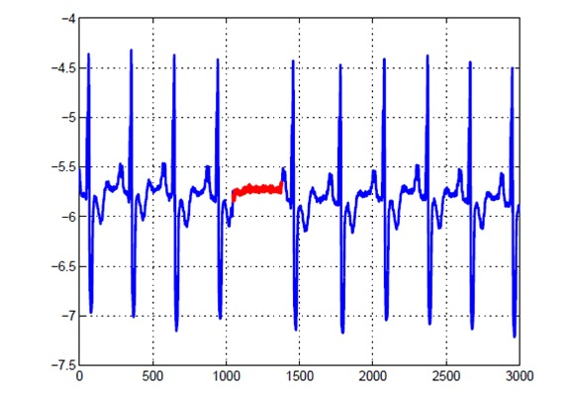

# Unsupervised anomaly detection

* Statistical - We build a model for the data with the anomalies.
* Proximity-based – An anomalous point is far from other points.
* Density-based - An anomalous point has a low density.
* Clustering-based - An anomalous point does not sit well in any cluster.

# Statistical anomaly detection

1. Define a statistical model on the data
2. Find improbable data points.

Example I – 1D gaussian data. - Anomalous points are points that are K SD from average.

Example II – Define GMM on the data and compute points with low probability in GMM.

1. Throw a coin if face then anomalous, if number then not. – probably lambda to be anomalous.
2. Each category has a different distribution.

Fit the data to the model.

More formally:

Assume a latent variable that defines for each point – with probability lambda anomalous, with probability (1-lambda) I am normal. Normal points have a distribution P1. We assume known \lambda and P.

$P\left(\left\{x_{i}\right\}\right)=Π_{i}p\left(x_{i}\right)$ = $Π_{i}\left[\left(\left(λ*P(x_{i} | i An\right)\right) or \left(\left(1-λ\right)*P1\left(x_{i}|model\right) | i Normal\right)\right]$

1. Assume that I know, which point is anomalous (A) and which point is not (N) and I have |A| number of anomalous point, |N| number of normal points.

$L\left(\left\{x_{i}\right\}\right)=Π_{i}p\left(x_{i}\right)$ = $λ^{\left|A\right|}*{\left(1-λ\right)}^{\left|N\right|}*Π_{A}P\left(x_{i}\right)*Π_{N}P\left(x_{i}|θ\right)$

$$\log\left(L\left(\left\{x_{i}\right\}\right)\right)={\left|A\right|\log\left(λ\right)}^{}+\left|N\right|*log{\left(1-λ\right)}^{}+\sum_{A}{log⁡(P)}+\sum_{N}{log⁡(}P\left(x_{i}|θ\right))$$

= ${\left|A\right|[log\left(λ*P\right))]}^{}+\left|N\right|*log{\left(1-λ\right)}^{}+\sum_{N}{log⁡(}P\left(x_{i}|θ\right))$

Derivate the last term by theta and obtain the ML parameters of the model.

1. Assume, I know the parameters theta, I can decide if a point is anomalous if its probability in the normal model is bellow some threshold.
2. Return to 1, until convergence.

# Proximity-based outlier detection



Outlier score is distance to kth nearest neighbor.

Problem – sensitive to the selection of k (k=5)

Also, cannot detect contextual anomalies.



# Density-based outlier detection

An anomaly is not dense (compared to its neighbors)

1. DBSCAN
2. K Density
 $K density\left(x\right)=[\frac{1}{K}{\sum_{\left\{KNN\right\}}{distance\left(x,Neighbor\left(x\right))\right]}}^{-1}$ $Anomalies have low K density (compared with its KNN)$ $Anomaly Score=K density\left(x\right)*K/∑K_Density(KNN\left(x\right))$* Sensitive (slightly less than distance based) to k
   * Expensive to compute if not implemented (Can cost up to $O\left(N^{2}\right)$ if not using a KD-tree, else $O(N*log(N))$).

# Cluster-based outlier detection

1. Cluster all the data (usually GMM/FCM/K means).
2. Remove all the points that have a low clustering score (negative silhouette score, or likelihood in GMM).
3. Go back to 1 until we find no points to remove.

# Machine learning based anomaly detection

* One class classifier.
* Autoencoder.

# Autoencoder

$x_{i}$ 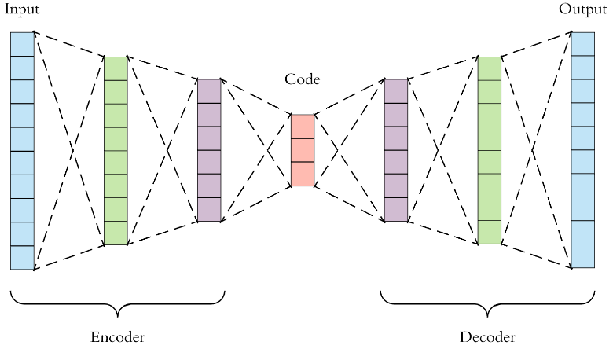 $X_{i}$

Train a machine to reproduce precisely the input by passing through a narrow layer.

$$Score =∑{\left|\left|x_{i}-X_{i}\right|\right|}^{2};x_{i}=inpute, X_{i}=output$$

$$Error in reconstruction of x_{i}- AS\left(x_{i}\right)= {\left|\left|x_{i}-X_{i}\right|\right|}^{2}$$

x(t)



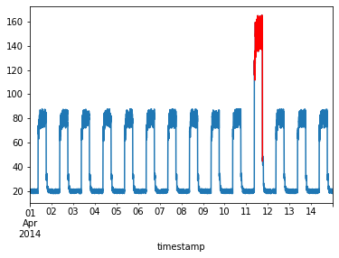

# One class SVM

SVM – support vector machine

Given input $x_{i}$ (a vector) and tag $y_{i} ∈ \{-1,1\}$. I want a linear function s.t $f\left(x_{i}\right)=w*x_{i}+b ≥1$ if $y_{i}=1$, and $w*x_{i}+b ≤-1$ if $y_{i}=-1$.

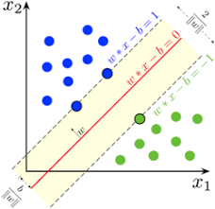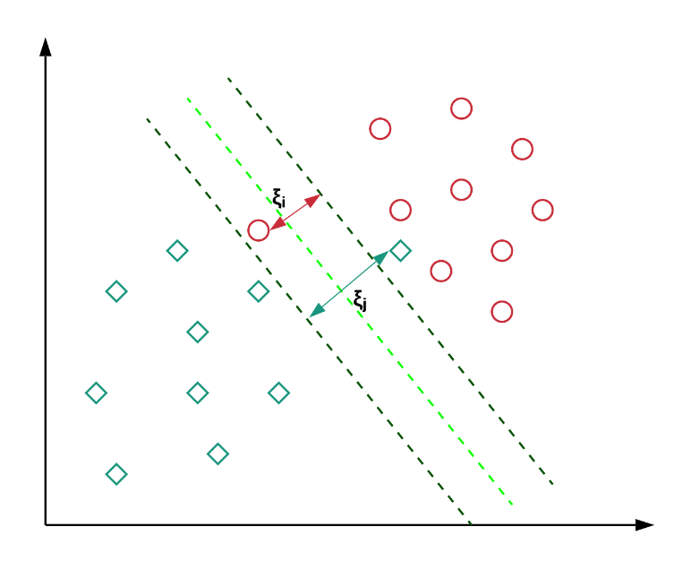

$$y_{i}\left[w*x_{i}+b\right]≥1 ∀i$$

$$y_{i}\left[w*x_{i}+b\right]≥1-χ_{i} ∀i, χ_{i}>=0$$

$$Loss =\frac{1}{2}{\left|\left|W\right|\right|}^{2}+ C*\sum_{i}{χ_{i}}$$

# One class SVM.

$$Min_{X0},r\left( r^{2}+ C*\sum_{i}{χ_{i}}\right), s.t. \left|\left|x_{i}-Xo\right|\right|<r+χ_{i} ∀i, χ_{i}≥0$$