1. (5 pts) The p-value from a test was found to be p = 0.034. Which of the following is a correct interpretation of the p-value with significance level = 0.05?
a) Accept the null hypothesis H0.
b) The probability the null hypothesis is true is 0.034 which is low, so we reject the null hypothesis.
c) Reject the null hypothesis because p is less than .
d) Fail to reject the null hypothesis because the probability of a type I error is 0.034.

2. (15 pts) A study comparing mercury levels in bass fish at two sites in the San Francisco Bay is being planned. A two-sample t-test using a significance level = 0.05 will be used and power of 80% achieved to detect a difference in mean mercury levels of 0.1mg/g. It is assumed that standard deviations at each site are equal := = = 0.06. The required sample size at each site was found to be n1 = n2 = 6. What would happen to the required sample size in each of the following circumstances (circle one answer for each part)
a) (3 pts) The power is increased to 90% from 80%. The required sample size would:
Increase Decrease Stay the Same Not enough information
b) (3 pts) The standard deviation is = 0.04 instead of 0.06. The required sample size would:
Increase Decrease Stay the Same Not enough information
c) (3 pts) The detectable difference was decreased from 0.1 to 0.05mg/g. The required sample size would:
Increase Decrease Stay the Same Not enough information
d) (3 pts) The significance level is decreased from 0.05 to 0.01. The required sample size would:
Increase Decrease Stay the Same Not enough information
e) (3 pts) Instead of bass fish, the study will compare mercury levels in jacksmelt fish. The required sample size would:
Increase Decrease Stay the Same Not enough information

3. (15 pts) Each of the following situations requires a hypothesis test. State the appropriate null hypothesis H0 and alternative hypothesis Ha in each case, state the appropriate statistical technique/test (one sample T-test, two sample paired T-test etc) for answering the research question, and name the distribution of the test statistics under H0.
- (5 pts) The mean area of several thousand apartments in a new development is advertised to be 1250 square feet. A tenant group thinks that the apartments are smaller than advertised. They hire an engineer to measure a sample of 100 apartments to test their suspicion.
H0: The mean area of the apartments is 1250 square feet
Ha: The mean area of the apartments is less than 1250 square feet
One sample T test
T distribution with DF = 99

- (5 pts) A researcher is interested if there is any mean difference in the students age of the community college students and the university students, assuming the same variance. He sampled 200 students in a community college and another 200 students in a university; and recorded their ages.
H0: there is no mean difference in the students age of the community college students and the university students
Ha: there is mean difference in the students age of the community college students and the university students
Two sample T test
T distribution with DF = 398

- (5 pts) Concentrations of nitrate were compared and contrasted among four major land covers: urban, forested, cropland, and pasture. Ten soil samples were obtained at each type of land cover. Investigators are interested if the mean nitrate concentrations differed among the four types of land cover.
H0: there is no difference in the mean nitrate concentrations among the four types of land cover
Ha: At least one land cover has different mean nitrate concentrations among the four types of land cover
ANOVA
F distribution with DF1 = 3 and DF2 = 36

4. (10 points) A common symptom of otitis media in young children is the prolonged presence of fluid in the middle ear, called middle-ear effusion. During the first 2 years of life, the presence of fluid may result in temporary hearing loss and other complications. Advocates of breastfeeding believe that breast feeding for at least 1 month builds up some immunity against disease and have a shorter duration of effusion than do bottle fed babies. A study on 24 pairs of babies is conducted, where the babies are matched on a one-to-one basis according to age, sex, socioeconomic status, and type of mediation taken. One member of the matched pair is breastfed and the other is bottle fed. The outcome is the duration of middle ear effusion after the first episode of otitis media. Here are the data:

Pair | Duration of effusion (days) |  | Difference  (Breast-Bottle fed)
Pair | Breastfed | Bottle fed | Difference  (Breast-Bottle fed)
1 | 20 | 18 | 2
2 | 11 | 35 | -24
3 | 3 | 7 | -4
4 | 24 | 182 | -158
5 | 7 | 6 | 1
6 | 28 | 33 | -5
7 | 58 | 223 | -165
8 | 7 | 7 | 0
9 | 39 | 57 | -18
10 | 17 | 76 | -59
11 | 17 | 186 | -169
12 | 12 | 29 | -17
13 | 52 | 39 | 13
14 | 14 | 15 | -1
15 | 12 | 21 | -9
16 | 30 | 28 | 2
17 | 7 | 8 | -1
18 | 15 | 27 | -12
19 | 65 | 77 | -12
20 | 10 | 12 | -2
21 | 7 | 8 | -1
22 | 19 | 16 | 3
23 | 34 | 28 | 6
24 | 25 | 20 | 5
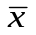 | 22.2 | 48.3 | -26.0
s | 16.8 | 70.0 | 55.1

The investigator did not take Introduction to Biostatistics and didn’t know how to properly analyze these data so he sent the data to a statistician without explaining the study design and received the following histograms and test results along with a note to call her to discuss which is the proper analysis (all tests are 2-sided):
paired t-test p-value=0.030,
Wilcoxon signed-rank test p-value=0.015,
2-sample t-test with unequal variances p-value=0.062,
Wilcoxon Rank Sum test p-value=0.22.

Breastfed Formula Difference
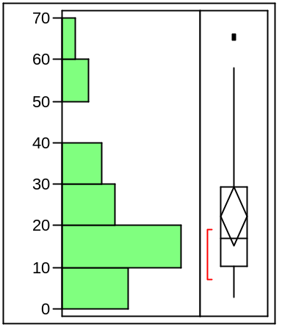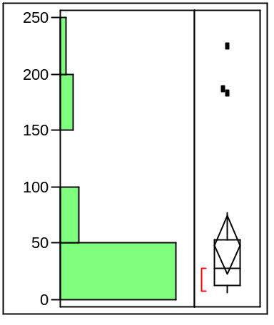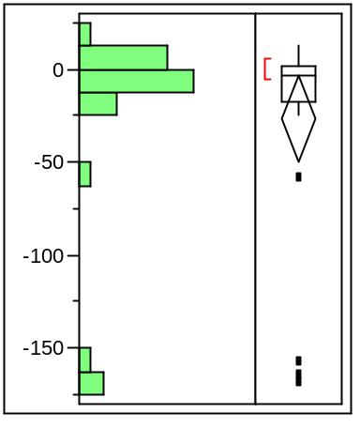
days

- (5) Which is the correct test to use and why?

Wilcoxon signed-rank test is the correct test to use. Because from the third graph of difference, we can see the data has outliers, we could not use the other two t-tests. Because this is a paired comparison, Wilcoxon Rank Sum test is not appropriate.
B) (5) Can you conclude that breastfeeding is better or worse than formula feeding with respect to duration of middle-ear effusion at α = 0.05 level?
Since Wilcoxon signed-rank test p-value=0.015, we reject the null hypothesis and conclude that breastfeeding is different from formula feeding (either better or worse) with respect to duration of middle-ear effusion.

