# Final Exam Sample Questions

1. The attack named MobilBye targets which type of sensor?
2. Camera
3. Lidar
4. Radar

ANS: ________________

A

1. Can an ASIL-D system be composed of multiple ASIL-B subsystems?
2. Yes
3. No

ANS: ________________

A

1. In PID control, which term(s) can be used to eliminate steady-state error?
2. P
3. I
4. D

ANS: ________________

B

1. True or False: twiddle() for PID controller tuning can be viewed as a form of Reinforcement Learning.
2. True
3. False

ANS: ________________

A

1. Why does AlphaGo not use Tabular RL, such as tabular Q Learning or Sarsa?

ANS: the state space is too large.

1. What is the probability of selecting the greedy action (assuming there is only one) in state $s$ in epsilon-greedy action selection, if the total number of possible actions in state $s$ is $N$?

ANS: $1-ϵ+\frac{ϵ}{N}$

1. What is an Episodic task?
2. A task that has a limited number of actions and then ends.
3. A task with memory

ANS: A

1. Consider the following MDP. Environment is deterministic. In each state, there are two possible actions a ∈{−1, 1}, where −1 corresponds to moving left, and 1 corresponds to moving right. Each movement incurs a reward of r=-1. State s=4 is the goal state: taking any action from s=4 results in reward of r=0 and ends the episode, hence $V\left(4\right)≡0,Q\left(4,a\right)≡0$ for any action $a$.

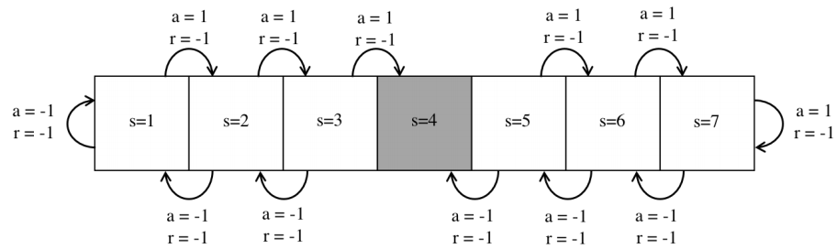

Consider this episode in the form of (s,a,r): (3, −1, −1),(2, 1, −1),(3, 1, −1),(4, 1, 0). Assume $γ=1, α=0.5$. All value functions are initialized to 0. Derive the following (only show the changed parts):

1. State value functions after TD learning.
2. Action value functions after Sarsa.
3. Action value functions after Q learning.

ANS:

TD update equation: $V\left(S_{t}\right)←V\left(S_{t}\right)+α(R_{t+1}+γV\left(S_{t+1}\right)-V(S_{t}))$

$V\left(3\right)←V\left(3\right)+0.5\left(-1+V\left(2\right)-0\right)=0+0.5\left(-1+0-0\right)=-0.5$

$V\left(2\right)←V\left(2\right)+0.5\left(-1+V\left(3\right)-0\right)=0+0.5\left(-1-0.5-0\right)=-0.75$

$V\left(3\right)←V\left(3\right)+0.5\left(-1+V\left(4\right)-0\right)=-0.5+0.5\left(-1+0+0.5\right)=-0.75$

Sarsa update equation: $Q\left(S_{t},A_{t}\right)←Q\left(S_{t},A_{t}\right)+α(R_{t+1}+γQ\left(S_{t+1},A_{t+1}\right)-Q\left(S_{t},A_{t}\right))$

$Q\left(3,-1\right)←Q\left(3,-1\right)+0.5\left(-1+Q\left(2,1\right)-0\right)=0+0.5\left(-1+0-0\right)=-0.5$

$Q\left(2,1\right)←Q\left(2,1\right)+0.5\left(-1+Q\left(3,1\right)-0\right)=0+0.5\left(-1+0-0\right)=-0.5$

$Q\left(3,1\right)←Q\left(3,1\right)+0.5\left(-1+Q\left(4,1\right)-0\right)=0+0.5\left(-1+0-0\right)=-0.5$

Q learning update equation: $Q\left(S_{t},A_{t}\right)←Q\left(S_{t},A_{t}\right)+α(R_{t+1}+γ\max_{a'}{Q\left(S_{t+1},a'\right)}-Q\left(S_{t},A_{t}\right))$

$Q\left(3,-1\right)←Q\left(3,-1\right)+0.5\left(-1+\max_{a^{'}} Q\left(2,a^{'}\right)-0\right)=0+0.5\left(-1+0-0\right)=-0.5$

$Q\left(2,1\right)←Q\left(2,1\right)+0.5\left(-1+\max_{a^{'}} Q\left(3,a^{'}\right)-0\right)=0+0.5\left(-1+\max{(-0.5,0)}-0\right)=-0.5$

$Q\left(3,1\right)←Q\left(3,1\right)+0.5\left(-1+\max_{a^{'}} Q\left(4,a^{'}\right)-0\right)=0+0.5\left(-1+0-0\right)=-0.5$