**4.Sentiment-Reliability-Renown Model**

4.1 Model description

We use 4 indicators to evaluate the quality of a product: **review reliability**, **review sentiment**, **product popularity**, and **time**. In the modeling process, we will quantify the above four indicators and integrate them to obtain a product’s**quality assessment score**.

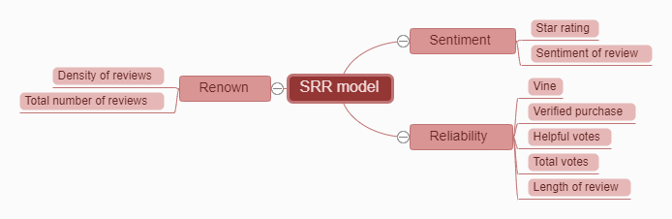

4.2 **Comment reliability**

We use 5 indicators to measure the **reliability of reviews**.

Whether the user is a **trial user**: If the user is a **trial user**, it means that the customer has used the product personally, but because the product is used for a shorter time than the purchaser, the contribution to the **reliability of the review** is correspondingly low. This item is 1 if the user is a **trial user**, otherwise 0.

Whether the user is a **purchaser**: If the use is a **purchaser**, it means that the customer has used the product personally and has used it for a long time and knows the product better, so the contribution to the **reliability of the review** is correspondingly higher. This item is 1 if the user is a **buyer**, otherwise it is 0.

**Useful votes**: The **useful votes** represent the affirmation of others to the comment. The more votes, the more referenced the comment and the higher the **reliability**.

**Total votes**: The **total votes** include **useful votes** and useless votes, that is, the sum of other people's positive and negative comments on the comment.

**Comment length**: Generally, the longer a comment is, the greater the amount of information it contains and the higher its **reliability**.

The mathematical expression of the **comment credibility** index in the SRR model equation is:

写式子

Where a12 is given in Section (5.5).

The sigmoid function in the formula is an X formula, and its image is as follow.

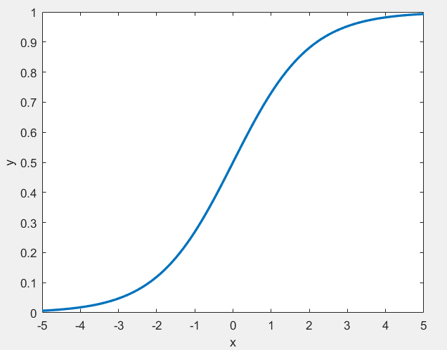

Since the sigmoid function is a monotonically increasing function, it converges to 1 at x towards positive infinity, and converges to 0 at x towards negative infinity, which is helpful for weight decay over time. Because the difference between the number of useful votes and the number of useless votes, and the length of the review are independent of whether they are trial or not, they should be multiplied in the formula. If the difference is larger, the comment length is longer, and the credibility of the review should increase, and we don’t want them to have a large impact on the growth of review credibility, so we use the sigmoid function to reflect this The effect of poor and increased comment length on the credibility of a comment.

4.3 Comment on emotions

We use 2 indicators to measure the positivity of reviews.

Star rating: Customers rate the product. If the star rating is higher, it means that the customer is more satisfied with it, which means that the review is more motivated.

Emotions: The emotions revealed from the semantics of the text reviews directly indicate the customer's satisfaction with the product. We extracted the emotions from the text reviews in section (3.2.1) and quantified them. The minimum is 0 and the maximum is 1. The closer to 0, the less satisfied, and the closer to 1, the more satisfied.

The mathematical expression of the comment motivation index in the SRR model equation is as follow.

写式子

The b12 is given in (5.5).

4.4 Product awareness

We use the density of reviews and the total number of reviews to measure product awareness at that point in time.

Review density: The review density represents the number of new reviews per unit time and directly reflects the popularity of the product at this point in time.

The total number of reviews: represents the total number of reviews before that point in time, and can also reflect the popularity of the product at this point in time, but it is less important than the density of reviews.

The mathematical expression of the product popularity index in the SRR model equation is as follow.

写式子

The c12 will be given in (5.5).

4.5 time weight

Because earlier comments have a larger deviation from the current product situation, and fewer people may pay attention to earlier comments, the earlier comments have a smaller impact on the SRR model score. We use the sigmoid function to assign time weights. The earlier the time, the lower the weight should be, and the closer the time is to the present, the higher the weight should be.

4.6 Calculation

The score of the SRR model measures the quality of a product. Higher scores indicate better quality, while lower scores indicate worse quality. The formula for calculating the SRR score is

写式子

The score of the SRR model measures the quality of a product. Higher scores indicate better quality, while lower scores indicate worse quality. The formula for calculating the SRR score is:

Write formula

The formula () shows the relationship between the SRR score and review reliability, review sentiment, product popularity, and time. Comment sentiment, comment reliability, and product popularity are independent of each other, and comment reliability affects comment sentiment, and the earlier the comment, the lower the reference value, so we use time to assign weight to each comment, the earlier the time, the more weight low. The score of each review is multiplied by the weight of the corresponding time and summed to get the score of the final product to measure the quality of the product.

The coefficients in the reliability of reviews, sentiment of reviews, and popularity of products are determined by the analytic hierarchy process (AHP).

The results are shown in Table ().

画表