6. Model analysis

Our model can assess the quality of products, so that Sunshine can improve products and develop development plans based on customer feedback in a timely manner. In addition, we can use this model to identify outstanding products and learn their excellence.

There are also many deficiencies in our model. First, our SRR model is based on text reviews and star ratings. To extract emotions from text reviews and quantify this step, we used naive Bayesian classification and overly simple feature extraction. On the one hand, Naive Bayes classification is based on the assumption that features are independent of each other, and feature words are generally not independent of each other. On the other hand, features chosen is not good enough, and some non-quality descriptor words are extracted, such as

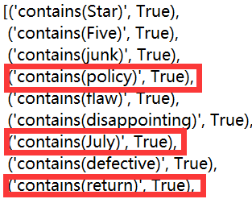

Moreover, from the graph (k), it can be seen that the positive rating is significantly more than the negative rating. If our classifier results are all positive, the accuracy will be very high at this time. It is not appropriate to use the accuracy to judge our algorithm. Then for our SRR model, due to the strong subjectivity of our model, the score has a relatively large error compared with the quality of the product in reality.