We want to get everyday increasing rates of the total number of reviews. Hence, we plan to fit curve to the everyday total number of reviews and then derive function of the curve with respect to time. Considering that the distribution of the points is uneven, we adopt cubic spline to interpolate some points between original points in order to get more evenly distributed points, since the uneven distribution effects the weight of residual error when we fit the curve.

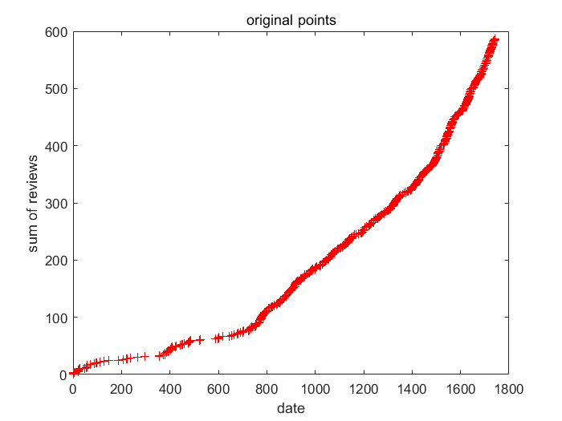

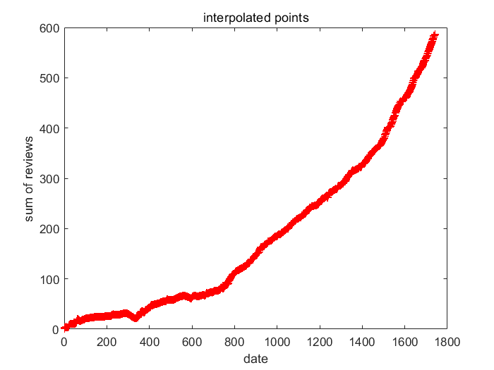

At last we plan to use linear regression to fit the curve. Then we choose the curve with the smallest J(θ).

