AI (Fall 2020) – Assignment 1

Search and game tree search
Due: 11:59pm, Tuesday, Sept. 29, 2020

1. Consider travel in Romania from Drobeta to Fagaras. Trace the operation of uniform-cost search with cycle-checking: draw the search tree.
图中画的节点均为从Fontier内取出的节点
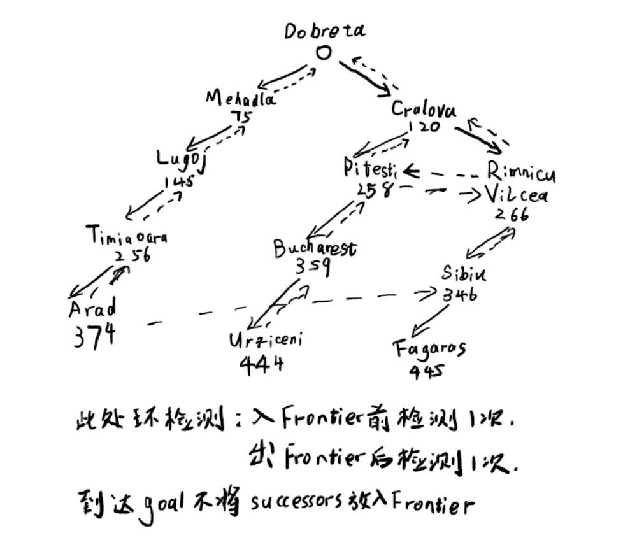

2. The missionaries and cannibals problem (see the lecture notes): Consider the case of M = 3 and K = 2. Use the heuristic function h(n) = M + C - 2B. Trace the operation of A* with cycle checking: Draw the search tree; for each node, mark its g and h values.
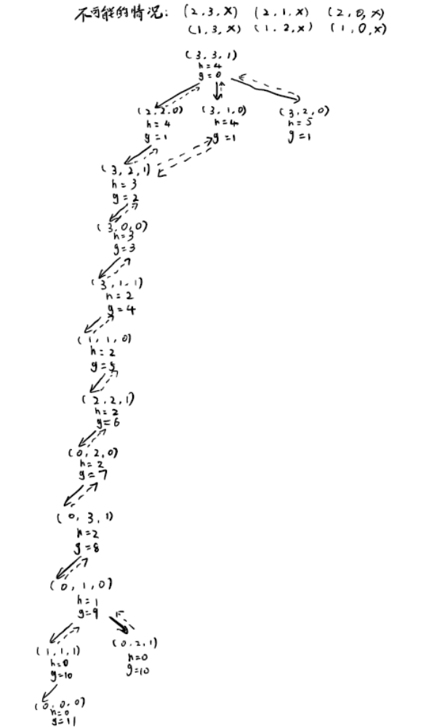

3. Perform alpha beta pruning on the following game tree and compute the utility value of the root.
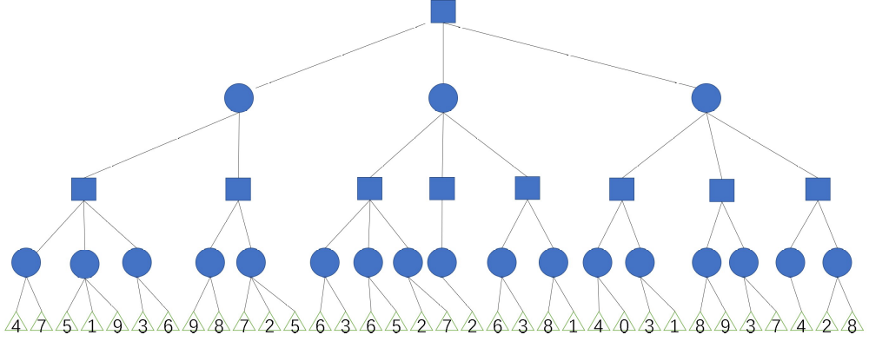
X
X
X
α=4
β=3
X
α=4
β=4
α=4
β=+∞
α=4
β=4
X
α=4
β=2
α=4
β=5
α=5
β=2
α=4
β=5
α=-∞
β=4
α=4
β=3
α=5
β=+∞
α=4
β=4
α=4
β=+∞
α=4
β=4
α=-∞
β=4
α=4
β=+∞
α=4
β=3
α=4
β=1
α=-∞
β=4
X
X
X
X

