14.

%Horner.m

function [P] = Horner(a, c)

b = zeros(size(a));

b(size(a)) = a(size(a));

for i = size(a, 1) - 1:-1:1

b(i) = b(i + 1) * c + a(i);

end

P = b(1);

end

(a)

%a14.m

a = [-12; -1; -13; 1; 1];

c = 3;

[P] = Horner(a, c);

P_ver = [1, c, c^2, c^3, c^4] * a;

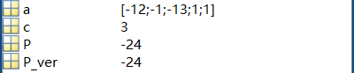

(b)

%b14.m

a = [23; -1; 0; 0; -2; 1; 1; 2];

c = 3;

[P] = Horner(a, c);

P_ver = [1, c, c^2, c^3, c^4, c^5, c^6, c^7] * a;

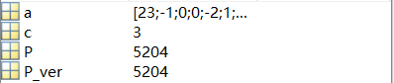

1.

%abc1.m

temp = [2.71828182; 98.350; 0.000068];

temp_a = [2.7182; 98.000; 0.00006];

E = abs(temp - temp_a);

R = E ./ abs(temp);

Ex = E(1);

Rx = R(1);

Ey = E(2);

Ry = R(2);

Ez = E(3);

Rz = R(3);

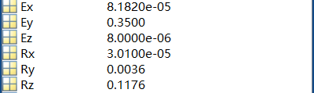

3.

$$\frac{\left|p-\hat{p}\right|}{\left|p\right|}<\frac{{10}^{1-d}}{2}$$

$$p-\frac{{10}^{1-d}}{2}×\left|p\right|<\hat{p}<p+\frac{{10}^{1-d}}{2}×\left|p\right|$$

(a) $p_{1}+p_{2}=1.50525$

$1.504497375<\hat{p_{1}+p_{2}}<1.506002625$

取 $\hat{p_{1}+p_{2}}=1.505$

$p_{1}×p_{2}=0.1290275$

$0.12896298625<\hat{p_{1}×p_{2}}<0.12909201375$

取 $\hat{p_{1}×p_{2}}=0.129$

(b) $p_{1}+p_{2}=31.442182$

$31.4406098909<\hat{p_{1}+p_{2}}<31.4437541091$

取 $\hat{p_{1}+p_{2}}=31.442$

$p_{1}×p_{2}=0.85392253$

$0.8538798338735<\hat{p_{1}×p_{2}}<0.8539652261265$

取 $\hat{p_{1}×p_{2}}=0.8539$

9. $\frac{1}{1-h}+\cos\left(h\right)=2+h+\frac{h^{2}}{2}+h^{3}+\frac{h^{4}}{4!}+O\left(h^{4}\right)$

$\frac{1}{1-h}×\cos\left(h\right)=1+h+\frac{h^{2}}{2}+\frac{h^{3}}{2}-\frac{{11h}^{4}}{24}-\frac{{11h}^{5}}{2}+\frac{h^{6}}{4!}+\frac{h^{7}}{4!}+O(h^{4})$