**中山大学数据科学与计算机学院本科生实验报告**

**（2019学年秋季学期）**

课程名称：**计算机组成原理实验**  任课教师：郭雪梅 助教：汪庭葳、刘洋旗

|  |  |  |  |
| --- | --- | --- | --- |
| 年级&班级 | **2018级1班** | 专业(方向) | **计算机类** |
| 学号 | **18308045** | 姓名 | **谷正阳** |
| 电话 | **13355426001** | Email | [**Guzy0324@163.com**](mailto:Guzy0324@163.com) |
| 开始日期 | **2019.11.20** | 完成日期 | **2019.11.20** |

**一、实验题目**

计算机结构与组成 实验7

1. **实验目的**

1.掌握单周期CPU控制器的工作原理及其设计方法。

2.掌握各个控制信号的作用和生成过程。**三、实验内容**

**1.** 实验步骤

1.编写存储器模块。该模块有4位地址输入和32位数据输出，首先将16种类型的16条指令写入存储单元中，然后根据4位地址输入选择相应的单元指令内容，将数据写入到输出变量中。地址输入数据、存储单元编号与指令的对应规则如下表所示：

表2寄存器堆模块约束

|  |  |  |  |
| --- | --- | --- | --- |
| 地址输入 | 存储编号 | 单元数据 | 含义 |
| 0000 | 0 | 00000000001000100001100000100000 | R-类型add |
| 0001 | 1 | 00000000001000100001100000100001 | R-类型addu |
| 0010 | 2 | 00000000001000100001100000101010 | R-类型slt |
| 0011 | 3 | 00000000001000100001100000101011 | R-类型sltu |
| 0100 | 4 | 00000000001000000000000000001000 | R-类型jr |
| 0101 | 5 | 00100000001000100001100000101010 | I-类型addi |
| 0110 | 6 | 00100100001000100001100000101010 | I-类型addiu |
| 0111 | 7 | 00111100000000100001100000101010 | I-类型lui |
| 1000 | 8 | 10001100001000100001100000101010 | I-类型lw |
| 1001 | 9 | 10101100001000100001100000101010 | I-类型sw |
| 1010 | 10 | 00010000001000100001100000101010 | I-类型beq |
| 1011 | 11 | 00010100001000100001100000101010 | I-类型bne |
| 1100 | 12 | 00101000001000100001100000101010 | I-类型slti |
| 1101 | 13 | 00101100001000100001100000101010 | I-类型addi |
| 1110 | 14 | 00001000001000100001100000101010 | J-类型j |
| 1111 | 15 | 00001100001000100001100000101010 | J-类型jal |

由于我们的主要目的是对所设计的控制器进行测试，故可以不使用IP核设计指令存储器，直接使用通用代码实现。

reg [31:0] regs [0:15]; // 寄存器组

根据输入，读取相应单元的的值输出，对相应存储单元进行写操作。

module regFile( input clk,

input [3:0] Addr, //寄存器地址编码

output [31:0] instruction// 寄存器的值

);

//寄存器地址都是 4 位二进制数，因为寄存器只有 16 个，4 位就能表示所有寄存器

reg [31:0] regs [0:15]; // 寄存器组

reg instruction;

integer i;

always @( posedge clk ) // 时钟上升沿操作

begin

for(i= 0; i < 16; i = i + 1)

instruction=regs[i] ; // 取指令

end

initial

begin

regs[3] = 32'b00000000001000100001100000101011;// add

regs[2] = 32'b00000000001000100001100000101010;// addu

regs[1] = 32'b00000000001000100001100000100001;// slt

regs[0] = 32'b00000000001000100001100000100000;// sltu

regs[4] = 32'b00000000001000000000000000001000;// jr

regs[5] = 32'b00100000001000100001100000101010;// addi

regs[6] = 32'b00100100001000100001100000101010;// addiu

regs[7] = 32'b00111100000000100001100000101010;// lui

regs[8] = 32'b10001100001000100001100000101010;// lw

regs[9] = 32'b10101100001000100001100000101010;// sw

regs[10] = 32'b00010000001000100001100000101010;//beq

regs[11] = 32'b00010100001000100001100000101010;//bne

regs[12] = 32'b00101000001000100001100000101010;// slti

regs[13] = 32'b00101100001000100001100000101010;// addi

regs[14] = 32'b00001000001000100001100000101010;//j

regs[15] = 32'b00001100001000100001100000101010;//jal

end

end

endmodule

2. 控制器模块

* 控制器模块输入为指令的操作码opCode段，输出各个复用器、存储器读写等的信号，控制数据通路的正常进行。根据指令的不同，输出不同的信号即可。

不同指令对应的各个控制信号总览如下：

|  |  |
| --- | --- |
| input | opcode[5:0] |
| output | regDst |
| output | aluSrc |
| output | memToReg |
| output | regWrite |
| output | memRead |
| output | memWrite |
| output | branch |
| output | aluop[1:0] |
| output | jmp |

参考代码：

以下 Verilog 代码：

module ctr(

input [5:0] opCode, output reg regDst, output reg aluSrc, output reg memToReg, output reg regWrite, output reg memRead, output reg memWrite, output reg branch,

output reg ExtOp, //符号扩展方式，1 为 sign-extend，0 为 zero-extend

output reg[3:0] aluop, // 经过 ALU 控制译码决定 ALU 功能

output reg jmp

);

always@(opCode) begin

// 操作码改变时改变控制信号

case(opCode) 6'b000010: begin

regDst = 0; aluSrc = 0; memToReg = 0;

regWrite = 0; memRead = 0; memWrite = 0; branch = 0; aluop = 4'b0000; jmp = 1; ExtOp = 1;

end // 'J 型' 指令操作码: 000010，无需 ALU

6'b000000: begin

regDst = 1; aluSrc = 0; memToReg = 0;

regWrite = 1; memRead = 0; memWrite = 0; branch = 0; aluop = 4'b1111; jmp = 0; ExtOp = 1;

end // 'R 型' 指令操作码: 000000

//'I'型指令操作码

6'b100011: begin

regDst = 0; aluSrc = 1; memToReg = 1;

regWrite = 1; memRead = 1; memWrite = 0; branch = 0; aluop = 4'b0000; jmp = 0; ExtOp = 1;

end // 'lw' 指令操作码: 100011

6'b101011: begin

regDst = 0; aluSrc = 1; memToReg = 0;

regWrite = 0; memRead = 0; memWrite = 1; branch = 0; aluop = 4'b0000; jmp = 0; ExtOp = 1;

end // 'sw' 指令操作码: 101011

6'b000100: begin

regDst = 0; aluSrc = 0; memToReg = 0;

regWrite = 0; memRead = 0; memWrite = 0; branch = 1; aluop = 4'b0001; jmp = 0; ExtOp = 1;

end // 'beq' 指令操作码: 000100

6'b000101: begin

regDst = 0; aluSrc = 0; memToReg = 0;

regWrite = 0; memRead = 0; memWrite = 0; branch = 1; aluop = 4'b0110; jmp = 0; ExtOp = 1;

end // 'bne' 指令操作码: 000101

6'b000101: begin

regDst = 0; aluSrc = 0; memToReg = 0;

regWrite = 0; memRead = 0; memWrite = 0; branch = 1; aluop = 4'b0001; jmp = 0; ExtOp = 1;

end // 'bne' 指令操作码: 000101

6'b001000: begin

regDst = 0; aluSrc = 1; memToReg = 0;

regWrite = 1; memRead = 0; memWrite = 0;

branch = 0; aluop = 4'b0000; jmp = 0;

ExtOp = 1;

end // 'addi' 指令操作码: 001000

6'b001100: begin

regDst = 0; aluSrc = 1; memToReg = 0;

regWrite = 1; memRead = 0; memWrite = 0; branch = 0; aluop = 4'b0100; jmp = 0; ExtOp = 0;

end // 'andi' 指令操作码: 001100

6'b001101: begin

regDst = 0; aluSrc = 1; memToReg = 0;

regWrite = 1; memRead = 0; memWrite = 0; branch = 0; aluop = 4'b0010; jmp = 0; ExtOp = 0;

end // 'ori' 指令操作码: 001101

6'b001110: begin

regDst = 0; aluSrc = 1; memToReg = 0;

regWrite = 1; memRead = 0; memWrite = 0; branch = 0; aluop = 4'b1100; jmp = 0; ExtOp = 0;

end // 'xori' 指令操作码: 001110

6'b001010: begin

regDst = 0; aluSrc = 1; memToReg = 0;

regWrite = 1; memRead = 0; memWrite = 0; branch = 0; aluop = 4'b0011; jmp = 0; ExtOp = 1;

end // 'slti' 指令操作码: 001010

6'b001111: begin

regDst = 0; aluSrc = 1; memToReg = 0;

regWrite = 1; memRead = 0; memWrite = 0; branch = 0; aluop = 4'b1011; jmp = 0; ExtOp = 1;

end // 'lui' 指令操作码: 001111

default: begin

regDst = 0; aluSrc = 0; memToReg = 0;

regWrite = 0; memRead = 0; memWrite = 0; branch = 0; aluop = 4'b0000; jmp = 0; ExtOp = 0;

end // 默认设置

endcase end

endmodule

**ALU控制译码模块**

ALU 主要执行 5 种操作：与，或，加，减，小于设置。这五种操作可以使用四位的编码表示：0000，0001，0010，01110，0111。指令不同，则对应的 ALU 运算不同，所以该模块需要根据指令来控制ALU 进行正确的运算。

lw，sw，addi 指令均要求 ALU 执行加操作，则可分为一类，编码 00； beq 指令要求 ALU 执行减操作，则分为一类，编码 01；

最后一类是 R 型指令，可以编码为 10；但不同的R 型指令对应不同的 ALU 运算，故需要再通过指令的功能码进一步确定 ALU 的运算。

最终该模块即实现 2 位操作码以及 6 位功能码输出 4 位ALU 控制信号码。

指令与 ALU 操作码及功能码的对应关系如下：

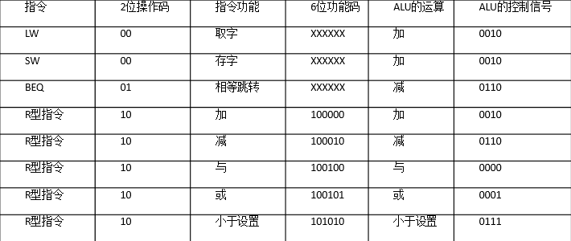以下 Verilog 代码：

module aluctr(

input [1:0] ALUOp, input [5:0] funct, output reg [3:0] ALUCtr

);

always @(ALUOp or funct) // 如果操作码或者功能码变化执行操作

casex({ALUOp, funct}) // 拼接操作码和功能码便于下一步的判断

8'b00xxxxxx: ALUCtr = 4'b0010; // lw，sw，addi 8'b01xxxxxx: ALUCtr = 4'b0110; // beq 8'b1xxx0000: ALUCtr = 4'b0010; // add 8'b1xxx0010: ALUCtr = 4'b0110; // sub 8'b1xxx0100: ALUCtr = 4'b0000; // and 8'b1xxx0101: ALUCtr = 4'b0001; // or 8'b1xxx1010: ALUCtr = 4'b0111; // slt

endcase endmodule

3.编写主模块，主模块有4位地址输入和16位输出，主模块首先调用寄存器堆模块生成32位指令信号，然后调用控制器模块生成相应的控制信号，将这16位控制信号赋值到输出变量中。

module top(

input clkin, input reset

);

// 指令寄存器Addr

reg[31:0] instruction;

reg[3:0] Addr

// CPU 控制信号线

wire reg_dst, jmp, branch, memread, memwrite, memtoreg; wire[1:0] aluop;

wire regwrite;

// ALU 控制信号线

wire[3:0] aluCtr;

// 例化寄存器

regFile regFile ( .clk(clkin), .Addr(Addr), .instruction(inst)

);

// 实例化控制器模块

ctr mainctr(

.opCode(inst[31:26]),

.regDst(reg_dst),

.aluSrc(alu_src),

.memToReg(memtoreg),

.regWrite(regwrite),

.memRead(memread),

.memWrite(memwrite),

.branch(branch),

.aluop(aluop),

.jmp(jmp));

// 实例化 ALU 控制模块

aluctr aluctr1(

.ALUOp(aluop),

.funct(inst[5:0]),

.ALUCtr(aluCtr));

endmodule

4.依次按照图3的步骤综合项目源文件、实施活动的设计合成的网表。综合的目的是检查代码是否存在语法错误，生成网表后可以绑定相应的管脚。

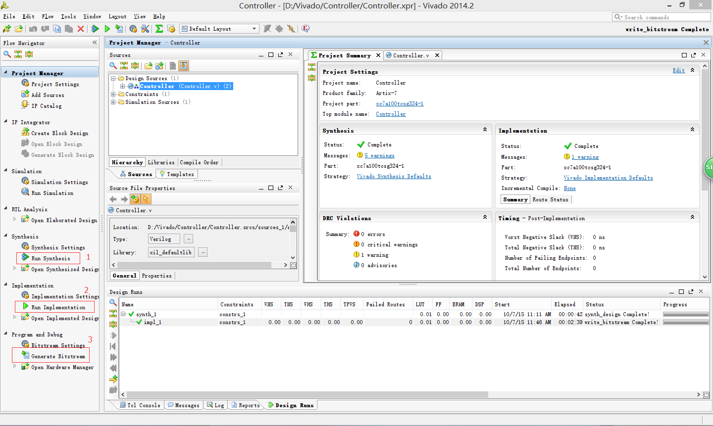

图3

**ALU控制器模块**

仿真模块

|  |
| --- |
| module aluctrsim;  // Inputs  reg [1:0] ALUOp;  reg [5:0] funct;  // Outputs  wire [3:0] ALUctr;  // Instantiate the Unit Under Test (UUT)  aluctr uut (  .ALUOp(ALUOp),  .funct(funct),  .ALUCtr(ALUctr)  );  initial begin  // Initialize Inputs  ALUOp = 0;  funct = 0;  // Wait 100 ns for global reset to finish  #100;  // Add stimulus here  ALUOp = 2'b01;  funct = 0;  #100;  ALUOp = 2'b10;  funct = 6'b100000;  #100;  ALUOp = 2'b10;  funct = 6'b101010;  end  endmodule |

ALUOp和funct共有四种不同的组合，得到了四种不同的ALUctr信号进行分析。

**控制器模块**

|  |
| --- |
| 1) 仿真代码 module ctrsim;  // Inputs  reg [5:0] opCode;  // Outputs  wire regDst;  wire aluSrc;  wire memToReg;  wire regWrite;  wire memRead;  wire memWrite;  wire branch;  wire [1:0] aluop;  wire jmp;  // Instantiate the Unit Under Test (UUT)  ctr uut (  .opCode(opCode),  .regDst(regDst), |
| .aluSrc(aluSrc),  .memToReg(memToReg),  .regWrite(regWrite),  .memRead(memRead),  .memWrite(memWrite),  .branch(branch),  .aluop(aluop),  .jmp(jmp)  ); |
| initial begin  // Initialize Inputs  opCode = 6'b000000;  #100;  opCode = 6'b000010;  // Wait 100 ns for global reset to finish  #100;  opCode = 6'b110000;  #100;  opCode = 6'b100011;  #100;  opCode = 6'b000100;  #100;  opCode = 6'b001000;  end  endmodule |

2) 仿真波形

分析指令与控制的关系

顶层仿真

1) 仿真代码

module topsim;

// Inputs

reg clkin;

reg reset;

// Instantiate the Unit Under Test (UUT)

top uut (

.clkin(clkin),

.reset(reset)

);

initial begin

// Initialize Inputs

clkin = 0;

reset = 1;

// Wait 100 ns for global reset to finish

#100;

reset = 0;

end

parameter PERIOD = 20;

always begin

clkin = 1'b0;

#(PERIOD / 2) clkin = 1'b1;

#(PERIOD / 2) ;

end

endmodule

2) 仿真结果及说明

**拓展：**

指导书控制器只实现了部分指令的译码, 如果如图加入移位指令、lui指令，需要添加控制信号shift, lui（左移16位）。



**加入jal指令，需译码jal信号**



**参照表1根据需要添加的指令，在如上程序中加入相关控制信号及实现其译码。**

**2.** 实验原理

控制器的基本任务是完成当前指令的翻译和执行，即将当前指令的功能转换成可以控制的硬件逻辑部件工作的命令序列，完成数据传送和各种处理操作。本实验根据MIPS的31种类型的指令以及根据该指令结构所设计出的数据通路模拟其中控制单元生成控制信号的过程。其中MIPS的31条指令类型如表1所示：

表1 MIPS的31种指令

|  |  |  |  |  |  |  |  |  |  |
| --- | --- | --- | --- | --- | --- | --- | --- | --- | --- |
| **助记符** | **指 令 格 式** | | | | | | **示 例** | **示例含义** | **操作及解释** |
| BIT # | 31..26 | 25..21 | 20..16 | 15..11 | 10..6 | 5..0 |  |  |  |
| **R-类型** | **op** | **rs** | **rt** | **rd** | **shamt** | **func** |  |  |  |
| add | 000000 | rs | rt | rd | 00000 | 100000 | add $1,$2,$3 | $1=$2+S3 | (rd)←(rs)+(rt); rs=$2,rt=$3,rd=$1 |
| addu | 000000 | rs | rt | rd | 00000 | 100001 | addu $1,$2,$3 | $1=$2+S3 | (rd)←(rs)+(rt); rs=$2,rt=$3,rd=$1,无符号数 |
| sub | 000000 | rs | rt | rd | 00000 | 100010 | sub $1,$2,$3 | $1=$2-S3 | (rd)←(rs)-(rt); rs=$2,rt=$3,rd=$1 |
| subu | 000000 | rs | rt | rd | 00000 | 100011 | subu $1,$2,$3 | $1=$2-S3 | (rd)←(rs)-(rt); rs=$2,rt=$3,rd=$1,无符号数 |
| and | 000000 | rs | rt | rd | 00000 | 100100 | and $1,$2,$3 | $1=$2&S3 | (rd)←(rs)&(rt); rs=$2,rt=$3,rd=$1 |
| or | 000000 | rs | rt | rd | 00000 | 100101 | or $1,$2,$3 | $1=$2|S3 | (rd)←(rs) | (rt); rs=$2,rt=$3,rd=$1 |
| xor | 000000 | rs | rt | rd | 00000 | 100110 | xor $1,$2,$3 | $1=$2^S3 | (rd)←(rs)^(rt); rs=$2,rt=$3,rd=$1 |
| nor | 000000 | rs | rt | rd | 00000 | 100111 | nor $1,$2,$3 | $1= ~($2 | S3) | (rd)←~((rs) | (rt)); rs=$2,rt=$3,rd=$1 |
| slt | 000000 | rs | rt | rd | 00000 | 101010 | slt $1,$2,$3 | if($2<$3)  $1=1 else  $1=0 | if (rs< rt) rd=1 else rd=0;rs＝$2，rt=$3, rd=$1 |
| sltu | 000000 | rs | rt | rd | 00000 | 101011 | sltu $1,$2,$3 | if($2<$3)  $1=1 else  $1=0 | if (rs< rt) rd=1 else rd=0;rs＝$2，rt=$3, rd=$1, 无符号数 |
| sll | 000000 | 00000 | rt | rd | shamt | 000000 | sll $1,$2,10 | $1=$2<<10 | (rd)←(rt)<<shamt,rt=$2,rd=$1,shamt=10 |
| srl | 000000 | 00000 | rt | rd | shamt | 000010 | srl $1,$2,10 | $1=$2>>10 | (rd)←(rt)>>shamt, rt=$2, rd=$1, shamt=10, (逻辑右移) |
| sra | 000000 | 00000 | rt | rd | shamt | 000011 | sra $1,$2,10 | $1=$2>>10 | (rd)←(rt)>>shamt, rt=$2, rd=$1, shamt=10, (算术右移，注意符号位保留) |
| sllv | 000000 | rs | rt | rd | 00000 | 000100 | sllv $1,$2,$3 | $1=$2<<$3 | (rd)←(rt)<<(rs), rs=$3,rt=$2,rd=$1 |
| srlv | 000000 | rs | rt | rd | 00000 | 000110 | srlv $1,$2,$3 | $1=$2>>$3 | (rd)←(rt)>>(rs), rs=$3,rt=$2,rd=$1, (逻辑右移) |
| srav | 000000 | rs | rt | rd | 00000 | 000111 | srav $1,$2,$3 | $1=$2>>$3 | (rd)←(rt)>>(rs), rs=$3,rt=$2,rd=$1, (算术右移，注意符号位保留) |
| jr | 000000 | rs | 00000 | 00000 | 00000 | 001000 | jr $31 | goto $31 | (PC)←(rs) |
| **I-类型** | **op** | **rs** | **rt** | **immediate** | | |  | | |
| addi | 001000 | rs | rt | immediate | | | addi $1,$2,10 | $1=$2+10 | (rt)←(rs)+(sign-extend)immediate,rt=$1,rs=$2 |
| addiu | 001001 | rs | rt | immediate | | | addiu $1,$2,10 | $1=$2+10 | (rt)←(rs)+(sign-extend)immediate,rt=$1,rs=$2 |
| andi | 001100 | rs | rt | immediate | | | andi $1,$2,10 | $1=$2&10 | (rt)←(rs)&(zero-extend)immediate,rt=$1,rs=$2 |
| ori | 001101 | rs | rt | immediate | | | ori $1,$2,10 | $1=$2|10 | (rt)←(rs)|(zero-extend)immediate,rt=$1,rs=$2 |
| xori | 001110 | rs | rt | immediate | | | xori $1,$2,10 | $1=$2^10 | (rt)←(rs)^(zero-extend)immediate,rt=$1,rs=$2 |
| lui | 001111 | 00000 | rt | immediate | | | lui $1,10 | $1=10*65536 | (rt)←immediate<<16 & 0FFFF0000H，将16位立即数放到目的寄存器高16位，目的寄存器的低16位填0 |
| lw | 100011 | rs | rt | offset | | | lw $1,10($2) | $1=Memory[  $2+10] | (rt)←Memory[(rs)+(sign_extend)offset],  rt=$1,rs=$2 |
| sw | 101011 | rs | rt | offset | | | sw $1,10($2) | Memory[  $2+10] =$1 | Memory[(rs)+(sign_extend)offset]←(rt),  rt=$1,rs=$2 |
| beq | 000100 | rs | rt | offset | | | beq $1,$2,40 | if($1=$2)  goto PC+4+40 | if ((rt)=(rs)) then (PC)←(PC)+4+( (Sign-Extend) offset<<2), rs=$1, rt=$2 |
| bne | 000101 | rs | rt | offset | | | bne $1,$2,40 | if($1≠$2)  goto PC+4+40 | if ((rt)≠(rs)) then (PC)←(PC)+4+(  (Sign-Extend) offset<<2) , rs=$1, rt=$2 |
| slti | 001010 | rs | rt | immediate | | | slti $1,$2,10 | if($2<10)    $1=1 else    $1=0 | if ((rs)<(Sign-Extend)immediate) then (rt)←1; else (rt)←0, rs=$2, rt=$1 |
| sltiu | 001011 | rs | rt | immediate | | | sltiu $1,$2,10 | if($2<10)    $1=1 else    $1=0 | if ((rs)<(Zero-Extend)immediate) then (rt)←1; else (rt)←0, rs=$2, rt=$1 |
| **J-类型** | **op** | **address** | | | | |  | | |
| j | 000010 | address | | | | | j 10000 | goto 10000 | (PC)←( (Zero-Extend) address<<2),  address=10000/4 |
| jal | 000011 | address | | | | | jal 10000 | $31=PC+4  goto 10000 | ($31)←(PC)+4;  (PC)←( (Zero-Extend) address<<2),  address=10000/4 |

由上表可知该指令主要分为三大类，分别为R-类型、I-类型和J-类型。每类指令对应的控制信号也不相同，根据这些指令所设计的数据通路如图1所示：

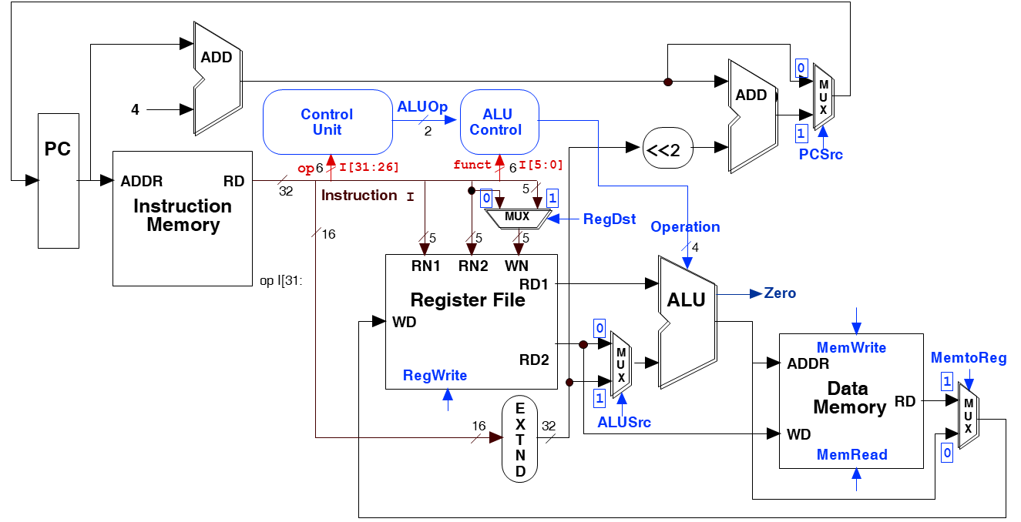

图1单周期CPU数据通路

本次实验是主要模拟指令生成控制信号的过程，本次实验根据输入指令从寄存器堆中选取相应的寄存器，然后读取该寄存器获得相应32位指令，取其高5位和低5位送入控制器单元，由控制单元进行译码，输出相应的控制信号。该控制器组成原理图如下图所示：

**Control（控制单元）**

* 根据指令中的指令码（op）和功能码（funct）的不同组合输出相应的控制信号。

|  |  |
| --- | --- |
|  | aluop 设计图  ALU 译码单元 |

图2 控制器组成原理图

该控制器的存储模块有16个存储单元，每一个单元都预先分配了一条指令信息，4位地址输入读取相应单元指令。控制器主要实现对输入的10位指令操作码的解析。

**四、实验结果**

aluctrsim：

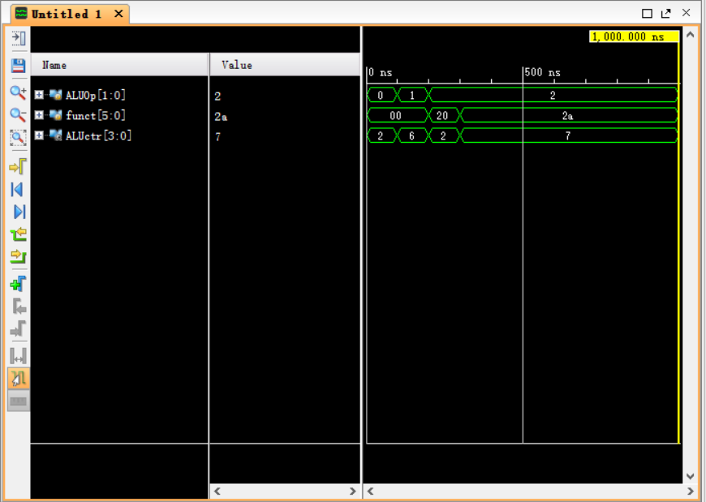

分别对应：

8'b00xxxxxx: ALUCtr = 4'b0010; // lw，sw，addi

8'b01xxxxxx: ALUCtr = 4'b0110; // beq

8'b1xxx0000: ALUCtr = 4'b0010; // add

8'b1xxx1010: ALUCtr = 4'b0111; // slt

ctrsim:

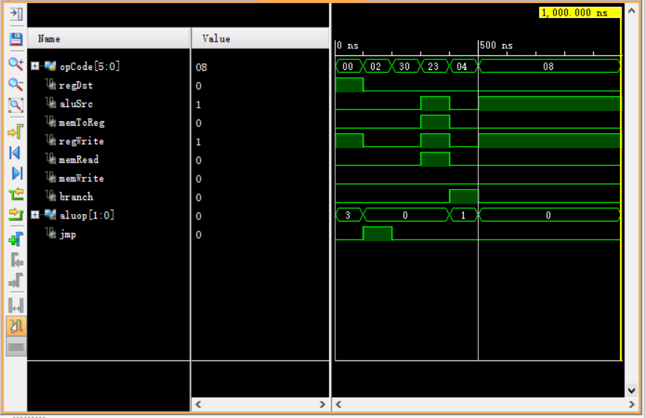

分别对应：

6'b000000: begin

regDst = 1; aluSrc = 0; memToReg = 0;

regWrite = 1; memRead = 0; memWrite = 0; branch = 0; aluop = 4'b1111; jmp = 0; ExtOp = 1;

end // 'R 型' 指令操作码: 000000

6'b000010: begin

regDst = 0; aluSrc = 0; memToReg = 0;

regWrite = 0; memRead = 0; memWrite = 0; branch = 0; aluop = 4'b0000; jmp = 1; ExtOp = 1;

end // 'J 型' 指令操作码: 000010，无需 ALU

default: begin

regDst = 0; aluSrc = 0; memToReg = 0;

regWrite = 0; memRead = 0; memWrite = 0; branch = 0; aluop = 4'b0000; jmp = 0; ExtOp = 0;

end // 默认设置

6'b100011: begin

regDst = 0; aluSrc = 1; memToReg = 1;

regWrite = 1; memRead = 1; memWrite = 0; branch = 0; aluop = 4'b0000; jmp = 0; ExtOp = 1;

end // 'lw' 指令操作码: 100011

6'b000100: begin

regDst = 0; aluSrc = 0; memToReg = 0;

regWrite = 0; memRead = 0; memWrite = 0; branch = 1; aluop = 4'b0001; jmp = 0; ExtOp = 1;

end // 'beq' 指令操作码: 000100

6'b001000: begin

regDst = 0; aluSrc = 1; memToReg = 0;

regWrite = 1; memRead = 0; memWrite = 0; branch = 0; aluop = 4'b0000; jmp = 0; ExtOp = 1;

end // 'addi' 指令操作码: 001000

topsim：

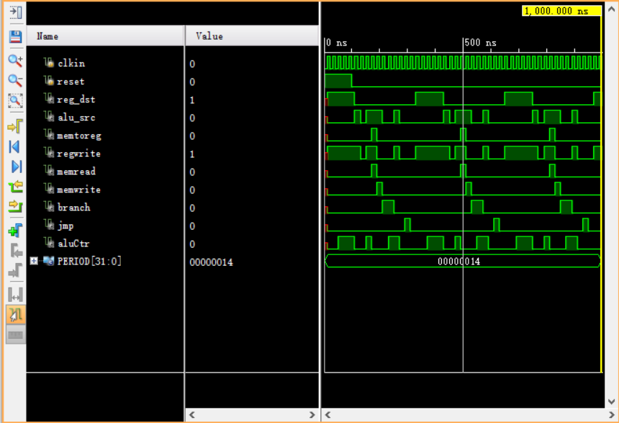

分别对应：

regs[3] = 32'b00000000001000100001100000101011;// add

regs[2] = 32'b00000000001000100001100000101010;// addu

regs[1] = 32'b00000000001000100001100000100001;// slt

regs[0] = 32'b00000000001000100001100000100000;// sltu

regs[4] = 32'b00000000001000000000000000001000;// jr

regs[5] = 32'b00100000001000100001100000101010;// addi

regs[6] = 32'b00100100001000100001100000101010;// addiu

regs[7] = 32'b00111100000000100001100000101010;// lui

regs[8] = 32'b10001100001000100001100000101010;// lw

regs[9] = 32'b10101100001000100001100000101010;// sw

regs[10] = 32'b00010000001000100001100000101010;//beq

regs[11] = 32'b00010100001000100001100000101010;//bne

regs[12] = 32'b00101000001000100001100000101010;// slti

regs[13] = 32'b00101100001000100001100000101010;// addi

regs[14] = 32'b00001000001000100001100000101010;//j

regs[15] = 32'b00001100001000100001100000101010;//jal

的情况

拓展：增加shift，jal信号和jal指令

module ctr(

input [5:0] opCode,

output reg regDst, output reg aluSrc, output reg memToReg, output reg regWrite, output reg memRead, output reg memWrite, output reg branch,

output reg ExtOp, //符号扩展方式，1 为 sign-extend，0 为 zero-extend

output reg[3:0] aluop, // 经过 ALU 控制译码决定 ALU 功能

output reg jmp

);

always@(opCode) begin

// 操作码改变时改变控制信号

case(opCode)

6'b000010: begin

regDst = 0; aluSrc = 0; memToReg = 0; shift = 0; jal = 0;

regWrite = 0; memRead = 0; memWrite = 0; branch = 0; aluop = 4'b0000; jmp = 1; ExtOp = 1;

end // 'j' 指令操作码: 000010，无需 ALU

6'b000011: begin

regDst = 0; aluSrc = 0; memToReg = 0; shift = 0; jal = 1;

regWrite = 0; memRead = 0; memWrite = 0; branch = 0; aluop = 4'b0000; jmp = 1; ExtOp = 1;

end // 'jal' 指令操作码: 000011，无需 ALU

6'b000000: begin

regDst = 1; aluSrc = 0; memToReg = 0; shift = 0; jal = 0;

regWrite = 1; memRead = 0; memWrite = 0; branch = 0; aluop = 4'b1111; jmp = 0; ExtOp = 1;

end // 'R 型' 指令操作码: 000000

//'I'型指令操作码

6'b100011: begin

regDst = 0; aluSrc = 1; memToReg = 1; shift = 0; jal = 0;

regWrite = 1; memRead = 1; memWrite = 0; branch = 0; aluop = 4'b0000; jmp = 0; ExtOp = 1;

end // 'lw' 指令操作码: 100011

6'b101011: begin

regDst = 0; aluSrc = 1; memToReg = 0; shift = 0; jal = 0;

regWrite = 0; memRead = 0; memWrite = 1; branch = 0; aluop = 4'b0000; jmp = 0; ExtOp = 1;

end // 'sw' 指令操作码: 101011

6'b000100: begin

regDst = 0; aluSrc = 0; memToReg = 0; shift = 0; jal = 0;

regWrite = 0; memRead = 0; memWrite = 0; branch = 1; aluop = 4'b0001; jmp = 0; ExtOp = 1;

end // 'beq' 指令操作码: 000100

6'b000101: begin

regDst = 0; aluSrc = 0; memToReg = 0; shift = 0; jal = 0;

regWrite = 0; memRead = 0; memWrite = 0; branch = 1; aluop = 4'b0110; jmp = 0; ExtOp = 1;

end // 'bne' 指令操作码: 000101

6'b001000: begin

regDst = 0; aluSrc = 1; memToReg = 0; shift = 0; jal = 0;

regWrite = 1; memRead = 0; memWrite = 0; branch = 0; aluop = 4'b0000; jmp = 0; ExtOp = 1;

end // 'addi' 指令操作码: 001000

6'b001100: begin

regDst = 0; aluSrc = 1; memToReg = 0; shift = 0; jal = 0;

regWrite = 1; memRead = 0; memWrite = 0; branch = 0; aluop = 4'b0100; jmp = 0; ExtOp = 0;

end // 'andi' 指令操作码: 001100

6'b001101: begin

regDst = 0; aluSrc = 1; memToReg = 0; shift = 0; jal = 0;

regWrite = 1; memRead = 0; memWrite = 0; branch = 0; aluop = 4'b0010; jmp = 0; ExtOp = 0;

end // 'ori' 指令操作码: 001101

6'b001110: begin

regDst = 0; aluSrc = 1; memToReg = 0; shift = 0; jal = 0;

regWrite = 1; memRead = 0; memWrite = 0; branch = 0; aluop = 4'b1100; jmp = 0; ExtOp = 0;

end // 'xori' 指令操作码: 001110

6'b001010: begin

regDst = 0; aluSrc = 1; memToReg = 0; shift = 0; jal = 0;

regWrite = 1; memRead = 0; memWrite = 0; branch = 0; aluop = 4'b0011; jmp = 0; ExtOp = 1;

end // 'slti' 指令操作码: 001010

6'b001111: begin

regDst = 0; aluSrc = 1; memToReg = 0; shift = 1; jal = 0;

regWrite = 1; memRead = 0; memWrite = 0; branch = 0; aluop = 4'b1011; jmp = 0; ExtOp = 1;

end // 'lui' 指令操作码: 001111

default: begin

regDst = 0; aluSrc = 0; memToReg = 0; shift = 0; jal = 0;

regWrite = 0; memRead = 0; memWrite = 0; branch = 0; aluop = 4'b0000; jmp = 0; ExtOp = 0;

end // 默认设置

endcase end

endmodule

**五、实验感想**

目前还没有完善取指令的功能。

**附录（流程图，注释过的代码）：**

top：

`timescale 1ns / 1ps

//////////////////////////////////////////////////////////////////////////////////

// Company:

// Engineer:

//

// Create Date: 2019/11/20 14:54:34

// Design Name:

// Module Name: top

// Project Name:

// Target Devices:

// Tool Versions:

// Description:

//

// Dependencies:

//

// Revision:

// Revision 0.01 - File Created

// Additional Comments:

//

//////////////////////////////////////////////////////////////////////////////////

module top(

input clkin, input reset,

output reg_dst, output alu_src, output memtoreg, output regwrite, output memread, output memwrite, output branch, output jmp,

output aluCtr

);

// 指令寄存器Addr

wire[31:0] instruction;

reg[3:0] Addr;

// CPU 控制信号线

wire reg_dst, jmp, branch, memread, memwrite, memtoreg;

wire[1:0] aluop;

wire regwrite;

// ALU 控制信号线

wire[3:0] aluCtr;

// 例化寄存器

regFile regFile (

.clk(clkin), .Addr(Addr), .instruction(instruction) );

// 实例化控制器模块

ctr mainctr(

.opCode(instruction[31:26]),

.regDst(reg_dst),

.aluSrc(alu_src),

.memToReg(memtoreg),

.regWrite(regwrite),

.memRead(memread),

.memWrite(memwrite),

.branch(branch),

.aluop(aluop),

.jmp(jmp));

// 实例化 ALU 控制模块

aluctr aluctr1(

.ALUOp(aluop),

.funct(instruction[5:0]),

.ALUCtr(aluCtr));

endmodule

regFile：

`timescale 1ns / 1ps

//////////////////////////////////////////////////////////////////////////////////

// Company:

// Engineer:

//

// Create Date: 2019/11/20 14:37:18

// Design Name:

// Module Name: regFile

// Project Name:

// Target Devices:

// Tool Versions:

// Description:

//

// Dependencies:

//

// Revision:

// Revision 0.01 - File Created

// Additional Comments:

//

//////////////////////////////////////////////////////////////////////////////////

module regFile(

input clk,

input [3:0] Addr, //寄存器地址编码

output [31:0] instruction// 寄存器的值

);//寄存器地址都是 4 位二进制数，因为寄存器只有 16 个，4 位就能表示所有寄存器

reg [31:0] regs [0:15]; // 寄存器组

reg [31:0] instruction;

integer i = 0;

always @( posedge clk ) // 时钟上升沿操作

begin

instruction = regs[i] ; // 取指令

i = i + 1;

if (i == 16) i = 0;

end

initial

begin

regs[3] = 32'b00000000001000100001100000101011;// add

regs[2] = 32'b00000000001000100001100000101010;// addu

regs[1] = 32'b00000000001000100001100000100001;// slt

regs[0] = 32'b00000000001000100001100000100000;// sltu

regs[4] = 32'b00000000001000000000000000001000;// jr

regs[5] = 32'b00100000001000100001100000101010;// addi

regs[6] = 32'b00100100001000100001100000101010;// addiu

regs[7] = 32'b00111100000000100001100000101010;// lui

regs[8] = 32'b10001100001000100001100000101010;// lw

regs[9] = 32'b10101100001000100001100000101010;// sw

regs[10] = 32'b00010000001000100001100000101010;//beq

regs[11] = 32'b00010100001000100001100000101010;//bne

regs[12] = 32'b00101000001000100001100000101010;// slti

regs[13] = 32'b00101100001000100001100000101010;// addi

regs[14] = 32'b00001000001000100001100000101010;//j

regs[15] = 32'b00001100001000100001100000101010;//jal

end

endmodule

ctr：

`timescale 1ns / 1ps

//////////////////////////////////////////////////////////////////////////////////

// Company:

// Engineer:

//

// Create Date: 2019/11/20 14:46:15

// Design Name:

// Module Name: ctr

// Project Name:

// Target Devices:

// Tool Versions:

// Description:

//

// Dependencies:

//

// Revision:

// Revision 0.01 - File Created

// Additional Comments:

//

//////////////////////////////////////////////////////////////////////////////////

module ctr(

input [5:0] opCode,

output reg regDst, output reg aluSrc, output reg memToReg, output reg regWrite, output reg memRead, output reg memWrite, output reg branch,

output reg ExtOp, //符号扩展方式，1 为 sign-extend，0 为 zero-extend

output reg[3:0] aluop, // 经过 ALU 控制译码决定 ALU 功能

output reg jmp

);

always@(opCode) begin

// 操作码改变时改变控制信号

case(opCode)

6'b000010: begin

regDst = 0; aluSrc = 0; memToReg = 0;

regWrite = 0; memRead = 0; memWrite = 0; branch = 0; aluop = 4'b0000; jmp = 1; ExtOp = 1;

end // 'J 型' 指令操作码: 000010，无需 ALU

6'b000000: begin

regDst = 1; aluSrc = 0; memToReg = 0;

regWrite = 1; memRead = 0; memWrite = 0; branch = 0; aluop = 4'b1111; jmp = 0; ExtOp = 1;

end // 'R 型' 指令操作码: 000000

//'I'型指令操作码

6'b100011: begin

regDst = 0; aluSrc = 1; memToReg = 1;

regWrite = 1; memRead = 1; memWrite = 0; branch = 0; aluop = 4'b0000; jmp = 0; ExtOp = 1;

end // 'lw' 指令操作码: 100011

6'b101011: begin

regDst = 0; aluSrc = 1; memToReg = 0;

regWrite = 0; memRead = 0; memWrite = 1; branch = 0; aluop = 4'b0000; jmp = 0; ExtOp = 1;

end // 'sw' 指令操作码: 101011

6'b000100: begin

regDst = 0; aluSrc = 0; memToReg = 0;

regWrite = 0; memRead = 0; memWrite = 0; branch = 1; aluop = 4'b0001; jmp = 0; ExtOp = 1;

end // 'beq' 指令操作码: 000100

6'b000101: begin

regDst = 0; aluSrc = 0; memToReg = 0;

regWrite = 0; memRead = 0; memWrite = 0; branch = 1; aluop = 4'b0110; jmp = 0; ExtOp = 1;

end // 'bne' 指令操作码: 000101

6'b000101: begin

regDst = 0; aluSrc = 0; memToReg = 0;

regWrite = 0; memRead = 0; memWrite = 0; branch = 1; aluop = 4'b0001; jmp = 0; ExtOp = 1;

end // 'bne' 指令操作码: 000101

6'b001000: begin

regDst = 0; aluSrc = 1; memToReg = 0;

regWrite = 1; memRead = 0; memWrite = 0; branch = 0; aluop = 4'b0000; jmp = 0; ExtOp = 1;

end // 'addi' 指令操作码: 001000

6'b001100: begin

regDst = 0; aluSrc = 1; memToReg = 0;

regWrite = 1; memRead = 0; memWrite = 0; branch = 0; aluop = 4'b0100; jmp = 0; ExtOp = 0;

end // 'andi' 指令操作码: 001100

6'b001101: begin

regDst = 0; aluSrc = 1; memToReg = 0;

regWrite = 1; memRead = 0; memWrite = 0; branch = 0; aluop = 4'b0010; jmp = 0; ExtOp = 0;

end // 'ori' 指令操作码: 001101

6'b001110: begin

regDst = 0; aluSrc = 1; memToReg = 0;

regWrite = 1; memRead = 0; memWrite = 0; branch = 0; aluop = 4'b1100; jmp = 0; ExtOp = 0;

end // 'xori' 指令操作码: 001110

6'b001010: begin

regDst = 0; aluSrc = 1; memToReg = 0;

regWrite = 1; memRead = 0; memWrite = 0; branch = 0; aluop = 4'b0011; jmp = 0; ExtOp = 1;

end // 'slti' 指令操作码: 001010

6'b001111: begin

regDst = 0; aluSrc = 1; memToReg = 0;

regWrite = 1; memRead = 0; memWrite = 0; branch = 0; aluop = 4'b1011; jmp = 0; ExtOp = 1;

end // 'lui' 指令操作码: 001111

default: begin

regDst = 0; aluSrc = 0; memToReg = 0;

regWrite = 0; memRead = 0; memWrite = 0; branch = 0; aluop = 4'b0000; jmp = 0; ExtOp = 0;

end // 默认设置

endcase end

endmodule

aluctr：

`timescale 1ns / 1ps

//////////////////////////////////////////////////////////////////////////////////

// Company:

// Engineer:

//

// Create Date: 2019/11/20 14:51:00

// Design Name:

// Module Name: aluctr

// Project Name:

// Target Devices:

// Tool Versions:

// Description:

//

// Dependencies:

//

// Revision:

// Revision 0.01 - File Created

// Additional Comments:

//

//////////////////////////////////////////////////////////////////////////////////

module aluctr(

input [1:0] ALUOp, input [5:0] funct, output reg [3:0] ALUCtr

);

always @(ALUOp or funct) // 如果操作码或者功能码变化执行操作

casex({ALUOp, funct}) // 拼接操作码和功能码便于下一步的判断

8'b00xxxxxx: ALUCtr = 4'b0010; // lw，sw，addi

8'b01xxxxxx: ALUCtr = 4'b0110; // beq

8'b1xxx0000: ALUCtr = 4'b0010; // add

8'b1xxx0010: ALUCtr = 4'b0110; // sub

8'b1xxx0100: ALUCtr = 4'b0000; // and

8'b1xxx0101: ALUCtr = 4'b0001; // or

8'b1xxx1010: ALUCtr = 4'b0111; // slt

endcase

endmodule

topsim：

`timescale 1ns / 1ps

//////////////////////////////////////////////////////////////////////////////////

// Company:

// Engineer:

//

// Create Date: 2019/11/20 15:14:03

// Design Name:

// Module Name: topsim

// Project Name:

// Target Devices:

// Tool Versions:

// Description:

//

// Dependencies:

//

// Revision:

// Revision 0.01 - File Created

// Additional Comments:

//

//////////////////////////////////////////////////////////////////////////////////

module topsim;

// Inputs

reg clkin;

reg reset;

// Instantiate the Unit Under Test (UUT)

top uut (

.clkin(clkin),

.reset(reset),

.reg_dst(reg_dst), .alu_src(alu_src), .memtoreg(memtoreg), .regwrite(regwrite), .memread(memread), .memwrite(memwrite), .branch(branch), .jmp(jmp),

.aluCtr(aluCtr)

);

initial begin

// Initialize Inputs

clkin = 0;

reset = 1;

// Wait 100 ns for global reset to finish

#100;

reset = 0;

end

parameter PERIOD = 20;

always begin

clkin = 1'b0;

#(PERIOD / 2) clkin = 1'b1;

#(PERIOD / 2) ;

end

endmodule

aluctrsim：

`timescale 1ns / 1ps

//////////////////////////////////////////////////////////////////////////////////

// Company:

// Engineer:

//

// Create Date: 2019/11/20 15:11:49

// Design Name:

// Module Name: aluctrsim

// Project Name:

// Target Devices:

// Tool Versions:

// Description:

//

// Dependencies:

//

// Revision:

// Revision 0.01 - File Created

// Additional Comments:

//

//////////////////////////////////////////////////////////////////////////////////

module aluctrsim;

// Inputs

reg [1:0] ALUOp;

reg [5:0] funct;

// Outputs

wire [3:0] ALUctr;

// Instantiate the Unit Under Test (UUT)

aluctr uut (

.ALUOp(ALUOp),

.funct(funct),

.ALUCtr(ALUctr)

);

initial begin

// Initialize Inputs

ALUOp = 0;

funct = 0;

// Wait 100 ns for global reset to finish

#100;

// Add stimulus here

ALUOp = 2'b01;

funct = 0;

#100;

ALUOp = 2'b10;

funct = 6'b100000;

#100;

ALUOp = 2'b10;

funct = 6'b101010;

end

endmodule

ctrsim：

`timescale 1ns / 1ps

//////////////////////////////////////////////////////////////////////////////////

// Company:

// Engineer:

//

// Create Date: 2019/11/20 15:13:10

// Design Name:

// Module Name: ctrsim

// Project Name:

// Target Devices:

// Tool Versions:

// Description:

//

// Dependencies:

//

// Revision:

// Revision 0.01 - File Created

// Additional Comments:

//

//////////////////////////////////////////////////////////////////////////////////

module ctrsim;

// Inputs

reg [5:0] opCode;

// Outputs

wire regDst;

wire aluSrc;

wire memToReg;

wire regWrite;

wire memRead;

wire memWrite;

wire branch;

wire [1:0] aluop;

wire jmp;

// Instantiate the Unit Under Test (UUT)

ctr uut (

.opCode(opCode),

.regDst(regDst),

.aluSrc(aluSrc),

.memToReg(memToReg),

.regWrite(regWrite),

.memRead(memRead),

.memWrite(memWrite),

.branch(branch),

.aluop(aluop),

.jmp(jmp)

);

initial begin

// Initialize Inputs

opCode = 6'b000000;

#100;

opCode = 6'b000010;

// Wait 100 ns for global reset to finish

#100;

opCode = 6'b110000;

#100;

opCode = 6'b100011;

#100;

opCode = 6'b000100;

#100;

opCode = 6'b001000;

end

endmodule