**中山大学数据科学与计算机学院本科生实验报告**

**（2019学年秋季学期）**

课程名称：**计算机组成原理实验**  任课教师：郭雪梅 助教：汪庭葳、刘洋旗

|  |  |  |  |
| --- | --- | --- | --- |
| 年级&班级 | **2018级1班** | 专业(方向) | **计算机类** |
| 学号 | **18308045** | 姓名 | **谷正阳** |
| 电话 | **13355426001** | Email | [**Guzy0324@163.com**](mailto:Guzy0324@163.com) |
| 开始日期 | **2019.12.11** | 完成日期 | **2019.12.11** |

**一、实验题目**

计算机结构与组成 实验9

1. **实验目的**

1) 了解流水线CPU基本功能部件的设计与实现方法，

2) 了解提高CPU性能的方法。

3) 掌握流水线MIPS微处理器的工作原理。

4) 理解数据冒险、控制冒险的概念以及流水线冲突的解决方法。

5) 掌握流水线MIPS微处理器的测试方法。

**三、实验内容**

**1.** 实验步骤

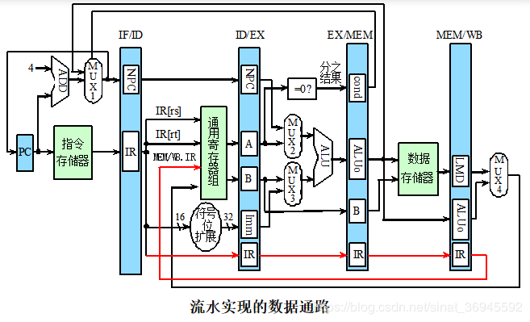

//级间寄存器

module flipflop(clk,reset,in,out);

parameter WIDTH=1;//根据需要改宽度

input clk;//

input reset;

output [WIDTH-1:0] out;//

reg[WIDTH-10] out;

always@(posedeg clk)

if(reset)

out<={WIDTH{1’b0}};

else

out<=in;

endmodule

### 1.取指令部分（IF）

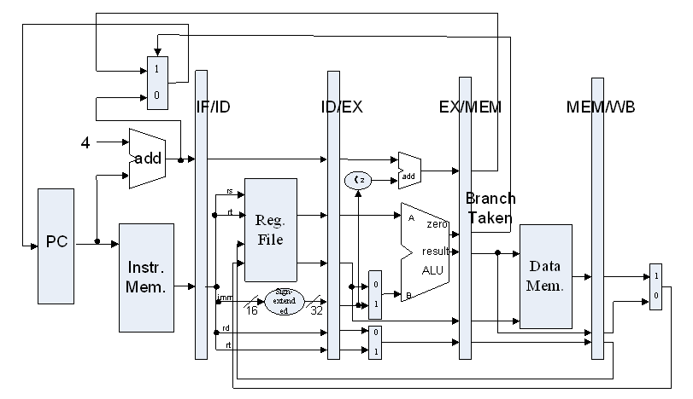

IF/ID.IR←Mem[PC]（将PC的指令取出放入指令寄存器表示当前运行的指令）

NPC←PC+4（PC指向下一条指令（32位加4））

PC模块功能

实现思路  
由于PC是32位，所以增加一个32位加法器，固定与32位的立即数4进行相加，PC+4结果在时钟信号的上升沿更新写进PC寄存器。

主要实现代码  
1.PCAdd4

module adder_if(a,b, c);

input [31:0] a,b;//偏移量

output [31:0] PCadd4;//新指令地址

assign c=a+b;

endmodule

2.指令存储器

INSTMEM 参照单周期CPU

MUX

REG_ifid

参考代码

module IF(clk,reset,branch_or_pc,

branch_addr,next_pc_if,inst_if,

pc

);

input clk;

input reset;

input branch_or_pc;//Branch&ALU_zero

input[31:0] branch_addr;//Branch跳转地址

output[31:0] next_pc_if;//pc+4

output[31:0] inst_if;//从ROM中读的指令

output[31:0] pc;

//PC的多选器

reg[31:0] pc_in;//pc选择

always@(*)

begin

case(branch_or_pc)

1'b0:pc_in<=next_pc_if;//没有分支也没有jump

1'b1:pc_in<=branch_addr;//有Branch

endcase

end

//PC寄存器

reg[31:0] pc;

always@(posedge clk)

begin

if(reset) pc<=32'b0;//复位

else pc<=pc_in;

end

//计算下一个PC的加法器

adder_if adder32_bits_if(

.a(pc),

.b(32'b00000000000000000000000000000100),

.c(next_pc_if)

);

//指令ROM

InstructionROM InstructionROM(.a(pc[11:2]),.spo(inst_if));

endmodule

其中next_pc_if(NPC) 和 inst_if(IR) 需要送到下个阶段

 2) Design ID



    ID means "instruction fetch". This module includes the CPU controller, which is responsible for decoding, and register files. The codes of MEM are as follow:

module ID(clk,reset,inst_id,

RegWrite_wb,RegWriteAddr_wb,RegWriteData_wb,

RegDst_id,MemtoReg_id,RegWrite_id,

MemWrite_id,MemRead_id,ALUCode_id,

ALUSrcB_id,Branch_id,

Imm_id,RsData_id,RtData_id,

RtAddr_id,RdAddr_id

);

input clk;

input reset;

input[31:0] inst_id;//IF给的指令

//WB级的输入

input RegWrite_wb;

input[4:0] RegWriteAddr_wb;

input[31:0] RegWriteData_wb;

//八个信号输出

output RegWrite_id;

output RegDst_id;

output MemRead_id;

output MemWrite_id;

output ALUSrcB_id;

output Branch_id;

output MemtoReg_id;

output[2:0] ALUCode_id;

//其他输出

output[31:0] Imm_id;//符号拓展

output[31:0] RsData_id;//寄存器堆输出1

output[31:0] RtData_id;//寄存器堆输出2

output[4:0] RtAddr_id;//rt

output[4:0] RdAddr_id;//rd

assign RtAddr_id=inst_id[20:16];//rt

assign RdAddr_id=inst_id[15:11];//rd

assign Imm_id={{16{inst_id[15]}},inst_id[15:0]};//符号扩展成32位立即数

/*控制模块*/

CtrlUnit CtrlUnit(

//输入

.inst(inst_id),

//输出

.RegWrite(RegWrite_id),.RegDst(RegDst_id),

.Branch(Branch_id),.MemRead(MemRead_id),.MemWrite(MemWrite_id),

.ALUCode(ALUCode_id),.ALUSrc_B(ALUSrcB_id),

.MemtoReg(MemtoReg_id)

);

/*寄存器堆模块*/

RegisterFiles RegisterFiles(

//输入，由WB级来提供

.clk(clk),.rst(reset),.L_S(RegWrite_wb),

.R_addr_A(inst_id[25:21]),.R_addr_B(inst_id[20:16]),

.Wt_addr(RegWriteAddr_wb),.wt_data(RegWriteData_wb),

//输出

.rdata_A(RsData_id),.rdata_B(RtData_id)

);

endmodule

 The following shows the design details for control unit:

    module CtrlUnit(inst,RegWrite,RegDst,

Branch,MemRead,

MemWrite,ALUCode,

ALUSrc_B,

MemtoReg

);

input[31:0] inst;

output RegWrite;

output RegDst;

output Branch;

output MemRead;

output MemWrite;

output[2:0] ALUCode;

output ALUSrc_B;

output MemtoReg;//1:来自mem

wire[5:0] op;

wire[5:0] func;

wire[4:0] rt;

assign op=inst[31:26];//op字段

assign func=inst[5:0];//func字段

//R指令

parameter R_type_op=6'b000000;

parameter ADD_func=6'b100000;

parameter AND_func=6'b100100;

parameter XOR_func=6'b100110;

parameter OR_func=6'b100101;

parameter NOR_func=6'b100111;

parameter SUB_func=6'b100010;

//R_type

wire ADD,AND,NOR,OR,SUB,XOR,R_type;

assign ADD=(op==R_type_op)&&(func==ADD_func);

assign AND=(op==R_type_op)&&(func==AND_func);

assign NOR=(op==R_type_op)&&(func==NOR_func);

assign OR=(op==R_type_op)&&(func==OR_func);

assign SUB=(op==R_type_op)&&(func==SUB_func);

assign XOR=(op==R_type_op)&&(func==XOR_func);

assign R_type=ADD||AND||NOR||OR||SUB||XOR;

//Branch

parameter BEQ_op=6'b000100;

parameter BNE_op=6'b000101;

wire BEQ,BNE,Branch;

assign BEQ=(op==BEQ_op);

assign BNE=(op==BNE_op);

assign Branch=BEQ||BNE;

// I_type instruction decode

parameter ADDI_op=6'b001000;

parameter ANDI_op=6'b001100;

parameter XORI_op=6'b001110;

parameter ORI_op=6'b001101;

wire ADDI,ANDI,XORI,ORI,I_type;

assign ADDI=(op== ADDI_op);

assign ANDI=(op==ANDI_op);

assign XORI=(op==XORI_op);

assign ORI=(op==ORI_op);

assign I_type=ADDI||ANDI||XORI||ORI;

// SW ,LW instruction decode

parameter SW_op=6'b101011;

parameter LW_op=6'b100011;

wire SW,LW;

assign SW=(op==SW_op);

assign LW=(op==LW_op);

// Control Singal

assign RegWrite=LW||R_type||I_type;//要写寄存器

assign RegDst=R_type;//RegDst=1，选择rd，只有R指令这样

assign MemWrite=SW;

assign MemRead=LW;

assign MemtoReg=LW;

assign ALUSrc_B=LW||SW||I_type;

// ALUCode

//自己定义的，只要能在ALU里对应的上就行

parameter alu_add=3'b010;

parameter alu_sub=3'b110;

parameter alu_and=3'b000;

parameter alu_or=3'b001;

parameter alu_xor=3'b011;

parameter alu_nor=3'b100;

reg[2:0] ALUCode;

always@(*)begin

if(op==R_type_op)begin

case(func)

ADD_func: ALUCode<=alu_add;

AND_func: ALUCode<=alu_and;

XOR_func: ALUCode<=alu_xor;

OR_func: ALUCode<=alu_or;

NOR_func: ALUCode<=alu_nor;

SUB_func: ALUCode<=alu_sub;

default: ALUCode<=alu_add;

endcase

end

elsebegin

case(op)

BEQ_op: ALUCode<=alu_sub;

BNE_op: ALUCode<=alu_sub;

ADDI_op: ALUCode<=alu_add;

ANDI_op: ALUCode<=alu_and;

XORI_op: ALUCode<=alu_xor;

ORI_op: ALUCode<=alu_or;

SW_op: ALUCode<=alu_add;

LW_op: ALUCode<=alu_add;

default: ALUCode<=alu_add;

endcase

end

end

endmodule

    The details for register files:

    module RegisterFiles(

input clk, rst, L_S,

input[4:0] R_addr_A, R_addr_B, Wt_addr,

input[31:0] wt_data,

output[31:0] rdata_A, rdata_B

);

reg[31:0] register [1:31];

integer i;

assign rdata_A=(R_addr_A==0)?0: register[R_addr_A];

assign rdata_B=(R_addr_B==0)?0: register[R_addr_B];

always@(posedge clk orposedge rst)begin

if(rst==1)

for(i=1; i<32; i= i+1)

register[i]<=0;

elseif((Wt_addr!=0)&&(L_S==1))

register[Wt_addr]<= wt_data;

end

endmodule

    The register files are the same as the previous (used inComputer Organization course)

3) Design EX



    EX means "execution". It contains ALU and an adder.

    The codes for EX module are shown below:

    module EX(clk,next_pc_ex,

ALUCode_ex,ALUSrcB_ex,

RegDst_ex,

Imm_ex,RsData_ex,RtData_ex,

RtAddr_ex,RdAddr_ex,

//输出

Branch_addr_ex,

alu_zero_ex,alu_res_ex,RegWriteAddr_ex

);

input clk;

input[31:0] next_pc_ex;

input[2:0] ALUCode_ex;

input ALUSrcB_ex;

input RegDst_ex;

input[31:0] Imm_ex;

input[31:0] RsData_ex;

input[31:0] RtData_ex;

input[4:0] RtAddr_ex;

input[4:0] RdAddr_ex;

//

output[31:0] Branch_addr_ex;

output alu_zero_ex;

output[31:0] alu_res_ex;

outputreg[4:0] RegWriteAddr_ex;

//分支地址

adder_32bits adder_32bits_ex(.a(next_pc_ex),.b(Imm_ex<<2),.c(Branch_addr_ex));

//ALUSrcB的多选器

reg[31:0] alu_in;

always@(*)begin

case(ALUSrcB_ex)

1'b0:alu_in<=RtData_ex;//来自寄存器堆第二个输出

1'b1:alu_in<=Imm_ex;//来自符号扩展

endcase

end

//ALU

ALU ALU(.ALU_operation(ALUCode_ex),.A(RsData_ex),.B(alu_in),

.res(alu_res_ex),.zero(alu_zero_ex),.overflow()//overflow什么也不连

);

//写寄存器堆地址的多选器

always@(*)begin

case(RegDst_ex)

1'b0:RegWriteAddr_ex<=RtAddr_ex;//rt

1'b1:RegWriteAddr_ex<=RdAddr_ex;//rd

endcase

end

endmodule



  4) Design MEM

    module MEM(clk,MemRead_mem,

MemWrite_mem,Branch_mem,alu_zero_mem,

alu_res_mem,RtData_mem,

branch_or_pc_mem,Dout_mem

);

input clk;

//MemRead信号暂时不要了

input MemRead_mem;

input MemWrite_mem;

input Branch_mem;

input alu_zero_mem;

input[31:0]alu_res_mem;

input[31:0] RtData_mem;

output branch_or_pc_mem;

output[31:0] Dout_mem;

DataRAM DataRAM(

.clka(clk),//input clka

.wea(~MemRead_mem&MemWrite_mem),//input [0:0] wea

.addra(alu_res_mem[11:2]),//input [9 : 0] addra

.dina(RtData_mem),//input [31:0] dina

.douta(Dout_mem)//output [31:0] douta

);

//and模块，确定跳转信号

and_1bit and_1bit(.a(Branch_mem),.b(alu_zero_mem),.c(branch_or_pc_mem));

endmodule

    Also an adder should be included, which is serving for calculating the proper address of writing back.

    module adder_32bits(

input[31:0] a,

input[31:0] b,

output[31:0] c

);

assign c= a+ b;

endmodule

    5) Design WB

    The stage is simple and can be done in top:

    /*WB级*/

//只有一个多选器，直接在顶层实现

//选择写回的内容

reg[31:0] reg_data_wb;

always@(*)begin

case(MemtoReg_wb)

1'b0:reg_data_wb<=alu_res_wb;//来自ALU

1'b1:reg_data_wb<=Dout_wb;//来自RAM

endcase

end

    6) Design top module

    Finally we come to the top module, this module is actually for connecting lines between registers and different stages, which is shown as below:

    module MipsPipelineCPU(clk,reset,inst_if,

alu_res_ex,Dout_mem,

RtData_id,PC_out

);

//CPU模块输入：clk、reset

//CPU模块输出：PC地址、指令、ALU运算结果、寄存器堆的数据输出B、Memory结果

//这些数据都是一开始产生就传递给输出

input clk;//100Mhz

input reset;

output[31:0] inst_if;//指令,送给顶层的data2

output[31:0] alu_res_ex;//ALU结果送给data4

output[31:0] Dout_mem;//memory输出送给data6,就是图里的Data_in

output[31:0] RtData_id;//寄存器堆的输出B，送给data5，就是图里的Data_out

output[31:0] PC_out;//pc，送给data7

/*IF级*/

wire branch_or_pc_mem;//本来是MEM级的！

wire[31:0] Branch_addr_mem;//本来是MEM级的！

wire[31:0] next_pc_if;

wire[31:0] inst_if;

IF IF(

//输入

.clk(clk),

.reset(reset),

.branch_or_pc(branch_or_pc_mem),//需要MEM的输入，branch_or_pc_mem

.branch_addr(Branch_addr_mem),//需要EX/MEM的输入

//输出

.next_pc_if(next_pc_if),

.inst_if(inst_if),

.pc(PC_out)//当前pc

);

/*IF-ID寄存器*/

wire[31:0] next_pc_id;

wire[31:0] inst_id;

flipflop#(.WIDTH(32))IF_ID1(

.clk(clk),

.reset(reset),

.in(inst_if),//送指令

.out(inst_id)

);

flipflop#(.WIDTH(32))IF_ID2(

.clk(clk),

.in(next_pc_if),//送pc+4

.reset(reset),

.out(next_pc_id)

);

//注意这里申明了WB级的东西：RegWrite和RegWriteAddr，有点混乱，写WB级注意不要重复！

wire[4:0] RtAddr_id,RdAddr_id;

wire RegWrite_wb,MemtoReg_id,RegWrite_id,MemWrite_id;

wire MemRead_id,ALUSrcB_id,RegDst_id,Branch_id;

wire[4:0] RegWriteAddr_wb;

wire[2:0] ALUCode_id;

wire[31:0] Imm_id,RsData_id,RtData_id;

/*ID级*/

wire[31:0] RegWriteData_wb;//WB级的东西，注意！

assign RegWriteData_wb=reg_data_wb;

ID ID(.clk(clk),.reset(reset),.inst_id(inst_id),

.RegWrite_wb(RegWrite_wb),.RegWriteAddr_wb(RegWriteAddr_wb),

.RegWriteData_wb(RegWriteData_wb),//送进来的数据要经过选择，在WB命名为reg_data_wb！

.RegWrite_id(RegWrite_id),.RegDst_id(RegDst_id),.MemtoReg_id(MemtoReg_id),

.MemWrite_id(MemWrite_id),.MemRead_id(MemRead_id),

.ALUCode_id(ALUCode_id),.ALUSrcB_id(ALUSrcB_id),

.Branch_id(Branch_id),.Imm_id(Imm_id),.RsData_id(RsData_id),.RtData_id(RtData_id),

.RtAddr_id(RtAddr_id),.RdAddr_id(RdAddr_id));

/*ID-EX级间寄存器*/

//总共14根线

wire[4:0] RtAddr_ex,RdAddr_ex;

wire MemtoReg_ex,RegWrite_ex,MemWrite_ex;

wire MemRead_ex,ALUSrcB_ex,RegDst_ex,Branch_ex;

wire[2:0] ALUCode_ex;

wire[31:0] Imm_ex,RsData_ex,RtData_ex,next_pc_ex;

flipflop#(.WIDTH(1))ID_EX1(

.clk(clk),

.reset(reset),

.in(RegWrite_id),//RegWrite

.out(RegWrite_ex)

);

flipflop#(.WIDTH(1))ID_EX2(

.clk(clk),

.reset(reset),

.in(RegDst_id),//RegDst

.out(RegDst_ex)

);

flipflop#(.WIDTH(1))ID_EX3(

.clk(clk),

.reset(reset),

.in(MemRead_id),//MemRead

.out(MemRead_ex)

);

flipflop#(.WIDTH(1))ID_EX4(

.clk(clk),

.reset(reset),

.in(MemWrite_id),//MemWrite

.out(MemWrite_ex)

);

flipflop#(.WIDTH(1))ID_EX5(

.clk(clk),

.reset(reset),

.in(ALUSrcB_id),//ALUSrcB_id

.out(ALUSrcB_ex)

);

flipflop#(.WIDTH(1))ID_EX6(

.clk(clk),

.reset(reset),

.in(MemtoReg_id),//MemtoReg

.out(MemtoReg_ex)

);

flipflop#(.WIDTH(1))ID_EX7(

.clk(clk),

.reset(reset),

.in(Branch_id),//Branch

.out(Branch_ex)

);

flipflop#(.WIDTH(3))ID_EX8(//注意这里的宽度是3！

.clk(clk),

.reset(reset),

.in(ALUCode_id),//ALUCode

.out(ALUCode_ex)

);

flipflop#(.WIDTH(32))ID_EX9(//注意是32位！

.clk(clk),

.reset(reset),

.in(next_pc_id),//pc+4

.out(next_pc_ex)

);

flipflop#(.WIDTH(32))ID_EX10(

.clk(clk),

.reset(reset),

.in(RsData_id),//寄存器堆A

.out(RsData_ex)

);

flipflop#(.WIDTH(32))ID_EX11(

.clk(clk),

.reset(reset),

.in(RtData_id),//寄存器堆B

.out(RtData_ex)

);

flipflop#(.WIDTH(32))ID_EX12(

.clk(clk),

.reset(reset),

.in(Imm_id),//Imm,符号拓展

.out(Imm_ex)

);

flipflop#(.WIDTH(5))ID_EX13(//注意宽度是5！

.clk(clk),

.reset(reset),

.in(RtAddr_id),//rt

.out(RtAddr_ex)

);

flipflop#(.WIDTH(5))ID_EX14(

.clk(clk),

.reset(reset),

.in(RdAddr_id),//rd

.out(RdAddr_ex)

);

/*EX级*/

wire[31:0] Branch_addr_ex;

wire[31:0] alu_res_ex;

wire alu_zero_ex;

wire[4:0] RegWriteAddr_ex;

EX EX(.clk(clk),.next_pc_ex(next_pc_ex),

.ALUCode_ex(ALUCode_ex),.ALUSrcB_ex(ALUSrcB_ex),

.RegDst_ex(RegDst_ex),

.Imm_ex(Imm_ex),.RsData_ex(RsData_ex),.RtData_ex(RtData_ex),

.RtAddr_ex(RtAddr_ex),.RdAddr_ex(RdAddr_ex),

//输出

.Branch_addr_ex(Branch_addr_ex),

.alu_zero_ex(alu_zero_ex),.alu_res_ex(alu_res_ex),

.RegWriteAddr_ex(RegWriteAddr_ex)

);

/*EX-MEM级间寄存器*/

wire RegWrite_mem;

wire MemRead_mem;

wire MemWrite_mem;

wire MemtoReg_mem;

wire[31:0] alu_res_mem;

wire alu_zero_mem;

wire[31:0] RtData_mem;

wire[4:0] RegWriteAddr_mem;

flipflop#(.WIDTH(1))EX_MEM1(

.clk(clk),

.reset(reset),

.in(RegWrite_ex),//RegWrite

.out(RegWrite_mem)

);

flipflop#(.WIDTH(1))EX_MEM2(

.clk(clk),

.reset(reset),

.in(MemRead_ex),//MemRead

.out(MemRead_mem)

);

flipflop#(.WIDTH(1))EX_MEM3(

.clk(clk),

.reset(reset),

.in(MemWrite_ex),//MemWrite

.out(MemWrite_mem)

);

flipflop#(.WIDTH(1))EX_MEM4(

.clk(clk),

.reset(reset),

.in(MemtoReg_ex),//MemtoReg

.out(MemtoReg_mem)

);

flipflop#(.WIDTH(1))EX_MEM5(

.clk(clk),

.reset(reset),

.in(Branch_ex),//Branch

.out(Branch_mem)

);

flipflop#(.WIDTH(32))EX_MEM6(//注意是32位！

.clk(clk),

.reset(reset),

.in(Branch_addr_ex),//Branch地址

.out(Branch_addr_mem)//注意这里送回IF级！

);

flipflop#(.WIDTH(32))EX_MEM7(

.clk(clk),

.reset(reset),

.in(alu_res_ex),//alu结果

.out(alu_res_mem)

);

flipflop#(.WIDTH(1))EX_MEM8(

.clk(clk),

.reset(reset),

.in(alu_zero_ex),//alu的零信号

.out(alu_zero_mem)

);

flipflop#(.WIDTH(32))EX_MEM9(

.clk(clk),

.reset(reset),

.in(RtData_ex),//RtData

.out(RtData_mem)

);

flipflop#(.WIDTH(5))EX_MEM10(

.clk(clk),

.reset(reset),

.in(RegWriteAddr_ex),//写回地址

.out(RegWriteAddr_mem)

);

/*MEM级*/

wire[31:0] Dout_mem;

MEM MEM(

.clk(clk),.MemRead_mem(MemRead_mem),.MemWrite_mem(MemWrite_mem),

.Branch_mem(Branch_mem),

.alu_zero_mem(alu_zero_mem),

.alu_res_mem(alu_res_mem),.RtData_mem(RtData_mem),

.branch_or_pc_mem(branch_or_pc_mem),.Dout_mem(Dout_mem)//注意信号要往回送，给IF

);

/*MEM-WB级间寄存器*/

wire[31:0] Dout_wb;

wire[31:0] alu_res_wb;

wire MemtoReg_wb;

flipflop#(.WIDTH(1))MEM_WB1(

.clk(clk),

.reset(reset),

.in(RegWrite_mem),//RegWrite

.out(RegWrite_wb)

);

flipflop#(.WIDTH(1))MEM_WB2(

.clk(clk),

.reset(reset),

.in(MemtoReg_mem),//MemtoReg

.out(MemtoReg_wb)

);

flipflop#(.WIDTH(32))MEM_WB3(//注意这里是32位

.clk(clk),

.reset(reset),

.in(Dout_mem),//Dout，RAM的输出

.out(Dout_wb)

);

flipflop#(.WIDTH(32))MEM_WB4(

.clk(clk),

.reset(reset),

.in(alu_res_mem),//alu的结果

.out(alu_res_wb)

);

flipflop#(.WIDTH(5))MEM_WB5(//注意是5位

.clk(clk),

.reset(reset),

.in(RegWriteAddr_mem),//RegWriteAddr

.out(RegWriteAddr_wb)

);

/*WB级*/

reg[31:0] reg_data_wb;

always@(*)begin

case(MemtoReg_wb)

1'b0:reg_data_wb<=alu_res_wb;//来自ALU

1'b1:reg_data_wb<=Dout_wb;//来自RAM

endcase

end

endmodule

    8) Debug

    The step is a tradition after finishing the writing the codes. Simply run the program again and again and eliminate the bugs.

    9) Test

        a. The content of RAM

        memory_initialization_radix=16;

        memory_initialization_vector=

00000000, 00000000, 00000000, 00000000, 00000000, 00000002,

00000002, 00000000, 00000000, 00000000, 00000000, 00000000,

00000000, 00000000, 00000000, 00000000, 00000000, 00000000,

00000000, 00000000, 00000001, 00000004, 00000000, 00000000;

        b. Instructions in ROM

        memory_initialization_radix=16;

        memory_initialization_vector=

8c010014,8c020015,00221820,00001020,

00232022,00642824,00853027,ac060016,

10c7fff8;

            The corresponding instructions are:

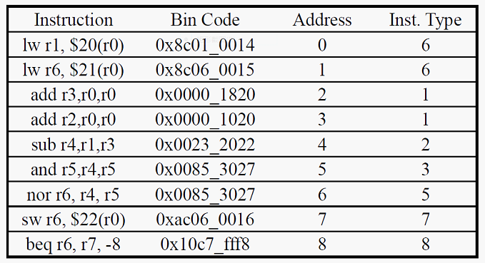

        c.

    10) Verify on the experiment box.

**2.** 实验原理

流水线是数字系统中一种提高系统稳定性和工作速度的方法，广泛应用于现代CPU的架构中。根据MIPS处理器的特点，将整体的处理过程分为取指令（IF）、指令译码（ID）、执行（EX）、存储器访问（MEM）和寄存器会写（WB）五级，对应多周期的五个处理阶段。一个指令的执行需要5个时钟周期，每个时钟周期的上升沿来临时，此指令所代表的一系列数据和控制信息将转移到下一级处理。  
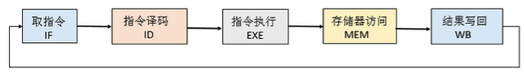  
流水线设计参考如下结构图（没有冒险处理）：



指令执行过程参考图

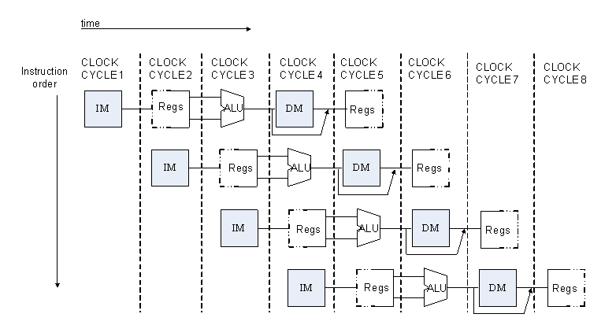

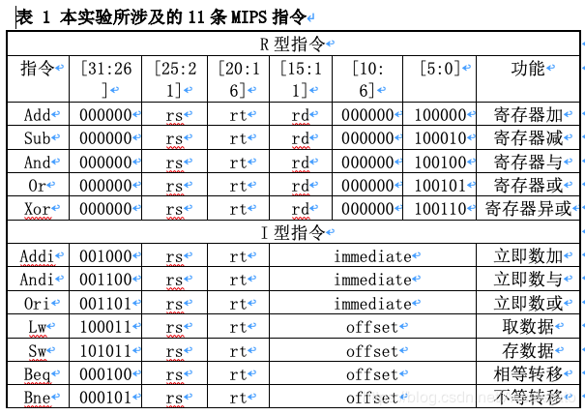

**四、实验结果**

 其中：

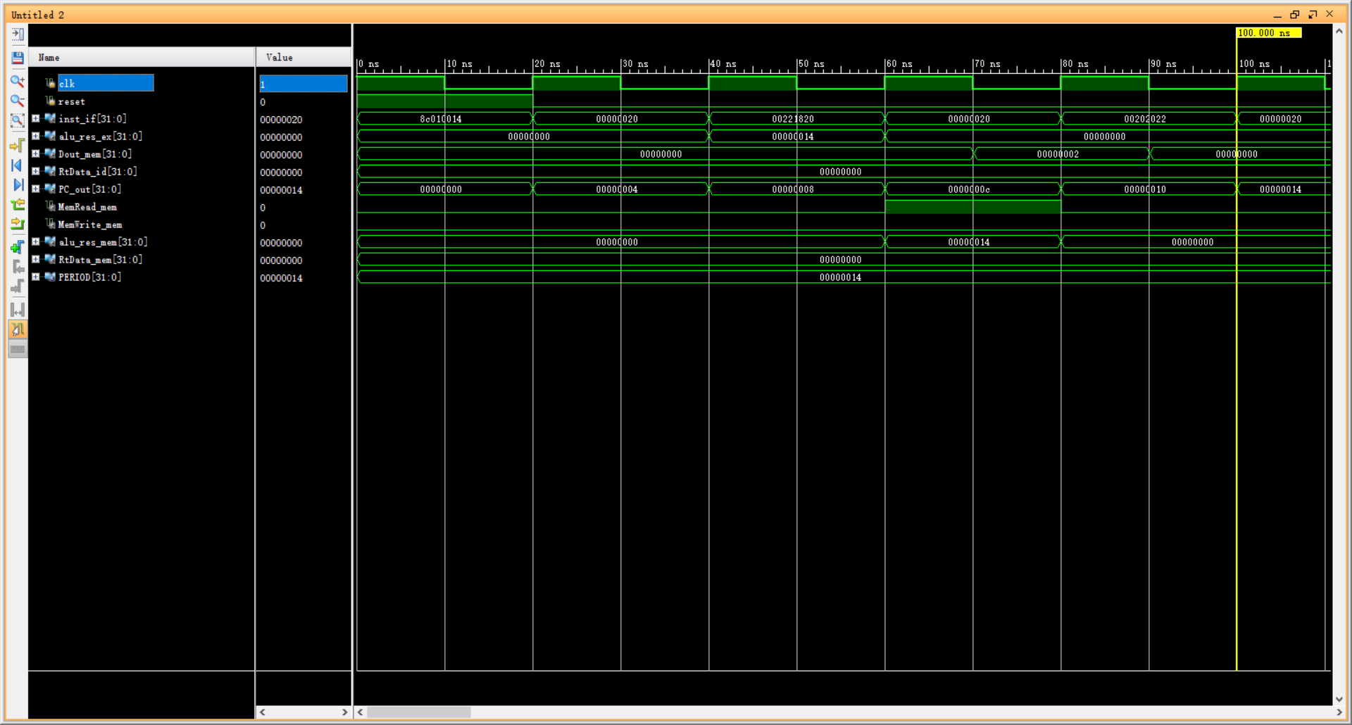

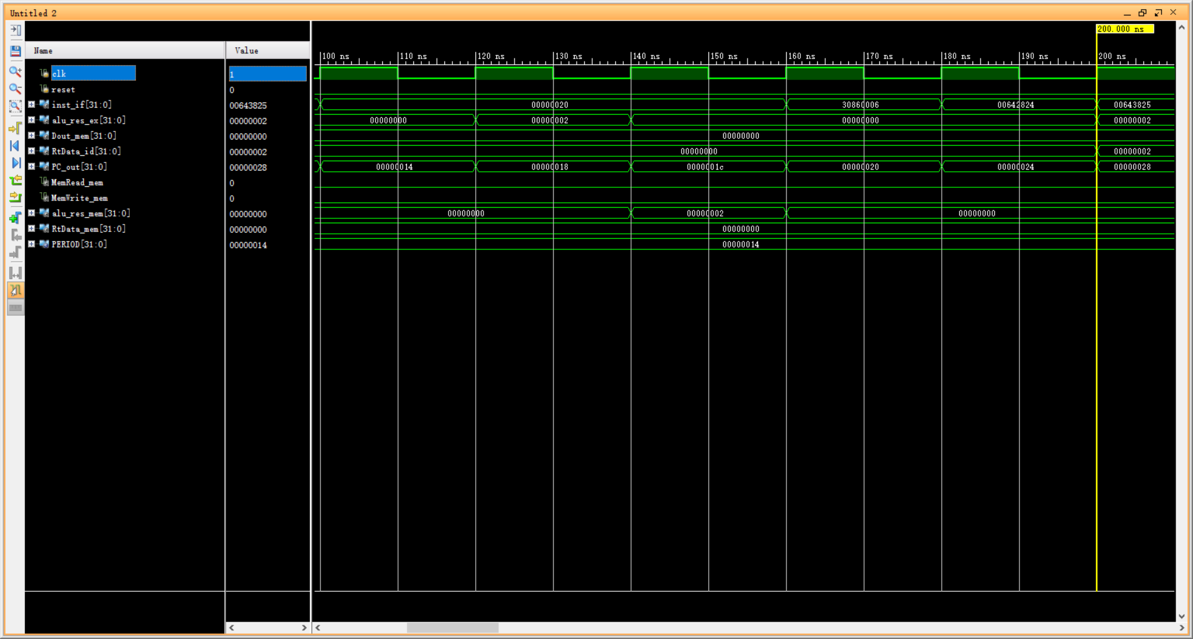

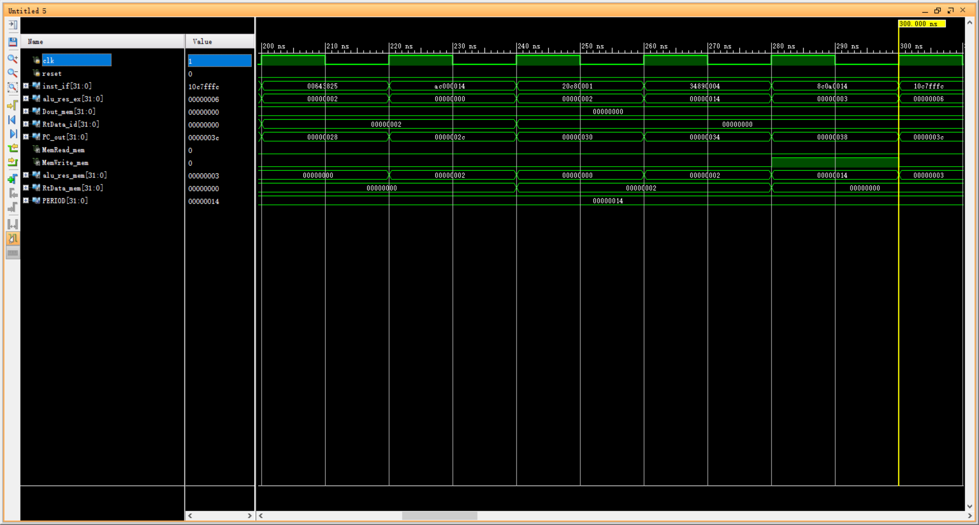

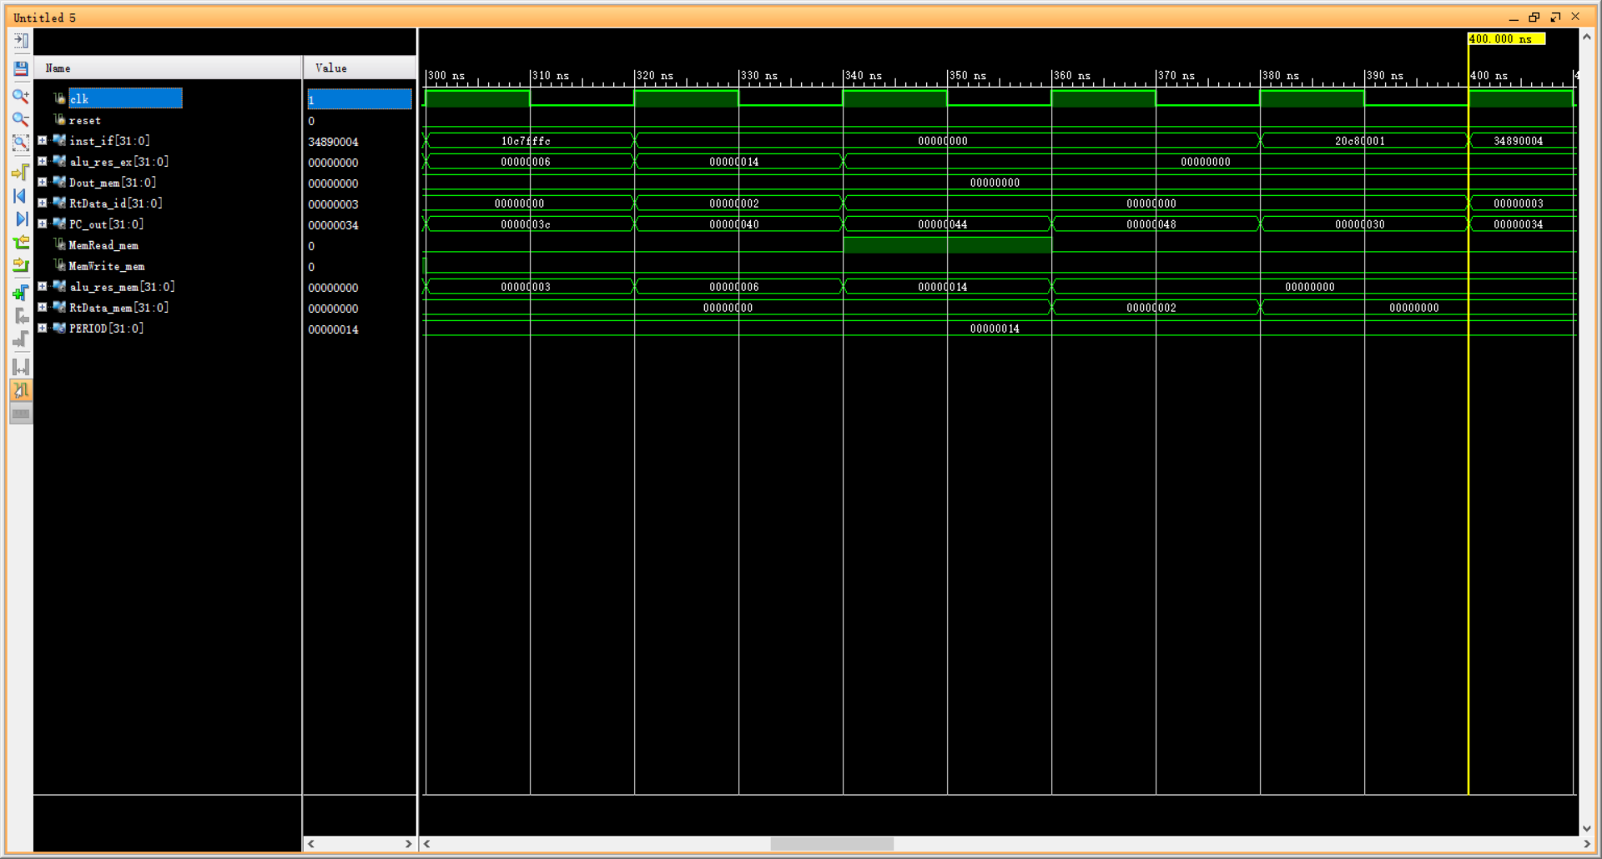

    1. lw $1, 20($0)

 dmem中地址0x14的内容为0x2，此指令使$1=0x2。从仿真结果可以看出，EX段ALU的输出为0x14， MEM段读取数据位0x2，到WR段即可写入，所以第5条sub不会发生数据冒险但是第3条add会发生数据冒险

2. add $0,$0,$0

相当于nop

    3. add $3,$1,$2

因为此时还未到达第1条lw的WR段，所以发生数据冒险，EX段结果未0x0而不是0x2

    4. add $0,$0,$0

相当于nop

    5. sub $4,$1,$0

此时因为完成第一条lw的WR段，所以没有数据冒险，EX段ALU的输出是0x2

    6. add $0,$0,$0

相当于nop

    7. add $0,$0,$0

相当于nop

    8. add $0,$0,$0

相当于nop

9. andi $6,$4,0x6

0x2 & 0x6 = 0x2，EX段ALU的输出是0x2，WR段即可写入，即第13条addi不会发生数据冒险

    10. and $5,$3,$4

0x0 & 0x2 = 0x0，EX段ALU的输出是0x0

11. or $7,$3,$4

0x0 | 0x2 = 0x2，EX段ALU的输出是0x2，WR段即可写入，即第16条不会发生数据冒险

  12. sw $0,20($0)

将0x0写入20($0)（原本是0x2），EX段结果0x14，在MEM段可以读取，即15条lw不会发生数据冒险

13. addi $8,$6,1

0x2 + 0x1 = 0x3，EX段ALU的输出是0x3

    14. ori $9,$4,0x4

0x2 | 0x4 = 0x6，EX段ALU的输出是0x6

15.lw $10,20($0)

将12条写入20($0)的0x0读出，EX段ALU的输出是0x14，在MEM段看到0x0

16. beq $6,$7,-4

0x2 == 0x2，EX段输出结果0x0，跳跃会发生，WR跳转发生

**五、实验心得：**

更加更加更加熟悉了ip核的使用，了解了rom & ram的block版本（对timing要求更高）和distributed版本（rom无clk端口）。了解了rom & ram的深度决定地址的宽度。了解了先写后读模式是下降沿读，上升沿写。（和这次实验中一个时钟周期先1再0的冲突，所以参考代码包括他的分析都是有错误的）解决方法就是改成~clk。

**附录（流程图，注释过的代码）：**

**MipsPipelineCPU：**

`timescale 1ns / 1ps

module MipsPipelineCPU(clk,reset,inst_if,

alu_res_ex,Dout_mem,

RtData_id,PC_out

);

//CPU模块输入：clk、reset

//CPU模块输出：PC地址、指令、ALU运算结果、寄存器堆的数据输出B、Memory结果

//这些数据都是一开始产生就传递给输出

input clk;//100Mhz

input reset;

output[31:0] inst_if;//指令,送给顶层的data2

output[31:0] alu_res_ex;//ALU结果送给data4

output[31:0] Dout_mem;//memory输出送给data6,就是图里的Data_in

output[31:0] RtData_id;//寄存器堆的输出B，送给data5，就是图里的Data_out

output[31:0] PC_out;//pc，送给data7

/*IF级*/

wire branch_or_pc_mem;//本来是MEM级的！

wire[31:0] Branch_addr_mem;//本来是MEM级的！

wire[31:0] next_pc_if;

wire[31:0] inst_if;

IF IF(

//输入

.clk(clk),

.reset(reset),

.branch_or_pc(branch_or_pc_mem),//需要MEM的输入，branch_or_pc_mem

.branch_addr(Branch_addr_mem),//需要EX/MEM的输入

//输出

.next_pc_if(next_pc_if),

.inst_if(inst_if),

.pc(PC_out)//当前pc

);

/*IF-ID寄存器*/

wire[31:0] next_pc_id;

wire[31:0] inst_id;

flipflop#(.WIDTH(32))IF_ID1(

.clk(clk),

.reset(reset),

.in(inst_if),//送指令

.out(inst_id)

);

flipflop#(.WIDTH(32))IF_ID2(

.clk(clk),

.in(next_pc_if),//送pc+4

.reset(reset),

.out(next_pc_id)

);

//注意这里申明了WB级的东西：RegWrite和RegWriteAddr，有点混乱，写WB级注意不要重复！

wire[4:0] RtAddr_id,RdAddr_id;

wire RegWrite_wb,MemtoReg_id,RegWrite_id,MemWrite_id;

wire MemRead_id,ALUSrcB_id,RegDst_id,Branch_id;

wire[4:0] RegWriteAddr_wb;

wire[2:0] ALUCode_id;

wire[31:0] Imm_id,RsData_id,RtData_id;

/*ID级*/

wire[31:0] RegWriteData_wb;//WB级的东西，注意！

assign RegWriteData_wb=reg_data_wb;

ID ID(.clk(clk),.reset(reset),.inst_id(inst_id),

.RegWrite_wb(RegWrite_wb),.RegWriteAddr_wb(RegWriteAddr_wb),

.RegWriteData_wb(RegWriteData_wb),//送进来的数据要经过选择，在WB命名为reg_data_wb！

.RegWrite_id(RegWrite_id),.RegDst_id(RegDst_id),.MemtoReg_id(MemtoReg_id),

.MemWrite_id(MemWrite_id),.MemRead_id(MemRead_id),

.ALUCode_id(ALUCode_id),.ALUSrcB_id(ALUSrcB_id),

.Branch_id(Branch_id),.Imm_id(Imm_id),.RsData_id(RsData_id),.RtData_id(RtData_id),

.RtAddr_id(RtAddr_id),.RdAddr_id(RdAddr_id));

/*ID-EX级间寄存器*/

//总共14根线

wire[4:0] RtAddr_ex,RdAddr_ex;

wire MemtoReg_ex,RegWrite_ex,MemWrite_ex;

wire MemRead_ex,ALUSrcB_ex,RegDst_ex,Branch_ex;

wire[2:0] ALUCode_ex;

wire[31:0] Imm_ex,RsData_ex,RtData_ex,next_pc_ex;

flipflop#(.WIDTH(1))ID_EX1(

.clk(clk),

.reset(reset),

.in(RegWrite_id),//RegWrite

.out(RegWrite_ex)

);

flipflop#(.WIDTH(1))ID_EX2(

.clk(clk),

.reset(reset),

.in(RegDst_id),//RegDst

.out(RegDst_ex)

);

flipflop#(.WIDTH(1))ID_EX3(

.clk(clk),

.reset(reset),

.in(MemRead_id),//MemRead

.out(MemRead_ex)

);

flipflop#(.WIDTH(1))ID_EX4(

.clk(clk),

.reset(reset),

.in(MemWrite_id),//MemWrite

.out(MemWrite_ex)

);

flipflop#(.WIDTH(1))ID_EX5(

.clk(clk),

.reset(reset),

.in(ALUSrcB_id),//ALUSrcB_id

.out(ALUSrcB_ex)

);

flipflop#(.WIDTH(1))ID_EX6(

.clk(clk),

.reset(reset),

.in(MemtoReg_id),//MemtoReg

.out(MemtoReg_ex)

);

flipflop#(.WIDTH(1))ID_EX7(

.clk(clk),

.reset(reset),

.in(Branch_id),//Branch

.out(Branch_ex)

);

flipflop#(.WIDTH(3))ID_EX8(//注意这里的宽度是3！

.clk(clk),

.reset(reset),

.in(ALUCode_id),//ALUCode

.out(ALUCode_ex)

);

flipflop#(.WIDTH(32))ID_EX9(//注意是32位！

.clk(clk),

.reset(reset),

.in(next_pc_id),//pc+4

.out(next_pc_ex)

);

flipflop#(.WIDTH(32))ID_EX10(

.clk(clk),

.reset(reset),

.in(RsData_id),//寄存器堆A

.out(RsData_ex)

);

flipflop#(.WIDTH(32))ID_EX11(

.clk(clk),

.reset(reset),

.in(RtData_id),//寄存器堆B

.out(RtData_ex)

);

flipflop#(.WIDTH(32))ID_EX12(

.clk(clk),

.reset(reset),

.in(Imm_id),//Imm,符号拓展

.out(Imm_ex)

);

flipflop#(.WIDTH(5))ID_EX13(//注意宽度是5！

.clk(clk),

.reset(reset),

.in(RtAddr_id),//rt

.out(RtAddr_ex)

);

flipflop#(.WIDTH(5))ID_EX14(

.clk(clk),

.reset(reset),

.in(RdAddr_id),//rd

.out(RdAddr_ex)

);

/*EX级*/

wire[31:0] Branch_addr_ex;

wire[31:0] alu_res_ex;

wire alu_zero_ex;

wire[4:0] RegWriteAddr_ex;

EX EX(.clk(clk),.next_pc_ex(next_pc_ex),

.ALUCode_ex(ALUCode_ex),.ALUSrcB_ex(ALUSrcB_ex),

.RegDst_ex(RegDst_ex),

.Imm_ex(Imm_ex),.RsData_ex(RsData_ex),.RtData_ex(RtData_ex),

.RtAddr_ex(RtAddr_ex),.RdAddr_ex(RdAddr_ex),

//输出

.Branch_addr_ex(Branch_addr_ex),

.alu_zero_ex(alu_zero_ex),.alu_res_ex(alu_res_ex),

.RegWriteAddr_ex(RegWriteAddr_ex)

);

/*EX-MEM级间寄存器*/

wire RegWrite_mem;

wire MemRead_mem;

wire MemWrite_mem;

wire MemtoReg_mem;

wire[31:0] alu_res_mem;

wire alu_zero_mem;

wire[31:0] RtData_mem;

wire[4:0] RegWriteAddr_mem;

flipflop#(.WIDTH(1))EX_MEM1(

.clk(clk),

.reset(reset),

.in(RegWrite_ex),//RegWrite

.out(RegWrite_mem)

);

flipflop#(.WIDTH(1))EX_MEM2(

.clk(clk),

.reset(reset),

.in(MemRead_ex),//MemRead

.out(MemRead_mem)

);

flipflop#(.WIDTH(1))EX_MEM3(

.clk(clk),

.reset(reset),

.in(MemWrite_ex),//MemWrite

.out(MemWrite_mem)

);

flipflop#(.WIDTH(1))EX_MEM4(

.clk(clk),

.reset(reset),

.in(MemtoReg_ex),//MemtoReg

.out(MemtoReg_mem)

);

flipflop#(.WIDTH(1))EX_MEM5(

.clk(clk),

.reset(reset),

.in(Branch_ex),//Branch

.out(Branch_mem)

);

flipflop#(.WIDTH(32))EX_MEM6(//注意是32位！

.clk(clk),

.reset(reset),

.in(Branch_addr_ex),//Branch地址

.out(Branch_addr_mem)//注意这里送回IF级！

);

flipflop#(.WIDTH(32))EX_MEM7(

.clk(clk),

.reset(reset),

.in(alu_res_ex),//alu结果

.out(alu_res_mem)

);

flipflop#(.WIDTH(1))EX_MEM8(

.clk(clk),

.reset(reset),

.in(alu_zero_ex),//alu的零信号

.out(alu_zero_mem)

);

flipflop#(.WIDTH(32))EX_MEM9(

.clk(clk),

.reset(reset),

.in(RtData_ex),//RtData

.out(RtData_mem)

);

flipflop#(.WIDTH(5))EX_MEM10(

.clk(clk),

.reset(reset),

.in(RegWriteAddr_ex),//写回地址

.out(RegWriteAddr_mem)

);

/*MEM级*/

wire[31:0] Dout_mem;

MEM MEM(

.clk(clk),.MemRead_mem(MemRead_mem),.MemWrite_mem(MemWrite_mem),

.Branch_mem(Branch_mem),

.alu_zero_mem(alu_zero_mem),

.alu_res_mem(alu_res_mem),.RtData_mem(RtData_mem),

.branch_or_pc_mem(branch_or_pc_mem),.Dout_mem(Dout_mem)//注意信号要往回送，给IF

);

/*MEM-WB级间寄存器*/

wire[31:0] Dout_wb;

wire[31:0] alu_res_wb;

wire MemtoReg_wb;

flipflop#(.WIDTH(1))MEM_WB1(

.clk(clk),

.reset(reset),

.in(RegWrite_mem),//RegWrite

.out(RegWrite_wb)

);

flipflop#(.WIDTH(1))MEM_WB2(

.clk(clk),

.reset(reset),

.in(MemtoReg_mem),//MemtoReg

.out(MemtoReg_wb)

);

flipflop#(.WIDTH(32))MEM_WB3(//注意这里是32位

.clk(clk),

.reset(reset),

.in(Dout_mem),//Dout，RAM的输出

.out(Dout_wb)

);

flipflop#(.WIDTH(32))MEM_WB4(

.clk(clk),

.reset(reset),

.in(alu_res_mem),//alu的结果

.out(alu_res_wb)

);

flipflop#(.WIDTH(5))MEM_WB5(//注意是5位

.clk(clk),

.reset(reset),

.in(RegWriteAddr_mem),//RegWriteAddr

.out(RegWriteAddr_wb)

);

/*WB级*/

reg[31:0] reg_data_wb;

always@(*)begin

case(MemtoReg_wb)

1'b0:reg_data_wb<=alu_res_wb;//来自ALU

1'b1:reg_data_wb<=Dout_wb;//来自RAM

endcase

end

endmodule

**IF：**

`timescale 1ns / 1ps

module IF(clk,reset,branch_or_pc,

branch_addr,next_pc_if,inst_if,

pc

);

input clk;

input reset;

input branch_or_pc;//Branch&ALU_zero

input[31:0] branch_addr;//Branch跳转地址

output[31:0] next_pc_if;//pc+4

output[31:0] inst_if;//从ROM中读的指令

output[31:0] pc;

//PC的多选器

reg[31:0] pc_in;//pc选择

always@(*)

begin

case(branch_or_pc)

1'b0:pc_in<=next_pc_if;//没有分支也没有jump

1'b1:pc_in<=branch_addr;//有Branch

endcase

end

//PC寄存器

reg[31:0] pc;

always@(posedge clk)

begin

if(reset) pc<=32'b0;//复位

else pc<=pc_in;

end

//计算下一个PC的加法器

adder_if adder32_bits_if(

.a(pc),

.b(32'b00000000000000000000000000000100),

.c(next_pc_if)

);

//指令ROM

//InstructionROM InstructionROM(.a(pc[11:2]),.spo(inst_if));

InstructionROM InstructionROM(.a(pc[9:2]),.spo(inst_if));

endmodule

**adder_if：**

`timescale 1ns / 1ps

module adder_if(a,b,c);

input [31:0] a,b;//偏移量

//output [31:0] PCadd4;//新指令地址

output [31:0] c;

assign c=a+b;

endmodule

**flipflop：**

`timescale 1ns / 1ps

//级间寄存器

module flipflop(clk,reset,in,out);

parameter WIDTH=1;//根据需要改宽度

input clk;//

input reset;

input [WIDTH-1:0] in;

output [WIDTH-1:0] out;//

reg[WIDTH-1:0] out;

always@(posedge clk)

if(reset)

out<={WIDTH{1'b0}};

else

out<=in;

endmodule

**ID：**

`timescale 1ns / 1ps

module ID(clk,reset,inst_id,

RegWrite_wb,RegWriteAddr_wb,RegWriteData_wb,

RegDst_id,MemtoReg_id,RegWrite_id,

MemWrite_id,MemRead_id,ALUCode_id,

ALUSrcB_id,Branch_id,

Imm_id,RsData_id,RtData_id,

RtAddr_id,RdAddr_id

);

input clk;

input reset;

input[31:0] inst_id;//IF给的指令

//WB级的输入

input RegWrite_wb;

input[4:0] RegWriteAddr_wb;

input[31:0] RegWriteData_wb;

//八个信号输出

output RegWrite_id;

output RegDst_id;

output MemRead_id;

output MemWrite_id;

output ALUSrcB_id;

output Branch_id;

output MemtoReg_id;

output[2:0] ALUCode_id;

//其他输出

output[31:0] Imm_id;//符号拓展

output[31:0] RsData_id;//寄存器堆输出1

output[31:0] RtData_id;//寄存器堆输出2

output[4:0] RtAddr_id;//rt

output[4:0] RdAddr_id;//rd

assign RtAddr_id=inst_id[20:16];//rt

assign RdAddr_id=inst_id[15:11];//rd

assign Imm_id={{16{inst_id[15]}},inst_id[15:0]};//符号扩展成32位立即数

/*控制模块*/

CtrlUnit CtrlUnit(

//输入

.inst(inst_id),

//输出

.RegWrite(RegWrite_id),.RegDst(RegDst_id),

.Branch(Branch_id),.MemRead(MemRead_id),.MemWrite(MemWrite_id),

.ALUCode(ALUCode_id),.ALUSrc_B(ALUSrcB_id),

.MemtoReg(MemtoReg_id)

);

/*寄存器堆模块*/

RegisterFiles RegisterFiles(

//输入，由WB级来提供

.clk(clk),.rst(reset),.L_S(RegWrite_wb),

.R_addr_A(inst_id[25:21]),.R_addr_B(inst_id[20:16]),

.Wt_addr(RegWriteAddr_wb),.wt_data(RegWriteData_wb),

//输出

.rdata_A(RsData_id),.rdata_B(RtData_id)

);

endmodule

**CtrlUnit：**

`timescale 1ns / 1ps

module CtrlUnit(inst,RegWrite,RegDst,

Branch,MemRead,

MemWrite,ALUCode,

ALUSrc_B,

MemtoReg

);

input[31:0] inst;

output RegWrite;

output RegDst;

output Branch;

output MemRead;

output MemWrite;

output[2:0] ALUCode;

output ALUSrc_B;

output MemtoReg;//1:来自mem

wire[5:0] op;

wire[5:0] func;

wire[4:0] rt;

assign op=inst[31:26];//op字段

assign func=inst[5:0];//func字段

//R指令

parameter R_type_op=6'b000000;

parameter ADD_func=6'b100000;

parameter AND_func=6'b100100;

parameter XOR_func=6'b100110;

parameter OR_func=6'b100101;

parameter NOR_func=6'b100111;

parameter SUB_func=6'b100010;

//R_type

wire ADD,AND,NOR,OR,SUB,XOR,R_type;

assign ADD=(op==R_type_op)&&(func==ADD_func);

assign AND=(op==R_type_op)&&(func==AND_func);

assign NOR=(op==R_type_op)&&(func==NOR_func);

assign OR=(op==R_type_op)&&(func==OR_func);

assign SUB=(op==R_type_op)&&(func==SUB_func);

assign XOR=(op==R_type_op)&&(func==XOR_func);

assign R_type=ADD||AND||NOR||OR||SUB||XOR;

//Branch

parameter BEQ_op=6'b000100;

parameter BNE_op=6'b000101;

wire BEQ,BNE,Branch;

assign BEQ=(op==BEQ_op);

assign BNE=(op==BNE_op);

assign Branch=BEQ||BNE;

// I_type instruction decode

parameter ADDI_op=6'b001000;

parameter ANDI_op=6'b001100;

parameter XORI_op=6'b001110;

parameter ORI_op=6'b001101;

wire ADDI,ANDI,XORI,ORI,I_type;

assign ADDI=(op== ADDI_op);

assign ANDI=(op==ANDI_op);

assign XORI=(op==XORI_op);

assign ORI=(op==ORI_op);

assign I_type=ADDI||ANDI||XORI||ORI;

// SW ,LW instruction decode

parameter SW_op=6'b101011;

parameter LW_op=6'b100011;

wire SW,LW;

assign SW=(op==SW_op);

assign LW=(op==LW_op);

// Control Singal

assign RegWrite=LW||R_type||I_type;//要写寄存器

assign RegDst=R_type;//RegDst=1，选择rd，只有R指令这样

assign MemWrite=SW;

assign MemRead=LW;

assign MemtoReg=LW;

assign ALUSrc_B=LW||SW||I_type;

// ALUCode

//自己定义的，只要能在ALU里对应的上就行

parameter alu_add=3'b010;

parameter alu_sub=3'b110;

parameter alu_and=3'b000;

parameter alu_or=3'b001;

parameter alu_xor=3'b100;

parameter alu_nor=3'b101;

reg[2:0] ALUCode;

always@(*)begin

if(op==R_type_op

)begin

case(func)

ADD_func: ALUCode<=alu_add;

AND_func: ALUCode<=alu_and;

XOR_func: ALUCode<=alu_xor;

OR_func: ALUCode<=alu_or;

NOR_func: ALUCode<=alu_nor;

SUB_func: ALUCode<=alu_sub;

default: ALUCode<=alu_add;

endcase

end

else

begin

case(op)

BEQ_op: ALUCode<=alu_sub;

BNE_op: ALUCode<=alu_sub;

ADDI_op: ALUCode<=alu_add;

ANDI_op: ALUCode<=alu_and;

XORI_op: ALUCode<=alu_xor;

ORI_op: ALUCode<=alu_or;

SW_op: ALUCode<=alu_add;

LW_op: ALUCode<=alu_add;

default: ALUCode<=alu_add;

endcase

end

end

endmodule

**RegisterFiles：**

`timescale 1ns / 1ps

module RegisterFiles(

input clk, rst, L_S,

input[4:0] R_addr_A, R_addr_B, Wt_addr,

input[31:0] wt_data,

output[31:0] rdata_A, rdata_B

);

reg[31:0] register [1:31];

integer i;

assign rdata_A=(R_addr_A==0)?0: register[R_addr_A];

assign rdata_B=(R_addr_B==0)?0: register[R_addr_B];

always@(posedge clk or posedge rst)

begin

if(rst==1)

for(i=1; i<32; i= i+1)

register[i]<=0;

else if((Wt_addr!=0)&&(L_S==1))

register[Wt_addr]<= wt_data;

end

endmodule

**EX：**

`timescale 1ns / 1ps

module EX(clk,next_pc_ex,

ALUCode_ex,ALUSrcB_ex,

RegDst_ex,

Imm_ex,RsData_ex,RtData_ex,

RtAddr_ex,RdAddr_ex,

//输出

Branch_addr_ex,

alu_zero_ex,alu_res_ex,RegWriteAddr_ex

);

input clk;

input[31:0] next_pc_ex;

input[2:0] ALUCode_ex;

input ALUSrcB_ex;

input RegDst_ex;

input[31:0] Imm_ex;

input[31:0] RsData_ex;

input[31:0] RtData_ex;

input[4:0] RtAddr_ex;

input[4:0] RdAddr_ex;

//

output[31:0] Branch_addr_ex;

output alu_zero_ex;

output[31:0] alu_res_ex;

output reg[4:0] RegWriteAddr_ex;

//分支地址

adder_32bits adder_32bits_ex(.a(next_pc_ex),.b(Imm_ex<<2),.c(Branch_addr_ex));

//ALUSrcB的多选器

reg[31:0] alu_in;

always@(*)begin

case(ALUSrcB_ex)

1'b0:alu_in<=RtData_ex;//来自寄存器堆第二个输出

1'b1:alu_in<=Imm_ex;//来自符号扩展

endcase

end

//ALU

/*

ALU ALU(.ALU_operation(ALUCode_ex),.A(RsData_ex),.B(alu_in),

.res(alu_res_ex),.zero(alu_zero_ex),.overflow()//overflow什么也不连

);*/

ALU ALU(.aluCtr({ALUCode_ex}),.input1(RsData_ex),.input2(alu_in),

.aluRes(alu_res_ex),.zero(alu_zero_ex)

);

//写寄存器堆地址的多选器

always@(*)begin

case(RegDst_ex)

1'b0:RegWriteAddr_ex<=RtAddr_ex;//rt

1'b1:RegWriteAddr_ex<=RdAddr_ex;//rd

endcase

end

endmodule

**adder_32_bits：**

`timescale 1ns / 1ps

module adder_32bits(

input[31:0] a,

input[31:0] b,

output[31:0] c

);

assign c= a+ b;

endmodule

**ALU：**

`timescale 1ns / 1ps

//module alu(

module ALU(

input [31:0] input1,

input [31:0] input2,

//input [3:0] aluCtr,

input [2:0] aluCtr,

output reg[31:0] aluRes,

output reg zero

//output reg zero,

//output reg negtive,

//output reg[31:0] hi

);

always @(input1 or input2 or aluCtr) // 运算数或控制码变化时操作

begin

case(aluCtr)

//4'b0110: // 减

3'b110:

begin

aluRes = input1 - input2;

if(aluRes == 0)

zero = 1;

else

zero = 0;

/*if(aluRes[31] == 1)

negtive = 1;

else

negtive = 0;*/

end

//4'b0010: // 加

3'b010:

aluRes = input1 + input2;

//4'b0000: // 与

3'b000:

aluRes = input1 & input2;

//4'b0001: // 或

3'b001:

aluRes = input1 | input2;

//4'b0100: // 异或

3'b100:

aluRes = input1 ^ input2;

//4'b0111: // 小于设置

3'b111:

begin

if((input1 < input2 && ~(input1[31]^input2[31])) || (input1[31] & ~input2[31]))

aluRes = 1;

else

aluRes = 0;

end

//4'b0101: //nor

3'b101:

aluRes = ~(input1 | input2);

/*

4'b1000: //sll, sllv

aluRes = input1 << input2;

4'b1001: //srl, srlv

aluRes = input1 >> input2;

4'b1010: //sra, srav

aluRes = $signed(input1) >>> input2;

4'b1011: // multu

{hi, aluRes} = input1 * input2;

4'b1100: // divu

begin

aluRes = input1 / input2;

hi = input1 % input2;

end*/

default:

aluRes = 0;

endcase

end

endmodule

**MEM：**

`timescale 1ns / 1ps

module MEM(clk,MemRead_mem,

MemWrite_mem,Branch_mem,alu_zero_mem,

alu_res_mem,RtData_mem,

branch_or_pc_mem,Dout_mem

);

input clk;

//MemRead信号暂时不要了

input MemRead_mem;

input MemWrite_mem;

input Branch_mem;

input alu_zero_mem;

input[31:0]alu_res_mem;

input[31:0] RtData_mem;

output branch_or_pc_mem;

output[31:0] Dout_mem;

DataRAM DataRAM(

.clka(~clk),//input clka

.wea(~MemRead_mem&MemWrite_mem),//input [0:0] wea

//.addra(alu_res_mem[11:2]),//input [9 : 0] addra

.addra(alu_res_mem[9:2]),

.dina(RtData_mem),//input [31:0] dina

.douta(Dout_mem)//output [31:0] douta

);

//and模块，确定跳转信号

and_1bit and_1bit(.a(Branch_mem),.b(alu_zero_mem),.c(branch_or_pc_mem));

endmodule

**and_1bit：**

`timescale 1ns / 1ps

module and_1bit(

input a,

input b,

output c

);

assign c = a & b;

endmodule

**sim：**

`timescale 1ns / 1ps

module sim;

reg clk;//100Mhz

reg reset;

wire [31:0] inst_if;//指令,送给顶层的data2

wire [31:0] alu_res_ex;//ALU结果送给data4

wire [31:0] Dout_mem;//memory输出送给data6,就是图里的Data_in

wire [31:0] RtData_id;//寄存器堆的输出B，送给data5，就是图里的Data_out

wire [31:0] PC_out;//pc，送给data7

// Instantiate the Unit Under Test (UUT)

MipsPipelineCPU uut (

.clk(clk),

.reset(reset),

.inst_if(inst_if),

.alu_res_ex(alu_res_ex),

.Dout_mem(Dout_mem),

.RtData_id(RtData_id),

.PC_out(PC_out)

);

initial begin

// Initialize Inputs

clk = 1;

reset = 1;

// Wait 100 ns for global reset to finish

//#100;

#40;

reset = 0;

end

parameter PERIOD = 20;

always begin

clk = 1'b1;

#(PERIOD / 2) clk = 1'b0;

#(PERIOD / 2) ;

end

endmodule

**rom.coe：**

memory_initialization_radix=16;

memory_initialization_vector=

8c010014

00000020

00221820

00000020

00202022

00000020

00000020

00000020

30860006

00642824

00643825

ac000014

20c80001

34890004

8c0a0014

10c7fffc;

**ram.coe：**

memory_initialization_radix=16;

memory_initialization_vector=

00000000, 00000000, 00000000, 00000000, 00000000, 00000002,

00000002, 00000000, 00000000, 00000000, 00000000, 00000000,

00000000, 00000000, 00000000, 00000000, 00000000, 00000000,

00000000, 00000000, 00000001, 00000004, 00000000, 00000000;