Creation Workshop
SLA Slicing and Control Software
User Manual
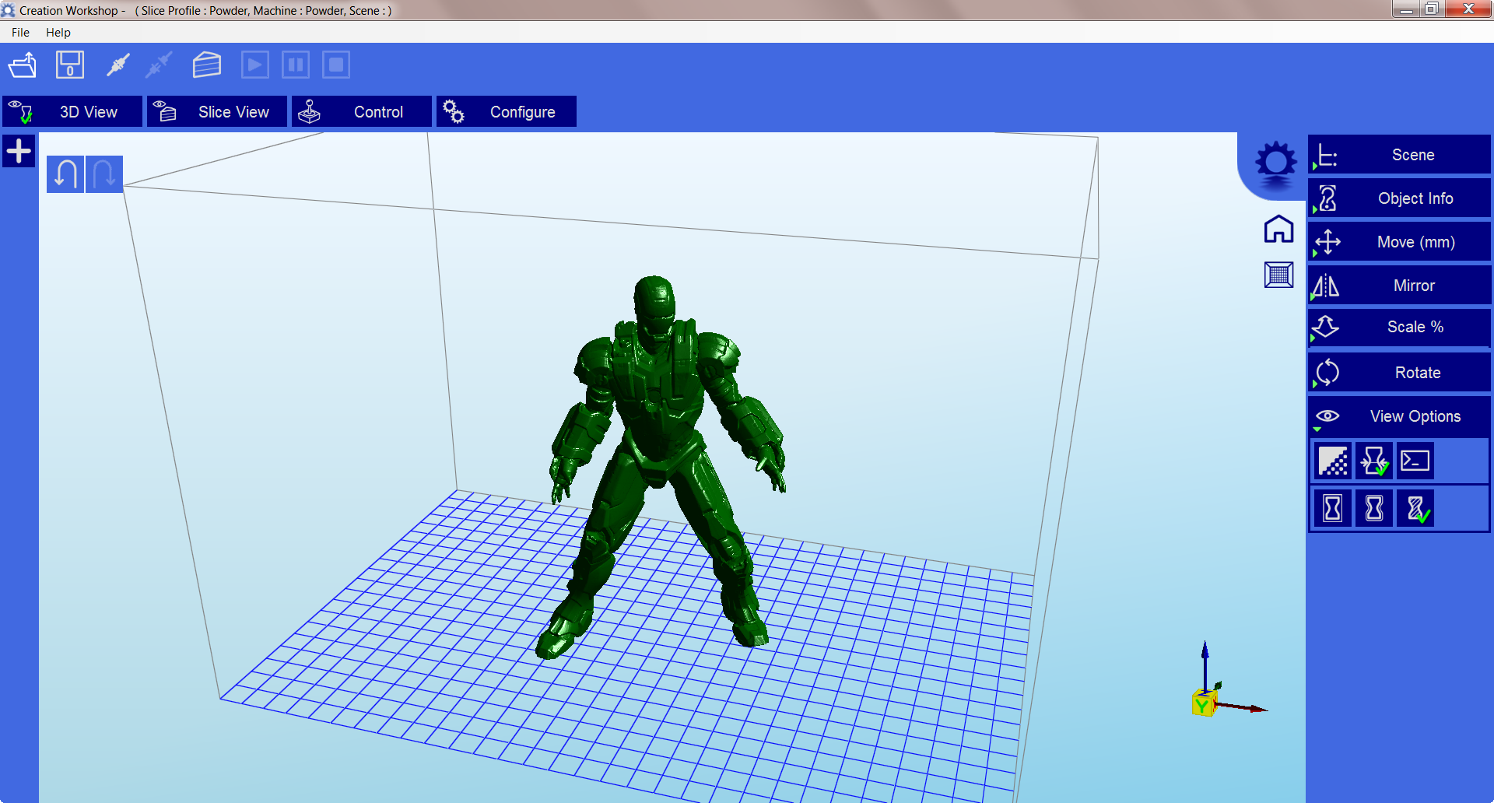

Code Contributors:
Steve Hernandez
Shai Segar

Creation Workshop has a new home at www.EnvisionLabs.net
Check out our forums at www.buildyourownsla.com

Revision History:
Date | Version | Author | Description
02/21/13 | Alpha 1 | Steve Hernandez | Initial notes, quick guide, and description
7/31/2013 | Beta 10 | Steve Hernandez | Current screen shots, added more description, re-wrote large portion to reflect current software.
10/22/2013 | Beta 12 | Steve Hernandez | Updated manual to reflect changes for version 12
11/13/2013 | Beta 13 | Steve Hernandez | Updates for version 13
7/24/14 | Release 25 | Steve Hernandez | Numerous updates to pictures and sections
4/4/2015 | 1.0.0.74 | Steve Hernandez | Updates to manual for build 1.0.0.74

Contents
Foreword: 5
Installation: 5
System Compatibility: 5
Running the application: 6
Loading a Model 6
Scene View 7
Selecting 7
Removing a Model 7
Cloning a model 7
Object Info 8
Move View 8
Mirroring Objects 9
Scaling objects 9
Rotating Objects 9
View Options 10
Working with Model Support tools 11
Using Supports 11
Saving a Scene 12
Setting up a UV Machine for Printing 12
Selecting a Machine Connection COM Port 13
Setting up display devices: 14
Machine Controls: 14
Setting up a profile for Slicing and Building. 14
Slicing a Model 16
Connecting to a machine 17
Manually controlling your machine. 17
The Build Process 18
Plug-in System 21
Licensing 21
Notes about the license: 21
Terminology: 21
Future Efforts: 22
Final Words: 22

Foreword:
Creation Workshop is a toolkit that can be used to generate machine tool paths and sequences to control a variety of 3d printers. It primarily can be used to control any and all serial Binary, ASCII & GCode-based 3d printers.
GCode Tools paths and image slices for DLP-based SLA printers are supported natively
Generic GCode host controller for loading and executing.
FDM printer control – Slicing done by Slic3r
CNC Control – external tool path generators
Galvo based SLA with the LaserShark board
Support Generation tools
Load/Save/Print scenes, supports & pre-rendered slices.
Network support
USB device support

Installation:
Installation of the application is fairly straightforward. Simply unzip the contents of the zip file into a directory of your choice. When the application is started for the first time, it will automatically create all necessary subdirectories and default machine and slicing profiles. *Note – You can carry forward all your machine and slicing profiles from previous versions.

System Compatibility:
Creation Workshop is a .NET 3.5 application written in C#. This is native to the Windows Operating System, but it also runs on many versions of Linux/Posix using the Mono Framework http://www.mono-project.com/Main_Page . You will need to download and install Mono when using Creation Workshop on a Linux-based system. Windows users may need to run the application as Administrator.

Running the application:

Loading a Model
You can load a binary or ASCII STL, OBJ, AMF, or 3DS model from disk by clicking on the ‘Load’ icon or choosing ‘Load Model from the ‘File’. Multiple models can be loaded and manipulated independently.

Scene View

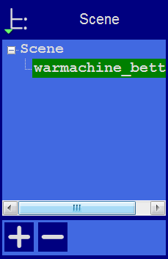
The Scene View allows you to manipulate various aspects of the scene.

Selecting
- Selected models appear in green.
- When a model is loaded, it will be automatically selected.
- You can select a model by double clicking on the model, or selecting it with the scene view

Removing a Model
- You can remove a model by right-clicking on the name in the scene graph and selecting “Remove”.
- The Minus sign “-” will also remove the current model.
- You can also delete a model by selecting it and then pressing the “delete” key on your keyboard.

Cloning a model
You can select a model in the scene and click the “+” sign to clone it. The cloned object will appear in the scene view. The cloned object will clone the support structures.

Object Info
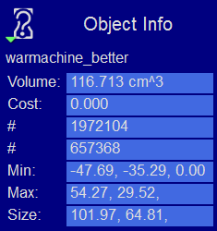
The Object Info view allows you to see various information about the model, including its volume and cost (per unit of build material).

Move View
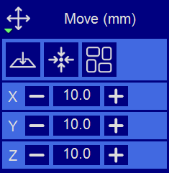
The Move view allows you to move objects on the build platform using the X/Y/Z buttons, the distance can be entered in the middle.
Several other tools are available in this view. From left to right, there are:
- The ‘Place on Platform’ button will position the bottom of the model to rest on the bottom of the build platform.
- The ‘Center’ button will center the model at (0,0,0).
- Auto-Arrange will automatically lay out all models to fit on the build platform. Any model that does not fit within the build platform will be moved outside the build area.
  - If an object is not in the build area, the walls of the build volume with be marked in red.
Protip:
- If you hold down the ‘Shift’ key, you can slide the selected model around the ground plane. The model will slide along the ground plane, following the mouse location.

Mirroring Objects
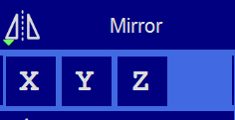
The Mirror view allows you to mirror the selected object on the specified axis.

Scaling objects
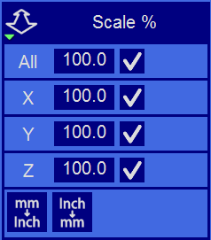
A model can be scaled by selecting it, and using the ‘Scale’ view to enter in a new scalar value. Clicking on the check button will perform the scaling operation. Individual axis of the model can be scaled by entering in a scalar value. Also included are two buttons to convert the model from mm to inches and inches to mm.

Rotating Objects
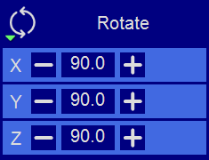
Rotating a model works in a similar way to moving a model. Simply select the model you want to work with, and use the X/Y/Z +/- buttons to rotate the model by the specified degrees.

View Options
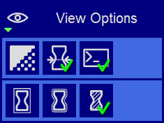
The view options panel allows you to manipulate various options regarding views and models.
On the top row from left to right:
- 50% Alpha-Blending toggle. This will allow you to see through the objects in the scene to allow you to better understand the geometry
- Show Slice Preview on Scene. After the scene has been sliced, this toggles on/off the view of the 3d polyline of the current slice layer as selected by the horizontal scrollbar.
- Show Console. This toggle button shows or hides the debug window. This window is used primarily for debugging purposes, but may contain useful information.

On the bottom row from left to right are tools to change the way the objects appear on the screen:
- Show objects with a bounding box.
- Show objects with and outline
- Show selected objects in a different color

Working with Model Support tools
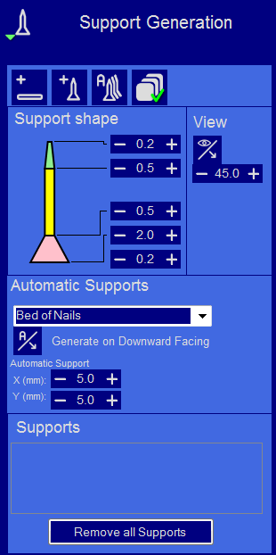

Using Supports
Supports are sometime required to properly attach a model to the build surface. Because of the nature of SLA printing, one layer at a time is printed, and lower layers must be supported directly or indirectly and attached to the build surface.

Adding a single Support

A single support can be generated for manipulation by clicking the Add support button, this will toggle on/off the ‘add support’ mode. When you are in the ‘add support’ mode, you can click on a model to add a support to the area you clicked on.

Moving Supports
After a manual or automatic support has been generated, individual supports can be moved around the X/Y plane the same way models can be moved. Select the support by double clicking on it to select it, and hold down the ‘Shift’ key on your keyboard and move the mouse. Supports will automatically scale vertically under the model they support.
Additionally, you can select the tip or base of a support individually. After selecting the tip or base, hold down the shift key and move your mouse cursor to the area that you wish to support. Supports will automatically change between ‘base supports’ and ‘intra-object supports’ as needed.

Manual Configuration
Under the Support Generation view, you can click ‘show downward facing polys’. This will highlight all polygons in the model that are pointed downward by the specified degree. This helps you manually place supports under un-supported downward facing areas of a model.

Auto Support on Grid
After a model is loaded into the scene and selected, you can automatically generate a ‘bed of nails’ support for the model. You can specify the grid spacing and the size of the generated supports. If you wish to only generate supports on downward facing polygons, check the boxes under ‘support general’ and ‘generate only on downward’

Adaptive supports
Creation Workshop also has the ability to identify and add supports to areas in the model that are unsupported. There are 2 algorithms to help you accomplish this.

Saving a Scene
After one or more models have been loaded and manipulated on the build platform, the entire scene can be saved as an STL model for later use. Simply click on the ‘File->Save Scene STL’ menu item to save the scene model. This will flatten all models in a scene into a single model and save it as an STL file. You will not be able to later move supports or auto-arrange.
Scenes can also be saved to CWS files. These Creation Workshop Scene files can be used to save and load complete scenes with multiple models, support, last sliced gcode and images slices. These scene files can be used to create a scene with supports, slice the scene, and later load to print your scene without the need for re-slicing. The scene files are a collection of files and directories stored in the ZIP file format in the CWS files.

Setting up a UV DLP Machine for Printing
This section covers the basics for setting up a Machine Profile to use with your 3d Printer. For a detailed guide on Hardware and troubleshooting, please refer to the ‘Hardware Guide’ manual.
When you ran ‘Creation Workshop’ for the first time, it created a default 3d UV DLP machine profile. You will need to configure this profile to meet the specifications of your 3d printer. To edit the current machine profile, select ‘Machine Config’ tab in the main window.
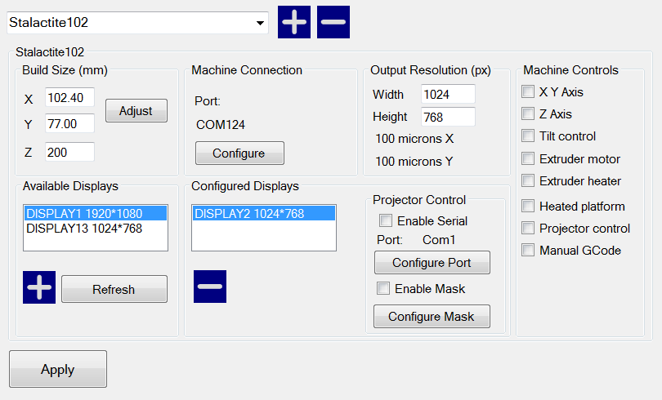
You can create new profiles from the left using the plus sign. The currently selected profile is indicated in the drop-down box.
For UV Printers, set the platform size for your machine in mm. This X/Y size refers to the projected size of the image on the surface of the build platform. For bottom-up machines, this will be on the surface of the bottom of the VAT, for top-down machines, this will be the surface of the resin. The Z size refers to the maximum Z printing height. This screen also allows you to select a display device the projected images will be displayed upon.

Selecting a Machine Connection COM Port
Once a Machine profile has been selected, the ‘Configure’ button on the ‘Machine Connection’ box can be selected to show the Connection setup screen.
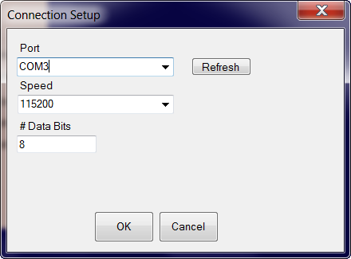
This screen allows you to choose the correct COM port and speed to communicate with the printers’ controller card via serial connection.
*NOTE – The current version of the application will allow connections up to 115200 bps. Please ensure your controller firmware is configured for the speed chosen.

Setting up display devices:

Available Displays
This shows you the available configured and connected displays on the system. You can click the Refresh button to refresh the list of displays. The ‘+’ button will add a display to the Configured display box.

Configured Displays.
This area shows the displays that will be used for projection on the system. Once a display is added to this area, it can be selected to configure the projector controls. Typically, only one display is used. Creation Workshop can support 2 projectors – each with the same resolution and projection size either in a horizontal or vertical format.
Selecting a Projector COM Port (Optional) – Projector control
Some video projectors have a serial control port. This feature allows you to connect to the serial control port of a projector and send it various commands. You will need to consult your projector’s user manual for a list of commands.

Machine Controls:
There is a column of check boxes on the right hand side of the machine configuration screen. Enabling these allows you to customize the controls that appear on the ‘Manual Control’ screen. Select the controls that are appropriate for your machine.

Saving your changes
After you have configured your machine profile, be sure to click the “Save Changes” button to save and apply the changes.

Setting up a profile for Slicing and Building.
In order to slice a model into images, you must first set up a slicing profile. A default profile has been created the first time the application was started. You can create new slicing profiles and manage them in much the same way you can manage machine profiles. The ‘Slice Profiles Config’ tab item will allow you to create, delete, or edit a slicing and building profile.

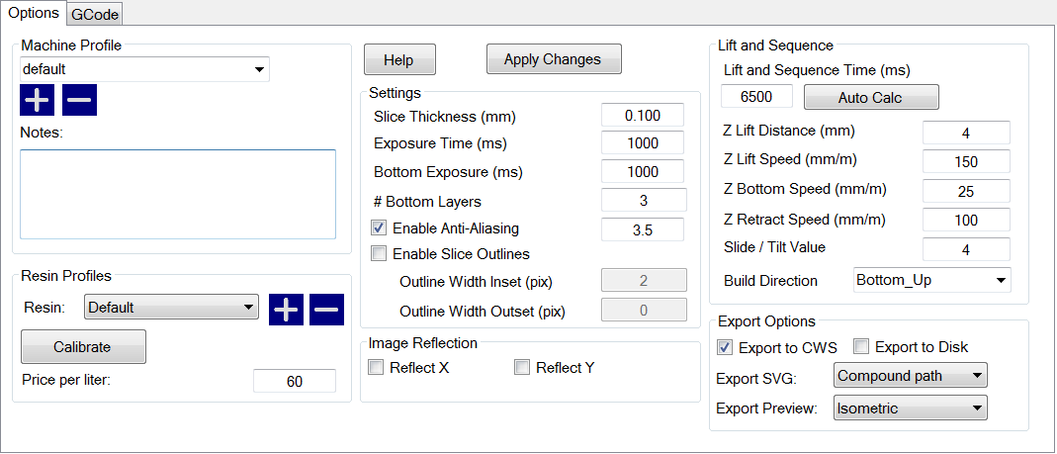
Slice Thickness: This field is to set the thickness of each slice in mm. The default is .05mm (20 slices per mm)
Exposure Time per Layer: This time value specifies how long the projector will display an image slice on a per-layer basis.
Bottom Layer exposure time: In order to ensure the model is properly adhered to the bottom of a vat, a longer exposure time can be used for a specified number of bottom layers.
# Bottom Layers: This specifies the number of ‘bottom layers’ that receive the longer exposure time.
Blanking time between layers: This is a time delay that allows the machine to perform a ‘Lift/tilt/slide’. You may have to experiment with this value to determine a proper timing for your machine.

Resin Price per liter
You can specify the cost of the resin used here. This is used to calculate printing costs under the ‘File->Calculate Volume & Costs’ menu item.
Lift and Sequence Time:
This time specifies in milliseconds how long the lift and retract sequence takes. You can use the “Auto Calc” button to generate a time estimate for the lift and retract. This value may need to be modified based on the speed of your machine.
Lift Distance: This is the distance that the printer will raise and lower the Z axis after the exposure has taken place.

Z Lift Speed:
When a layer is printed on a bottom up machine, a large amount of force may be required to separate the slide from the vat. This speed indicates how fast to perform the lift, a slower speed may be required to help vat separation.

Z Lift Retract speed:
After the lift occurs, this speed indicates how fast the z axis should travel back to the initial start position.
Slide/Tilt Value: for machine with a slide or tilt mechanism connected to the X axis, this value specifies how much to more in conjunction with the Lift.
X/Y Pixel Offset: This X/Y value allows you to offset the rendered image by a pixel amount.
Build Direction: Top down or Bottom up. This value determines which direction the Lift occurs. For a bottom up machine, this is used to peel the model from the bottom of the build vat, sometimes in conjunction with a tilt/slide. For a Top-down machine, this makes the lift operation dip into the resin.

Image Slice Export Options
This allows you to control how the generated image slices and gcode files are saved. You have the option of exporting to Zip file or to a subdirectory when the ‘Export Images and GCode’ button is checked. If this is left unchecked, slices and gcode will still be generated, but not saved to disk.

Slicing a Model
Once you have loaded one or more models, configured your machine profile, and configured your build & slicing profile, you can slice a model.
 Choose the Slice Icon from the toolbar to bring up the Slicing Screen.
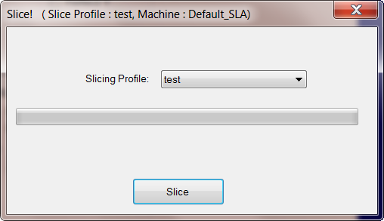
You can change the currently selected slicing profile to use.
Click the ‘Slice’ button to begin slicing. You can stop slicing by pressing the ‘Cancel’ button. If your slicing profile is configured to export images, a progress bar will appear here. Otherwise, just the gcode for the scene will be generated and the images will be rendered during build-time.

Connecting to a machine
You can connect to your 3d printer with the ‘Connect’ toolbar item.

Please ensure that you’re properly configured your machine profile as well as setting up the correct COM port before connecting.

Manually controlling your machine.
Once successfully connected to a machine, you can use the Machine Control screen to control various portions of your machine. Here, you have access to homing, movement, sending arbitrary GCode. You can use the projector controls to show a blank screen, calibration, etc..
The controls that you see on this screen are determined by the selections made on the Machine Configuration screen. These controls can be customized through plug-ins.
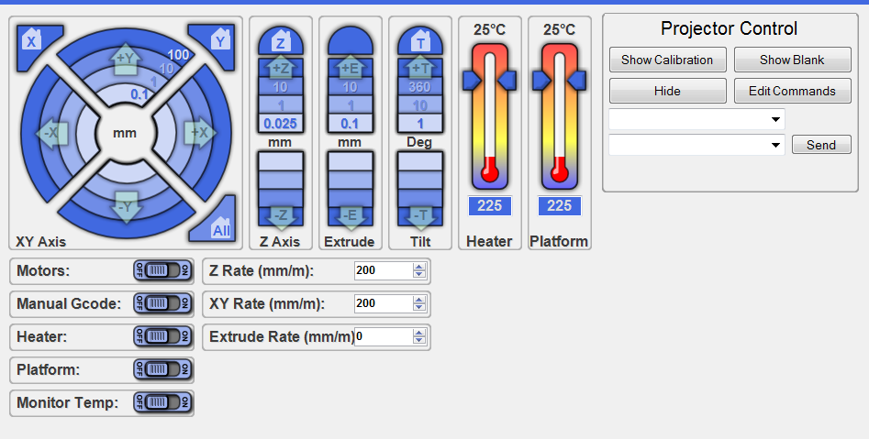

GCode Window

The Build Process
Once you have sliced a model and connected to a machine, you can click the “Start Build” button to start the build process. If you have a secondary monitor (or projector) connected to your system, a full-screen window will appear that displays the individual image slices. If you are using only a single monitor, this screen will appear over your primary display (probably not what you want)
For testing purposes and to get an idea of what the build process does, use the null driver in your machine configuration, or set up an additional machine configuration just for testing.
How the build process works:
This program uses information from the sliced model, rendered slice image, along with generated GCode to control both the printer hardware and projector simultaneously. Special comment lines are generated inside the GCode file that tells the build manager to perform special actions:
;********** Pre-Slice Start ********
;Set up any GCode here to be executed before a lift
;********** Pre-Slice End **********
;<Slice> 1
;<Delay> 3000
;<Slice> Blank
;********** Lift Sequence ********
G1 Z4.0 F200.0
G1 Z-3.9 F200.0
;<Delay> 4900
;********** Lift Sequence **********

You might recognize the G1 as a movement command. The ;<Slice> 2 line tells the build manager to display slice 2, and the ;<Delay> 5000 line tells the build manager to pause for 5000 milliseconds (5 seconds). The next G1 movement command will not be sent to the machine until AFTER the slice and delay commands have executed. This differs from most G-Code build systems that will send as many commands as possible to the device. You should note that the build process uses relative movement mode instead of absolute mode.

Use of the custom G-Code pre-processor:
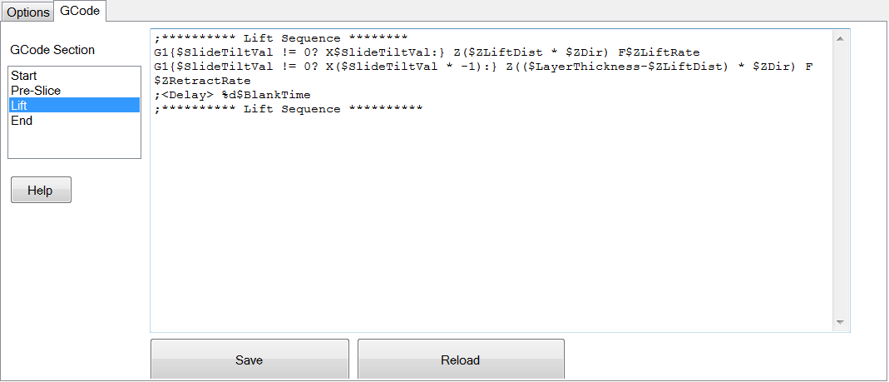
When the slicing profile is created, 4 GCode segment files are created as well in the slicing profile:
Start
Preslice
Lift
End

The contents of the ‘Start’ segment is inserted at the beginning of the generated gcode file. Likewise, the ‘End’ segment is inserted at the end of file for any shut down commands. You can see the relative insertion positions of the Pre-slice, and Lift gcode segments.

You can modify the contents of these g-code pre-processor sections to suit your machines individual needs to add additional commands such as a shutter control, or Slide/Tilt mechanism.
If you make changes to any of these files, you will need to save and re-slice the scene.

Slice-time variables
You may have notice special variables appearing in the 4 GCode sections listed above. These variables are tied directly to the corresponding variables in the GUI. During slice time, these variables are replaced with the actual values.
- $LayerThickness - the thickness of the layer in mm
- $ZLiftDist - how far we're lifting in the Z-axis
- $ZLiftRate - the rate at which we're lifting the z axis
- $ZBottomLiftRate - the rate at which we're lifting the z axis during the first bottom layers
- $ZRetractRate - how fast the z axis is retracting
- $SlideTiltVal - any used slide / tilt value on the tilt axis
- $BlankTime - how long to show the blank in ms
- $LayerTime - total delay for a layer for gcode commands to complete - not including exposure time
- $FirstLayerTime -time to expose the first layers in ms
- $NumFirstLayers - number of first layers
- $ZDir – The direction used for the Z axis 1 for bottom-up or -1 for top-down
- $CURSLICE – this variable is updated for each slice, this is the current layer number

Slice-Time Scripting
Some basic scripting can occur at slice-time. This allows for powerful gcode pre-processing. In addition to using the variables noted above, you can also perform simple expression evaluation using the variables along with constants. The following operators are supported:
Numeric operators:
+, -, /, *, %

Equality operators:
<, >, >=, <=, !=

Grouping:
(,)

Printing:
%d – integer cast

There is also an if-then expression that can be used. This takes the form of:
[condition]?[true statement]:[false statement]

This allows slice-time testing of variables to meet certain criteria during slice-time. For example:
This line appears in the default.slicing file in the lift.gcode section:

G1{$SlideTiltVal != 0? X$SlideTiltVal:} Z($ZLiftDist * $ZDir) F$ZLiftRate

If the user enters a Slice / Tilt value in the GUI, the section in green is passed through to the output. The variables $ZLiftDist and $ZDir are multiplied for the output.
If the user had entered a value of 2 for the Slide tilt, 4 for the Z lift distance, and this is bottom up machine (ZDir = 1), and the Z lift rate was 400, this statement would generate to be:

G1 X2 Z4 F400

Another example is using a wiper system on the Y-Axis that alternates direction every other layer:
{$CURSLICE%2 == 0?G1 Y39.5 F1200:G1 Y-39.5 F1200}
This example uses the modulus operator to get the remainder of a division. If the slice number is even the section in yellow will be written. If the slice number is odd, the green section will be written

Plug-in System
Creation Workshop supports a plug-in based system. This allows for a vast array of customizations to the GUI as well as additions to the functionality of the entire program. Some of these customizations may include (but are not limited to)
- Splash screen
- Branding
- Licensing
- New machine-specific GUI’s on any portion of the existing GUI
- Creation of new GUI screens
- New/modified menu items
- Alternate Slicers
- New machine drivers
  - Custom binary or ascii protocols
  - SLS
  - SLA
  - DLP
  - FDM
  - GALVO Laser
Commercial Printer vendors can purchase custom plug-ins.

Licensing

Notes about the license:
Creation Workshop is released under the Creation Commons Attribution-Non-Commercial-ShareAlike license. This software and its source code are free for home hobby, research, and academic use. Any commercial re-distribution of the software or any portion of the software requires licensing.
- Licensing can be done through per-machine sales or vendor yearly site licensing.
- Creation Workshop pricing is based off of the machine total sale cost at 5%.
- License registration and license key handling are handled through Vendor Plug-ins.

Future Efforts:
One of the goals of this project is to support the machine tool path generation and slicing of as many 3d printer CNC/SLS/SLA/FDM/Powder/Laser machines as possible.

Final Words:
This project has taken quite a bit of time and effort. I would love to see this application become a part of the community tools for printer control. Please take the time to report any bugs, give any constructive feedback and design recommendations to:
Pacmanfan321@gmail.com
If you appreciate this program, please also consider donating via @ www.paypal.com !

