InstalLATION

1.1. Introduction
gvSIG Desktop (gvSIG henceforth) set up it is very simple. There are available (installable) binary to gvSIG for:
- Linux 32 bits
- Linux 64 bits
- Windows 32 bits
- Windows 64 bits
- Max OS X (only portable version)
There are portable versions of gvSIG for each of these options. The portable versions don't require setting up, just download and unzip them to run gvSIG and begin to use it.
You can find binary and portable version in this link:
http://www.gvSIG.com/en/products/gvSIG-desktop/downloads

1.2. Installation step by step
The installation process is similar in Windows as well as in Linux.
The only additional precaution in Linux is that the downloaded file has executing permissions. In Ubuntu, we would have to select it, then click on the secondary button of the mouse and open its “Properties”. We would mark the option to permit to run the file as an application.
Step 1: Selecting installation language
When running installation file, a window appears, where we can select installation language. We select our language and we press “OK”.
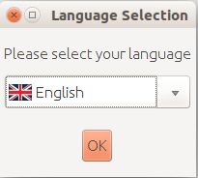
Step 2: License agreement
When the installation starts, a welcome message appears. We press “Next”.
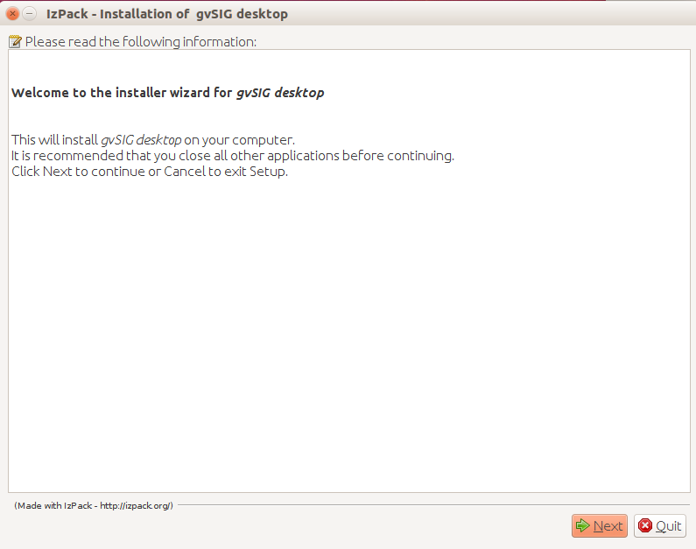
The gvSIG license is shown (GNU/GPL v.3). We mark “I accept the therms of this license agreement” option.
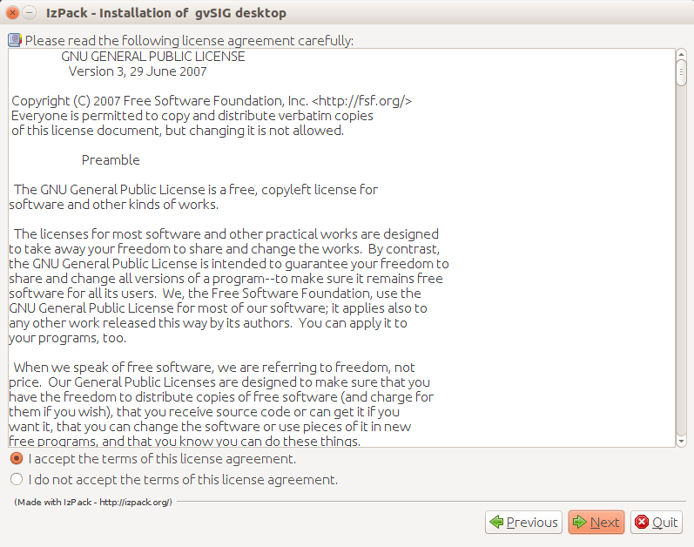
Step 3: Select location
Now we have to select the folder where gvSIG will be installed. By default it's created in the user folder. Pressing “Browse...” we can change the location.
Once it's confirmed, we press “Next”.
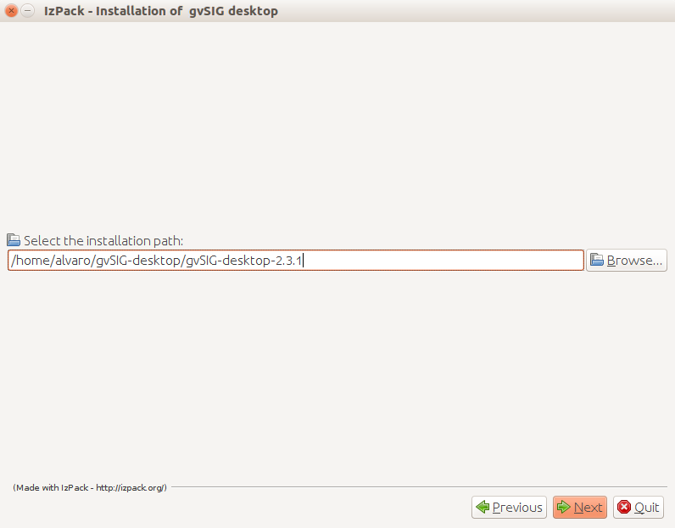
A message to confirm the creation of the folder will appear. We press “Accept” button.
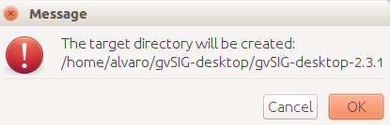
Step 4: Starting installation
A window with a progress bar will indicate that gvSIG is being installed.
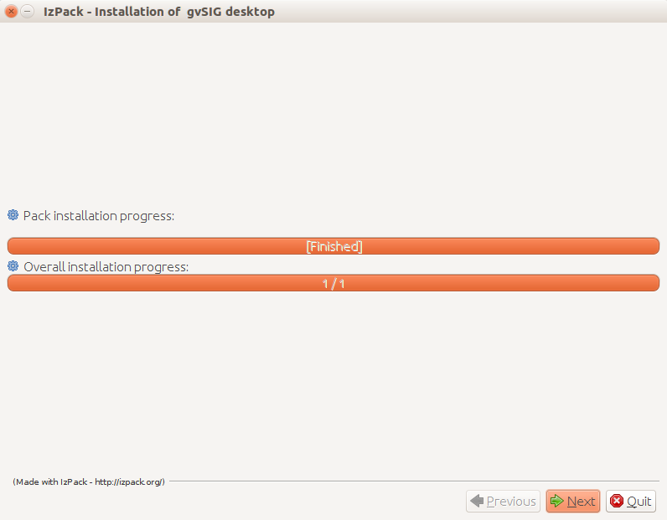
Once it finishes we press “Next”.
A new window informs us that the basic gvSIG has been installed. At the next steps we will be able to customize the gvSIG installation, installing the typical add-ons or adding other ones.
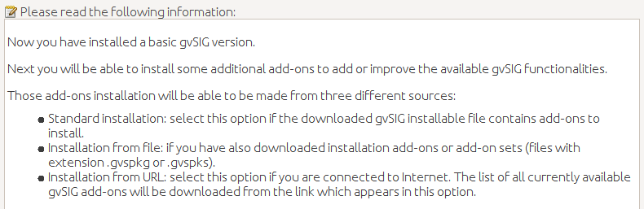

Step 5: Customizing the installation
A first window indicates that the packages (plugins) that are available in that gvSIG Desktop version are being extracted
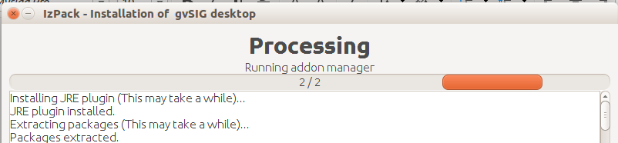
A new window will indicate that we can install additional add-ons in gvSIG. We select the add-ons installation source and then we press “Next”.
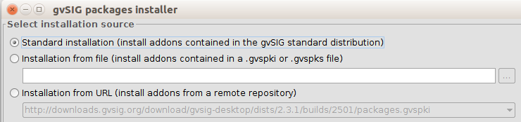
The add-ons can have three different sources:
- The installation binary. The installation file that we have downloaded contains a lot of plugins that aren't installed by default, but they are available to be installed. It allows to customize gvSIG without internet connection.
- Installation from file. We can have a file with a set of plugins to install in gvSIG.
- From URL. Through an Internet connection we can access to every plugin that is available at the gvSIG server and install whatever we need. The only difference between this option an the first one is that additional plugins or updates of the existing ones can be released after a final gvSIG version.
It's not necessary to install any complement in that moment. The Add-ons manager is always available in gvSIG and we can access to it from the “Tools” menu.
The next window shows two options:
- Typical installation. It installs the add-ons by default. It doesn't allow to add any additional plugin during installation process.
- Advanced installation. It allows to access to the “Add-ons manager” and select the plugins that we want to add to the typical installation (for further information you can see “Add-ons manager” section)
Note: during the installation all functional plugins can be installed but not the symbol libraries because installation has to be finished for it. They can be installed later running the “Add-ons manager” from gvSIG.
Once the add-ons are selected or the “Typical installation” option has been chosen, we will press “Next” button.
Step 7: Finishing installation
A new window informs us about the installing process, indicating the number of add-ons (packages) that are being installed. Once the packages installation finishes we press “Finish”.
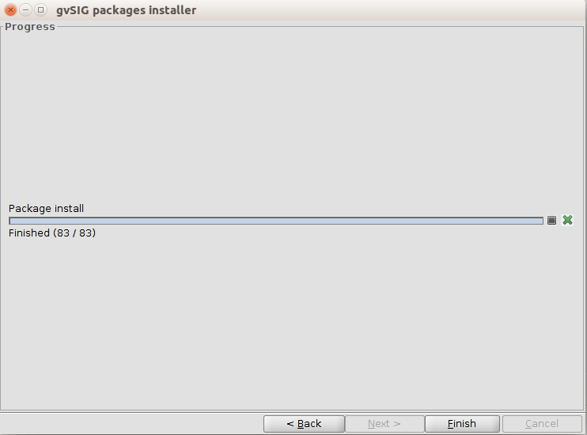
The information window of the installation process will show the list of installed plugins. We press “Nest” button.
The last window will show installation process finishing, showing (check boxes) with options to create direct accesses.
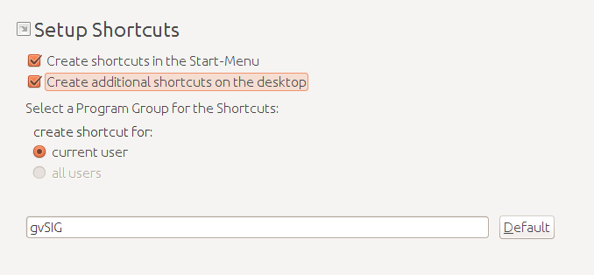
We press “Next” and a message about the successful end of the installation will be shown. We will finish the wizard finally.
We can start to work with gvSIG Desktop now.

