Addons Manager

2.1. Interface and behaviour
The Addons Manager is a function which allowsus to personalize gvSIG installing new addons, functional or otherwise (symbols libraries)
We can execute it from “Tools>Addons Manager”. It is accesible during the installation progress.
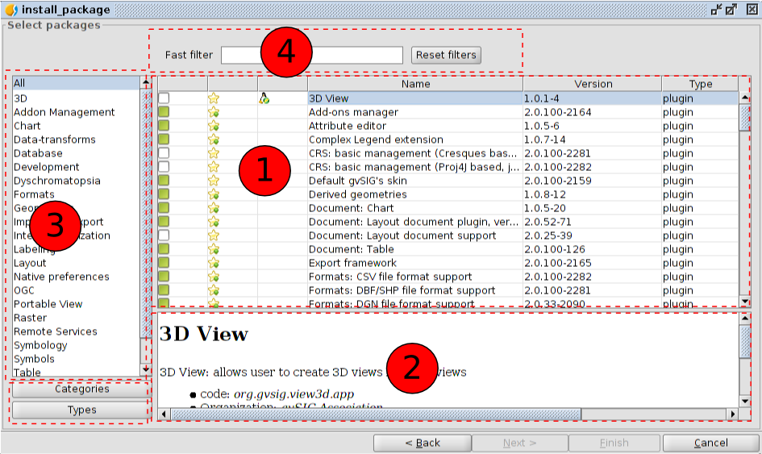
The “Add-on Manager” interface is divided into four parts:
- List of available add-ons. The plug-in name, version, and type are indicated. The verifcation check boxes allow to distiguish between available (white) or already installed add-ons (green).
- Information area concerning the selected plug-in (1)
- Area that shows the “Categories” and “Types” in which the plug-in is classified.
When we choose a category or type from the list, a filter that runs on “1” shows only the plug-ins related to this category or type.
- Fast filter. Enables a filter from a text string entered by the user.

2.2. Introduction
In the add-ons list we can see several icons that we should know.

The plug-in is only valid for Linux 32 bits.

The plug-in is only valid for Linux 64 bits.
The plug-in is official
The plug -in is official and recommended for the proper functioning of gvSIG (included in the typical installation )

