finding out about gvSIG
gvSIG allows to work with different types of documents. These documents allow to work with data from different points of view: data as a map, as a alphanumeric table, as graphics... Each document has a serie of menus and buttons.
When we save a session or project in gvSIG, this is saved in a file with a “.gvsproj” extension.

4.1. Interface
Let's see the main components of the gvSIG interface.
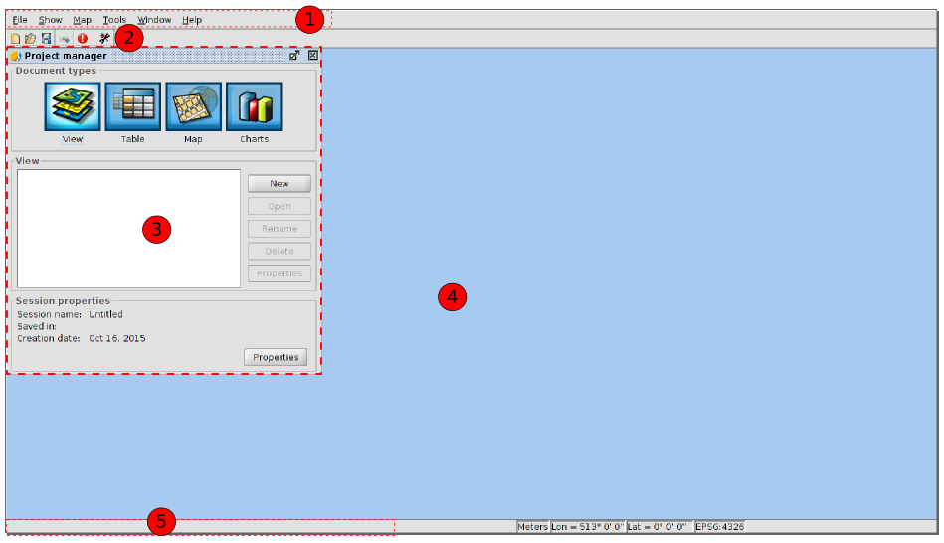
- Menu bar.
- Buttons bar
- Project manager. It allows to manage all the documents which make a project.
- Work area. In this space we will be able to have the different project documents opened and work with them.
- Status bar. The status bar provides information about coordinates, distances, etc. to the user.

4.2. Types of documents
In gvSIG there are the following documents:
- Views: It allows to work with geographical data. The geographical information is represented as a set of layers.
- Tables: It allows to work with alphanumeric data
- Maps: It allows to design maps with the different cartographic elements which make a map (View, legend, escale...) to print it or export it as a PDF. ca.
Note: Some of the complements add new documents to gvSIG. An example is the new complement of “Portable view”.

4.3. Vocabulary used in gvSIG?
It is advisable that the gvSIG user gets familiar with the following terms:
Project (.gvsproj) | gvSIG projects allows to save your work sessions in a file with a .gvsproj. extension. A gvSIG project has the origins of the information (file paths, geodatabases, web links) and the work done on this data (legends, labeled, designed maps, graphics...)
Layer | The information with a geographical component is shown as layers . Each layer represents a given dataset. Layers can represent the information through collections of points, lines or polygons, continuous surfaces such as Digital Terrain Model or raster images (aerial photos or satellite images).
Table of contents (TOC) | It is the area where you can find a list of the layers which are available for a viewing. It allows to change the position of our layers (the order of appearance of the layers in the “View” ties in with the display order), to activate or deactivate the viewing and to show how each layer represents the information using a legend.
WMS | Web Mapping Service, is a OGC (Open Geospatial Consortium) standard service for visualization. It represents geographical information in an image format such as PNG, GIF o JPEG.
WMTS | Web Map Tiled Service, is a OGC standard service for visualization. It uses tessellation to improve the response speed relative to WMS. It represents the geographical information in an image format. servicio de visualización estándar del OGC.
WFS | Web Feature Service, another OGC standard service to access to vector information.
WCS | Web Coverage Service, OGC standard service to access to raster data.
OSM | Access to OpenStreetMap tile services.
CRS | Coordinate Reference System. Also known as Spatial Reference System. Sistema de referencias coordenado o, como se denomina más habitualmente, sistema de referencia.

