PROJECTs

5.1. Project tools
gvSIG projects have .gvsproj extension. In "File" menu are the main tools related to the project. We also have the corresponding button bar.
Menu | Button bar
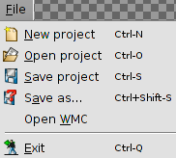
Let see every tools available:
Icon | Tool | Shortcut key | Description
 | New project | Ctrl+N | Create a new project
 | Open project | Ctrl+O | Open an existing project
 | Save project | Ctrl+S | Save the session work.  If you are working with a new project, we will request the name by which the project is saved (with .gvsproj extension).  If you are working with an existing project, update changes the working session.
 | Save as.. | Ctrl+Shift+S | Save the work session on a new file, requesting the name.

5.2. Save project changes
When a work session in gvSIG closes, a window asking if you want to save changes to the project appears.
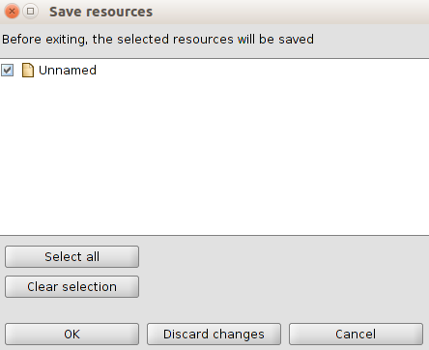
By default gvSIG have all fields activated about changes that have occurred in the project and then can be saved. These changes also make reference to the project, show the layers and tables that were in edit mode before trying to close the project.
The "Select all" and "Clear selection" buttons allow to enable and disable the check boxes.
The available options are:
- Ok: saves the changes of the elements that are activated.
- Discard changes: no changes are saved, regardless of whether or not the elements activated.
- Cancel: closes the window and return to the workshop.

5.3. Change resource folder
gvSIG stores the paths of the various data sources used in the project. It may be happen that some of the routes to a particular data source has been modified since last session. For example, you may have changed the name of a folder where one of the layers used was located.
In this case gvSIG warns that this problem exists.
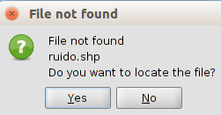
If select "Yes" it will be displayed in a new window that allow you to locate the current location of the file. If "No" is selected, the project is opened, whether to display information on the layer not found.
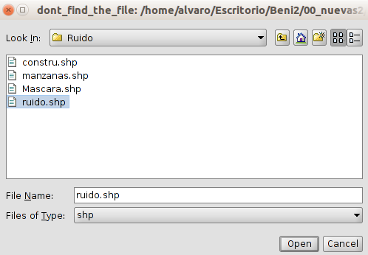
Once selected, the project will open, accessing the layer information from its new location.

