PROJECT MANAGER

6.1. Interface
Project manager is the window where all documents that are part of a gvSIG project are organized.
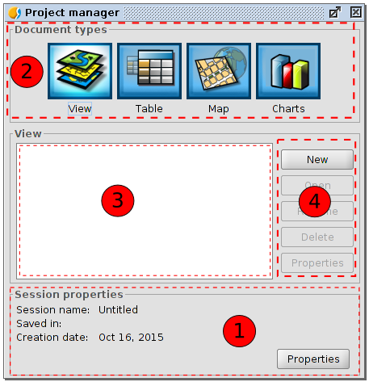
Project manager window consists of four main areas:
- Session properties. It is reported the main session data (name, location and .gvsproj file creation date).
Button "Properties" gives access to a new window where you configure the properties of the session.
In session window "Properties" we can change the color selection. By default gvSIG uses yellow color to indicate that an item is selected.

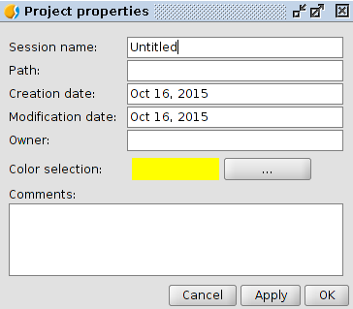
- Type documents. Shows the documents available in gvSIG. The typical installation of gvSIG shows four types of documents (View, Chart, Map and Graphic); some compplements can add new types of documents.
Clicking on the icon of one of these documents, change its lighting, indicating that it is the active document, activating the 3rd and 4th areas for this type of document. By default, when you create a new project, the View document is active.
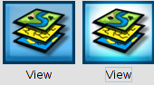
- Document list. Displays the list of existing documents on the selected document type. If, for example, the View document is selected, all views created in the project appears. If no element is created the box stay blank.
- Toolbar. It contains tools to create, open, rename, delete and access the properties of each type of document.

Quick access to project manager: using the "Show/Project manager" menu or the Shortcut "Alt + P" gvSIG shows the project manager in the foreground.

Copy / Paste documents: in the area of the list of documents, taking one of the listed documents selected, with the right button we will show a context menu that lets you cut, copy and paste documents

