preferencES

7.1. Introduction
In “Preferences” window you can set certain preferences in gvSIG configuration. These preferences apply to all sessions of gvSIG.
To open the "Preferences" dialog you can use the "Display/Settings" menu or the corresponding button.
Menu | Button
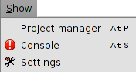
This dialog box includes several sections organized in a tree. Each section corresponds to specific settings.
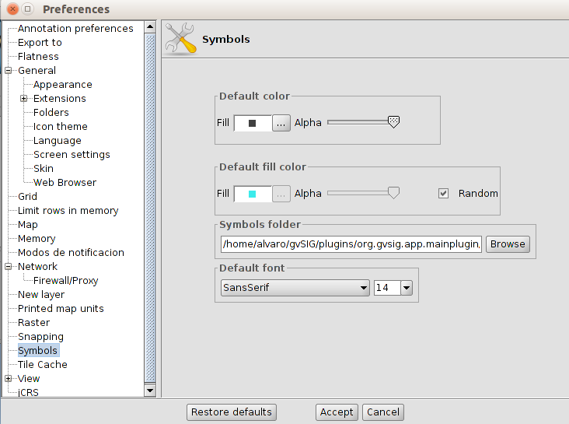

Installation of some supplements can add new setting options.

Restore defaults: eliminate changes that have been configured and restore the default settings of the Preferences window.

7.2. Settings
Here are the different preferences that can be configured in gvSIG
Anotations | It shows an options list that allow you to configure the format of the annotation layers.  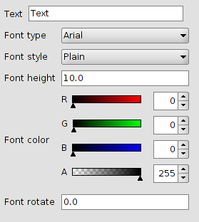
Export to | Sets the formats that appear when launching the "Export to .." from "Layer" menu tool  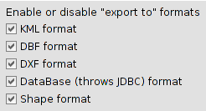
Appearence | It lets you modify the appearence of gvSIG. It requires a restart for changes take effect.  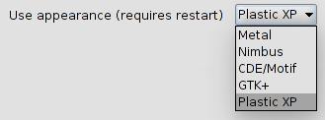
Folders | Sets default folders used to access gvSIG projects, data, map templates and symbol libraries.  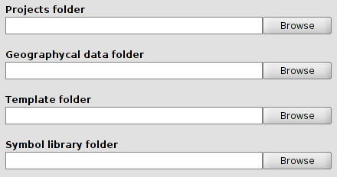
Display settings | Configure display settings resolution.  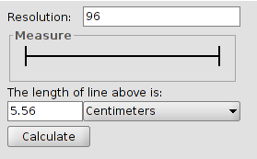  Lets calculate the resolution automatically following steps:  - Measure with a ruler on the line drawn in the "Test Measurement" dialog screen.  - Write in the text box and the measurement obtained and their units.  - Pressing the "Calculate resolution" button, will automatically provide the default resolution in dots per inch.
Add-ons | It provides access to the add-ons list, activate/deactivate and set its priority. It is not recommended to change these settings if you are not an expert on the implications of these changes.
Language | Set the interface language of gvSIG. Restart required for proper application.  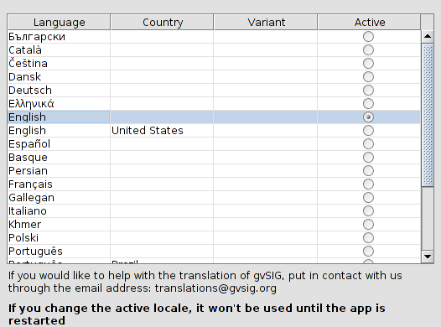
Icon Packs | Although by default only has a set of icons installed, gvSIG is prepared to apply different sets of icons to your interface.
Web Browser | Selects the default web browser will use gvSIG to those tools that require it.  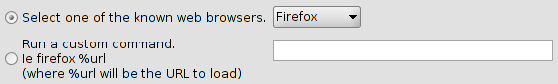
Skin | Although there is only one default skin available, gvSIG is prepared to apply different "skins" that change the look of the application.
Map | It allows you to customize preferences Map work with documents.  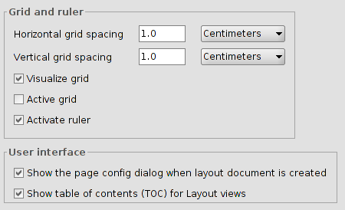
Notification Modes | Set the mode of notification of findings, with a message on the status bar or opening a window with information about the incident.  To restart gvSIG to apply the changes.
New layer | It allows you to dial the formats available for layering. gvSIG default given the option to Shapefile (.shp).
Raster | It lets you modify the default settings for working with raster data.  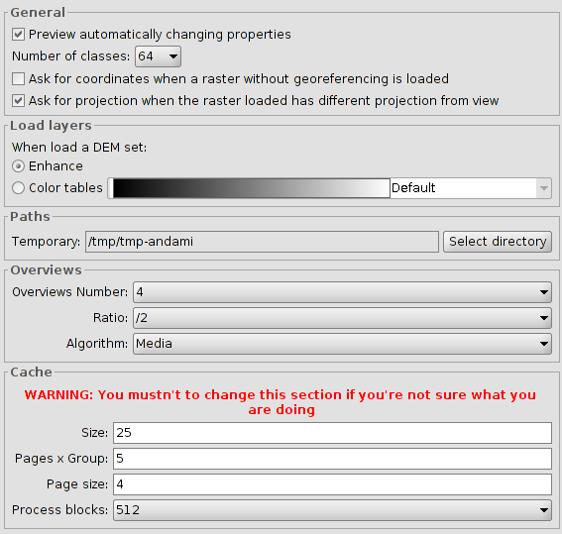
Network | It lets check the status of the Internet connection.  
Firewall/Proxy | If you connect to the Internet through a proxy, this section allows you to set the connection parameters used gvSIG.  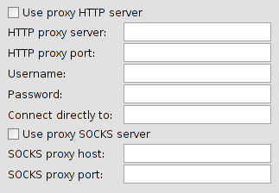
Symbols | Set the symbology that is applied by default when you add a vector layer.  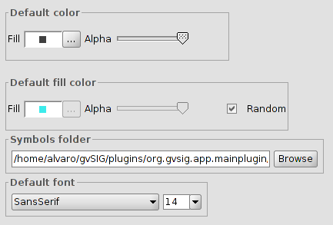
Tile Cache | Sets the cached properties that use gvSIG.  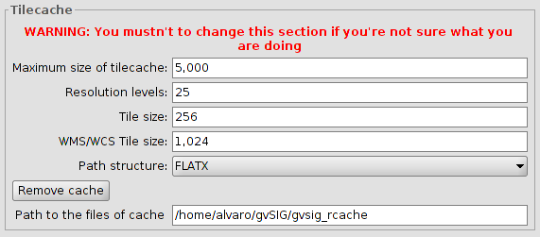
Printed map units | It sets the default measurement units.  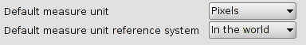
View | Sets the options for working with View documents.  Set the projection system will default to the view, zoom factors, and background color selection and units.  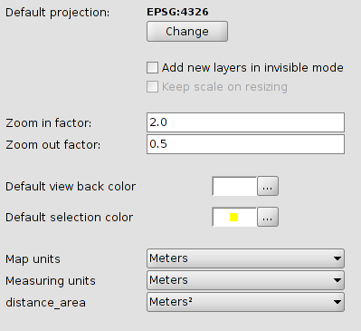
Behavior | It sets the screen refresh.  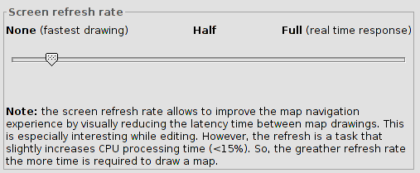
Layer order in TOC | It sets the position where a new layer in the TOC will be placed (and thus the display order).  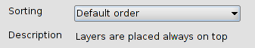
Grid | You set up the options grid.  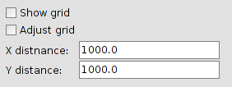
jCRS | Through the "Plugin Manager" you can install different versions of the EPSG data base.  In this section we can select, if you have more than one EPSG database installed base, which we want to work with.  