VIEW DOCUMENT

8.1. Create a view
To create a new View in a gvSIG project from the “Project manager”:
- Select the View icon.
- Choose the button “New”, then automatically the View is open.
A new view with the name “Untitled” appears by default. You can change it by clicking the button “Rename” from the project manager (The View that we want to rename should be selected). Then a dialog box appears where we can type the new name:
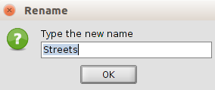

From the View Properties window you can also rename the View.
With the “Delete” button from the project manager you can delete the selected Views.
With the “Open” button from the project manager you can open the selected Views.

8.2. View properties
You can open the View properties configuration window trough:
- An open View document , in the “View/Properties” menu.
- From the “Project Manager” and having the View selected, click the “Properties” button.
Menu (View document) | Button (Project manager)
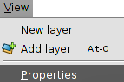 | 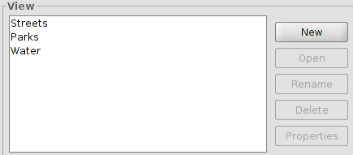
The configuration options from the View properties window are:
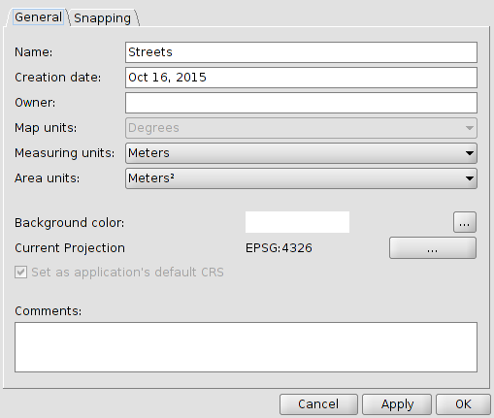
- Name: The View’s name. You can rename the View.
- Creation date: Date created of the View.
- Creator: this is optional, to specify the creator of the View.
- Map units, measures and areas: dropdown box where you can choose the measure units for your work (meters, miles, yards,...).
- Background color. White is the color by default. But you can change the View background color. A new window with tabs for the different options of color selection will be displayed.
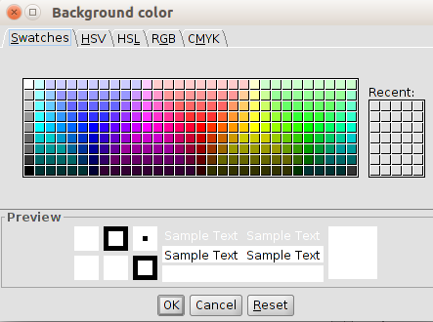
- Current projection: The default projection is EPSG:4326. You can select another projection. It will display a new window (see “coordinate system” topic).
- Comments: You can add comments about the View.
All options in this window only apply to the current document view. In the dialog box gvSIG “Preferences” we can change the background color and the default projection.

Certain supplements (plugins) can add additional tabs to the View properties dialog box.

