COORDINATE SYSTEM

9.1. Change the View Coordinate System
Each View uses a coordinate system to visualize the data properly. It determines the map projection of the View.
The View coordinate system doesn’t need to be the same to the data used in the view, since gvSIG has reprojection options available.
The gvSIG Views uses the “EPSG:4326” projection by default. From the View “Properties” we can change the coordinate system of a View and make geographic transformations.
When you open the projection dialog box named “New CRS” from Coordinate Reference System, it will display a list of coordinate systems used recently.
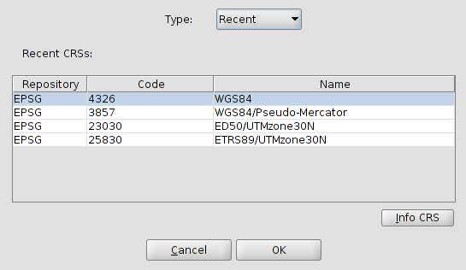
Using the dropdown “Type” you can access the rest of options that gvSIG provides to select a coordinate system: EPSG, CRS, ESRI, IAU2000 and CRS user. EPSG contains the official coordinate systems more used.
European Petroleum Survey Group or EPSG was a scientific organization linked to the european oil industry. EPSG compiled and spread a set of EPSG geodetic parameters, a widely used database containing ellipsoids, datums, coordinate systems, map projections, etc. The roles performed by the EPSG previously were taken up by the International Association of Oil and Gas Producers Surveying and Positioning Committee (OGP) in 2005.
This Spatial Reference Identifier system (SRID, English acronym) is still know as EPSG (Source: Wikipedia)

Select the type “EPSG” from the dropdown box and it will display the following options to find a coordinate system.
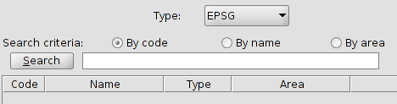
- Indicate the Search criteria (code, name or area).
- Write the text string you want to search, either a code, name or geographical area.
- Click the “Search” button. The list of coordinate system containing the text string will be displayed.
- From the list select the CRS that you want to apply to the View and click OK.
The “InfoCRS” button that is in the “New CRS” dialog box allows access to the report of the coordinate system properties.
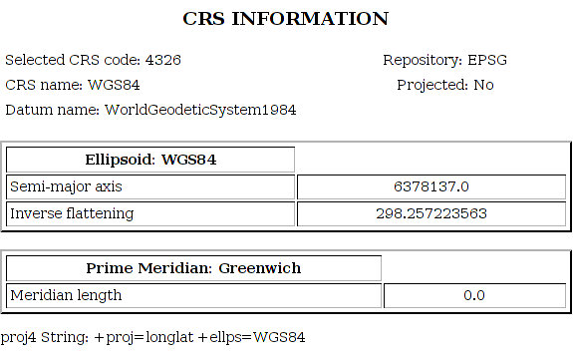

9.2. Define a User’s CRS.
It allows the definition of user’s CRS. When you select “User CRS” type, in the “New CRS” window, the following options are displayed:
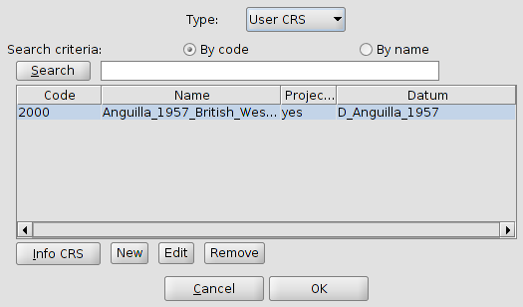
- Choose a previously created CRS, you just need to select it from the list with the different user’s CRS available y click OK.
- Choose the “Edit” button to modify an existing user’s CRS.
- Choose the “Remove” button to delete an existing user’s CRS.
- Choose the “New” button to create a new CRS. This option will open a new dialog box with three tabs.
  - User CRS
  - Datum
  - Coordinate System.
Let’s see each of them:
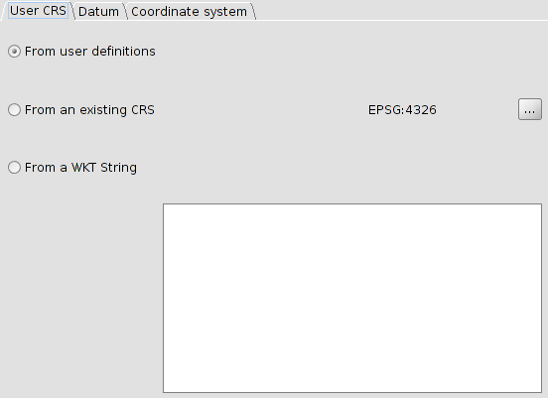
The user CRS tab lets you Select from three options to create the CRS.
- From user definitions. You can put manually all information. By selecting this option the “Datum” and “Coordinate system” panel tabs are shown empty.
- From an existing CRS. You can choose a CRS from EPSG pressing the “...” button and upload you “Datum” and “Coordinate system” data, being able to create the new CRS from these data.
- From a wkt string. Similar to the previous option, upload “Datum” and “Coordinate system” data from CRS defined by the wkt string entered.
You can paste a wkt string using the “Ctrl+V” shortcut.
The data contained in the “Datum” and “Coordinate system” panel are shown in the following images:
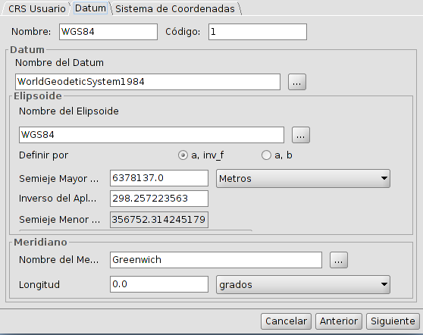
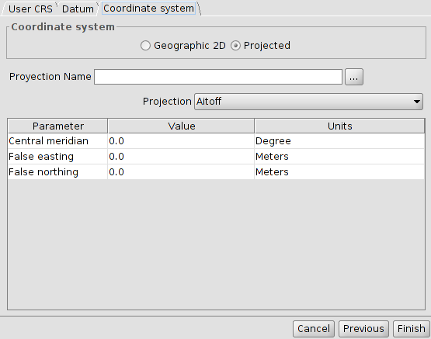
After defining the several parameters, click the “Finish” button, on the “Coordinate system” panel and the new user’s CRS will be created.

9.3. Reprojecting a layer
When adding layers to a View with different CRS, we have the option of reprojecting them. To do this simply indicates the projection of the layer and if necessary a geographic transformation.
The window for reprojecting a layer is similar to the “New CRS” window, adding the function of applying a geographic transformation.
For more information see the “Add layer” topic.

9.4. Reprojecting a layer with PRJ file
A PRJ is a file which goes associated with an information layer (shapefile, raster…) and contains information about the coordinates reference system of that layer.
In gvSIG there is support for PRJ files, so that application will interpret these types of files and will identify the layer projection automatically. Similarly, when creating or exporting the layer Hill automatically generate its PRJ file.

