VIEW InterfaCE

10.1. View Interface
The Views are the gvSIG document that constitute the main working area of the geographical information. In a view you can display different layers of information (hydrography, road networks, administrative boundaries, contours, etc.).
When you open a View from the project manager, a new window composed of the following sections appears:
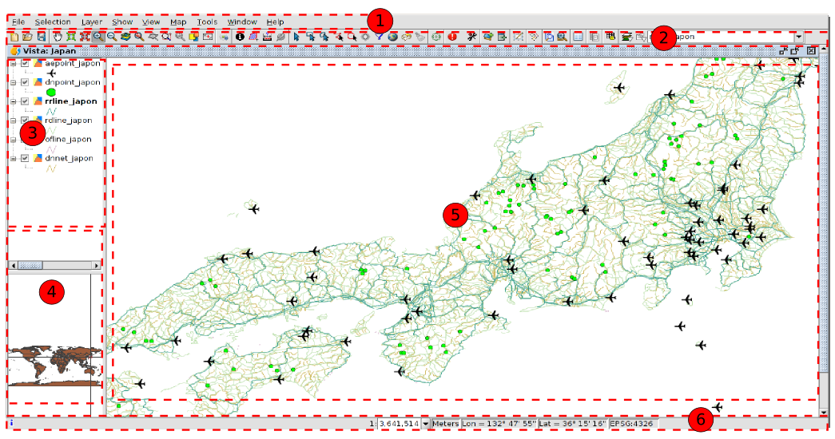
- Menu toolbar.
- Buttons bar.
- Table of contents (ToC): All the layers containing in the View and the Legend representing the simbology of each layer are listed.
- Locator. Displays the current frame in the total work area.
- Visualization area. Workspace where the geographical information is displayed and the main work is taken place (navigation, selection, edition, etc.).
- Status Bar. Displays information of the View coordinate system, scale, coordinates and units. The information resulting from the use of certain tools is shown in the status bar.
The 3, 4 and 5 components are resizables, dragging its edge to the right/left and for the Locator and the TOC from up/down.

