Create a new layer

12.1. New Layer
It allows us to create a new Shapefile layer.
It is available from the View/New Layer menu.
The interface guides us through the steps to create a new layer:
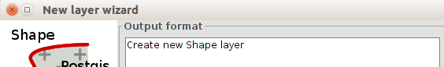
- We must select “Creat new Shape layer” and click on “Next” button.
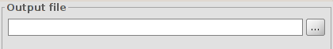
- Output file. It allows us to indicate the name and file path where the new layer will be saved.
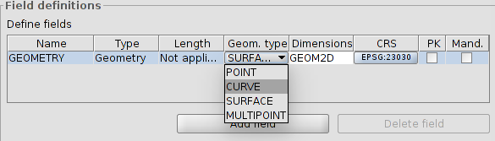
- Field definitions. It allows us to define the type of layer.
- Point: Point.
- Curve: Line.
- Surface: Polygon.
- Multipoint: Multipoint.
- With the “Add field” button we can add attribute fields to the new layer. Once the geometry type and possible additional fields are set, click on the “Next” button.
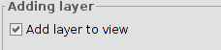
- At last, we can add the new layer to the View. Click on “Finish” button to finish.

12.2. Layer export
It allows to export a vector layer. All the elements of a layer or only a selection of them can be exported. Supported formats for export are kml, dxf, shp and PostGIS.
It is available from “Layer/Export to...”
A new window allowing us to select the export format opens.
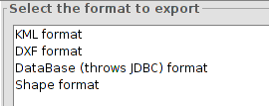
Once the format is selected, click on the "Next" button. We are then guided through the export process. Export options depend on the selected format.

12.2.1. Export layer to a shp format
It allows us export a vector layer to a shapefile.
The interface will guide us through the export process:
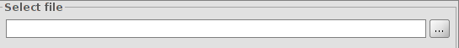
- First of all, we must select the name and file location of the new layer. Once those fields are set click on the “Next” button.
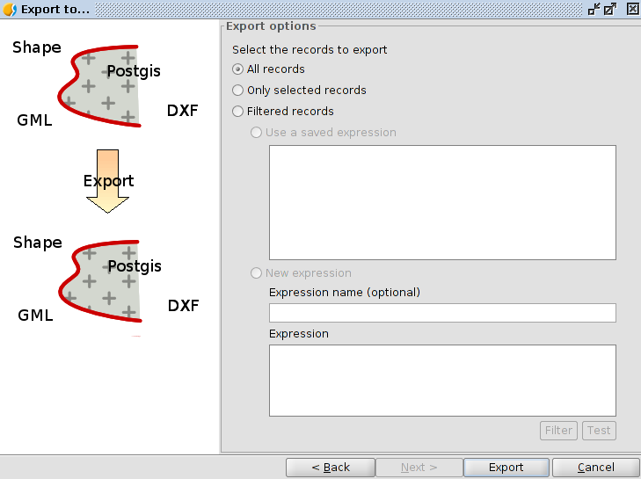
- Export options. It allows us to indicate if we want to export all the elemnts of the original layer, those that are selected or those that meet certain selected criteria. In the latter case we can enter filter expressions. To finish the export we must click on the “Export” button.

12.2.2. Export layer to a dxf format
It allows us to export a vector layer to a dxf format
The interface will guide us through the export process:
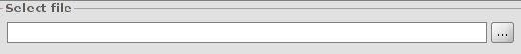
- First of all, we must select the name and file location of the new layer. Once those fields are set click on the “Next” button.
- Export options. It allows us to indicate if we want to export all the elements of the original layer, those that are selected or those that meet certain selected criteria. In the latter case we can enter filter expressions. Click on the “Export” button to finish the export.

12.2.3. Export layer to a kml format
It allows us to export a vectorial layer to a kml format.
The interface will guide us through the export process:
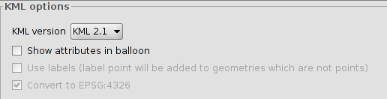
- At first we must define the kml options: version, whether we want to show atributtes in balloons and to use labels. Once those fields are set click on the “Next” button.
- We must select the name and file location of the new layer. Once those fields are set click on the “Next” button.
- Export options. It allows us to indicate if we want to export all the elements of the original layer, those that are selected or those that meet certain selected criteria. In the latter case it lets us enter filter expressions. Click on the “Export” button to finish the export.

12.2.4. Export layer to a PostGIS format
It allows us to export a vectorial layer to a PostGIS format.
The interface will guide through the export process:
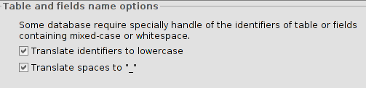
- Tables and fields name options. It allows us to select if we want to move identifiers to lowercase and spaces "_". Once this is set, press the "Next" button.
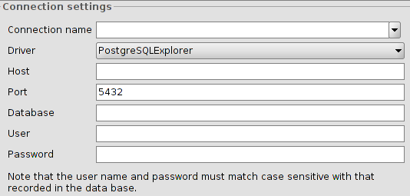
- Connection settings. It allows us to define the connection parameters of the PostGIS database to which data are exported. Once this is set, click on the "Next" button.
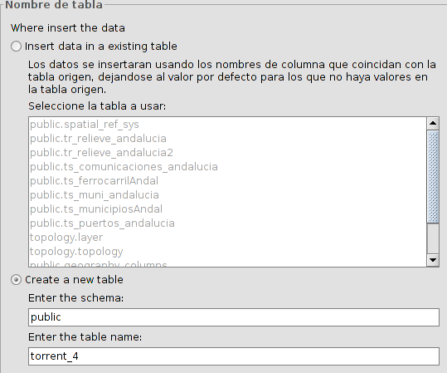
- Table name. It allows us to select if you want to insert the data into an existing table or in a new one. Once this is set, click on the "Next" button.
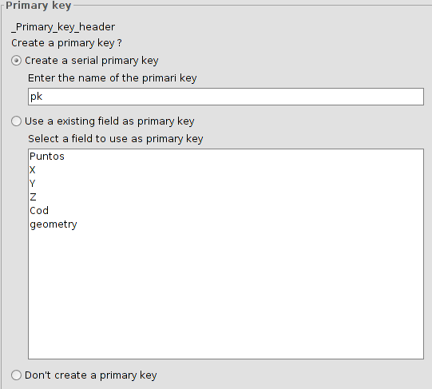
- Primary Key. It allows us to select between the different options to define the primary key. Once this is set, click on the "Next" button.
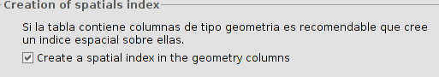
- Creation of spatial index. It creates a spatial index for geometry type fields. Once this is set, click on the "Next" button.
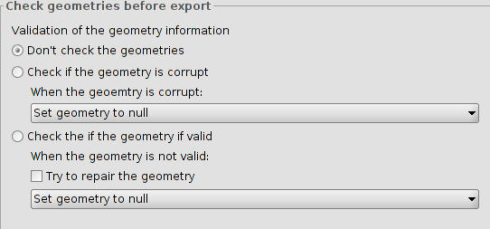
- Check the geometry before exporting. It allows the selection among different options to perform a validation of geometric information. Once this is set, click on the "Next" button.
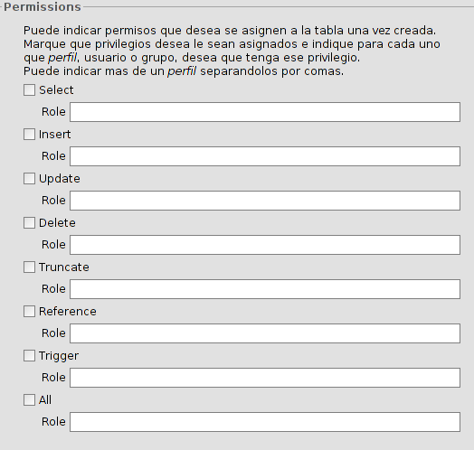
- Permissions. It allows to assign permissions to the table. Once this is set, click on the "Next" button.
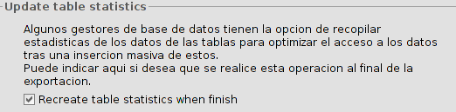
- Update table statistics. It allows to recalculate the table statistics at the end of the export. Once this is set, click on the "Next" button.
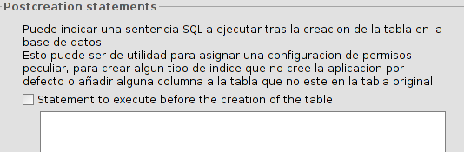
- SQL post-creation. It allows to designate an SQL statement to be executed after completion of the export. Once this is set, click on the "Next" button.
- Export options. They allow to indicate if we want to export all elements of the original layer, those that are selected or those that meet certain selected criteria. In the latter case it allows us to enter filter expressions. Click on the "Export" button to inish the export.

12.2.5. Export layer to .las (LIDAR)
This command exports a vector layer to .las format (LiDAR).
The interface guides in the steps to carry out the export:
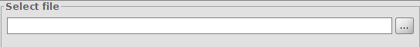
- First, select the name and location of the new layer. Once defined, click on the “Next” button.
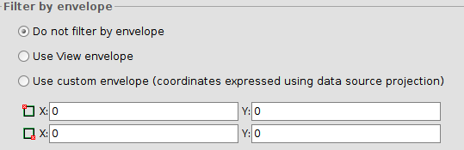
- The following steps allow one to select a sub-group of data to export them as a new file. By filtering the data, it will be exported the points within the selected geometric area. The possible options are:
  - Do not filter by geometric extension
  - Filter data by using the visible extension in the active view
  - Filter data by using a user custom geometric extension
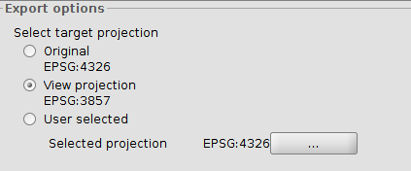
- The following step defines the projection system of the exported layer. It selects the layer’s original projection, the View’s projection (in case it is different from the original) or any other projection
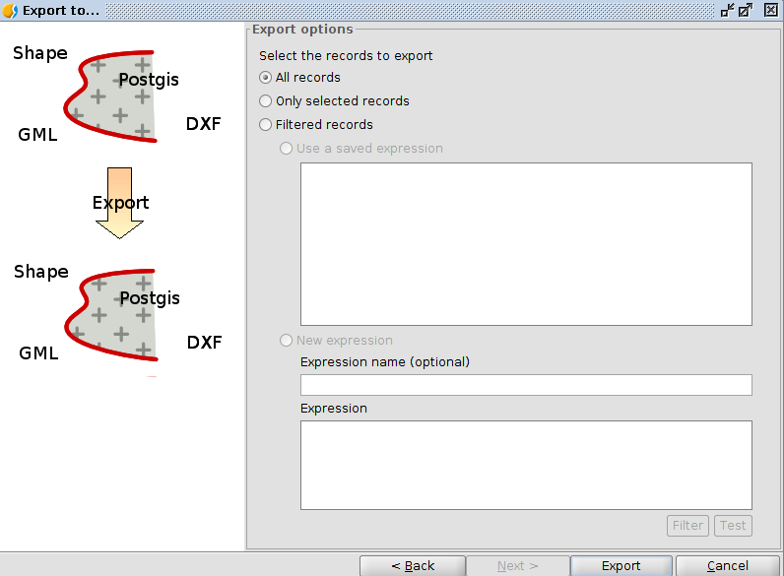
- Export options. It exports all the elements of the original layer, only those elements selected, or those elements that follow specific criteria. In this latter case, provide an expression. To finish, click on the “Export” button.
It is important to highlight that if we have loaded the layer in View with the “clarified” (simplification) of data, the export tool will respect those options; hence, it will export a simplified version of data.

12.3. Export to annotations
It allows us to export a vector layer to an annotation layer.
It is Available from the menu “Layer/Export to annotations”
The interface will guide us through the export process:
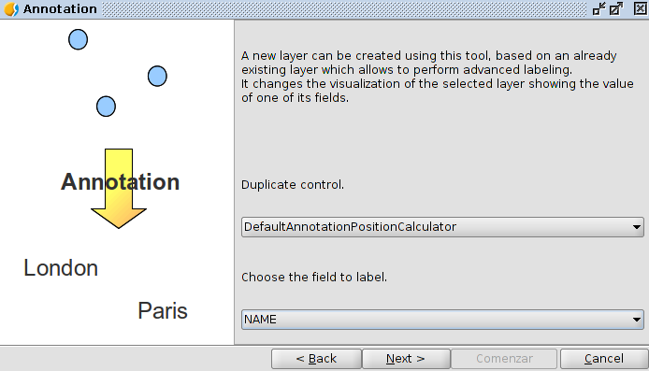
- Choose the field to label. First, we have to select the field from which the annotations will be created. Once this is set, click on the "Next" button.
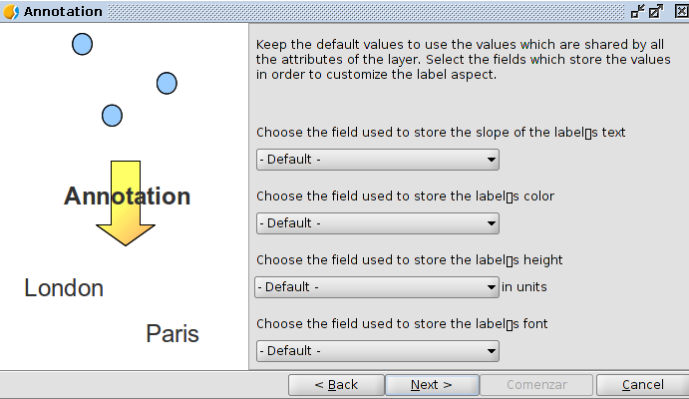
- It allows us to select fields where the different annotations properties will be stored. Once this is set click on the "Next" button.
- Select file. First, we must select the name and file location of the new layer. Once this is set click on the “Comenzar” button.
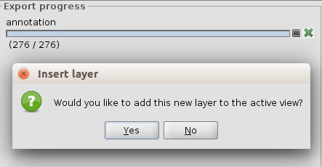
- The export process is performed and a new window allows us to select if we want to add the annotation layer in the View.

