Table of Contents (TOC). common operations with layers

14.1. Introduction
Table of Contents or TOC is the View area where the layers and its legends are listed. In the TOC we can perform some of the most common operations with layers. The TOC helps manage the display order of the layers and the assignment of symbols.
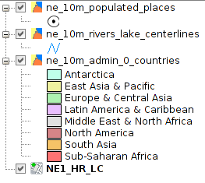
A layer is accompanied by an icon that indicates its type (file, remote service group, etc.), a legend that can display / hide and a display activation box.

14.2. Enable / disable layers
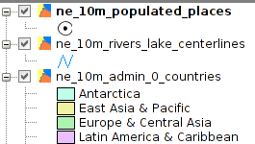 | When a layer is active we can take action on it  A layer is activated when its name appears in bold.  A layer is activated clicking with the left mouse button on it.
From the menu "View /Set all layers to" we have access to "Active" and "Inactive" orders. We can activate or deactivate all layers of the TOC.

14.3. Display / hide layers

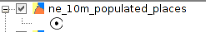 | When a layer is visible it is viewed in the map area.  A layer is visible when you have marked the checkbox.

A layer can be visible and inactive, or active and hidden.

14.4. Display / hide legends
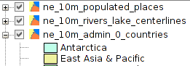 | We can show or hide the legend of a layer in the TOC.  A legend is hidden when the mark of dropdown appears with a "+". When a "-" is shown the legend is unfolded and on display..

14.5. Change the order of layers in the TOC
The order in which the layers appears in the TOC is important because it corresponds to the display order. The layers of the upper TOC are drawn on top of which are below.
It is desirable that layers formed by text elements, points and lines are at the top, leaving the lower positions of TOC for polygonal layers and images that form the background of the view.
To move and change the order of the layers in the TOC, place the cursor over them, click the left mouse button and holding it, drag the layer to the desired location.
You can also select multiple layers in the TOC pressing Control or Shift key while selecting with the left mouse button.

14.6. Layer context menu
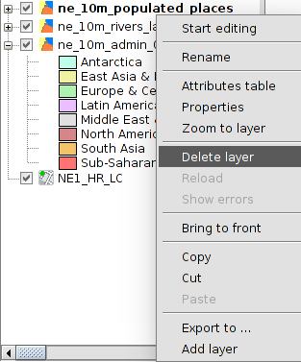 | Clicking the right mouse button on an active layer shows the contextual menu layer.  This menu contains some of the most common features that perform on a layer.

14.7. Remove layers
- Activate the layers we want to to delete.
- We click on one of the active with the right mouse button in the context menu and select "Delete Layer".

14.8. Copy / Cut / Paste layers
- Activate the layers that we want to cut or paste.
- We click on one of the active with the right mouse button and select the context menu "Cut" or "Copy" layers.
- We click the right mouse button on the view TOC-in a space where there are no layers- the context menu and select "Paste"
We can copy and cut layers in the same view or between views.

14.9. Groups of layers
gvSIG allows to group different layers in a cluster. This is useful because it enables that we can have in the TOC many layers without taking up much space therein, enabling group those that are related.
This option allows operations simultaneously on all the layers that form the group.
To make a grouping:
- Activate the layers that we want to group.
- We click on the right mouse button on one of them and from the context menu select "Grouping layers".
- A new window where the name of the Association shall indicate opens.
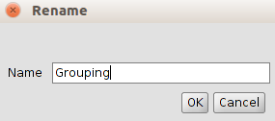
- Press "OK" and the layers will appear grouped in the TOC.
To undo a grouping, select the "Ungroup layers" option from the context menu.

14.10. Rename a layer
- Activate the layer that we want to to rename.
- We click on it with the right mouse button in the context menu and select "Rename".
- A new window showing the new layer name is displayed.
- Press "OK" and the layer will be displayed with its new name in the TOC.
The name change is at a visual level in TOC. The file name does not change in any case.

