Layer properties

15.1. Introduction
The layer properties are those characteristics that define the layer. Most layer properties can be modified by the user.
The vector and raster layers have different properties. In both cases to access the Properties window, click with the right mouse button on the layer in the TOC and select the command "Properties"(for vector layers) and “Raster Properties” (for raster layers).
Access to a vector layer Properties | 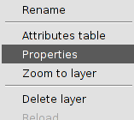
Access to a raster layer Properties | 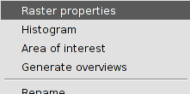
Vector layer properties | 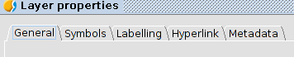
Raster layer properties | 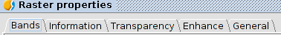
Also, it has to be taken into account that, first, the remote services have the connection properties and, second, the properties depending on being vector or raster data. In the WFS case, the connection properties are in the “Properties” window; in the rest of service cases, the two options (connection properties and properties depending on data) are separated in the context menu.
The connection properties of a remote service allow us to access to the window “Add layer” of the remote service and modify the connection parameters for that layer.
Some add-ons can add new layer properties.

