Vector layer properties

16.1. General
The layer properties show the description of the layer and allow to specify the drawing properties linked to the scale.
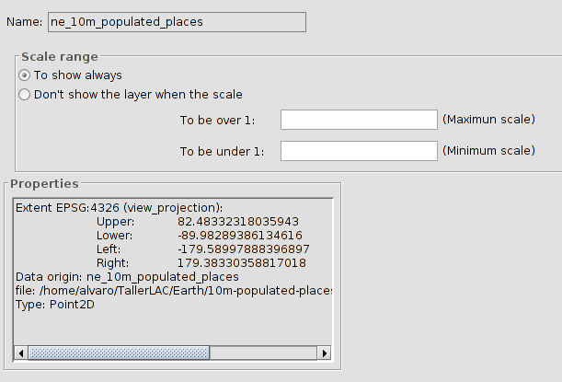
It´s possible to set the automatic visualization of the layers within a determined scale range. To set the viewing scale range:
- In “Scale range” click on “Don´t show the layer when the scale”.
- Indicate maximum and minimum values for the scale. With the denominator is enough. The greatest numbers are referred to smaller map scales.
“To be over 1:” is the greatest scale aimed which are the smallest numbers of the map scale, (maximum scale).
“To be under 1:” is the smallest scale aimed in the active layer in the view (minimum scale).
Once the scale range is defined, the layer will not be drawn if the View scale is out of the visible scale range of the layer

16.2. Hyperlink
It allows to enable/disable and set the hyperlink of one layer. A hyperlink is a link with other resource (image, website,...) and it´s associated with one element of the layer.
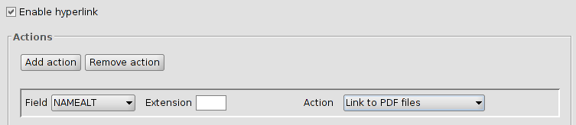
One layer can have different hyperlink´s actions. To add or delete one action, the buttons “Add action” or “Remove action” are used.
The configuration settings of each hyperlink action are:
- Field: Select the field in the attribute table of the layer containing the hyperlink (path to the resource). A drop-down menu appears with all the available fields.
- Extension: to define the resource extension. For instance, if the hyperlink is a JPG image, here “JPG” can be indicated. If the extension is indicated in the attribute table, the space should be empty; the extension only has to be used when the resource path has been indicated without the extension.
- Action: Drop-down menu with all the available hyperlinks supported by gvSIG. When the hyperlink tool is used, gvSIG will open a new window with the selected link type. Those supported links are:
  - Image files (jpg, png, bmp,...).
  - PDF files.
  - SVG files.
  - Text files and HTML.

16.3. Metadata
It allows to consult the metadata of one layer. At the moment, only the name and the CRS of the layer.
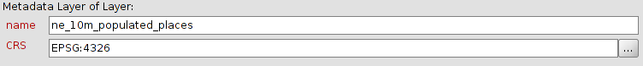

16.4. 3D
See section “3D”

