vector symbology

17.1. Introduction
The symbology is one of the most important properties of one layer. In gvSIG, a great variety of options are available for representing layers with symbols, graphs and colours. The symbols are assigned to each element depending on its attribute values and the selected symbology type.
By default, when a layer is added into the View, will be in one random colour; all the elements of the layer with the same symbol. To modify the symbology, access to the “Properties” window and select “Symbols”.
On the left part, you can see all the available legends for representing data in gvSIG. The symbology panel shows different options depending on the selected legend type.
The different legend types will depend on the layer type and the attribute type. There are some legends that they can only applied with numeric attributes.
The interface contains the following elements:
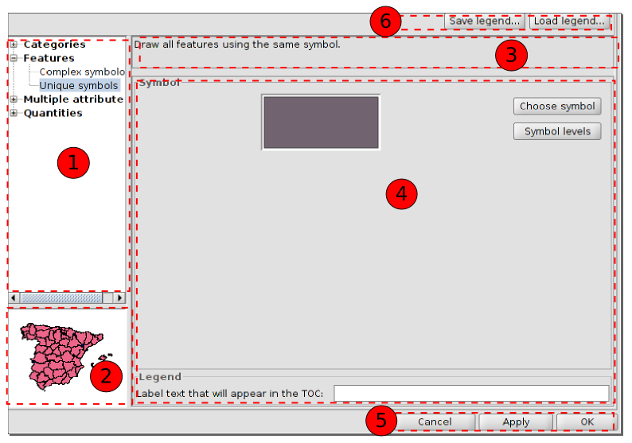
- Symbology types.
- Visual representation. It changes depending on the selected symbology.
- Description. It changes depending on the selected symbology.
- Options. To define the characteristics of the symbology. It changes depending on the selected symbology.
- Buttons to apply for the defined symbology..
- Buttons to save or load one legend.

17.2. Unique symbol
All the entities of the layer will be represented with one unique symbol. Click on “Choose symbol” to access to the “Symbol selector”.
There is an option to introduce a label text that will appear in the TOC. TOC.
To apply for the legend, click “Apply” and “Accept”.
To change the symbol or the layer colour in a fastest way, double click in the symbol that appears in the TOC and the “Symbol selector” window will open.

17.3. Categories. Unique values
Each record can be represented with a symbol according to the unique value adopted in a certain field in the attributes table. Each element will be drawn depending on the attribute value indicated by the category. For instance, in a field of a uses map, each use will have a specific colour.
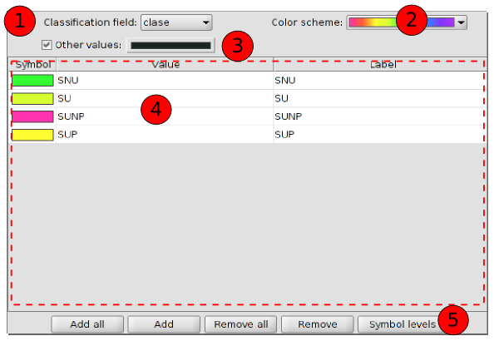
The interface contains:
- Classification field: A drop-down menu where you can select the field of the attributes layer which contains the data to carry out the classification.
- Color scheme: Drop-down menu where you can select a colour scheme for generating automatically the symbols.
- Other values: If this is enabled, all the values without a symbol for its value will be represented with a specific symbol. If it´s not active, those elements will not be shown.
- To define the symbol, the value and the label.
To modify the symbol, double click on it. A new window will open to access the screen dialogue “Symbol selector”.
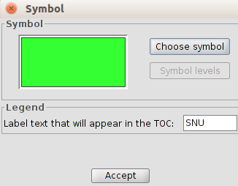
Double click on a concrete value to modify it. The value is the one found in the attributes table.
Double click on the label to modify its text. The label is the text that will appear e¡in the TOC legend. By default, the label will be the same than the value on that field.
- Buttons area
Add all/Add: Once the “Classification field” and the “Colour scheme” are selected, clicking on the “Add all” buttons, all the different values are shown by assigning a symbol (colour) different to each one. Clicking on “Add” you can add new values to the list.
Delete all/Delete: Allows to delete all (delete all) or some (delete) of the elements that make up the legend.
Symbolology level: To define a specific order of visualizing the elements. This is important when some geometries of the same layer intersect, because defining that order can make to some symbols appear over others.
It´s activated clicking on the verification space. The value “0” will be the symbol under the rest. The value “1” will be over that and so on.
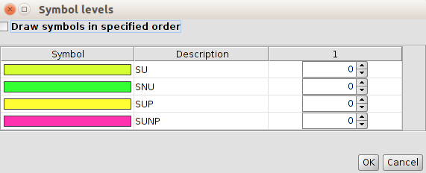

17.4. Categories. Expressions
It shows layer elements according to a certain filtered expression.
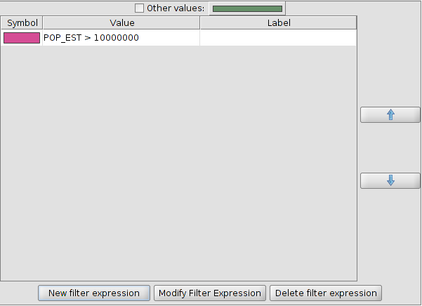
The interface contains:
- New filtered expression: The “Expression creator” window opens where you can configure expressions (filters) for applying onespecific symbol. Each of those filters will be shown as a row in the main window of this legend type. The syntax used by these filters is SLD.
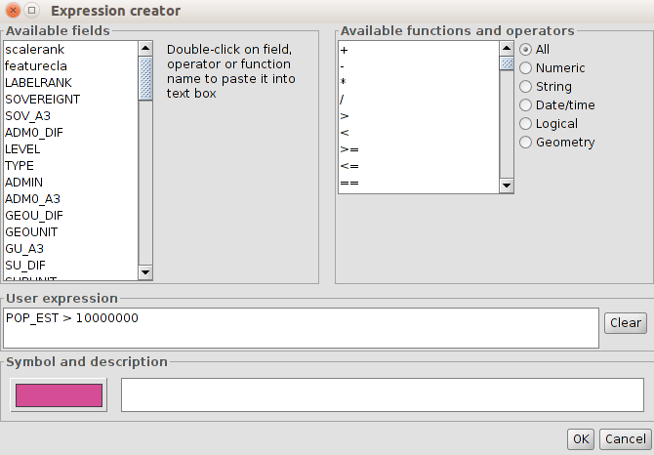
- Modify filter expression: To modify an expression by selecting it.
- Delete filter expression: To delete an expression by selecting it.
- Up/Down: To move the created expressions up or down as we wanted to have them in the TOC.
- Other values: If this is enabled, all the values without a symbol for its value, will be represented with a specific symbol. If it´s not active, those elements will not be shown. If this is enabled, all the values

17.5. Quantities. Dot density
To show the quantity of one attribute in one area as a dot density map. Each dot will be a specific number of element; for instance, in a layer of the world countries, one dot can be a population of 1,000,000.
The dots will be distributed randomly in each area and will not be real ubications.
This legend is only for polygon layers.
The interface is:
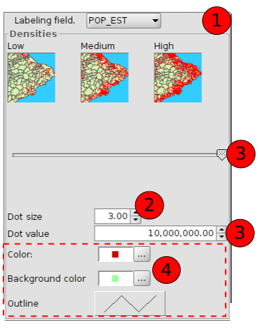
- Labelling field: Drop-down menu to choose the numeric field to make up the legend.
- Dot size: To define the size of the point.
- Dot value: this is the numeric value which will be given to each point. It can be set up with numbers or with the buttons.
- Options to define the symbology:
Colour: Dot colour.
Background colour: For the polygons in the background.
Outline: For defining the outline in the background polygons.

17.6. Quantities. Intervals
This legend represents the elements of one layer using a range of colours. Within that value range all the elements will have the same colour. The intervals or graduated symbols are used for representing quantitative data with a progression; population, temperature,....
The interface is:
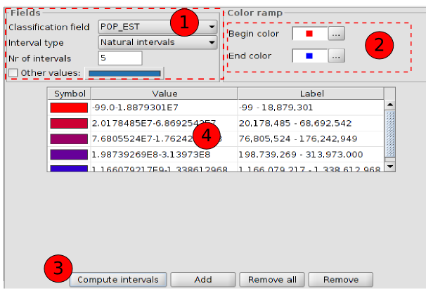
- Fields. Options to define the intervals.
Classification field: Drop-down menu to chose the numeric field to make the classification.
Interval type: There are three different intervals:
- Equal intervals: Calculate equal intervals from the values found in the selected field to make the classification.
- Natural intervals: The number of intervals are specified and the sample of this number is divided into this number according to the Jenk optimisation method, regarding to the natural localization of intervals.
- Quantile intervals: The number of intervals are specified and the sample is divided into this number but putting them into groups according to their order.
Number of intervals: To indicate the number of intervals of the legend.
- Begin color and End color: To select the colours that will be used to make the graduation. The initial colour will be for the lower values and the final one for the higher ones.
- Compute intervals: Once all the previous options have been defined, this button will calculate the intervals defined by the legend.
Add: To add new ranks.
Remove all/Remove: To delete all (remove all) or some (remove) of the elemens that make up the legend.
- To modify the symbols, labels and intervals.

17.7. Quantities. Graduated symbols
To represent quantities using the symbol size to show relative values. Within a value range, all the elements will have the same symbol.
The interface contains:
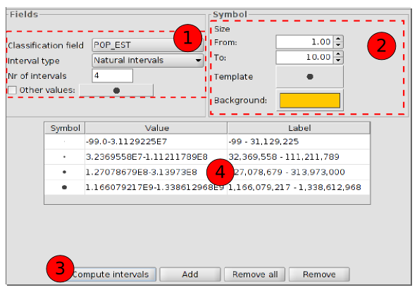
- Fields. Options for defining the intervals.
Classification field: To choose the numeric field from which the intervals will be calculated.
Interval types: There are three interval types.
- Equal intervals: Calculate equal intervals from the values found in the selected field to make the classification.
- Natural intervals: The number of intervals are specified and the sample of this number is divided into tyhis number according to the Jenk optimisation method, regarding to the natural localization of intervals.
- Quantile intervals: The number of intervals are specified and the sample is divided into this number but putting them into groups according to their order.
Number of intervals: To indicate the number of the intervals for the legend.
- Symbol: To define the symbol for the graduation. The size is defined with a minimum value (From) to a maximum value (Until). You can also modify all the features of a specific symbol by clicking on the “Template” button or in its “Background”.
- Computentervals: Once the above options have been defined, this button will calculate the intervals defining the legend.
Add: New ranks to the calculation can be added.
Remove all/Remove: to delete all (remove all) or some (remove) of the elements which make up the legend.
- To modify symbols, labels and intervals automatically.

17.8. Quantities. Proportional symbols
To represent quantities using symbol size to show exact values.
The interface contains:
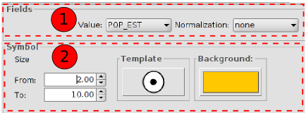
- Fields
Value: To choose the numeric field for which the classification will be made.
Normalization: It´s possible to choose a numeric field which will normalize the results, being the quantities proportional.
- Symbol: To define the symbol for the graduation. The size is defined with a minimum value (From) to a maximum value (Until). You can also modify all the features of a specific symbopl by clicking on the “Template” button or in its “Background”.

17.9. Multiple attributes. Bars
To represent numeric values of one element using bar charts. It´s useful when there are few categories.
The interface contains:
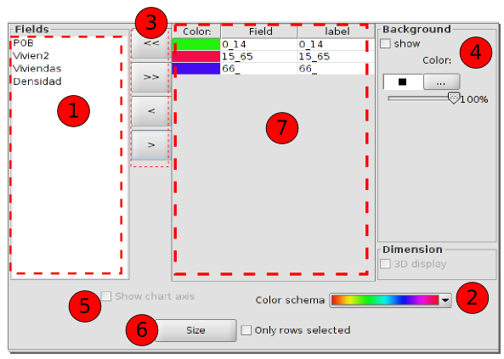
- Fields. List of all the available numeric field to be part of the chart.
- Colour scheme. Drop down menu to choose the colour scheme which will be used in the chart by default.
- Buttons to add/remove all the fields or the selected ones. The selected fields in 1 will be added in 7. The selected fields in 7 can be removed and will appear again in 1.
- Background symbol: If “show” is not active, the background will be transparent.
- Show chart axis
- Size. It opens a new window to set up the chart size. These are the options:
  - Fixed height: All charts will have the same size.
  - Sum of field values: The size of the bars will be indicated by the sum of all the records for the fields making up the chart and it will be represented in a proportional way.
  - Field size depending on one field: The chart will be proportional to a specific field.
  - Draw symbols within specific boundaries: Only the symbols within this range will be drawn, avoiding the rest.
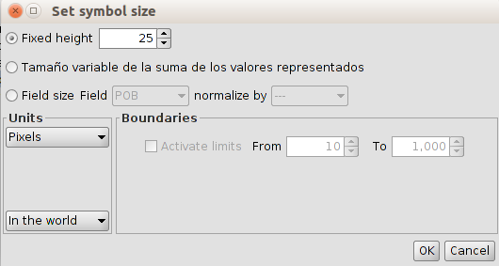

17.10. Multiple attributes. Pies
To represent numeric values of one element using pie charts. These charts show how the individual parts pèrform within a full group. They are usefule when there are not many categories.
The interface contains:
1. Fields. List of all the available numeric field to be part of the chart.
2. Colour scheme. Drop down menu to choose the colour scheme which will be used in the chart by default.
3. Buttons to add/remove all the fields or the selected ones. The selected fields in 1 will be added in 7. The selected fields in 7 can be removed and will appear again in 1.
4. Background symbol: If “show” is not active, the background will be transparent.
5. Show chart axis
6. Size. It opens a new window to set up the chart size. These are the options:
  - Fixed height: All charts wwill have the same size.
  - Sum of field values: sThe size of the bars will be indicated by the sum of all the records for the fields making up the chart and it will be represented in a proportional way.
  - Field size depending on one field: The chart will be proportional to a specific field.
  - Draw symbols within specific boundaries: Only the symbols within this range will be drawn, avoiding the rest.

17.11. Multiple attributes. Quantity by category
To represent one field of the layer with a colour intervals and other field with graduated symbols. Both fields must be numerical.
The interface contains:
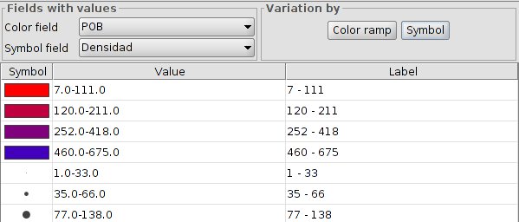
- Fields with values.
Colour field: Drop down to select the field for the intervals legend.
Graduated symbol field: Drop down to select the field for the graduated symbols legend.
- Colour ramp: Options for defining the intervals legend. “Colour ramp” will open a new window:
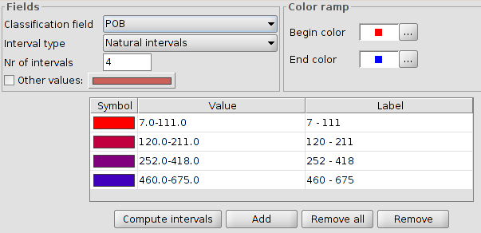
- Symbol. Options for definig the graduated symbols legend. “Symbol” will open a new window:
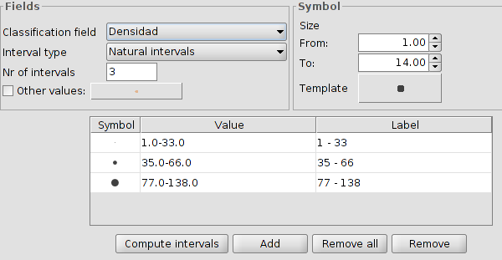
- To modify symbols, labels and intervals automatically.Permite modificar los símbolos, etiquetas e intervalos calculados de forma automática.

17.12. Multiple attributes. Join Table
TO DO

17.13. Multiple attributes. Complex symbol
To define different symbologies by scale ranges for one layer. gvSIG will apply the legend depending on the scale visualization.
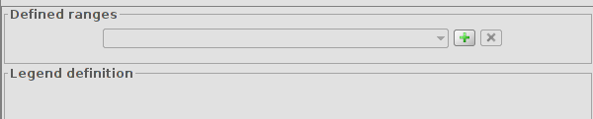
The process to create the legend by scale is:
- Ranges defined. Click on “+” to open a new window where the scale ranges can be defined.
- Define the scale ranges and legend type to apply. The legend type will be selected from a dropdown menu with all the different types supported by gvSIG.
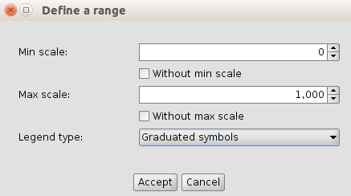
- Click on “Accept”.
- The options for defining the selected legend will be created automatically in the panel area called “Legend definition”
- Legend settings.
- Now, it´s possible to add a new legend by scale range, clicking on “+” again in the panel area called “Ranges defined”.
- Once the different legends have been defined by scale ranges, click on “Apply” or “Accept” in the “Layer properties” window.

