Raster layer properties

19.1. Information
Provides general information about the raster layer, such as the file path, number of bands, pixel size, and geographic coordinates of the corners.
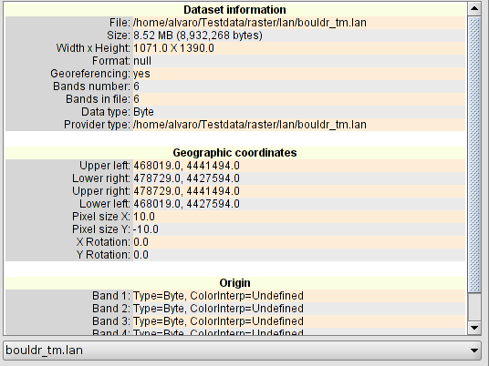

19.2. General
To change the general raster properties. It sets a scale range for the image visualization, set the NoData values, check and recalculate the statistics of the image.
The interface is:
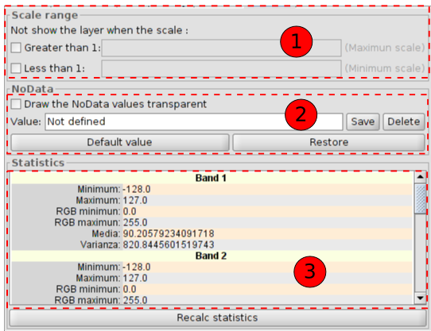
- Scale range. To hide the layer when the display scale is above or below the defined ranges.
- Set and use the NoData values as transparent if it is checked.
- Layer statistics, sorted by band. It may be the case that statistics are badly generated or not calculated, in which case is possible to recalculate them, clicking on “Recalc statistics”. In each band we will see:
- Minimum: Minimum value of the band.
- Maximum: Maximum value of the band.
- RGB minimum:RGB minimum value of the band.
- RGB maximum: RGB maximum value of the band.
- Media: Shows the average of all values of the band.
- Varianza: Shows the varianza of the band.

19.3. Bands
To change the way in which each band of the image is displayed. It allows to make compositions using the different bands of the raster.It is also possible add more bands from other files. This is useful when working with Landsat type images, where each band is from a different file.
The interface is:
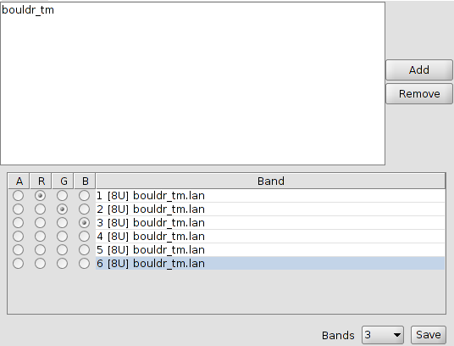
At the top there is a list with all the files of the layer. Here, you can add more files considering that must be a relation between them, they have to be from the same geographic area. This is useful for loading in the same layer, various files frome the same sensor, where each file represents a band.
At the bottom, you can select the display order. By default, the display order is assigned by the colour interpretation of the bands if this information is available. From the display selector , we can change this display order, marking the band we want to be displayed in red (R), green (G), blue (B) or alpha(A). If we click on “Save” the interpretation of colour we have at the moment in the picture will be saved. This means that the next time we open it with gvSIG, the bands will be displayed in that order.

19.4. Transparency
It provides tools to change the transparency levels that can be applied to a raster coverage.
The interface is:
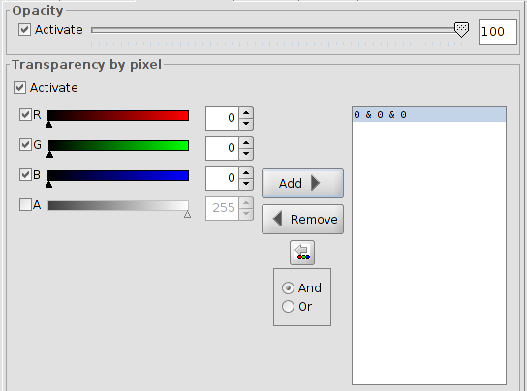
On one hand, there is the “Opacity” option which indicates a opacity percentage. A smaller percentage of opacity, a greater transparency percentage. If is enabled, it is possible to indicate the degree of opacity by numbers or by the slider.
On the other hand, there is the ”Transparency by pixel” option which allows to the (RGB) colour groups to be completely transparent. This is useful, for example, to remove the “wedges” in the ortophotos or satellite scenes, or for deleting the edges between the images of one mosaic.
We must add the RGB transparents in the layer by clicking on “Add”. Three different values will be added, separated with "&" or "|". These values mean the RGB value of the pixel which will be trabsparent. The added values are those that appear on the text boxes, the alpha value is optional. The information in these text boxes can be changed by three methods: typing the value, varying the color sliders or by clicling on the View a colour value. This last option will be activated clicking on "Select RGB clicking on the View". This activates a gvSIG tool in the View to change the RGB values in the transparency box.
If we add the line "255 & 0 & 0", all the pixels with the red colour set as the maximum (255) and green and blue set as the minimum (0), all of them will be transparent. All the full red pixels will be transparent. The symbol "&" can be changed with "And" y "Or". If "Or" is activated, any new entry in the table will appear with the symbol"|". If we add the line "255 | 0 | 0", all the pixels with a red value of 255, or with a green value 0 or with a blue value 0, will be transparent.

19.5. Enhance
It provides a tool for making enhancements over the raster coverage. It allows to modify brightness, contrast and enhance. This last option is essential for correct viewing of images of 16 bits.
The interface is:
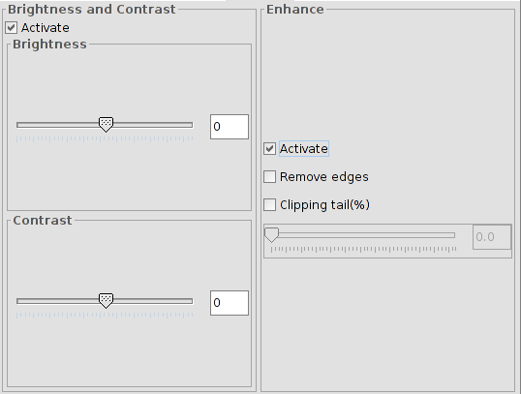

Any changes in this panel will be applied to the display and will never be aimed at generating a new layer. If we want that, the enhancement must apply from the bar raster tools "Enhance".
On the left side of the dialog appear the controls to adjust the brightness and contrast. By defaul, they must appear disabled and if we begin to manipulate, we have to select the check box "Enable".
The right side applies to the linear enhancement. This is a simplification of linear radiometric enhancement to monitor the display of images with different data byte types. By default this enhancement controls are deactivated, unless the image would be of a different data byte type; in that case, it is automatically assigned when the raster is loaded. It is reccomended only to use this interface to automatically vary the values ​​assigned. If you want to assign an enhancement and have more flexibility in the implementation, it is more appropriate to use the functionality "Enhancements Radiation".
This enhancement assigns data input range to a range between 0 and 255 for display.
"Delete ends" option does not take into account the most extreme data values ​​(maximum and minimum) of those in the raster. The "Cut queue (%)" sorts the image data from low to high values. Then, apply the percentage indicated on the right and the left. Those who remain on the outside of the percentage values ​​are removed and only values ​​matching those left inside will be applied. The effect created is to have displaced the maximum and minimum.

19.6. 3D
See section “3D”.

