Edition and symbol management

20.1. Symbol browser
From “Tools/Symbols/Browse Symbols” menu:
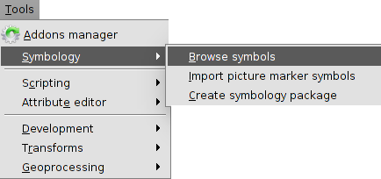
It allows to explore the different symbols in the program and they are classified in three tabs:
- Marker: Point symbols for layers containing point geometries.
- Line: Linear symbols for layers containing linear geometries.
- Fill: Fill symbols for layers containing polygonal geometries.
The interface is similar to the “Symbology selector” window which appears when we want to change any symbol of the legend. In this last case, it will not appear the three tabs, only the relevant for the layer type.
The “Symbol browser” allows to explore the available symbols and through the “Symbol property Editor” to create new symbols or modify the existent ones.
The interface is:
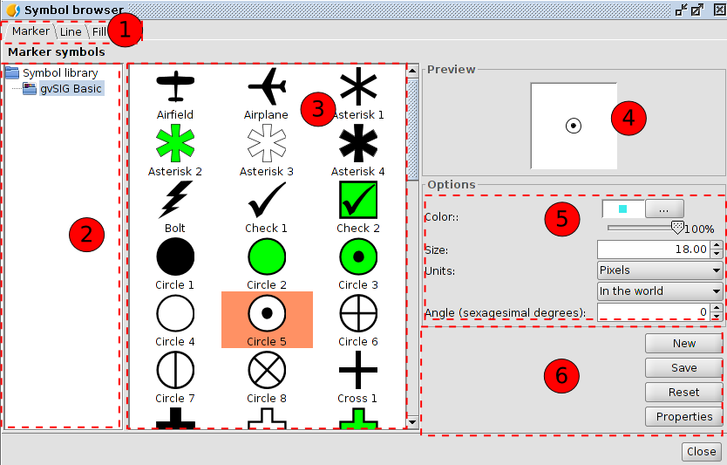
- Tabs with the different types of symbols depending on the geometry of the features.
- Symbol library. The library contains a group of symbols organized in folders and subfolders. The same library can have marker, line or fill symbols. Select the folder or subfolder to see the symbols.
- Symbol viewer of the symbols in one folder or subfolder. Select the symbol to apply or modify.
- Preview of the selected symbol according to the selected properties (size, rotation angle, colour and transparency).
- Options. To define colour, transparency percentage, size and rotation angle of the symbol.
With the units drop-down is possible to choose the unit type to apply. By default is pixel, but is possible to choose between, kilometres, meters, centimetre, millimetres, miles, yards, feet, inches, degrees and pixels. Also, is possible to specify if they are units “in the word” (the size will depend on the zoom) or "in the paper" (it will have a fixed size in screen and printing).
If it is an image file (svg, jpg,...) the colour and transparency will not be applied.
- Buttons to create a new symbol (button “New”) or modify the properties of one already existent (button “Properties”). In both cases the “Symbol Property Editor” will open.
The button “Reset” to start again with the edition of the symbol, deleting all the changes.
The button “Save” to save the new symbol. It will be saved with the extension.gvssym. By default, it will be saved in the “Symbols” folder, which is the root of the symbol library list. The user will have to save the symbol in the folder or subfolder chosen by the user.
The gvSIG basic installation has one single symbol library called “gvSIG Basic”. It is possible to install more symbol libraries from the “Addons manager”.

20.2. Editor. Simple marker symbol
Selecting the “Symbol marker symbol” the interface is:
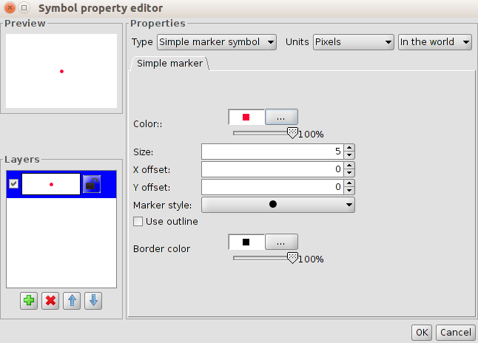
In the left side, there is the symbol preview and the list of the layers. The selected layer is the one with the values showed in the right side (color, size,...)
Simple marker symbol options:
- Colour. Marker colour. It is possible to apply transparency.
- Size. Marker size.
- Offset in X and Y. To move the symbol in relation to the X axis and Y axis.
- Marker style. To select between the available markers (circle, square, cross,...)
- Use outline and border colour. Enabling the space, the marker will have the chosen colour. It is possible to apply transparency.
With the options in “Layers” is possible to create a symbol composed by different layers, with the button “Add layer (green +)”.The layers can be deleted or ordered, with the buttons “Delete layer” and “Order layer”
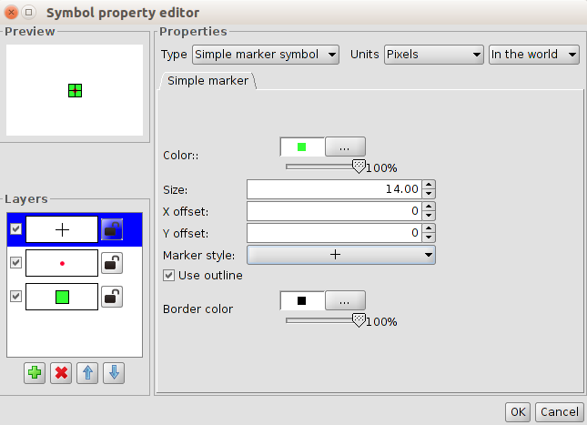

20.3. Editor. Simple marker symbol
Selecting the “Simple marker symbol” the interface is:
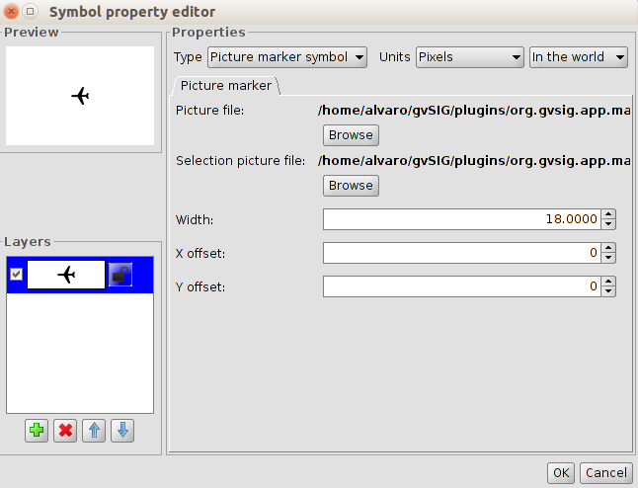
It is possible to select the image for representing one symbol. This image can be (jpg, png,bmp, svg,..) To add it, select the path to the image, clicking on “Browse” and “Picture file”.
Also, it is possible to put as a reference any image “URL” if the format is supported by gvSIG.
There is the option to select other image to represent the geometries when they are selected in the View with the path “Image of selection”.
It allows displacement in X e Y depending on the X axis and Y axis of the image.

20.4. Editor. Simple line symbol
Selecting the “Simple line” the interface with three tabs is:
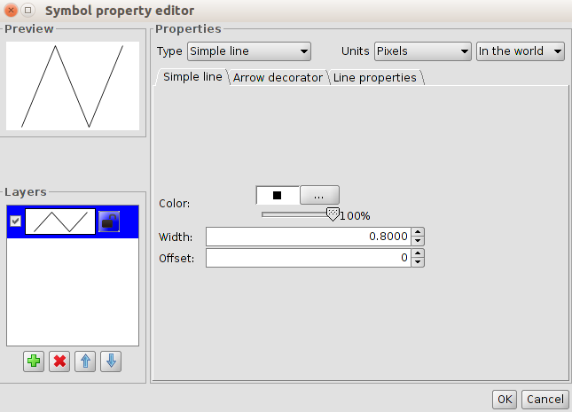
In “Simple line symbol” are the options to select the colour of the line, the transparency, its width and the offset.
As the point layers, it is possible to create a line composed by different lines or line symbols.
“Line properties” is to modify the join and end style, along the fill pattern.
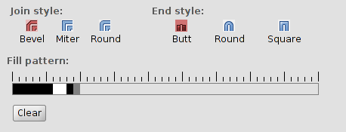
- Join style. There are three types: bevel, miter and round.
- End style. There are three types: butt, round and square.
- Fill pattern. By default gvSIG shows continuous lines. Modifying the fill pattern is possible to create dashed lines.
How it works: Click on the grey section over the ruler and move it to the right. Then click over the ruler section wanted and a black section will appear, which can be deleted if clicks again in a new section. This way new sections to define the line can be added. The black sections are the filled sections and the white ones will be transparent. To delete the created line, press “Clear”.
“Arrow decorator” allows to use the decorate the arrows of the lines enabling “Use decorator”.
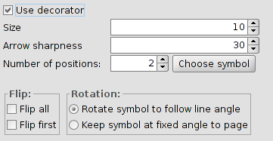
The options are:
- Arrow size
- Arrow sharpness
- Number of positions. Number of times that the arrow is repeated in one line.
- Choose symbol. It opens the “Symbol selector” window for markers. It allows to select the arrow shape and set it up as a dot symbol.
- Flip. To flip just one arrow or all the arrows.
- Rotation. Rotate symbol to follow line angle or keep symbol at fixed angle to page.

20.5. Editor. Picture line symbol
Selecting “Picture line symbol” the interface is:
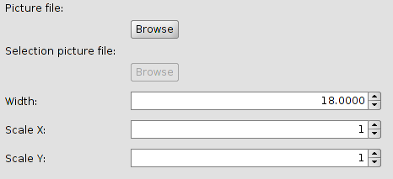
It is possible to select the image that we want to be part of the line. This image has to be (jpg, png,bmp, svg...). To add it, select the route path to the image clicking on “Browse”.
There is the option to set up the width and scale the image in “X” and “Y”.

20.6. Editor. Simple fill symbol
Selecting “Simple fill symbol” the interface is:
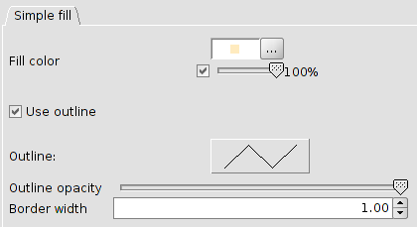
It is possible to select the fill colour of the polygon and its outline opacity.
Clicking on the button showing the border, the “Symbol selector” for lines is open to set up the outline.
There is the option to set up the width and the outline opacity.

20.7. Editor. Picture fill symbol
Selecting “Picture fill symbol” the interface with two tabs is:
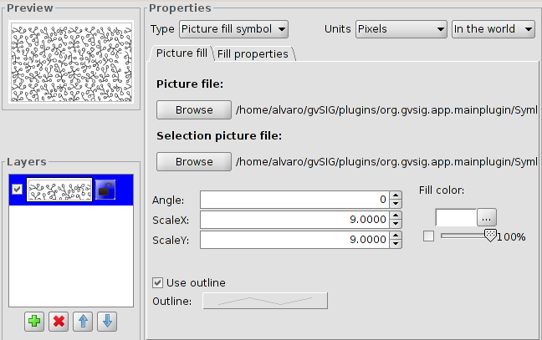
To fill the polygon with one image. It is possible to modify the angle and scale it in “X” and “Y”.
It allows to choose the fill colour and transparency.
These images can be outlined with different lines.
The tab “Fill properties” is to set up the fill depending on the offset (in X and Y) and the separation (in X e Y) of the image.
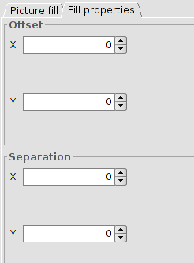

20.8. Editor. Marker fill symbol
Selecting “Marker fill symbol” the interface with two tabs is:
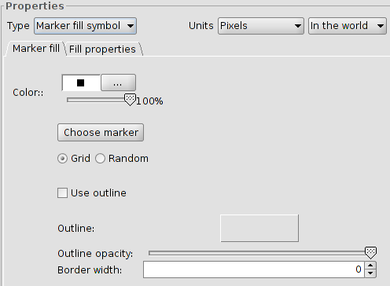
It is possible to give a fill with different marker types: dot, images....with their properties. The fill can be placed as grid as randomly..
The tab “Fill properties” is to set up the fill depending on the offset (in X and Y) and the separation (in X e Y) of the image.
