symbol libraries

21.1. AIGA
AIGA is the American Institute of Graphic Arts acronym. AIGA is known by its activities in graphic design, specially in the pictograms for the American Department of Transport in 1979. The library is based on this pictogram group.
The symbols for lines and fills are inspired on the colour palette of the document “Thinking inside the box. AIGA identity and branding guidelines“.
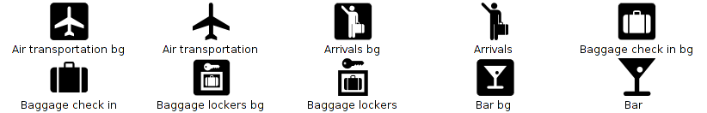
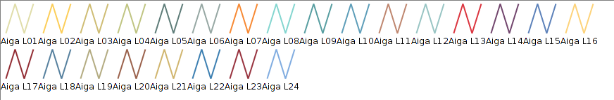
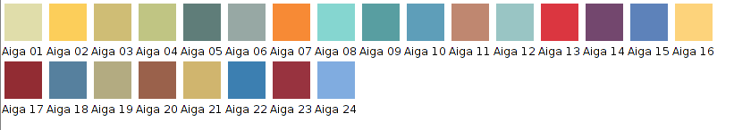

21.2. Collective Mapping
It is a symbology orientated to the collective mapping workshops. It is far from the usual symbology for geographic elements. Its iconography is orientated to ideological representation.
This library is based on the “Collective mapping tutorial. Critical mapping resources for shared mapping ” in Spanish, by Iconoclasistas.
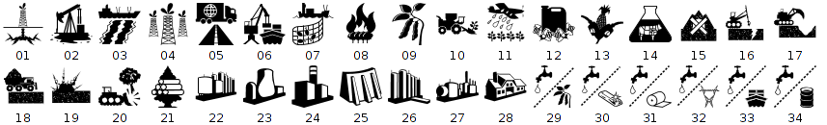
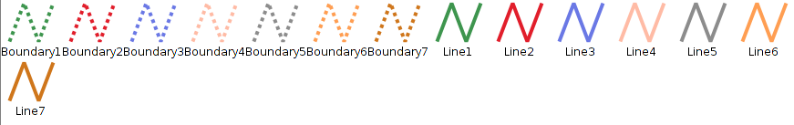
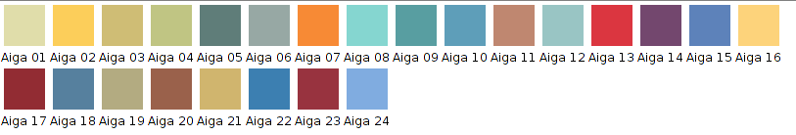

21.3. Colours
Symbology with colour palettes for quantitative data..
The symbol library is based on the colour palettes of “Colour Brewer: Colour Advice for Maps”.
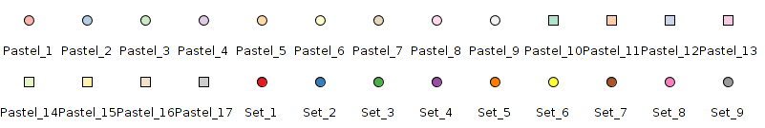
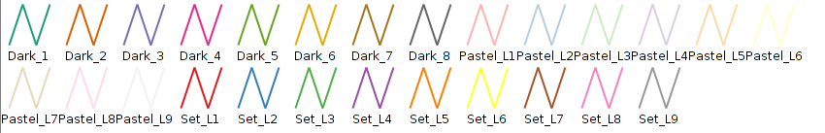
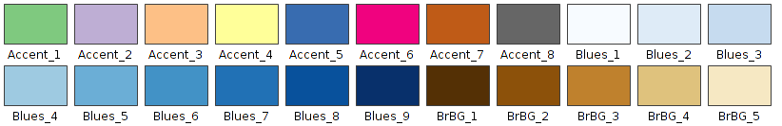

21.4. Commerce
Symbology for commercial activities.
The symbol library is based on the symbols of E-commerce Business Icons of Design Contest, GIS/GPS/MAP Icons of Icons-Land, Bag And Boxes Icons of Babasse and Vista Artistic Icons of Lokas Software.
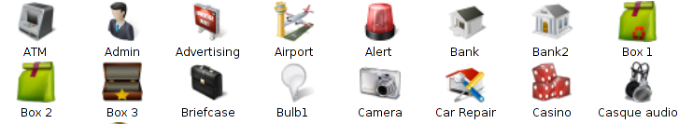
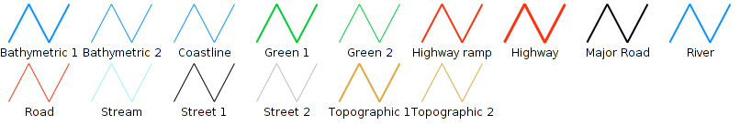
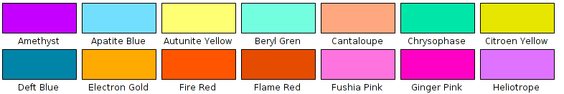

21.5. Crime Mapping Symbology (CMS)
This symbol library is based on the “CMS. The Crime Mapping Symbology”, designed by the US Department of Justice for covering the symbology needs of the Police Department. CMS includes two core systems, Computer Aided Dispatch (CAD) and the Records Management System (RMS).
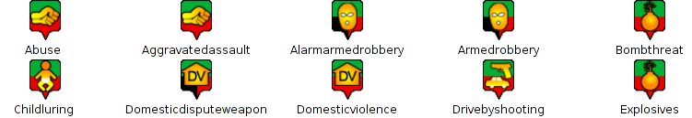
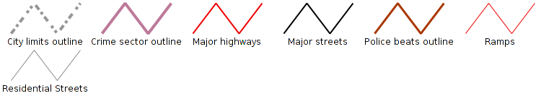
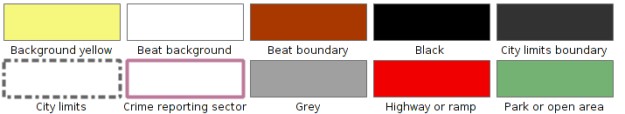

21.6. Emergency
Symbology related to the emergency management.
The symbol library is based on the “EMS. The Emergency Mapping Symbology”, made by the Department of Natural Resources.
The linear and fill symbols are inspired by the document “Biosecurity Emergency Management – Mapping Symbology”.
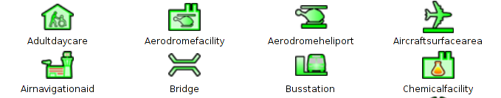
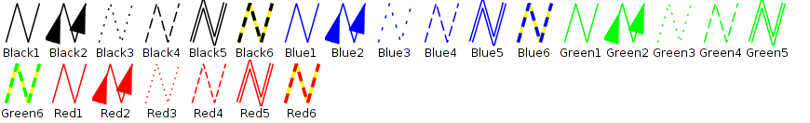
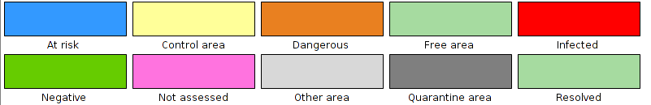

21.7. Forestry
This symbol library is based on the NPS (U.S. National Park Service) symbology and also based on “Trees & Shrubs” made by Jim Mossman.
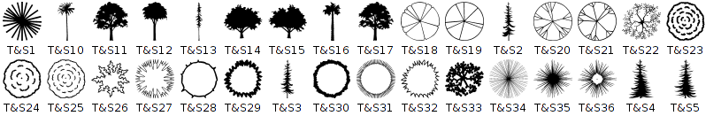
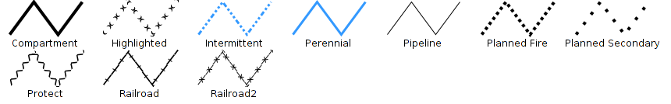
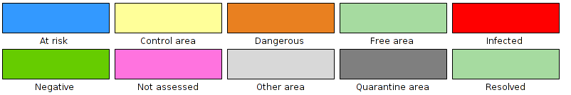

21.8. G-Maps
This symbol library is based on the symbols of Nicolas Mollet, called “Map Icons Collection” and is for Google Maps.
When using point symbols you have to remember that, by default, no “y” offset is applied thus, if you want that the symbol will be over the geometrical point, symbol properties have to be edited adding a “y” offset with a value equal to the half of symbol size (in our case, since the symbol has a default size of 32, an offset of 16 will be used).
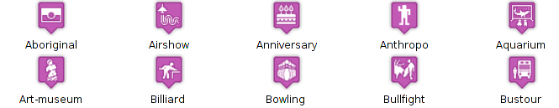
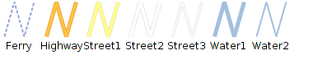
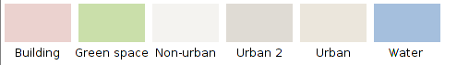

21.9. Geology
This symbol library is based on the “Digital Cartographic Standard for Geologic Map Symbolization “ guide of the FGDC (Federal Geographic Data Committee). The symbols are classified in folders and subfolders (bedding, cleavage, eolian, pluvial/alluvial, foliation, geohydrology…).
The set of filled designed from the RGB colour codes defined by the CGMW (Commission for the Geological Map of the World) represent the different stratigraphic units.
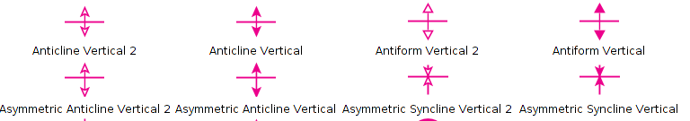
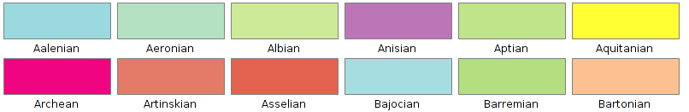

21.10. gvSIG Basic
Basic gvSIG symbol library
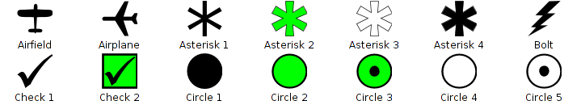
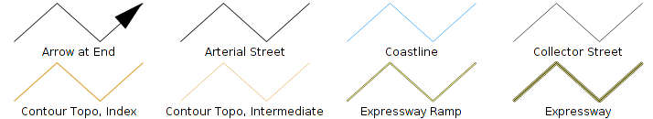
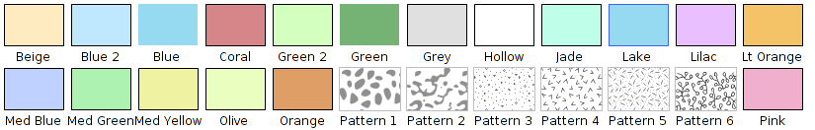

21.11. Japanese
The symbology used in Japan for the representation of maps. It is based on the “Japanese Map Symbols” of the Geographical Survey Institute.
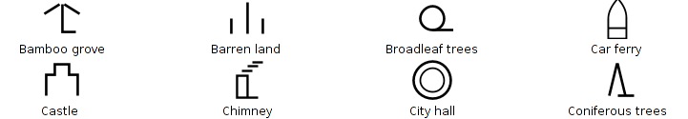
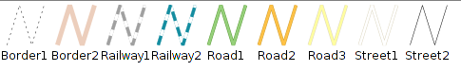
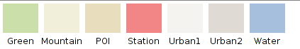

21.12. Military-APP6
This library has all the symbols which are part of the APP6 standard used by the Defence sector. This library is based on the document “Commented APP-6A – Military symbols for land based systems. Defence Research and Development Canada – Valcartier. Technical Notel DRDC Valcartier TN 2005-222. “.
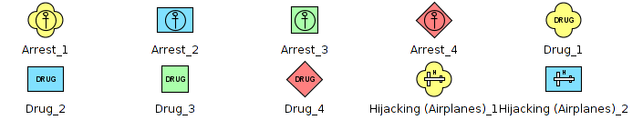
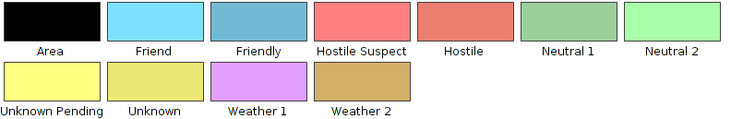

21.13. Navigational
Symbology used for maritime shipping and nautical charts.
This symbol library is based on the symbology used by the IHO (International Hydrographic Organization) and the ECDIS (Electronic Chart Display and Information System).
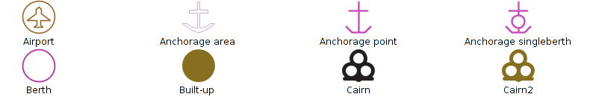
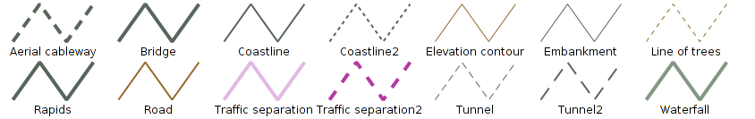
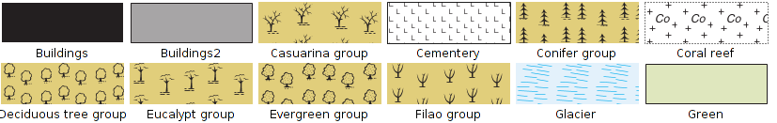

21.14. Numbers
Library with numeric symbols.
This library is based on the symbols of “Letters & Numbers” published by Little Web Things that contains beyond symbols from number 0 to 99, letters symbols in upper-case of Latin alphabet, text fonts from Data Deja View (DDV) called “Circle, Diamond, Hexagon, Pentagon, Shield and Square”, that and the numbers icons belonging to the set called Red Orb Alphabet Icons of Icon Archive.
When using point symbols of set “IwtMapIcons” consider that by default it don’t have applied an offset in “y”, if wanted the vignette appears over geometric point we have to edit the symbol properties and add an offset in “y” of a half the size (in our case, as we set these symbols in size 32, we’ll use an offset of 16).
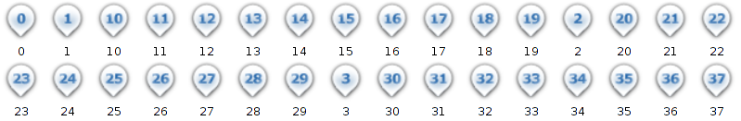
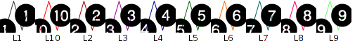
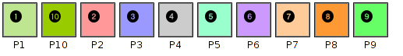

21.15. OCHA-Humanitarian
It is the set of symbols created by the Office for the Coordination of Humanitarian Affairs (OCHA) with humanitarian goals aiming help workers and volunteers show and interpret information about emergencies and crisis quickly and easily. This is the standard or the emergencies symbology.
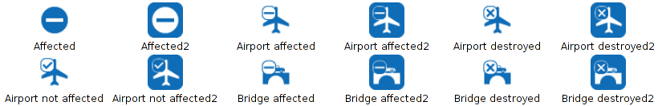
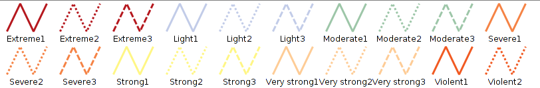
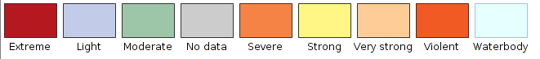

21.16. OSM
This symbol library is based on the symbology made by “SJJB Management” and called “SJJB SVG Map Icons”. Some of these icons have their oringin in the “US National Park Service Cartography”.
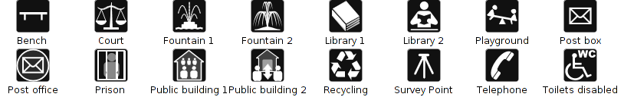
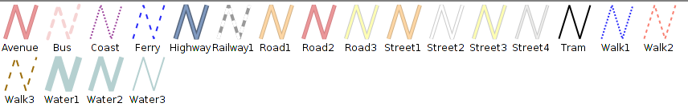
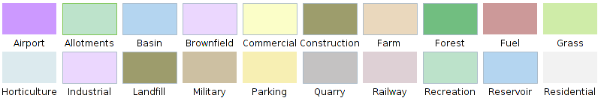

21.17. POI Cities
This library includes a set of symbols that represent the main attractions of a city: parks, airports, subway stations, different types of shops, museums, monuments, ...
It is based on the symbology that MapBox project uses and, specifically, in the library called Maki.

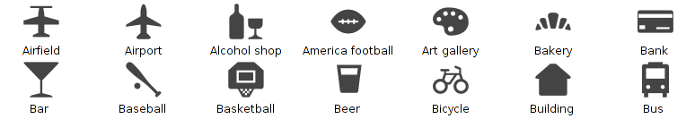
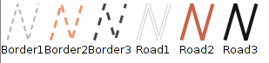
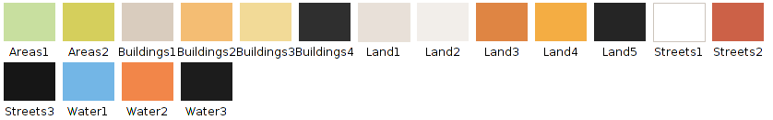

21.18. Weather
Symbology for climate mapping according to the standard World Meteorological Organization in the document “WMO No. 485 – Manual on the Global Data Processing and Forecasting System Manual” the work done by the group MetOceanDWG of OGC related to the symbology to represent the Climatology.
