Create symbol libraries

22.1. Import picture marker symbols
With the “Import picture marker symbols” tool, the user can create new symbol libraries from image files (.png,.svg,...) or add these marker symbols to libraries already installed. This tool is located in “Tools/Symbols/Import picture marker symbols”
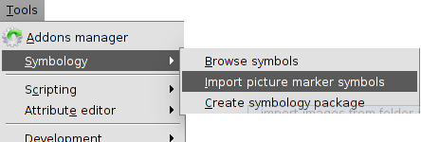
The interface is:
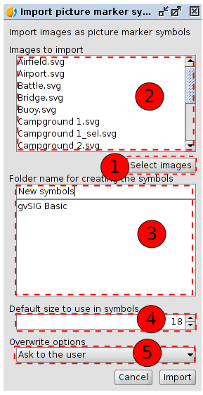
- Clicking on “Select images” a new window appears where we can search and select the images to import.
- Listing of all the selected images to be imported to the symbol library.
- In “Folder name for creating the symbols” we will indicate the name of the new library. It is possible to create subfolders. If we want the symbols saved in one subfolder, we use “/” as the separator between the folder name and the subfolder (folder name/subfolder name).
Listing of installed libraries. If the folder where we want to save the symbols is already in the list, we just need to select it.
- Size by default of the symbols.
- Drop down menu for overwriting options.
- Clicking on “Import”, all the selected symbols will be saved in the defined folder (or subfolder) with the wanted size. A window will appear indicating that the import have been finished.
If we want to have a different symbol when we make a selection, we can do it automatically during the import. We only have to take into account the name of the images that will represent every symbol during the selection; we have to add “_sel” to the symbol name.

22.2. Create package symbols
gvSIG allows to create packages for sharing symbol libraries with other users.
This tool is located in “Tools/Symbols/Create package”.
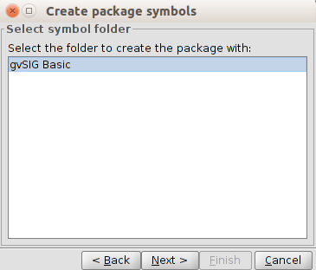
In this window we can see all the symbol libraries available in our gvSIG, in this case “gvSIG Basic”, which is the default library plus the ones created by the user. We can select the library from we want to create the package and click on “Next”.

A form appears to fill the metadata of the package.
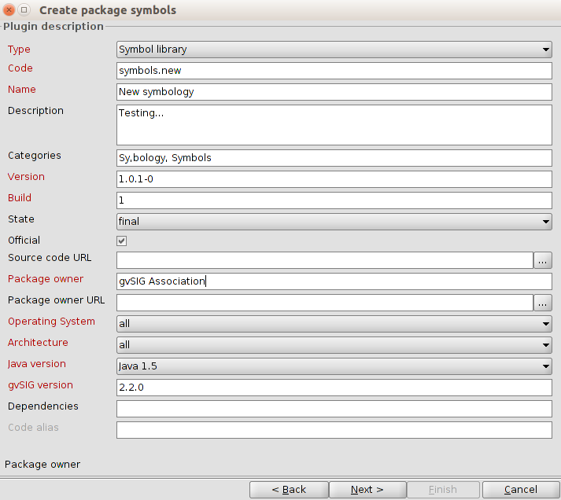
The option “Categories” must have the categories “Symbology, Symbols” to make easier the localization in “Add ons manager”.
Clicking on “Next” one last window will appear where all the output options must be indicated.
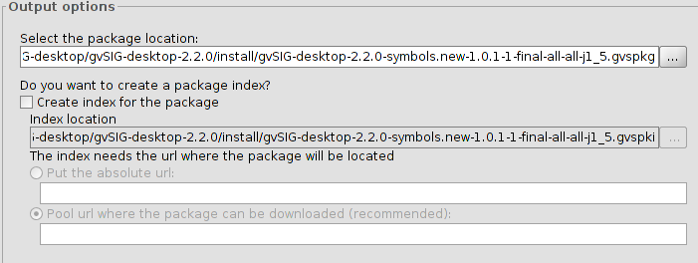
- Package file. It is the folder where the generated package will be saved in. By default, packages are saved in the gvSIG install folder, inside a folder called “install” (usually with a default name and with.gvspkg extension.
- In the case of we want to share the package from an URL, we need to take into account:
– Creating the package index. We will only check this option if we want to share the package. The package index is a GVSPKI file which is useful to install it on-line from gvSIG. No need to check it in any other case.
– Download URL. The server address where the package is available has to be indicated (server/package name)

