Navigation tools

23.1. Introduction
The navigation tools are those that allow navigation within the View data and basically make changes to the display scale (zoom) and movements (pan).
These tools are available from the "View / Navigation" menu and in its own button bar.
Menu | Toolbar
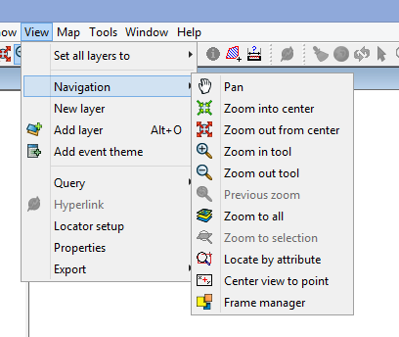
Let´s see all the available tools:
Icon | Tool | Shortcut key | Description
 | Pan |  | This allows you to change the View frame by dragging the viewing field all over the View with the mouse. Click and hold down de primary button of the mouse and move it in the required direction.
 | Zoom in to center |  | Zoom in to the center of the View data.
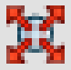 | Zoom out from center |  | Zoom out from the center of the View data.
 | Zoom in tool |  | Enlarges a particular area of the View.
 | Zoom out tool |  | Reduces a particular area of the View.
 | Previous zoom |  | To go back to the previous used zoom.
 | Zoom to all |  | Full extent zoom of the total area defined by all the layers of the View.
 | Zoom to selection |  | Full zoom of the area with all the selected elements.
 | Locate by attribute |  | Zoom in the area of the layer defined by one specific attribute.
 | Center view to point |  | Locate any point in the View by its coordinates and centre the View on this point..
 | Frame manager |  | Save and go back to many zooms as you want.
 | Zoom to layer |  | Zoom to the total extension of the layer..  Right click on the selected layer in TOC and click “Zoom to layer” in the contextual menu.
 | Zoom to raster resolution |  | Zoom to a screen pixel with the same pixel size of the raster layer.  Right click on the selected layer in TOC and click “Zoom to raster resolution” in the contextual menu. Clickingf on the visible area and it will center the View on this point.
Scrolling the mouse is possible to zoom in and zoom out. In this case, the enlargement will use as focus, the View center. With the mouse wheel pressed and moving it, the frame order will be executed.
In the status bar is possible to indicate the View scale, writing the scale factor or selecting any of the available in the drop-down menu.

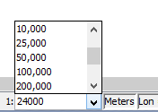

23.2. Zoom Manager
It is possible to save a zoom and go back to it at any time.
This tool is available in the “View/Navigation/Frame Manager” and in the specific tool bar.
The interface is:

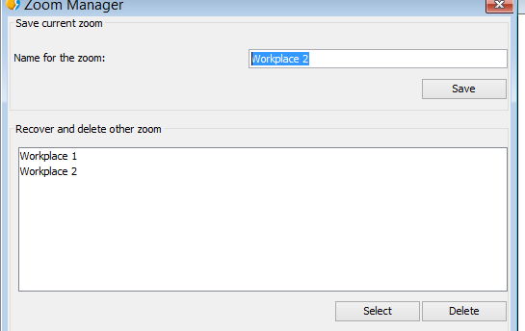
- Name for the zoom. It allows to give a name to the actual zoom of the View.
- “Save” button. The zoom currently in the View will be added to the Zoom Manager text box with the given name and with the rest of available zooms.
- Recover and delete other zooms. Available zooms list.
- “Select” button. Selecting one zoom from the list, the View will recover that selected zoom.
- “Delete” button. Delete the selected zoom from the list.

23.3. Center View to point
Center the View to one point with its specific coordinates.
This tool is available in the “View/Navigation/Center View to point” and in the specific tool bar.
The interface is:
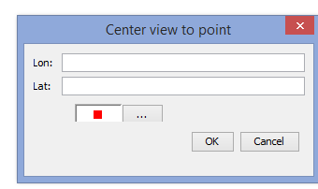
Input any required coordinates and select the colour of the point. Clicking “Accept”, the zoom will be focused on that point and it will show an information screen of that point.

23.4. Locate by attribute
This tool allows to zoom in the entities of one layer with a particular attribute.
It is available in the “View/Navigation/Locate by attribute” and in the specific toolbar.
The interface is:
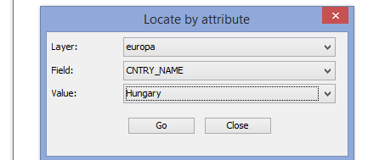
- Layer. Drop-down menu for selecting any available layer of the View.
- Field. Drop-down menu for selecting one field of the selected layer of the View.
- Value. Drop-down menu for selecting one value from the selected field.
- “Go” button. It will show a zoom of the View which contains all the entities of the layer with the indicated attribute.

23.5. Locator map
The locator is a general map which is displayed in the bottom left corner of the View´s window and it will locate the working area (main window zoom).
Available in “View/Locator Map” menu.
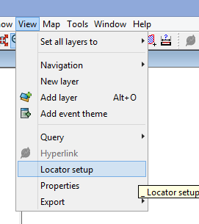
It shows the following window:
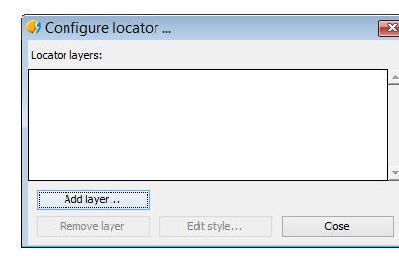
We can add layers which will be part of the locator map. From this window, we can delete layers or edit the legends.
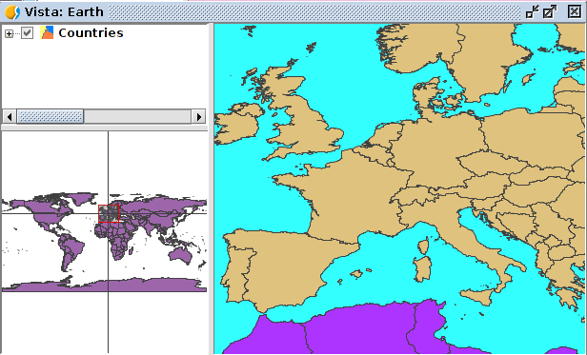
Locator elements:
- Red box. It is the View zoom..
- Horizontal/vertical axis indicates the central point in the View zoom.
Some of the properties are:
- Clicking on the locator with the primary button mouse and dragging, the frame (zoom and displacement) of the View.
- Clicking on the locator with the secondary button mouse and dragging, the View frame will be displaced, maintaining the scale.

23.6. Finding by Gazetteer
A Gazetter or geographical dictionary is one group of data in where all the toponyms are related to its geographic coordinates. It is a geographic index for identifying the geographical place of one toponym.
Available in the specific toolbar:
Let´s see all the available tools:
Icon | Tool | Shortcut key | Description
 | Finding by Gazetter |  | Search by Gazetteer.
 | Delete previous searches |  | Delete the searches made by Gazetteer. This button will appear with the first search.
It shows the following window:
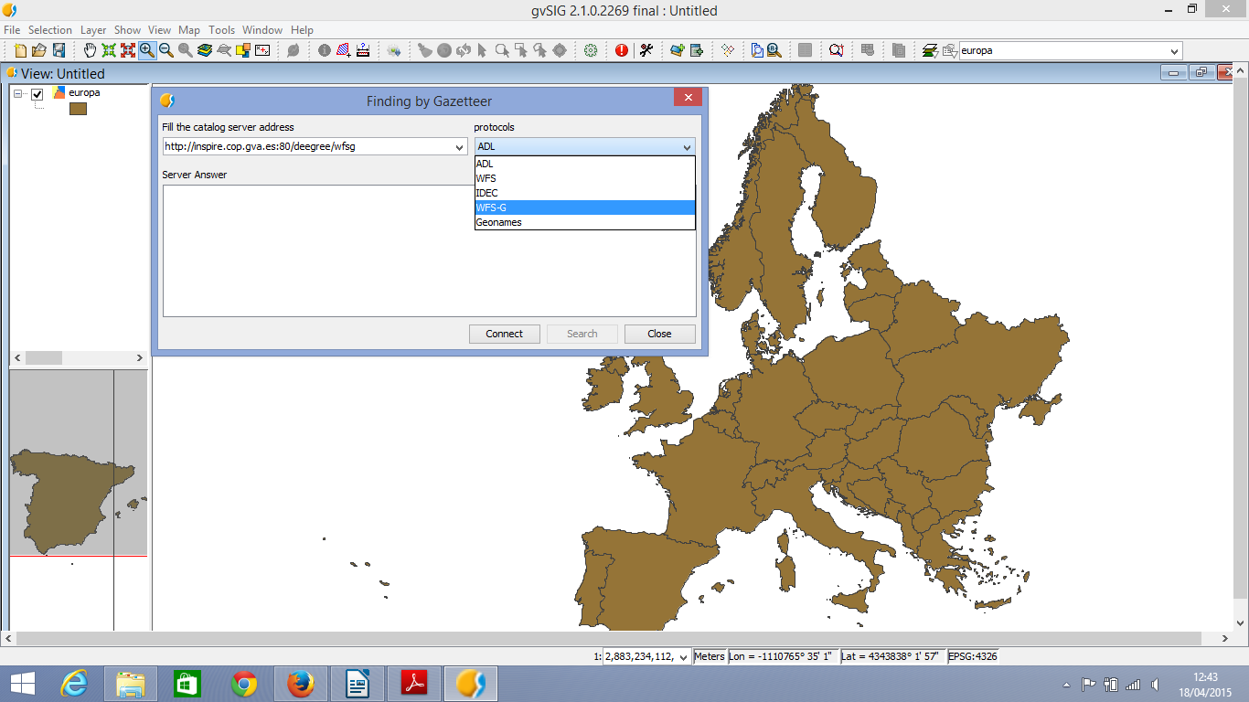
- Fill in the catalog server address: Blank space to introduce the URL. With “Ctrl+V” is possible to paste a text from the clipboard.
- Protocols: To select the server- The available ones are:
  - ADL. Protocol specified by Alexandria Digital Library.
  - WFS. Protocol for the searching for any place name, always in the case of having a text attribute in any of the tables. At the same time, it allows to make searches using any other field, not only with text attributtes.
  - IDEC. Protocol for using the Gazetteer service of the “Instituto Cartográfico de Cataluña” (ICC).
  - WFS-G. Protocol defined by OGC.
  - Geonames. Protocol for using the Geonames web service with a world database.
  - “Connect”. To connect to the server. A new window will appear for the search.
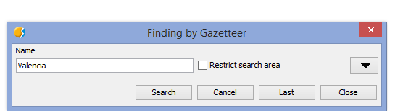
- This window allows to make a criteria search defined by the user. It is possible to view the form in a summarised way or make an advanced search clicking the triangle at the top right corner.
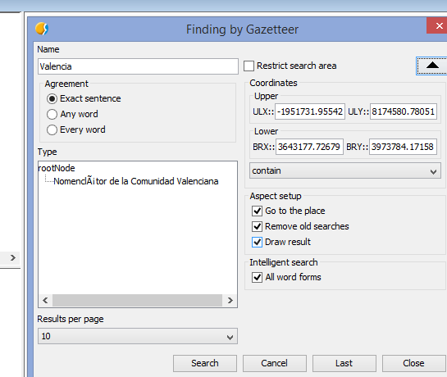
- Name. Write down the name for the search.
- Agreement. Define the search criteria of the input text:
  - Exact sentence.
  - Any word.
  - Every word.
- Coordinates. To define the coordinates of the searching area. By default, the coordinates will be the ones referred to the View frame.
- Restrict search area. Clicking it, the searching area will be restricted.
- Aspect setup:
  - Go to the place. The searched place name will be the center of the View.
  - Remove old searches. Delete all the old searching texts from the View.
  - Draw result. Draw one point and one label text in the place of the searching.
- Results per page. To indicate the number of results for each page.
- “Search” button. To launch the searching process. A new window will be opened:
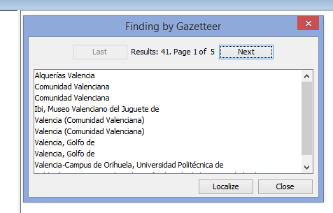
- Use the buttons “Last” and “Next” to move for the results pages.
- Selecting the place name from the result list and clicking “Localize”, the View will be focused on the place name.

