Consulting tools

24.1. Introduction
These tools are for getting information from the layers and are available from the “Layer/Query” menu or in its specific buttons in the toolbar.

Menu | Toolbar
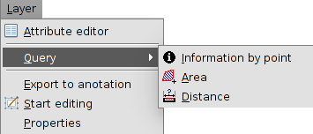
Let´s see all the available tools:
Icon | Tool | Shortcut key | Description
 | Information by point |  | To see the attribute values for one entity.
 | Query area |  | To measure areas and perimeters. It is possible to draw a polygon over the View area and obtain the area and peimeter.
 | Query distance |  | To measure distances. It is possible to draw lines and obtain the lenght.
 | Hyperlink |  | To see the hyperlinks of any entity.

24.2. Information
With this tool is possible to see the attribute values for one entity.
This tool is available from the “Layer/Query” menu or in its specific buttons in the toolbar.
The steps to follow are:
- Activate in TOC the layer or layers which contains the elements to be identified.
- Click on “Information”.
- Click on in any point of the area of the View frame to identify the entities of the ubication.
- A new window will be showed; “Identify results”.
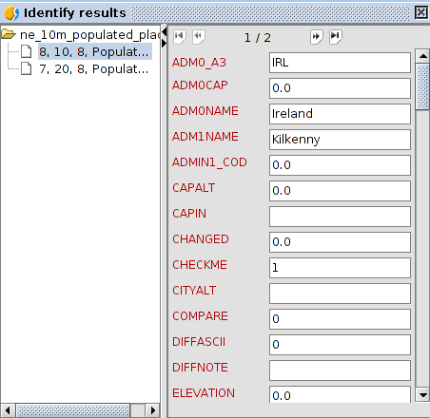
On the left side, the elements from which the information has been asked and its layer will be visible.
On the rigth side, the attribute values of the seleced element on the left part.

24.3. Query area
To measure areas and perimeters over the area of the View frame.
This tool is available in its specific toolbar.
The steps to follow are:
- Click on “Query area”.
- Click on the point which represents the first vertex of the area to be measured and drag the mouse and make click on each new vertex., ending with a double click.
- On the right bottom part of the View window, the area (A) and perimeter (P) can be found.

24.4. Query distance
To measure distances over the area of the View frame.
This tool is available in its specific toolbar.
The steps to follow are:
- Click on “Query distance”.
- Click on the point which represents the first vertex of line to be measured and drag the mouse and make click on each new vertex., ending with a double click.
- On the right bottom side, the distance of the last line (Dist) and the sumatory of all the measured lines (Total).can be found.

24.5. Hyperlink
To consult the hyperlinks of one entity. The hyperlink is one link to other resource(image, website,...) and it is associated to the elements of one layer.
This tool is available in its specific toolbar.
The steps to follow are:
- In the layer properties, the hyperlink option must be activated.
- Activate in TOC the layer with the elements whose hyperlinks are going to be consulted.
- Click on “Hyperlink”.
- Clicko on the element.
- The hyperlink results will appear. These results will depend on the hyperlink properties: image, PDF,....

