Selection Tools

25.1. Introduction
These tools are the ones that allow you to select a group of features in a layer. ome tools in gvSIG can work only on selected features.
The selection of vector features can be performed both from the view like from the attributes table associated with a layer.
These tools are available from the "Layer / Selection" menu on the corresponding button bar.

Menu | Button bar
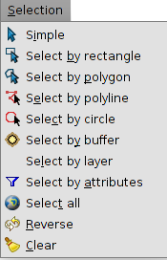
Let's see one by one all the available tools:
Icon | Tool | Shortcut | Description
 | Clear selection |  | Clean the previously done selection
 | Select all |  | Select all the elements of a layer
 | Select By Attributes |  | Selects entities based on a query by attribute
 | Reverse |  | Reverse selection
 | Simple |  | Selecting feature by feature
 | Select by circle |  | Select features that intersect the circular area defined by the user
 | Select by Layer |  | Spatial selection of features in a layer respect to another
 | Select by rectangle |  | Select features intersecting the rectangular area defined by the user
 | Select by polygon |  | Select features intersecting the polygonal area defined by the user
 | Select by buffer |  | Selection by area of influence
To select the elements of a layer, it is required that the layer is active.
To apply most of the graphic selection tools, you should click the left mouse button on the selection starting point, then drag and drop to finalize the selection. In the case of the simple selection, just click on the item you want to select. In the case of selection by polygon, click on each vertex of the polygon and double-click to finalize the selection.
To add features to an already existing selection, you must hold down the "Control" key while selecting features. To unselect one or more selected features of a multiple selection, you must hold down the "Control" key and click over them.
The selected features are displayed in yellow
In the "Preferences" of the View, it is possible to change the default color of the selection

25.2. Select by buffer
Permite realizar una selección por área de influencia a partir de uno o más elementos seleccionados. Crea áreas de influencia utilizando la distancia de área de influencia en torno a las entidades fuente (elementos seleccionados de partida) y devuelve todas las entidades que intersectan las áreas de influencia.
Allows to perform a buffer selection from one or more selected features. It creates buffer areas using the distance of an influence area around the source elements (starting selected features) and produce as output all the features intersecting the areas of influence.
This tool is available from the "Selection" menu on the corresponding button bar.
There must be at least one element selected from a layer. The resulting selection is applied to the active layers.
This is the user interface:
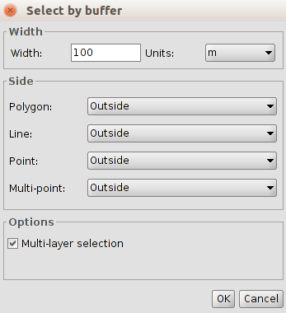
- Width: width of the area of the buffer.
- Unit. measurement unit selectable via a drop down list.
- Side. Depending on the type of layer, selects the direction to be applied to the buffer: Outside (external), Inside (internal).
- Options. Multi-layer selection. Activating the check box selection, the buffer is applied to all layers that are multi-layer.

25.3. Select by layer
You can select features based on their poistion in relation to other layer(s) feature(s) by using several selection methods.
This tool is available from the "Selection" menu through this interface:
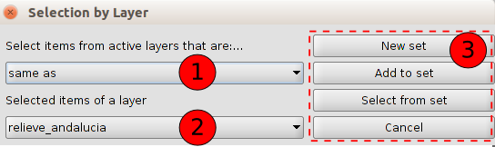
- Select the active layers and by the dropdown list define the selection method.

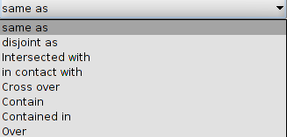
The location selection methods include:
- Same as. Select the features that are the same in another layer. Two elements are considered equal if their geometries are exactly the same. Layers type must be the same.
- They are disjoint as. Select features in a layer that are different from other layers. Two features are considered different if their geometries are not exactly the same.
- Intersected with. Select the entities that are completely or partially overlapped with the source features.
- In contact with. A target feature is selected if the intersection of geometry to the source entity is not empty, but the intersection of their interiors is empty.
- Cross over. Selects features crossing the limits of the source features. The boundaries of the source and destination features must share at least one side, vertex or node.
- Contain. The geometry of the source entity should be within the geometry of the target layer, including its boundaries.
- Contained in. Select the entities that are within the geometry of the source entities.
- Over. Select the features that overlap with the geometries of the source entities.
- Selected features of the layer. Selects by a drop down list, the selected layer selected of the source features.
- Selection Options.
- New set. Create a new selection
- Add to set. Create a selection considering the already existing query and summing the result of the current query to it.
- Select from set. Create a selection only from the already selected features
If we want to use all elements of a layer as the source entities, we must previously select all the elements of that layers.

25.4. Select by attributes
It makes user able to select features by using an attributes query
This is its user interface.
- Fields. List of attribute fields in the layer. Double-click on the field to add it in the query.
- Logical operators. Inserts, by clicking on them, a logic operator to the query expression.
- Known values. Lists the values present in the layer attribute table for the selected field. Double click on the value to add it to the selection query.
- Expression. Text box reporting the query that is going to be run. It allows direct typing.
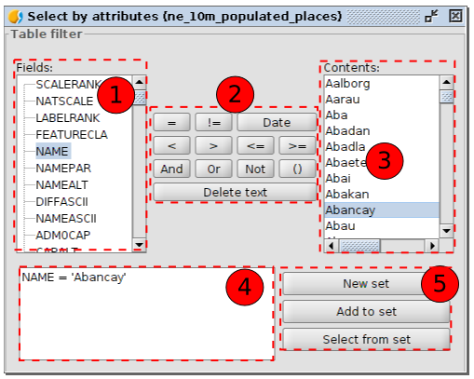
- Selection Options.
- New set. Create a new selection
- Add to set. Apply the query considering the already existing query and sum the result.
- Select from set. Apply the query only to the already selected features

