Graphic editing tools

26.1. Introduction
To create and edit various types of vector data with some feature formats. Other formats are read-only and don´t allow editing.
To add or modify elements of one layer, it requires that the layer is active and in editing mode. Depending on the layer type the options will be different.
These tools are available from “Layer” menu and “Remove”, “Insert” and “Modify” submenus, from the “Edit” menu and from the specific button bar.
Button bar
Menu
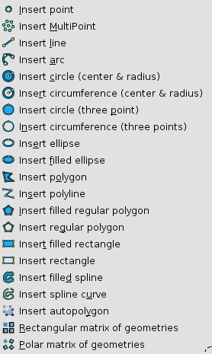  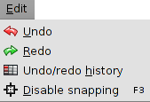 | 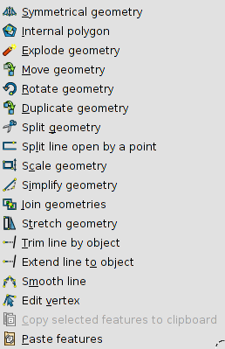

gvSIG allows to have more than one layer active at the same time.
With “Esc” key any edition operation will finished.

26.2. Start / Finish editing
To start or finish the editing session (the layer must be active).
The tool changes itself depending on the status of the edition. When the layer is not in editing mode, it will be “Start editing” and when the editing session has been initiated, it will be “Finish editing”.
It is available from “Layer” menu, in the context menu of the layer and in the specific button bar.
Menus
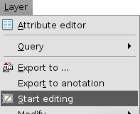 | 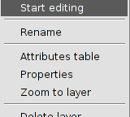

Icon | Tool | Shortkey | Description
 | Start / Finish editing |  | To start of finish the edition.

26.3. Command console
To introduce orders and editing options using the command console.
It is located at the bottom part of the View frame when the layer is in editing mode.
The console can be resized and hidden.
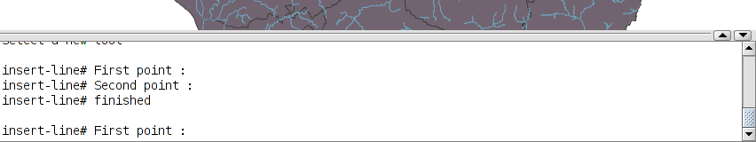
To write down the commands use the keyboard. Once the selected option is indicated, press “Enter” for being registered.

26.4. Flatness
In gvSIG any curved geometry is made up of one determined number of sections. Flatness is the parameter to define the density of the straight lines which define the curved geometries. A high Flatness number can make that the curved elements will be visualized as polylines.
In “Preferences/Flatness”, its value can be modified.

