Tools for modifying features

27.1. Introduction
To modify elements of one layer in editing mode.
These tools require a selection of features (geometries) where to apply the tool.
Once the tool is executed, press the right button to access to a context menu which allows to select between the different tool options, indicate points with its exact coordinates,.....
Let´s see all the available tools:
Icon | Tool | Shortkey | Description
 | Geometric Symmetry |  | To create symmetries of existing elements.
 | Internal polygon |  | To delete internal parts of one polygon, creating an island polygon.
 | Explode/Break down geometry |  | Break downs a multigeometry in geometries.
 | Move geometry |  | Move the geometries between two specific points.
 | Rotate geometry |  | Rotate the selected geometries a specific angle.
 | Copy geometry |  | To copy and move existing geometries.
 | Split geometry |  | To split one geometry using a cut option.
 | Split line in one point |  | To split one line in one specified point
 | Scale geometry |  | To modify the size of one geometry using a scale value.
 | Simplify geometry |  | To simplify the geometry preserving the essential size of the geometry.
 | Join geometries |  | To join geometries.
 | Insert autopolygon |  | To insert a polygon next to the existing ones.
 | Stretch geometries |  | To stretch a geometry moving the selected vertex.
 | Extend line to object |  | To extend one line to one object.
 | Cut line with one object |  | To cut one line with a cutting edge defined by other objects.
 | Smooth line |  | To smooth the angles of one line.
 | Edit vertex |  | To edit the vertex of one geometry (move, remove or add).
 | Copy features |  | To copy selected elements to the clipboard.
 | Paste features |  | To paste copied features from the clipboard.
 | Delete |  | To delete the selected features.

27.2. Symmetry
To create symmetries of the existing features. The resulting geometries will have the same attributes.
This tool is available from the "Layer / Modify" menu and from the relevant button bar.
The steps are:

1. Select the feature or features on which to apply the tool. If there are selected features previously to the use of the tool, the tool will be applied on these. To end the selection, press "Enter".
2. First point on the axis of the symmetry. You can enter it graphically by clicking with the mouse, specifying the coordinates of the point using the console command or with the context menu by selecting "First point..." that opens a window for entering the coordinates.
3. Second point on the axis of symmetry. You can enter it graphically by clicking with the mouse, specifying the coordinates of the point using the console command or with the context menu by selecting “Second point..." that opens a window for entering the coordinates.
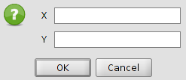

4. Select between delete or keep the original geometries. The aimed option can be indicated in the command console or with the context menu.
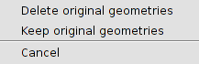

27.3. Internal polygon
To delete internal parts of one polygon. It generates an “island” polygon.
This tool is available from the "Layer / Modify" menu and from the relevant button bar.
The steps are:
1.Select the feature or features on which to apply the tool. If there are selected features previously to the use of the tool, the tool will be applied on these. To end the selection, press "Enter".
2.Select one tool from the ones used to insert features to draw the internal polygon or cutting area.

27.4. Explode geometry
To break down one multigeometry into geometries. The resultant geometries will have the same attributes.
This tool is available from the "Layer / Modify" menu and from the relevant button bar.
The steps are:
1.Select the feature or features on which to apply the tool. If there are selected features previously to the use of the tool, the tool will be applied on these. To end the selection, press "Enter".

27.5. Move geometry
To move the selected geometries between two specified points.
This tool is available from the "Layer / Modify" menu and from the relevant button bar.
The steps are:

1. Select the feature or features on which to apply the tool. If there are selected features previously to the use of the tool, the tool will be applied on these. To end the selection, press "Enter".
2. First point. You can enter it graphically by clicking with the mouse, specifying the coordinates of the point using the console command or with the context menu by selecting "First point..." that opens a window for entering the coordinates.
3. Second point. You can enter it graphically by clicking with the mouse, specifying the coordinates of the point using the console command or with the context menu by selecting “Second point..." that opens a window for entering the coordinates.

27.6 Rotate geometry
To rotate the selected geometries one specified angle.
This tool is available from the "Layer / Modify" menu and from the relevant button bar.
The steps are:
1. Select the feature or features on which to apply the tool. If there are selected features previously to the use of the tool, the tool will be applied on these. To end the selection, press "Enter".
2. Rotation centre. You can enter it graphically by clicking with the mouse, specifying the coordinates of the point using the console command or with the context menu by selecting "Rotation centre..." that opens a window for entering the coordinates.
3. Rotation angle. You can enter it graphically by clicking with the mouse, specifying the grades of the rotation angle using the console command or with the context menu that opens a window for entering the rotation angle.
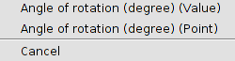
In the case of using the angle graphically, a visual aid will be available indicating the value of the rotation angle.
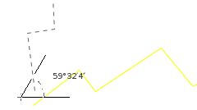

27.7. Duplicate geometry
To copy and move existing geometries. The duplicated geometries will keep the same attributes.
This tool is available from the "Layer / Modify" menu and from the relevant button bar.
The steps are:

1. Select the feature or features on which to apply the tool. If there are selected features previously to the use of the tool, the tool will be applied on these. To end the selection, press "Enter".
2. First point. You can enter it graphically by clicking with the mouse, specifying the coordinates of the point using the console command or with the context menu by selecting "First point..." that opens a window for entering the coordinates.
3. Second point. You can enter it graphically by clicking with the mouse, specifying the coordinates of the point using the console command or with the context menu by selecting “Second point..." that opens a window for entering the coordinates.

27.8. Split geometry
To divide a geometry in various geometries using a cutting element. The resultant geometries will have the same attributes.
This tool is available from the "Layer / Modify" menu and from the relevant button bar.
The steps are:

1. Select the feature or features on which to apply the tool. If there are selected features previously to the use of the tool, the tool will be applied on these. To end the selection, press "Enter".

2. Select one inserting tool to draw the cutting element.

27.9. Split line in one point
Split one line from a specified point.
This tool is available from the "Layer / Modify" menu and from the relevant button bar.
The steps are:

1. Select the feature or features on which to apply the tool. If there are selected features previously to the use of the tool, the tool will be applied on these. To end the selection, press "Enter".

2. Cutting point. You can enter it graphically by clicking with the mouse, specifying the coordinates of the point using the console command or with the context menu by selecting "Point" that opens a window for entering the coordinates.

27.10. Scale geometry
To resize the geometry using a scale value.
This tool is available from the "Layer / Modify" menu and from the relevant button bar.
The steps are:

1. Select the feature or features on which to apply the tool. If there are selected features previously to the use of the tool, the tool will be applied on these. To end the selection, press "Enter".

2. Origin. You can enter it graphically by clicking with the mouse, specifying the coordinates of the point using the console command or with the context menu that opens a window with two options for entering the scale origin.

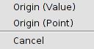
3. Scale factor or reference point. You can enter it graphically by clicking with the mouse, specifying the coordinates of the point using the console command or with the context menu that opens a window with two options for entering the scale origin.
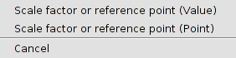
4. Second reference point. You can enter it graphically by clicking with the mouse, specifying the coordinates of the point using the console command or with the context menu by selecting “Second reference point” that opens a window with two options for entering the coordinates.
In the case of using the angle graphically, a visual aid will be available indicating the value of the scale factor and the possible result.
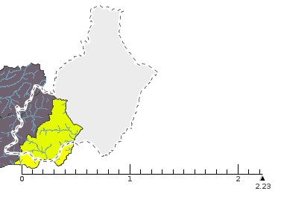

27.11. Simplify geometry
To simplify a geometry keeping the essential form of the geometry.
This tool is available from the "Layer / Modify" menu and from the relevant button bar.
The steps are:

1. Select the feature or features on which to apply the tool. If there are selected features previously to the use of the tool, the tool will be applied on these. To end the selection, press "Enter".

2. Tolerance. It is the maximum distance between two lines which define the geometry of the three sequential nodes and the line of the simplified geometry from joining the first and the last of those nodes. You can enter the value by using the console command or with the context menu that opens a window for entering the value.
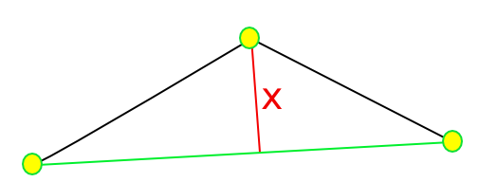

27.12. Join geometries
To join various geometries in one unique geometry.
This tool is available from the "Layer / Modify" menu and from the relevant button bar.
The steps are:

1. Select the feature or features on which to apply the tool. If there are selected features previously to the use of the tool, the tool will be applied on these. To end the selection, press "Enter".

27.13. Insert autopolygon
To insert one polygon next to other existing elements, without drawing the common borders.
This tool is available from the "Layer / Modify" menu and from the relevant button bar.
The steps are:

1. Select one tool for inserting polygons and draw the autopolygon.

27.14. Stretch geometry
To stretch one geometry moving the selected vertex.
This tool is available from the "Layer / Modify" menu and from the relevant button bar.
The steps are:

1. Select the feature or features on which to apply the tool. If there are selected features previously to the use of the tool, the tool will be applied on these. To end the selection, press "Enter".

2. Select one tool for inserting polygons and draw the polygon, which allows to select the vertex to stretch. The selected vertex will be shown.

27.15. Extend line to object
To extend one line to object.
This tool is available from the "Layer / Modify" menu and from the relevant button bar.
The steps are:

1. Select the feature or features on which to apply the tool. If there are selected features previously to the use of the tool, the tool will be applied on these. To end the selection, press "Enter".

2. Select each line to extend. When the mouse is over the line, a result preview is shown; at the time the lines are being selected, they will be extended until the indicated objects in the previous step.

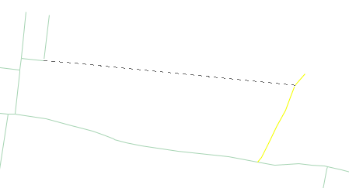
3. Once all the lines have been extended, press “Esc” to close the function.

27.16. Split line with an object
To split a line in a cutting edge defined by other objects.
This tool is available from the "Layer / Modify" menu and from the relevant button bar.
The steps are:

1. Select the feature or features on which to apply the tool. If there are selected features previously to the use of the tool, the tool will be applied on these. To end the selection, press "Enter".

2. Select each line to split. When the mouse is over the line, a result preview is shown; at the time the lines are being selected, they will be extended until the selected objects in the previous step.
3. Once all the lines have been extended, press “Esc” to close the function.

27.17. Smooth line
To smooth angles in one line.
This tool is available from the "Layer / Modify" menu and from the relevant button bar.
The steps are:

1. Select the feature or features on which to apply the tool. If there are selected features previously to the use of the tool, the tool will be applied on these. To end the selection, press "Enter".

2. Intermediate steps [1,9].

3. Smooth method. There are three methods available: natural cubic splines, Bézier curves, B-splines

27.18. Edit vertex
To edit the vertex of one geometry(move, delete and add).
This tool is available from the "Layer / Modify" menu and from the relevant button bar.
The steps are:

1. Select the feature or features on which to apply the tool. If there are selected features previously to the use of the tool, the tool will be applied on these. To end the selection, press "Enter".The vertex of the geometry will be shown.

2. Select one vertex. You can enter it graphically by clicking with the mouse, specifying the coordinates of the point using the console command or with the context menu by selecting “Select one vertex..." that opens a window for entering the coordinates.

3. Move, insert or delete vertex. Once the vertex has been selected, there these options available:
  - Move. Moving the mouse and clicking in the new position to move the selected vertex.
  - Insert vertex. Pressing on “+”.
  - Delete vertex. Pressing on “-”.

27.19. Converting to polyline
Allow converting curve lines to polylines.
The steps are:
- Select the element to which will be applied the tool. If a selected element exists prior to the tool use, it will be applied the tool on it. To complete the selection press “Enter”. The selected curved lines will become polylines

27.20. Reverse direction
Allows you to reverse the digitization sense of a geometry.
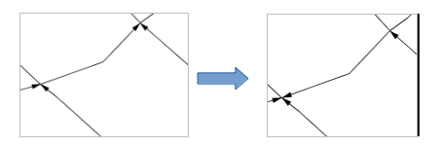
The steps are:
- Select the element on which we want to apply the tool. If a selected element exists prior to the tool use, it will be applied the tool on it. To complete the selection press “Enter”. The selected elements will automatically reverse their digitization sense.

27.21. Paralell Geometry
Allows selecting lines series and create a parallel with them.
The steps are:
- Select the element on which we want to apply the tool. If a selected element exists prior to the tool use, it will be applied the tool on it. To complete the selection press “Enter”.
- Distance. It can be input in a graphic way with the mouse clic, specifying the point coordinates through the commands console or with the shorcut menu, selecting “Distance (value)” to open a window to enter the distance value or “Distance (point)” which opens a window for entering the coordinates.
- Keep or delete original geometries. It will allow the selection between keeping or removing the original geometries. The option can be indicated either through the commands console or the shortcut menu which let us choose between both options.

27.22. Copy features
To copy selected features to the clipboard. It allows to copy features between laers.
This tool is available from the "Layer / Modify" menu and from the relevant button bar.
The steps are:
- Select the feature or features to copy.
- Run “Copy features”.
- It will be given the option to copy as well the alphanumeric attributes along the graphic elements.
The features are copied in the clipboard and can be pasted in another layer which allows the same type of geometry than the original layer.

27.23. Paste features
Paste the features from the clipboard.
This tool is available from the "Layer / Modify" menu and from the relevant button bar.
The steps are:
- Put the layer where we want to paste the features in editing mode to paste the available features in the clipboard.
- Run “Paste features” and the copied features will be pasted.

27.24. Delete features
To delete the selected features.
This tool is available from the relevant button bar.

