drawing supporting tools

29.1. Snapping
The Snapping lets you to create entities that are connected to each other more accurately. By activating the snapping, the pointer is set to other geometric features when it is close to them and within a specific tolerance. This allows to locate a feature concerning other locations.
This tool is available from the "Edit / Enable snapping" menu or by the key "F3". Each time you run this tool, it will change its state;it is activated or deactivated depending on the previous state of snapping.

Menú
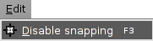
In the window "View Properties / Snapping" you can select the layers to be used for snapping.
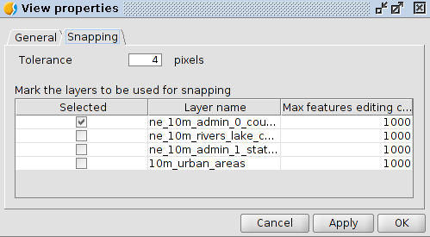
If the snapping tolerance is 4 pixels, the two features which are at a distance equal to or less than 4 pixels will be joined into a common coordinate.
The values of the column "Maximum number of features in memory" can be changed to accelerate snappings in edition. It is the maximum number of geometries with which you want to work in memory.
The types of snapping can be defined in the window "Preferences" in the "Snapping" section.
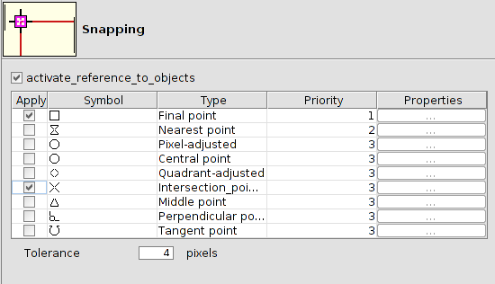

29.2. Grid
The grid is a pattern of dots that extends along the drawing area. It allows to align the objects and magnify the distance between them.
To access to the grid tools, it should be a layer in editing mode.
This tool is available from the tab “Show / Grid /Show-Hide" menu or with the key "F7". Each time you run this tool, it will change its state; it is activated or deactivated depending on the previous state of the grid.

Menú
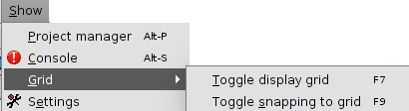
Using the "Show / Grid / Turn- turn off snapping to the grid" or by the key "F9" tool, it is possible to enable or disable snapping to the grid points. Each time you run this tool, it will change its state; it is activated or deactivated depending on the previous state of the snapping. drawing supporting tools

29.1. Snapping
The Snapping lets you to create entities that are connected to each other more accurately. By activating the snapping, the pointer is set to other geometric features when it is close to them and within a specific tolerance. This allows to locate a feature concerning other locations.
This tool is available from the "Edit / Enable snapping" menu or by the key "F3". Each time you run this tool, it will change its state;it is activated or deactivated depending on the previous state of snapping.

Menú
In the window "View Properties / Snapping" you can select the layers to be used for snapping.
If the snapping tolerance is 4 pixels, the two features which are at a distance equal to or less than 4 pixels will be joined into a common coordinate.
The values of the column "Maximum number of features in memory" can be changed to accelerate snappings in edition. It is the maximum number of geometries with which you want to work in memory.
The types of snapping can be defined in the window "Preferences" in the "Snapping" section.

29.2. Grid
The grid is a pattern of dots that extends along the drawing area. It allows to align the objects and magnify the distance between them.
To access to the grid tools, it should be a layer in editing mode.
This tool is available from the tab “Show / Grid /Show-Hide" menu or with the key "F7". Each time you run this tool, it will change its state; it is activated or deactivated depending on the previous state of the grid.

Menú
Using the "Show / Grid / Turn- turn off snapping to the grid" or by the key "F9" tool, it is possible to enable or disable snapping to the grid points. Each time you run this tool, it will change its state; it is activated or deactivated depending on the previous state of the snapping.

